BSC 181 Exam Two
Each question has one correct answer. Please read each question carefully before responding.

- Apocrine sweat glands
- are most common in the armpit and groin
- respond only to elevated body temperature
- are located in the palms of the hand and soles of the feet
- are associated with mucus
- produce a conditioning oil for the skin

- Red bone marrow is responsible for
  - fat storage
  - formation of red and white blood cells
  - formation of white blood cells only
  - formation of red blood cells only
  - carbohydrate storage

- As epidermal cells are pushed toward the surface, strands of tough water-proof protein called _____ develop in their cytoplasm
- stratum germinativum
- collagen
- keratin
- elastin
- carotene
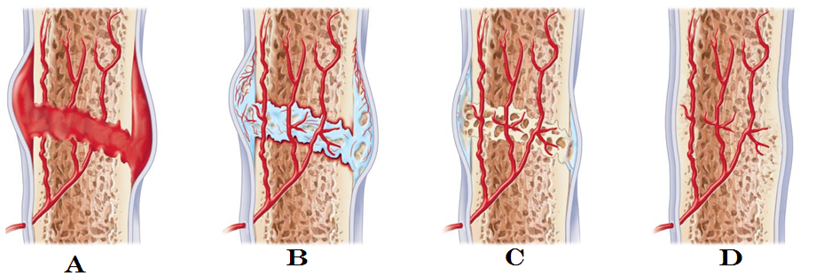

- The image above demonstrates bone repair. In which one would you find the bony callus?
  - Image 1
  - Image 2
  - Image 3
  - Image 4
  - The bony callus is present in all stages

- Which cell type is NOT present in the epidermis?
  - Melanocytes
  - Langerhans cells
  - Merkel Cells
  - Keratinocytes
  - Kuppfer cells

- The type of articular cartilage that is found at the end of joints as well as the soft portions of the nose is
- myocartilage
- keratin
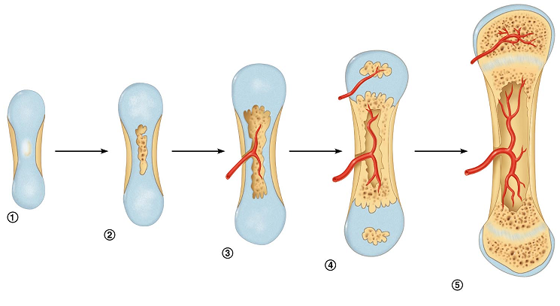
- elastic
- hyaline
- fibrocartilage

- Which process is represented above?
  - Osteopoesis
  - Interosseus calcification
  - Endochondral ossification
  - Osteogenesis
  - Intramembranous ossification

- Which layer of epidermis is the deepest layer and responsible for growth?
  - Stratum lucidum
  - Stratum basale
  - Stratum granulosum
  - Stratum corneum
  - Stratum spinosum

- Osteoblasts are ____________________; whereas osteoclasts are _______________.
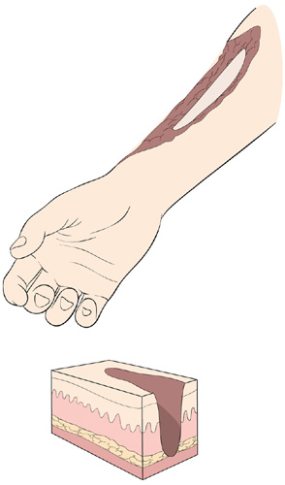
- mature bone cells; immature bone cells
- bone building cells; bone destroying cells
- immature bone cells; mature bone cells
- bone destroying cells; bone building cells
- bone repairing cells; bone repairing cells

- What type of burn is described?
Full thickness burn, no pain, no edema. Cherry red
- first degree burn
- second degree burn
- third degree burn
- fourth degree burn
- fifth degree burn

- The presence of an epiphyseal disk indicates
- the marrow has ruptured out of its cavity
- the bone is still growing
- the bone has matured
- the person is over 30 years old
- the bone diameter is increasing
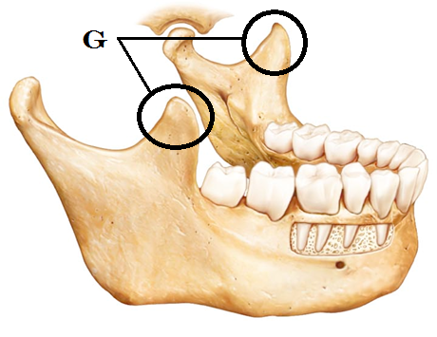
- Identify the bone to the right
  - Mandible
  - Maxilla
  - Sphenoid bone
  - Vomer
  - Temporal bone

- Identify “G”
  - Occipital Condyle
  - Mandibular fossa
  - Alveolar Margin
  - Mandibular condyle
  - Coronoid Process

- Which type of hair would be found in both children and in adult females?
- lanugo
- alopecia
- vellus
- terminal
- axillary

- Exposure to ultraviolet light causes the skin to darken by stimulating the production of
- keratin
- carotene
- melatonin
- seratonin
- melanin

- Which of the ABC’s of skin cancer are incorrectly paired?
    - A: Appearance
    - B: Border
    - C: Color
    - D: Darkness

  - 1 and 2 are incorrect
  - 2 and 3 are incorrect
  - 3 and 4 are incorrect
  - 1 and 4 are incorrect
  - 4 is the only incorrect option

- Which three pigments are responsible for skin color?
      - Melanin
      - Biliverdin
      - Carotene
      - Hemoglobin
      - Myoglobin

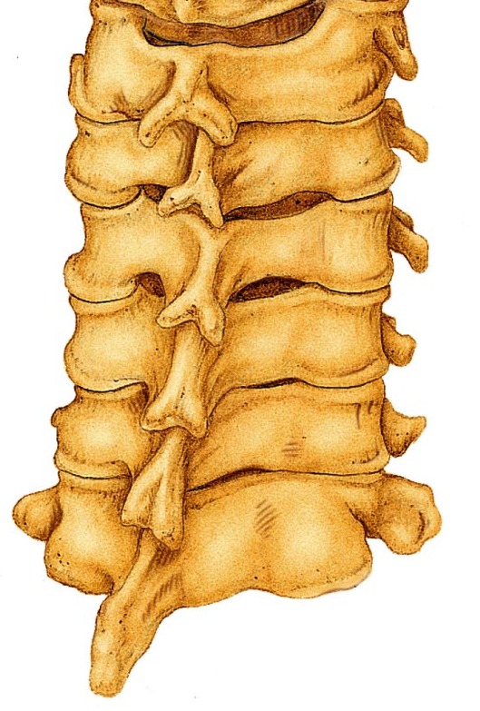
        - 1, 4, 5
  - 2, 4, 5
  - 1, 2, 3
  - 1, 2, 5
  - 1, 3, 4

- Which region are these vertebrae from?
  - Cervical
  - Thoracic
  - Lumbar
  - Sacral
  - Coccygeal

- Which of the following is NOT an exocrine gland?
a. salivary glands
b. sweat glands
c. sebaceous glands
d. digestive glands
e. pituitary gland

- Which skin cancer is being described: Arises from keratinocytes of stratum spinosum; most often appears on scalp, ears, and lower lip; fast growing; treated by removal or radiation
- Basal cell carcinoma
- Squamous cell carcinoma
- Small cell carcinoma
- Melanoma
- The description fits both basal cell and squamous cell carcinomas
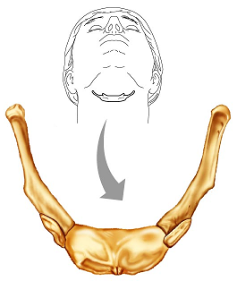

- Which bone is shown in the image to the right? This bone does not articulate with other bones.
- C1, atlas
- C2, axis
- First rib
- hyoid
- patella

- Match the term to the following definition:
“narrow, slit like opening”
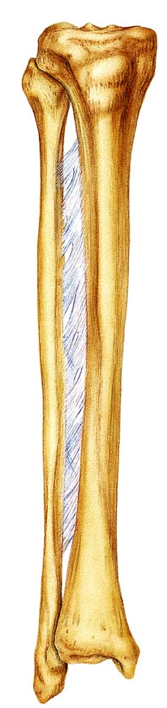
- Trochanter
- Tuberosity
- Fissure
- Foramen
- Fossa

- The thinner and more slender of these two bones is the
  - Radius
  - Ulna
  - Tibia
  - Fibula
  - Femur

- Match the term to the following definition:
“a rounded articular projection”
  - Head
  - Facet
  - Condyle
  - Turburcle
  - Meatus

- Within an osteon, what is the function of the canaliculi?
- Provides structural support for the bone
- Provides a pathway between the lacunae and the central canal
- Clears out the debris within the central canal
- Acts as an attachment site for muscles
- Provides small cavities or nests that house osteocytes

- Which type of ossification starts with a thin, fibrous tissue that gets filled in with bone: seen in the skull
- synchondesmal ossification
- syndesmosis ossificiation
- chondrocartilaginous ossification
- endochondral ossification
- intramembranous ossification

- Where are the secondary ossification centers located in long bones?
- epiphysis
- diaphysis
- enuresis
- syndesmosis
- most long bones will not have secondary ossification centers

- Which “law” relates to bony growth and adaptation to stresses?
  - Wolff’s Law
  - Weirneke’s Law
  - The law of osseous hyperplasia
  - Starling’s Law
  - Cole’s Law

- In which bones are we most likely to observe a depression fracture?
- Vertebra
- Skull
- Femur
- Rib
- Sternum

- In which bones are we most likely to observe a compression fracture?
  - Femur
  - Vertebra
  - Skull
  - Rib
  - Sternum

- Which ribs have no attachment to the sternum
- all of the ribs are attached to the sternum
- floating ribs
- true ribs
- flying ribs
- ribs one through seven

- The half-moon shaped structure at the base of the nail is called
  - Moonula
  - Lateral fold
  - Lunula
  - Eponychium
  - Hyponychium

- Which of these bones of the skull is NOT a bone found in the cranium?
  - Parietal
  - Occipital
  - Sphenoid
  - Vomer
  - Frontal

- The epidermis has four or five layers, depending on its location. One layer is present in thick skin that is not present in any other location. Which is it?
  - Stratum germinativum
  - Stratum granulosum
  - Stratum corneum
  - Stratum spinosum
  - Stratum lucidum

- Identify the structure “w”
  - Trochlea
  - Olecranon Process
  - Ulnar Head
  - Capitulum
  - Medial epicondyle
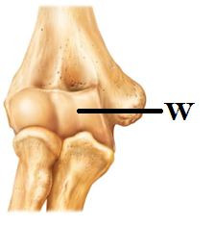

- Which of the following statements is correct regarding spinal curves?
- The cervical kyphosis is formed after the infant holds up his/her own head
- The cervical lordosis is a primary curve
- The thoracic kyphosis is a primary curve
- The lumbar kyphosis is a secondary curve
- The sacral lordosis is formed after an infant begins to walk upright

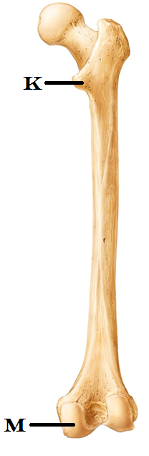
- Which of these is NOT a carpal bone?
- lunate
- hamate
- cuneiform
- scaphoid
- capitate

- Identify “K”
  - Greater Tubercle
  - Fovea centralis
  - Femoral head
  - Lesser Trochanter
  - Medial epicondyle

- Identify “M”
  - Lateral Epicondyle
  - Medial Condyle
  - Patellar surface
  - Acetabulum
  - Intercondylar fossa

- Which of the vertebrae have a transverse foramina?
  - all of the cervical vertebrae
  - all of the thoracic vertebrae
  - all of the lumbar vertebrae
  - all of the vertebrae
  - some of the cervical and some of the thoracic vertebrae

- Which of the following is correct of the female pelvis when comparing it with the male pelvis?
- there are no anatomical differences
- distance between the female ischial spines is less
- the female pelvis is tall and narrow
- the angle of the female pubic arch is smaller
- distance between the female ischial spines is greater

- Calculate how many long bones there are in the hand (do not include the carpals)
- fourteen
- twenty
- nineteen
- twenty five
- twenty four

- The ceruminous gland produces cerumin. What is cerumin?
  - Breast milk
  - Mucus
  - Sweat
  - Ear wax
  - Conditioning oil

- Identify the “x”
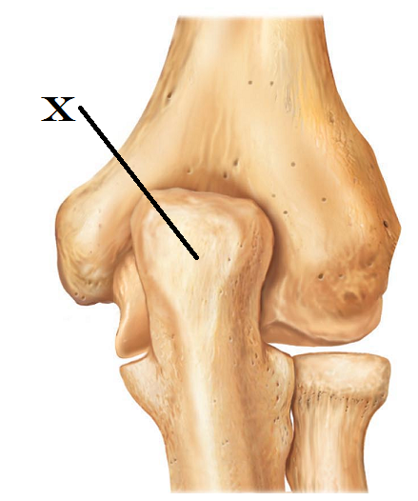
  - Tibial tuberosity
  - Olecranon Process
  - Ulnar condyle
  - Head of radius
  - Capitulum

- Which pelvic structure is responsible for supporting your weight as you sit? (The “sitting bones”)
  - Pubic rami
  - Iliac crest
  - Ischial tuberosity
  - Sacral ala
  - Posterior inferior iliac spine

- The periosteum is
- the cartilage that covers the articular surface of a bone
- a layer of epithelium that covers bone
- a layer of connective tissue that covers bone
- tissue that covers the medullary cavity
- closely associated with yellow bone marrow

- In the epiphyseal plate, what is the osteogenic zone responsible for?
  - meiosis
  - mitosis
  - destruction (cavitation) of cartilage
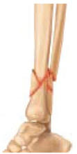
  - producing the periosteum
  - producing the new bone material

- This type of break in bone occurs when there is a
complete break that causes the bone to shatter.
  - Comminuted
  - Greenstick
  - Spiral
  - Compound
  - Oblique

- The fibula is
- short and thick
- located on the medial aspect of the lower leg
- articulates with the radius bone in the forearm
- forms the lateral malleolus (ankle bone)
- often absent after skeletal maturation

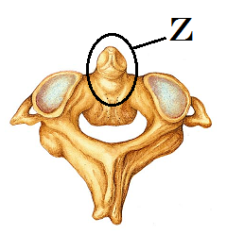
- Identify the structure “Z”
- Spinous Process
- Pedicle
- Centrum (body)
- Transverse process
- Odontoid process (Dens)

Please turn in your exam.

Put your name and set it in a separate pile ONLY if you have made a comment for me to read on the exam.

Please double check to see that your name and ID# are correctly entered and bubbled-in on the Opscan form

Turn in your Opscan

Enjoy the rest of your day.
Grades should be posted late tonight or early tomorrow.

