BSC 181Exam Three:
Chapters 8, 9, and 10

- Which of the following is not a synovial joint?
- gliding
- ball and socket
- suture
- saddle
- condyloid

- Which of the following is a gomphosis?
- intervertebral disc
- knee
- elbow joint
- teeth
- pubic symphysis

- The connective tissue that covers each skeletal muscle cell (muscle fiber) is
  - sarcoplasmic reticulum
  - endomysium
  - sarcolemma
  - epimysium
  - perimysium

- In which two places would you find a synchondrosis?
    - where the first rib articulates with the sternum
    - between the tibia and fibula
    - between vertebral bodies
    - in the long bones at the growth plates
    - at the pubic symphysis

  - 1 and 2
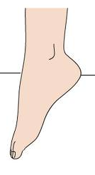
  - 1 and 4
  - 2 and 3
  - 2 and 5
  - 3 and 5

- This motion of the ankle is
- plantarflexion
- inversion
- elevation
- dorsiflexion
- protraction

- What is the function of a bursa?
  - Promotes nutrition to the synovium
  - Increases the activity of the chondrocytes
  - Encourages synovial expansion
  - Prevents overheating of the pannus
  - Reduces the amount of friction at a joint

- A sheet-like extension of the epimysium that connects muscle to muscle is
- ligament
- aponeurosis
- fascicle
- sarcoplasmic reticulum
- tendon

- The term “ankylosis” was used in describing a result of Rheumatoid arthritis. What does ankylosis mean?
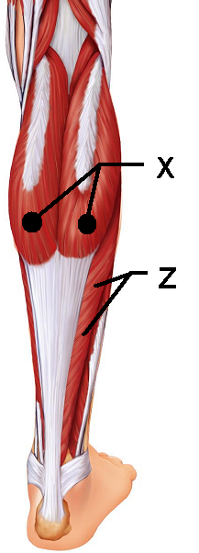
  - Inflammation of the synovium
  - Flattened sheets of tissue
  - Erosion of bone
  - Dislocation
  - Fusion of bone

- This muscle “X” is responsible for plantar flexion
  - Soleus
  - Gastrocnemius
  - Fibularis posterior
  - Semitendinosus
  - Semimembranosus

- This muscle “Z” lies deep to the muscle in question 9.
It is also responsible for plantar flexion
- Soleus
- Gastrocnemius
- Fibularis posterior
- Semimembranosus
- Semitendinosus

- In a resting skeletal muscle cell the myosin binding sites are blocked by ________
- actin
- myosin
- calmodulin
- calcium
- tropomyosin

- The joint between C1 and C2 uses the dens (also known as the odontoid process) to create which type of joint motion
  - Supination
  - Circumduction
  - Rotation
  - Flexion
  - Extension

- Smooth muscle cells can contract as a unit due to the presence of
- dense bodies
- gap junctions
- dystrophin
- motor end plates
- intercalated discs

- This muscle “Q” is one of the muscles of the rotator cuff
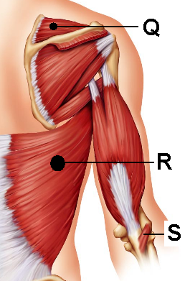
- Subscapularis
- Levator Scapulae
- Supraspinatus
- Infraspinatus
- Teres Major

- This muscle “R” is responsible for extension
at the shoulder and medial rotation
- Rhomboid major
- Trapezius
- Latissimus Dorsi
- Quadratus Lumborum
- Teres Major

- The perimysium can be found
- Wrapped around a muscle like the triceps
- Wrapped around an individual muscle fiber
- Wrapped around a myosin
- Wrapped around a fascicle
- Wrapped around a motor unit

- What is SR: Sarcoplasmic reticulum?
- The shortest functional unit within a muscle fiber
- Rough endoplasmic reticulum in a muscle cell responsible for high energy outputs
- Endoplasmic reticulum in a muscle cell responsible for creating mitochondria
- The region in muscle responsible for the production of ATP
- Smooth endoplasmic reticulum in a muscle cell responsible for the distribution of calcium

- What unique characteristic of smooth muscle allows your stomach to stretch as you eat and not contract immediately to expel food?
- slow contraction
- single unit contraction
- hyperplasia
- stress-relaxation response
- peristalsis

- Synergistic muscles that immobilize a joint are also classified as ________.
- agonists
- synovialists
- fixators
- prime movers
- antagonists

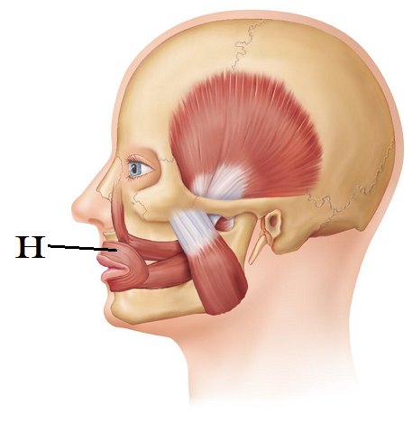
- This muscle “H” helps to purse the lips.
- Zygomaticus
- Oribicularis oris
- Orbicularis oculi
- Masseter
- Orbicularis labii

- Which muscles are part of the hamstring group?
- Biceps femoris
- Gracilis
- Semimembranosus
- Semitendinosus
- Vastus Lateralis

  - 1, 2, 5
  - 2, 4
  - 1, 2, 4, 5
  - 1, 3, 4
  - 3, 4, 5

- As the actin and myosin filaments slide past one another, they generate a contraction. The smallest contractile unit in a skeletal muscle is called
  - T tubule
  - Sarcoplasmic reticulum
  - Z band
  - Sarcomere
  - Myoplex

- Calveoli are present in
- T tubules
- Mitochondria of cardiac muscles
- The dorsum of the foot and are responsible for toe flexion
- The plasma membranes of smooth muscle cells
- Actin and myosin arrangements

- A fascicle is defined as
- A small bundle of muscle fibers
- The functional unit of the myofibril
- An individual muscle fiber
- A muscle fiber innervated by the somatic nervous system
- The membrane that surrounds a large muscle group

- The prime mover in abduction of the arm is __________.
- Latissimus dorsi
- Levator scapulae
- Triceps brachii
- Deltoid
- Biceps brachii

- A muscle that allows us to shrug our shoulders is __________. (Prime mover for shoulder elevation.)
- Latissimus dorsi
- Subclavius
- Trapezius
- Pectoralis major
- Teres major

- Which arthritis is being described: This type of arthritis commonly presents as pain in the big toe. It can be aggravated by dietary factors and if left untreated, the bones can fuse together.
  - Rheumatoid arthritis
  - Gouty arthritis
  - Bursitis
  - Osteoarthritis
  - Synoarthritis

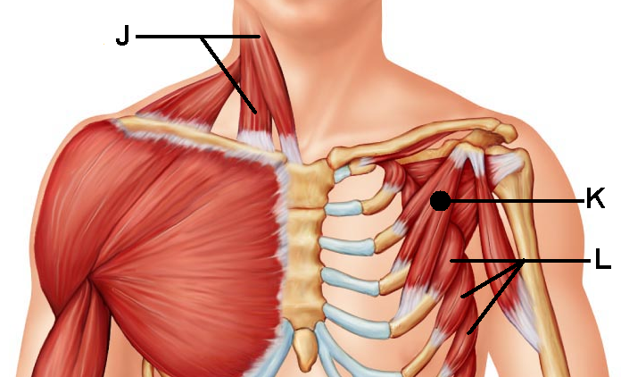
- This muscle “J” is responsible for head flexion when activated bilaterally or lateral flexion if activated alone.
- Anterior scalene
- Flexor mentalis profundus
- Suprascapularis
- Sternocleidomastoid
- Splenius capitis

- This muscle “K” shares its
name with a larger counterpart
- Rhomboid minor
- Deltoid
- Subscapularis
- Pectoralis minor
- External intercostals

- This muscle “L” can help to stabilize the scapula as well as pull the scapula forward. Its jagged appearance contributes to its name.
- Teres minor
- Serratus Anterior
- Stylohyoid
- Internal intercostals
- Subscapularis

- A motor unit is
  - The distance between sarcomeres
  - The distance between Z lines
  - The skeletal muscle fibers that are innervated by a single nerve fiber
  - The bundle of nerve fibers that run to smooth muscle
  - The bundle of muscle cells surrounded by epimysium

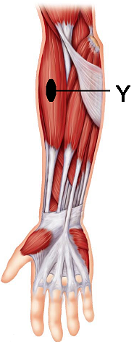
- This muscle “Y” acts as a synergist that helps to stabilize the
elbow during flexion
- Brachialis
- Biceps brachii
- Palmaris longus
- Brachioradialis
- Extensor carpi digitorum

- This type of joint uses both concave and convex joint surfaces to create a large range of motion. It is seen at the thumb.
  - Condyloid
  - Elliptical
  - Hinge
  - Ball and socket
  - Saddle

- Carla is doing bicep curls. What type of contraction is being demonstrated by her biceps as she flexes her forearm?
- Myotonic
- Hyperplastic
- Hypertrophic
- Isotonic
- Isometric

- Which muscle is the prime mover for flexion at the shoulder?
- brachialis
- brachioradialis
- pectoralis major
- biceps brachii
- triceps brachii

- Peristalsis is
- Seen only in skeletal muscles
- Seen only in cardiac muscles
- Seen only in smooth muscles
- Related to the diagonal muscle arrangement of the fibers
- Related to the irregularly space muscle fibers

- Which of the following is not an intrinsic muscle of the hand?
- Flexor pollicis brevis
- Opponens digiti minimi
- Opponens hallicus
- Palmar interossei
- Lumbricals

- Smooth muscles lack ____ but they have ____
- Actin; myosin
- Troponin; calmodulin
- Sarcoplamic reticulum; calveoli
- Myosin; ATP
- Nuclei; nucleoli

- This muscle “T” is responsible for thigh flexion
- Iliocostalis
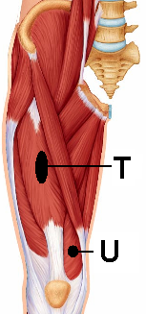
- Iliopsoas
- Biceps femoris
- Rectus femoris
- Quadriceps

- This muscle “U” assists in leg extension
- Sartorius
- Vastus Lateralis
- Vastus medialis
- Vastus intermedius
- Gluteus medius

- This muscle “O” is found in the anterior compartment and is
responsible for dorsiflexion
- Sartorius
- Extensor digitorum longus
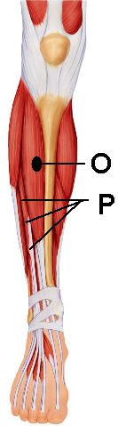
- Fibularis Anterior
- Fibularis
- Tibialis Anterior

- This muscle “P” is located in the anterior compartment
and is responsible for extension of the second
through the fifth toes.
- Extensor carpi ulnaris
- Extensor tibialis brevis
- Extensor fibularis
- Extensor hallicus longus
- Extensor digitorum longus

- What term is used for muscle fibers that have a circular arrangement?
- Pennate
- Simplex
- Scaphoid
- Orbicularis
- Ocular

- Which of the following has a syndesmoses?
  - Teeth
  - Patella-femur
  - C1-Occiput
  - Interphalangeal joints
  - Distal Tibia-Fibula

- The metacarpophalangeal joint is composed of an ovoid surface that fits into a depression to create which joint type?
  - Saddle joint
  - Condyloid joint
  - Ball and socket joint
  - Suture
  - Synchondrosis

- Describe circumduction
  - a movement that causes an increases in the joint angle
  - a movement anchored at one point, free at another that describes a cone in space
  - movement that creates a spinning or pivoting around the long axis
  - a movement away from midline
  - lifting a structure

- Which structures are involved in the act of opposition?
  - Hallux and digiti minimi
  - Biceps/triceps
  - Pollux and fifth digit
  - Abdominal muscles and erector spinae muscles
  - Patella and femur

- Hyperplasia is seen ______ during ___________.
  - Skeletal muscle; overload
  - Skeletal muscle; oxygen debt
  - Smooth muscle; reflexive contractions
  - Cardiac muscle; ventricular diastole
  - Smooth muscle; pregnancy

- Just by the name alone, which muscle would you expect to have the following action: “pull the lower lip down”
  - Risorus
  - Mentalis
  - Depressor labii inferioris
  - Orbicularis oris
  - Levator labii superioris

- The external intercostals muscles are responsible for
  - Spine flexion
  - Lateral flexion of the neck
  - Opposition
  - Inhalation
  - Childbirth

Turn in Opscan
Turn in Exam packet
If you have left a comment, be sure that your name is on the exam with a message on the front page.

