BSC 181Exam Three:
Chapters 8, 9, and 10

- Which of the following is not a synovial joint?
- gliding
- ball and socket
- suture
- saddle
- condyloid

- Which of the following is a gomphosis?
- intervertebral disc
- knee
- elbow joint
- teeth
- pubic symphysis

- The connective tissue that covers each skeletal muscle cell (muscle fiber) is
  - sarcoplasmic reticulum
  - endomysium
  - sarcolemma
  - epimysium
  - perimysium

- In which two places would you find a synchondrosis?
    - where the first rib articulates with the manubrium
    - between the costal cartilage and the xiphoid process
    - between vertebral bodies
    - in the long bones at the growth plates
    - at the pubic symphysis

  - 1 and 2
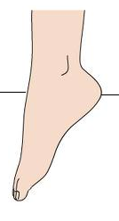
  - 1 and 4
  - 2 and 3
  - 2 and 5
  - 3 and 5

- This motion at the ankle is
- plantarflexion
- inversion
- elevation
- dorsiflexion
- protraction

- What is the function of a bursa?
  - Promotes nutrition to the synovium
  - Increases the activity of the chondrocytes
  - Encourages synovial expansion
  - Prevents overheating of the pannus
  - Reduces the amount of friction at a joint
- A sheet-like extension of the epimysium that connects muscle to muscle is
- ligament
- aponeurosis
- fascicle
- sarcoplasmic reticulum
- tendon

- The term “ankylosis” was used in describing a result of Rheumatoid arthritis. What does ankylosis mean?
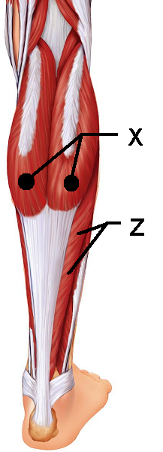
  - Inflammation of the synovium
  - Flattened sheets of tissue
  - Erosion of bone
  - Dislocation
  - Fusion of bone

- This muscle “X” is responsible for plantar flexion
  - Soleus
  - Gastrocnemius
  - Fibularis posterior
  - Semitendinosus
  - Semimembranosus

- This muscle “Z” lies deep to the muscle in question 9.
It is also responsible for plantar flexion
- Soleus
- Gastrocnemius
- Fibularis posterior
- Semimembranosus
- Semitendinosus

- Hunter has been feeling unwell lately. His flu-like symptoms and joint paint have caused him to seek medical attention. If his physician asks about a bull’s-eye type rash, what is the cause of the condition the doctor is considering?
  - Elevated Uric Acid crystals
  - Bacteria-infected tick
  - Out-of-control autoimmune response
  - Inflamed bursa
  - Depressed blood calcium levels

- The joint between C1 and C2 uses the dens (also known as the odontoid process) to create which type of joint motion
  - Supination
  - Circumduction
  - Rotation
  - Flexion
  - Extension

- This muscle “Q” is one of the muscles of the rotator cuff
- Subscapularis
- Levator Scapulae
- Supraspinatus
- Infraspinatus
- Teres Major

- In a resting skeletal muscle cell the myosin binding sites are blocked by ________
- actin
- myosin
- calmodulin
- calcium
- tropomyosin

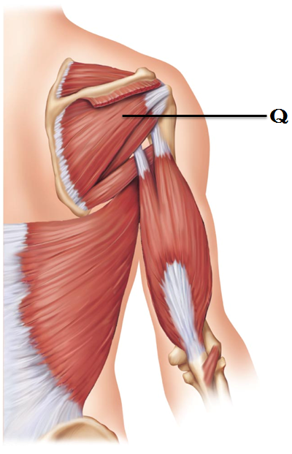
- Smooth muscle cells can contract as a unit due to the presence of
- dense bodies
- gap junctions
- dystrophin
- motor end plates
- intercalated discs

- The perimysium can be found
- Wrapped around a muscle like the triceps
- Wrapped around an individual muscle fiber
- Wrapped around a myosin
- Wrapped around a fascicle
- Wrapped around a motor unit

- What is SR: Sarcoplasmic reticulum?
- The shortest functional unit within a muscle fiber
- Rough endoplasmic reticulum in a muscle cell responsible for high energy outputs
- Endoplasmic reticulum in a muscle cell responsible for creating mitochondria
- The region in muscle responsible for the production of ATP
- Smooth endoplasmic reticulum in a muscle cell responsible for the distribution of calcium

- Synergistic muscles that immobilize a joint are also classified as ________.
- agonists
- synovialists
- fixators
- prime movers
- antagonists

- What unique characteristic of smooth muscle allows your stomach to stretch as you eat and not contract immediately to expel food?
- slow contraction
- single unit contraction
- hyperplasia
- stress-relaxation response
- peristalsis

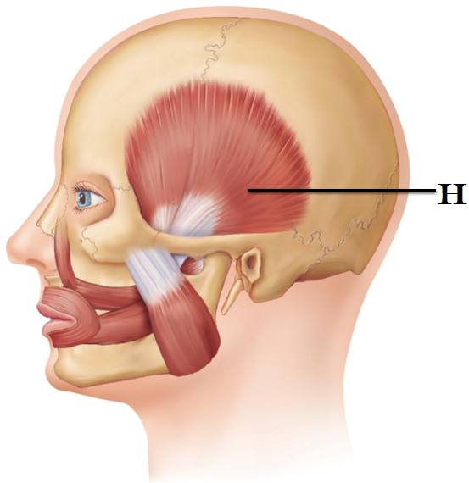
- This muscle “H” helps to close the jaw.
- Temporalis
- Frontalis
- Masseter
- Lateral Pterygoid
- Buccinator

- Which muscles are part of the hamstring group?
- Biceps femoris
- Gracilis
- Semimembranosus
- Semitendinosus
- Vastus Lateralis

  - 1, 2, 5
  - 2, 4
  - 3, 4, 5
  - 1, 2, 4, 5
  - 1, 3, 4

- As the actin and myosin filaments slide past one another, they generate a contraction. The smallest contractile unit in a skeletal muscle is called
  - T tubule
  - Sarcoplasmic reticulum
  - Z band
  - Sarcomere
  - Muscle fiber

- Calveolae are present in
- T tubules
- Mitochondria of cardiac muscles
- The dorsum of the foot and are responsible for toe flexion
- The plasma membranes of smooth muscle cells
- Actin and myosin arrangements

- A fascicle is defined as
- A small bundle of muscle fibers
- The functional unit of the myofibril
- An individual muscle fiber
- A muscle fiber innervated by the somatic nervous system
- The membrane that surrounds a large muscle group

- The prime mover in extension of the arm is __________.
- Latissimus dorsi
- Levator scapulae
- Triceps brachii
- Deltoid
- Biceps brachii

- Which arthritis is being described: This type of arthritis commonly presents as pain in the big toe. It can be aggravated by dietary factors and if left untreated, the bones can fuse together.
  - Rheumatoid arthritis
  - Gouty arthritis
  - Bursitis
  - Osteoarthritis
  - Synoarthritis

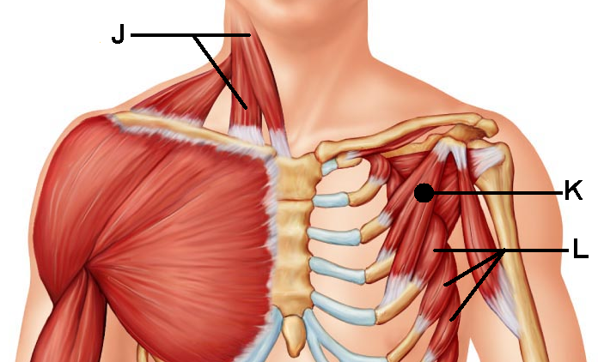
- This muscle “J” is responsible for head flexion when activated bilaterally or lateral flexion if activated alone.
- Anterior scalene
- Flexor mentalis profundus
- Suprascapularis
- Sternocleidomastoid
- Splenius capitis

- This muscle “K” shares its
name with a larger counterpart
- Rhomboid minor
- Deltoid
- Subscapularis
- Pectoralis minor
- External intercostals

- This muscle “L” can help to stabilize the scapula as well as pull the scapula forward. Its jagged appearance contributes to its name.
- Teres minor
- Serratus Anterior
- Stylohyoid
- Internal intercostals
- Subscapularis

- A motor unit is
  - The distance between sarcomeres
  - The distance between Z lines
  - The skeletal muscle fibers that are innervated by a single nerve fiber
  - The bundle of nerve fibers that run to smooth muscle
  - The bundle of muscle cells surrounded by epimysium

- This muscle “Y” is located in the posterior forearm. Its activation can result in an ulnar flexion at the wrist.
- Extensor indices
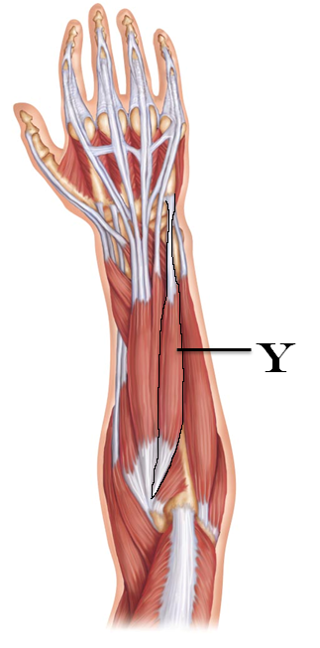
- Extensor carpi ulnaris
- Flexor carpi radialis
- Flexor pollicis longus
- Extensor carpi digitorum

- This type of joint uses both concave and convex joint surfaces to create a large range of motion. It is seen at the thumb.
  - Condyloid
  - Elliptical
  - Hinge
  - Ball and socket
  - Saddle

- Carla is doing bicep curls. What type of contraction is being demonstrated by her biceps as she flexes her forearm?
- Myotonic
- Hyperplastic
- Hypertrophic
- Isotonic
- Isometric

- Which muscle is the prime mover for flexion at the shoulder?
- brachialis
- brachioradialis
- pectoralis major
- biceps brachii
- triceps brachii

- Peristalsis is
- Seen only in skeletal muscles
- Seen only in cardiac muscles
- Seen only in smooth muscles
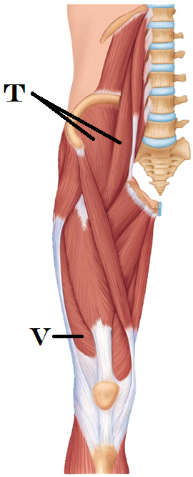
- Related to the diagonal muscle arrangement of the fibers
- Related to the irregularly space muscle fibers

- Smooth muscles lack ____ but they have ____
- Actin; myosin
- Troponin; calmodulin
- Gap junctions; calveolae
- Myosin; ATP
- Nuclei; nucleoli

- This muscle “T” is responsible for thigh flexion
- Iliocostalis
- Iliopsoas
- Biceps femoris
- Rectus femoris
- Tensor Fasciae Latae

- This muscle “V” is part of the Quadriceps group and contributes to leg extension
- Vastus lateralis
- Vastus medialis
- Vastus intermedius
- Rectus femoris
- Biceps femoris
- Which of the following is not an intrinsic muscle of the hand?
- Flexor pollicis brevis
- Opponens digiti minimi
- Opponens hallicus
- Palmar interossei
- Lumbricals

- This muscle “O” is located in the anterior compartment
and is primarily responsible for toe extension and dorsiflexion
- Tibialis brevis
- Tibialis anterior
- Extensor digitorum longus
- Fibularis tertius
- Soleus

- This muscle “P” is found in the lateral compartment and is
responsible for eversion at the ankle. It shares a name with a shorter counterpart.
- Popliteus
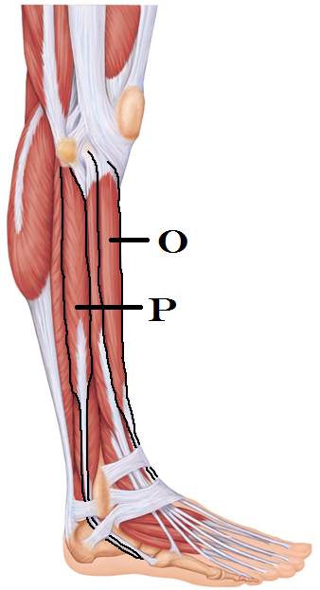
- Extensor digitorum longus
- Fibularis Anterior
- Fibularis longus
- Gemellus brevis

- What term is used for muscle fibers that have a circular arrangement? Seen in muscle names associated with the mouth and eye.
- Pennate
- Simplex
- Scaphoid
- Orbicularis
- Ocular

- Which is the only neurotransmitter to be released into the synapse at a neuromuscular junction?
  - Acetylcholine
  - Epinephrine
  - Norepinephrine
  - Dopamine
  - Ca⁺⁺

- The metacarpophalangeal joint is composed of an ovoid surface that fits into a depression to create which joint type?
  - Saddle joint
  - Condyloid joint
  - Ball and socket joint
  - Suture
  - Synchondrosis

- Describe circumduction
  - a movement that causes an increases in the joint angle
  - a movement that combines two angular movements to describes a cone in space
  - movement that creates a spinning or pivoting around the long axis
  - a movement away from midline
  - lifting a structure

- Which structures are involved in the act of opposition?
  - Hallux and digiti minimi
  - Biceps/triceps
  - Pollux and fifth digit
  - Abdominal muscles and erector spinae muscles
  - Patella and femur

- Hyperplasia is seen ______ during ___________.
  - Skeletal muscle; overload
  - Skeletal muscle; oxygen debt
  - Smooth muscle; reflexive contractions
  - Cardiac muscle; ventricular diastole
  - Smooth muscle; pregnancy

- Just by the name alone, which muscle would you expect to have the following action: “pull the lower lip down”
  - Risorus
  - Mentalis
  - Depressor labii inferioris
  - Orbicularis oris
  - Levator labii superioris

- The external intercostals muscles are responsible for
  - Spine flexion
  - Lateral flexion
  - Opposition
  - Rib elevation during inspiration
  - Childbirth

- What option reflects the conditions that need to be met for Rigor Mortis?
  - Elevated Ca⁺⁺ and elevated ATP
  - Elevated Ca⁺⁺ and decreased ATP
  - Decreased Ca⁺⁺ and increased ATP
  - Decreased Ca⁺⁺ and decreased ATP
  - All smooth muscle within living systems will demonstrate Rigor Mortis

Turn in Opscan
Turn in Exam packet
If you have left a comment, be sure that your name is on the exam with a message on the front page.

