BSC 181 Exam Four

Please read all questions carefully. There is one best answer for each question.

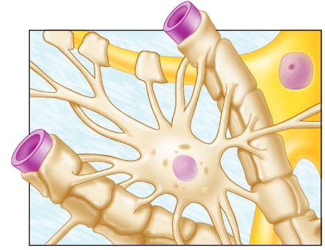
- This highly branched neuroglial cell has a star-shaped appearance. It is associated with capillaries and helps with neuron nutrition.
  - Oligodendrocyte
  - Schwann cell
  - Microglial cell
  - Ependymal cell
  - Astrocyte

- Neurons are described as “amitotic.” What does this mean
  - They are filled with fluid
  - They lack a nucleus
  - They do not undergo cellular division
  - They absorb toxins
  - They are unable to repair minor damage

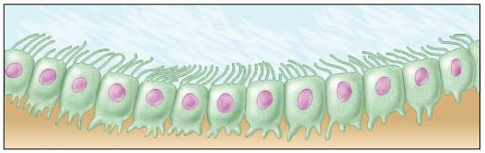
- Which neuroglial cells are associated with cerebrospinal fluid production?
  - Schwann cell
  - Oligodendrocyte
  - Astrocyte
  - Ependymal cell
  - Microglial cell

- An axon bundle that runs through the central nervous system is referred to as a ___ while an axon bundle that runs in the peripheral nervous system is a ____.
  - Primary fiber; secondary fiber
  - Fiber; process
  - Axon; dendrite
  - Tract; nerve
  - Afferent; efferent

- Regarding dendrites, indicate the answer that is a false statement
  - Dendrites are often short and diffuse
  - Most dendrites are highly branched
  - All nerves have at least one extension that functions as a dendrite
  - Dendrites are the input region of the neuron
  - Dendrites convey action potentials towards the cell body

- What is the function of the choroid plexus?
  - Oxygenates blood within the brain tissue
  - It acts as a chemoreceptor sensitive to H+
  - Filters/makes the cerebrospinal fluid
  - Regulates the blood flow through the ventricles
  - Provides nutrients for glial cells

- In the PNS, the ______ produces the myelination surrounding an axon while in the CNS, the _____ produces it.
  - Oligodendrocyte; Schwann cell
  - Schwann cell; Nissl body
  - Nissl body; Microglia
  - Schwann cell; Ependymal cell
  - Schwann cell; Oligodendrocyte

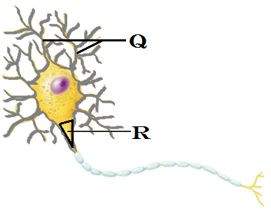
- Identify the structure indicated by “Q”
  - Nissl body
  - Soma
  - Dendrite
  - Axon
  - Axonal hillock

- Identify the structure indicated by “R”
  - Podocyte
  - Nissl body
  - Soma
  - Dendrite
  - Axonal hillock

- The above image represents
  - A nerve commonly found in the olfactory tissues
  - A nerve commonly found in the ear
  - The most common nerve type in the CNS
  - The most common nerve type in the PNS
  - A nerve commonly found in the retina

- With a resting membrane,
    - There are more positive ions inside the membrane than outside the membrane
    - The voltage gates are triggered to move the anions
    - There are more positive ions outside the membrane than inside the membrane
    - The overall charge across the membrane is negative
    - The overall charge across the membrane is positive

  - 1 and 2
  - 3 and 4
  - 3 and 2
  - 1, 2, and 4
  - 2, 3, and 5

- Where would one find the tentorium cerebelli?
  - Separating cerebrum and cerebellum
  - Attached to the posterior median sulcus
  - Along the central canal of the spinal cord
  - Separating right and left cerebral hemispheres
  - Tightly adhered to the brainstem

- At -55 mV threshold becomes self-generating. Which event occurs as the threshold is met?
  - Voltage gates open and K⁺ rushes into the membrane
  - Voltage gates open and K⁺ rushes out of the membrane
  - Voltage gates open and Na⁺ rushes into the membrane
  - Voltage gates open and Cl⁻ rushes into the membrane
  - Voltage gates open and Na⁺ rushes out of the membrane

- During repolarization,
  - Voltage gates open and Na⁺ rushes out of the membrane
  - Voltage gates open and K⁺ rushes into the membrane
  - Voltage gates open and Cl⁻ rushes into the membrane
  - Voltage gates open and Na⁺ rushes into the membrane
  - Voltage gates open and K⁺ rushes out of the membrane

- At which stage does the membrane potential become positive?
  - Repolarization
  - The membrane potential never becomes positive
  - Hyperpolarization
  - Resting
  - Depolarization/Action Potential

- Which neuroglial cells are described as small and phagocytic?
  - Astrocytes
  - Microglia
  - Oligodendrocytes
  - Ependymal cells
  - Neuron

- Which axon would have the greatest rate of conduction?
  - All axons will conduct their impulses at the same rate.
  - A large diameter, myelinated axon
  - A small diameter, myelinated axon
  - A small diameter, unmyelinated axon
  - A large diameter, unmyelinated axon

- Which of the following means are used to inactivate neurotranmitters once they’ve bound to the dendritic receptors?
  - Acids are released to change the conformation of protein-based neurotransmitters
  - Enzymes are released to break down neurotransmitters
  - The axon terminal blocks the neurotransmitters from being reabsorbed
  - The neurotransmitters can be reabsorbed by oligodendrocytes
  - Only inhibitory neurotranmitters need to be degraded, and they break away naturally.

- The function of a divergent neuronal pool is to
  - Suppress the signal
  - Convert the signal
  - Simplifiy the signal
  - Modify the signal
  - Amplify the signal

- Which structure is found in the telencephalon?
  - Midbrain
  - Pons
  - Cerebrum
  - Thalamus
  - Medulla oblongata

- Where are the pyramidal cells found? (The pyramidal cells are the cell bodies for the motor neurons in the corticospinal tract)
  - Precentral sulcus
  - Postcentral sulcus
  - Precentral gyrus
  - Postcentral gyrus
  - Prefrontal cortex

- Which of the neurotransmitters listed below shares a similar function to the endorphins and enkephalins?
  - Substance P
  - GABA
  - Dopamine
  - Nitric oxide
  - Acetylcholine

- The diencephalon
  - Is composed of the pituitary gland and the parietal lobe
  - Is the transition site between pons and medulla oblongata
  - Is composed of the pineal gland and the endothalamus
  - Is composed of thalamus, hypothalamus, and epithalamus
  - Is composed of the fourth ventricle and the cerebellum

- This auditory association area permits the perception of sound and can store sound memories
  - Occiptial association area
  - Broca’s area
  - Wernicke’s area
  - Limbic region
  - Prefrontal cortex

- This area is present usually in the left hemisphere and helps to control the muscles of speech.
- Occiptial association area
- Limbic region
- Broca’s area
- Prefrontal cortex
- Wernicke’s area

- Which option best describes the function of the cerebellum?
  - Provides physical support for the occipital lobe
  - Modifies and relays incoming visceral impulses.
  - Integration of sensory input and coordination of motor input
  - Generates delta waves during sleep
  - Origination of all conscious motor control

- Identify “Q” This structure allows CSF movement.
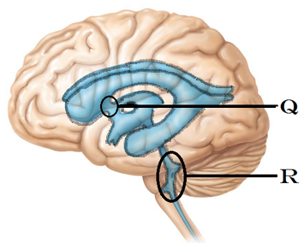
  - Cerebral Aqueduct
  - Lateral aperture
  - Lateral Ventricle
  - Interventricular foramina
  - Homunculus

- Identify “R”
  - Central Canal
  - Canal of Schlemm
  - Cerebral Aqueduct
  - Third Ventrical
  - Fourth Ventrical

- In which region is the auditory cortex located?
  - Temporal region
  - Parietal region
  - Frontal region
  - Insular region
  - Occipital region

- In which time frame will a stimulated neuron be unable to respond
  - During its resting state
  - During the absolute refractory period
  - During the relative refractory period
  - During the hyperpolarized period
  - During the initial depolarizing period

- Which fibers will pass through the thalamus
  - Olfactory
  - Somatic motor fibers
  - Autonomic motor fibers
  - All motor fibers
  - All spinal ascending fibers

- This midbrain structure connects the third ventricle to the fourth ventricle
  - Interventricular foramen
  - Lateral foramina
  - Central canal
  - Cerebral aqueduct
  - Ventricular bridge

- In the medulla oblongata, what are the two longitudinal ridges that are formed by the corticospinal tracts?
  - Longitudinal fissure
  - Pyramids
  - Gyri
  - Sulcus
  - Tranverse fissure
- Identify “X” This structure allows communication between hemispheres
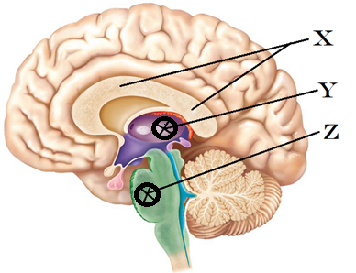
  - Corpus callosum
  - Pituitary gland
  - Optic Chiasma
  - Olfactory bulb
  - Pons

- Identify “Y”
  - Mammillary body
  - Pons
  - Pyramidal tract
  - Pineal gland
  - Thalamus

- Identify “Z”
  - Pons
  - Third ventricle
  - Fourth ventricle
  - Midbrain
  - Medulla oblongata

- A dendrite receives, in rapid succession, several excitatory sub-threshold stimulations that add up and trigger an action potential. What is the process called?
  - Temporal summation
  - Spatial summation
  - Bilateral summation
  - Repetitive summation
  - Recurrent summation

- The Corpus Collosum connects right and left hemispheres. What type of white fibers is expected to be seen?
  - Radiation fibers
  - Commisural fibers
  - Striation fibers
  - Projection fibers
  - Association fibers

- The falx cerebri is made up of _____ and is located _
  - Dura mater: within the transverse fissure
  - Pia mater: along the cerebellum
  - Pia mater; within the longitudinal fissure
  - Dura mater; within the longitudinal fissure
  - Arachnoid mater: along the vermis of the cerebellum

- A fiber in the white matter of the brain that originates in the right primary visual cortex and then runs to the right visual association area would fall into which category?
  - Radiation fibers
  - Commisural fibers
  - Striation fibers
  - Projection fibers
  - Association fibers

- This region of the brain is associated with intellect, recall, and personality. It is also linked to the limbic system. Which region is it?
  - Temporal region
  - Insula of Reil
  - Lemnitic nuclei
  - Postcentral cortex
  - Prefrontal cortex

- Which division is created by the lateral sulcus on the surface of the brain?
  - Separates precentral from postcentral regions
  - Separates occipital lobe from cerebellum
  - Separates motor cortex from sensory cortex
  - Separates parietal lobe and temporal lobe
  - Separates white matter from gray matter

- Which of the following is true with regards to a graded potential
  - Graded potentials occur only in the axons
  - Graded potentials are almost always inhibitory
  - Graded potentials are able to travel long distances without degrading
  - Graded potentials degrade quickly
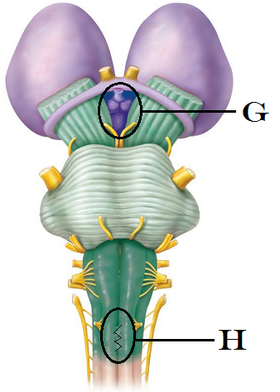
  - Graded potentials can cross the synapse

- Identify “G”
  - Lateral Geniculate nucleus of the Thalamus
  - Mammillary Bodies of the Hypothalamus
  - Pineal gland of the Epithalamus
  - Olfactory lobe
  - Cerebellar peduncle

- Identify “H”
  - Decussation of the Pyramids
  - Pons
  - Epithalamus
  - Cerebral peduncle
  - Arbor Vitae

- Where are the satellite cells found?
  - At the axon terminus
  - Surrounding the soma of a neuron
  - In the white matter of the spinal cord
  - In the white matter of the brain
  - Within the ventricles of the brain

- This type of neuron is commonly found as a sensory neuron. Based on its structure, how would it be classified?
  - Efferent
  - Multipolar
  - Bipolar
  - Unipolar
  - Northpolar

- In which region of the brain is the general (common) interpretation area located?
  - Parietal
  - Temporal
  - Occipital
  - All of the above

- In which area of the brain is the blood-brain barrier lacking or incomplete in order to allow the chemical composition of the blood to be evaluated?
  - Pineal gland
  - Hypothalamus
  - Pons
  - Cerebellum
  - Prefrontal cortex

- Which meningeal tissue is composed of two layers that occasionally separate to create spaces called sinuses?
  - Pia mater
  - Arachnoid mater
  - Dura mater
  - Doesn’t mater

Turn in Opscan
Turn in Exam packet

If you have a question/comment, put your name on your exam and place it in a separate pile at the front.

Grades should be posted by late tonight.

