Exam Five
Please read all questions carefully. There is one best answer for each question.

- Which of the following structures is NOT part of the peripheral nervous system
  - Skeletal muscle effector
  - Thermoreceptor
  - Dorsal Root ganglion
  - Visceral afferent fiber
  - Somatic efferent fiber

- On a hot day, Freya was desperate to get the last bottle of water down at the bottom of a cooler filled with ice. Initially, she noted that icy cold of the cooler was refreshing, but the longer she struggled to find a bottle of water, the less comfortable it got. What was happening that the cold sensation was turning into a pain sensation?
  - Her brain was adapting to the cold and was only able to perceive pain from that input
  - Her cold receptors in the superficial dermis had gotten so cold that the nociceptors began transmitting
  - Her cold receptors in the deep dermis became overwhelmed and damaged. The tissue damage was being interpreted as pain by the brain.
  - Her Meissner’s corpuscles adapted to the cold and began to transmit pain information instead
  - The deep continuous cold triggered her Ruffini endings, and they transmitted an impulse that the brain interpreted as pain.

- Identify “X”
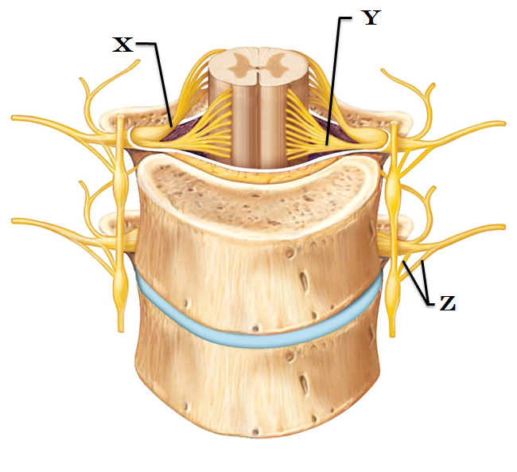
  - Ventral root
  - Dorsal ramus
  - Motor pathway
  - Spinal nerve
  - Dorsal root

- Identify “Y”
  - Ventral Root
  - Ventral Ramus
  - Dorsal Root
  - Dorsal Ramus
  - Spinal Nerve

- Identify “Z”
  - Paravertebral Ganglia
  - Lateal column
  - Rami Communicantes
  - Meningeal Ramus
  - Spinal Nerve

- Which of the following cranial nerves is sensory only?
  - Hypoglossal
  - Oculomotor
  - Trochear
  - Trigeminal
  - Optic
- This type of receptor responds to stimuli arising in the internal viscera and blood vessels
  - Proprioceptor
  - Interoceptor
  - Exteroceptor
  - Dermatoceptor
  - Glandular plexus

- Which of the following is NOT an encapsulated receptor?
  - Thermoreceptor
  - Meissner’s corpuscle
  - Muscle Spindle
  - Bulbous corpuscle
  - Pacinian corpuscle

- What are the receptor types that are pain receptors?
  - Nociceptors
  - Thermoceptors
  - Exteroceptors
  - Myoceptors
  - Rhabdoceptors

- Indicate the one true statement from the list below
  - Norepinephrine and Acetylcholine are common neurotransmitters that stimulate pain receptors
  - Endogenous opiods work to intensify the pain response
  - Constant pain will lessen over time because the pain receptors will adapt
  - A person who claims to be tolerant to pain will have receptors that respond to pain at a lower frequency that a person who is sensitive to pain.
  - Failure to interrupt a chronic pain response can lead to an amplification in the pain sensation

- Visceral referred pain is when pain from one organ region is perceived in a different region. In lecture we looked at the referred pain map and discussed left arm pain as referral pain during a heart attack. In which other location does heart pain refer?
  - Groin
  - Lateral Right Upper Extremity
  - Right Pectoral
  - Left cheek and jaw
  - Umbilicus (navel)

- A third order neuron would run from
  - From the medulla to the cerebellum
  - From the thalamus to the cerebral cortex
  - From the posterior horn of the spinal cord to the cerebral cortex
  - From the dorsal root ganglion to the posterior horn of the spinal cord
  - From the spinal cord to the thalamus

- Adelyne woke up one morning and found that it was difficult for her to speak and eat because half of her face didn’t seem to be under her control any more. It seemed that her regular breakfast didn’t have much flavor. As the day went on, friends became concerned with her drooping lower eyelid and excessive tear production. What condition might she have?
  - Tic douloureux
  - Bell’s Palsy
  - Internal Strabismus
  - Minier’s Disease
  - Acoustic Neuroma

- The motor portion of this cranial nerve innervates the tongue and Parotid salivary gland, while the sensory portion is responsible for taste from the posterior tongue and throat.
  - Vestibulocochlear
  - Accessory
  - Facial
  - Glossopharyngeal
  - Vagus

- Taking a break from studying, Iris put her glasses on top of her head. Initially she could feel the light weight of the frames resting on her hair. After responding to a few texts and stretching her legs, she returned to study, but could not find her glasses. Why couldn’t she feel them on her head any longer?
  - Excessive studying has damaged Iris’ brain, and she was no longer able to feel the glasses on her head.
  - Her tonic receptors had adapted to the unchanging pressure
  - Her phasic receptors had adapted to the weight of the resting glasses
  - Her chemoreceptors became overwhelmed with stimulation and ceased firing
  - Her ginand receptors had undergone adaptation

- From the brachial plexus, which nerve innervates essentially all of the extensor muscles?
  - Median nerve
  - Radial nerve
  - Musculocutaneous nerve
  - Axillary nerve
  - Ulnar nerve

- The sciatic nerve comes from the ____ plexus and is compose of these two nerves:
  - Sacral: tibial and fibular
  - Lumbar: tibial and peroneal
  - Coccygeal: tibial and peroneal
  - Cervical: tibial and peroneal
  - Brachial: tibial and fibular nerves

- A Golgi Tendon Organ will be activated by
  - Muscle contraction
  - Muscle stretch
  - Tissue damage
  - Temperature changes
  - Carbon dioxide concentrations

- With muscle spindle activation, which of the following are true,
    - The primary muscle has been contracted
    - The primary muscle has been stretched
    - The antagonistic muscle receives an impulse to contract
    - The antagonistic muscle receives an impulse to relax

  - 1 and 3
  - 1 and 4
  - 1, 3, and 4
  - 2 and 4
  - 2 and 3

- Which option below describes the function of the cervical plexus?
  - The cells responsible for producing and filtering CSF
  - An area of cell bodies located outside of the central nervous system
  - The location for the autonomic nerve cell bodies
  - The network of nerves that produce the radial, median, and ulnar nerves
  - A network of nerves coming from C1 – C4 that produce the phrenic nerve

- A spinal nerve usually contains
  - Autonomic fibers only
  - Ascending fibers only
  - Mixed sensory and motor nerve fibers
  - Non-myelinated fibers
  - Efferent fibers only

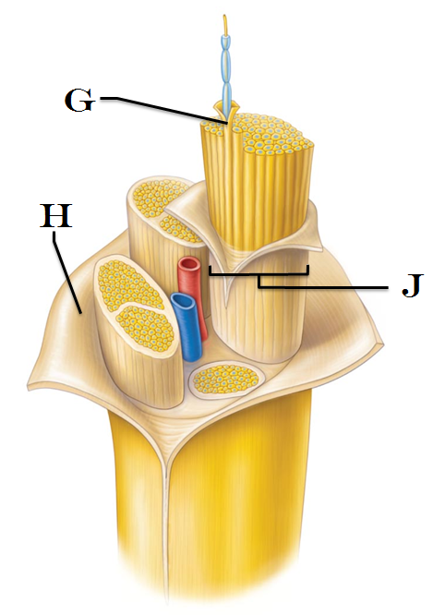
- Identify “G”
  - Corticospinal tract
  - Epineurium
  - Myometrium
  - Perineurium
  - Endoneurium

- Identify “H”
  - Pyramidal tract
  - Epineurium
  - Myometrium
  - Perimysium
  - Endoneurium

- Identify “J”
  - Extrapyramidal tract
  - Epimysium
  - Myometrium
  - Fascicle
  - Axon

- Which branch of the spinal nerve would you expect to see innervate the dura mater?
  - Ventral root
  - Dorsal rami
  - Dorsal root
  - Meningeal rami
  - Ventral rami

- Where is the cauda equina located?
  - At the level of the third lumbar vertebrae
  - Anchored to the sacrum
  - In the precentral gyrus
  - In the cervical segments of the spinal cord
  - At the level of the third thoracic vertebrae

- Which of the following senses uses a chemoreceptor?
  - Pain
  - Taste
  - Light touch
  - Hearing
  - Vision

- There are three levels of neural integration. Which levels corresponds to a second order sensory neuron?
  - Primary level
  - Receptor level
  - Perceptual level
  - Somatic level
  - Circuit level

- External Strabismus is
  - The result of damage to Cranial Nerve III, Oculomotor
  - The result of damage to Cranial Nerve IV, Trochlear
  - The result of damage to Cranial Nerve VII; Facial
  - The inability to laterally move the jaw while chewing
  - The lateral deviation of the uvula with Cranial Nerve IX damage

- Anulospiral nerve endings provide primary sensory input for
  - Smooth muscle varicosities
  - Vasa vasorum
  - Muscle spindles
  - Nociceptors
  - Autonomic visceral afferent fibers

- Which of the following is a simple unencapsulated receptor?
  - Meissner’s corpuscle
  - Pacinian corpuscle
  - Golgi Tendon Organ
  - Photoreceptor in the retina
  - Merkel’s disc

- Which type of reflex can be monosynaptic?
  - Withdrawal reflex
  - Visceral reflex
  - Pain reflex
  - Crossed extensor reflex
  - Somatic stretch reflex

- The perineurium is
  - Connective tissue that surrounds a fascicle
  - Connective tissue that surrounds a neuron
  - Composed of myelin
  - Found surrounding mixed nerves only
  - Connective tissue that surrounds a nerve

- The Plantar Response elicits an extension of the toes when there is damage to the corticospinal tracts. In what population might this response be normal?
  - In infants less that an year of age
  - In prepubescent females
  - In elderly males
  - Pregnant females
  - It is never considered a normal response. It always indicates a pathology

- Within the Central Nervous System, this glial cell produces scar tissue. It prevents the axon from re-growing following an injury?
  - Ependymal
  - Oligodendrocytes
  - Microglia
  - Astrocyte
  - Schwann Cell

- Agnes is performing the “H” pattern to test the extrinsic eye muscles. She notes that her patient’s right eye can successfully look up and down, as well as left (toward the midline/nose). Her patient’s right eye can not follow Agnes’ finger to the right (away from the nose). Which cranial nerve is damaged? (Please refrain from gesturing/reproducing the movements described in the question as you contemplate your response.)
  - Oculomotor
  - Optic
  - Trigeminal
  - Abducens
  - Trochlear

- The cell body of an afferent, unipolar neuron would be found
  - In the Paravertebral Ganglion
  - In the Dorsal Root Ganglion
  - In a Collateral Ganglion
  - In a Visceral Ganglion
  - In the Craniosacral Ganglion

- This cranial nerve is associated with the cribriform plate.
  - Olfactory
  - Abducens
  - Trigeminal
  - Optic
  - Oculomotor

- The oculomotor nerve innervates four of the six extrinsic eye muscles. Which of the list below is not innervated by cranial nerve III?
  - Superior oblique
  - Medial rectus
  - Inferior rectus
  - Inferior oblique
  - Superior rectus

- Which of the following reflexes would include a contralateral response?
  - Golgi Tendon Organ Reflex
  - Crossed Extensor Response
  - Cremasteric Reflex
  - Patellar reflex
  - Plantar reflex

- A somatic motor fiber releases the neurotransmitter ______ into the neuromuscular junction
  - Acetylcholine
  - Norepinephrine
  - Epinephrine
  - Nitric Oxide
  - ATP

- Melvin suffered from a stroke that damaged some of the gray matter of his midbrain. His upper eyelid is drooping and he has difficulty focusing on objects. Which of the cranial nerves has been damaged?
  - Trochlear
  - Abducens
  - Facial
  - Oculomotor
  - Trigeminal

- Which cranial nerve is responsible for taste sensation on the anterior two thirds of the tongue
  - Vagus
  - Facial
  - Trochlear
  - Trigeminal
  - Glossopharyngeal

- Which is the only branch of the trigeminal nerve that carries efferent fibers to skeletal muscles?
  - Opthalmic division
  - Zygomatic division
  - Superciliary division
  - Maxillary division
  - Mandibular division

- The Vagus nerve extends throughout the body. To which organ does it not go?
  - Stomach
  - Kidney
  - Lung
  - Heart
  - It goes to all of the organs listed above

- Which cranial nerve does NOT carry parasympathetic fibers?
  - Oculomotor
  - Trigeminal
  - Facial
  - Glossopharyngeal
  - Vagus

- The corneal reflex is tested by making light contact on the cornea of the eye. If the Trigeminal nerve is intact, this sensory input will be processed at the brain, and a “blink” response is generated. Which Cranial Nerve is responsible for allowing us to blink?
  - Oculomotor
  - Trigeminal
  - Facial
  - Abducens
  - Optic

- “Anosmia” is
  - The loss of the ability to smell
  - The loss of the ability to taste
  - The loss of the ability to maintain posture
  - Part of the regeneration tube associate with Schwann cells and axon repair
  - The axonal fragments left behind following nerve damage

- How is the cremasteric reflex elicited?
  - Cutaneous sensation to the plantar aspect of the foot
  - Scratching the skin near the umbilicus (navel)
  - Gently tapping the scrotum with a reflex hammer
  - Light touch to the medial thigh
  - Providing a pain response in alternating dermatomes

**Take a moment to put your name on the front of this exam.
Make sure you’ve darkened the “1” in the first column of the MISC section on your scantron.

Answer question 50 on the next page before you turn in your work.**

- There are several branches that come off of the spinal nerves. Which of these branches (rami) is consistently the largest?
  - Rami Communicantes
  - Dorsal Ramus
  - Ventral Ramus
  - Meningeal Ramus
  - Everybodyloves Ramus
This is Version A
Please put your name on this exam
