Exam Five

Please read all questions carefully. There is one best answer for each question.

- Which the following is true of the lateral spinothalamic tracts?
- It is an ascending tract
- It is a descending tract
- It conveys motor impulses
- It conveys pain and touch
- It conveys stretch sensations from the viscera

  - 1, 3, and 5
  - 1 and 4
  - 2 and 4
  - 2, 3, and 5
  - 3 and 5

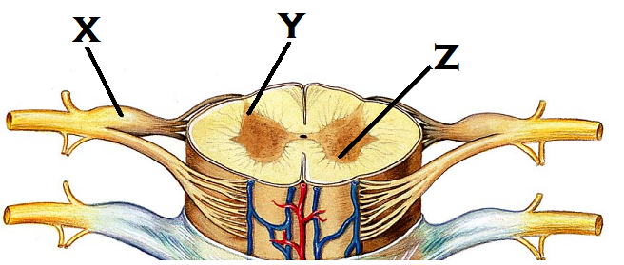
- Identify “x”
  - Ventral root
  - Dorsal root ganglion
  - Motor pathway
  - Spinal nerve
  - Dorsal root

- Identify “Y”
  - Lateral horn
  - Posterior column
  - Anterior horn
  - Posterior horn
  - Anterior column

- Identify “Z”
  - Anterior column
  - Posterior column
  - Anterior horn
  - Lateral horn
  - Posterior horn

- The term “funiculi” (column) refers to
  - The posterior gray matter in the spinal cord
  - The gray matter of the cerebral cortex
  - The white matter of the spinal cord
  - The white matter of the cerebral cortex
  - The anterior gray matter in the spinal cord

- What happens if there is damage to the lower motor neurons
  - Involuntary control of the muscle remains intact
  - Sensory information fails to reach the brain
  - Spastic paralysis results
  - Muscles display an irregular stimulation pattern
  - Flaccid paralysis results

- Where would you expect to see the soma of a second order neuron?
  - Posterior horn of spinal cord
  - Anterior horn of the spinal cord
  - Cerebral cortex
  - Thalamus
  - Dorsal root ganglion

- What are the receptor types that are pain receptors?
  - Nociceptors
  - Thermoceptors
  - Exteroceptors
  - Myoceptors
  - Rhabdoceptors

- Which of the following cranial nerves is sensory only?
  - Hypoglossal
  - Oculomotor
  - Trochear
  - Trigeminal
  - Optic

- Which of the following cranial nerves is mixed (ignore proprioception for this question. Look for the mixed nerve that has sensory input from the skin.)
  - Olfactory
  - Optic
  - Oculomotor
  - Facial
  - Vestibulocochlear

- Which is true about the spinocerebellar tract?
  - It carries fibers for the autonomic system only
  - It does not contribute to the perception of sensation
  - It decussates at the thalamus
  - It is a descending tract
  - It carries fibers for pain to the thalamus

- The motor portion of this cranial nerve innervates the tongue and Parotid salivary gland, while the sensory portion is responsible for taste from the posterior tongue and throat.
  - Vestibulocochlear
  - Spinal accessory
  - Facial
  - Glossopharyngeal
  - Vagus

- From the brachial plexus, which nerve innervates the extensor muscles?
  - Median nerve
  - Radial nerve
  - Musculocutaneous nerve
  - Axillary nerve
  - Ulnar nerve

- The sciatic nerve comes from the ____ plexus and is compose of these two nerves:
  - Sacral: tibial and fibular
  - Lumbar: tibial and peroneal
  - Coccygeal: tibial and peroneal
  - Cervical: tibial and peroneal
  - Brachial: tibial and fibular nerves

- A Golgi Tendon Organ will be activated by
  - Muscle contraction
  - Muscle stretch
  - Tissue damage
  - Temperature changes
  - Carbon dioxide concentrations

- Which of the following is true about the lateral horn of the spinal cord
  - The lateral horn contains descending nerve tracts
  - The lateral horn contains cell bodies for sensory fibers
  - The lateral horn contains cell bodies of motor fibers running to skeletal muscle
  - The lateral horn contains cell bodes of motor fibers running to smooth muscle and glands
  - The lateral horn contains ascending nerve tracts

- With muscle spindle activation, which of the following are true,
    - The primary muscle has been contracted
    - The primary muscle has been stretched
    - The antagonistic muscle receives an impulse to contract
    - The antagonistic muscle receives an impulse to relax

  - 1 and 3
  - 1 and 4
  - 1, 3, and 4
  - 2 and 4
  - 2 and 3

- A spinal nerve usually contains
  - Autonomic fibers only
  - Ascending fibers only
  - Mixed sensory and motor nerve fibers
  - Non-myelinated fibers
  - Efferent fibers only

- Where is the cauda equina located?
  - At the level of the third lumbar vertebrae
  - Anchored to the sacrum
  - In the precentral gyrus
  - In the cervical segments of the spinal cord
  - At the level of the third thoracic vertebrae

- Which option below describes the function of the cervical plexus?
  - The cells responsible for producing and filtering CSF
  - An area of cell bodies located outside of the central nervous system
  - The location for the autonomic nerve cell bodies
  - The network of nerves that produce the radial, median, and ulnar nerves
  - A network of nerves coming from C1 – C4 that produce the phrenic nerve

- What do the gray commisure of the spinal cord and the corpus callosum have in common?
  - Both are ascending tracts
  - Both carry pain and temperature
  - Both structures link the left and right sides of their respective structures
  - Both contain a predominantly unipolar type neuron within their structures
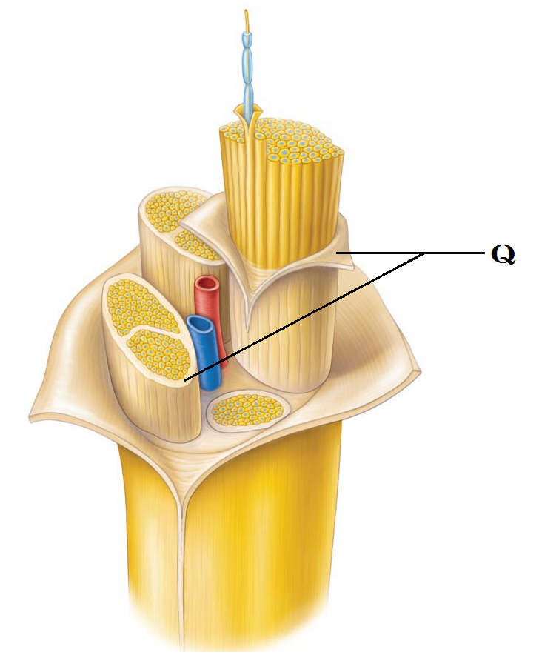
  - Both are considered association areas.

- Identify “Q”
  - Corticospinal tract
  - Epimysium
  - Myometrium
  - Perineurium
  - Endoneurium

- Which branch of the spinal nerve would you expect to see innervate the dura mater?
  - Ventral root
  - Dorsal rami
  - Dorsal root
  - Meningeal rami
  - Ventral rami

- Which of the following senses uses a chemoreceptor?
  - Pain
  - Taste
  - Light touch
  - Hearing
  - Vision

- Which of the following is a simple unencapsulated receptor?
  - Meissner’s corpuscle
  - Pacinian corpuscle
  - Golgi Tendon Organ
  - Photoreceptor in the retina
  - Merkel’s disc

- There are three levels of neural integration. Which levels corresponds to a second order sensory neuron?
  - Primary level
  - Receptor level
  - Perceptual level
  - Somatic level
  - Circuit level

- Of the following senses, which will not adapt?
  - Taste
  - Light touch
  - Deep pressure
  - Pain
  - Smell

- Where would you expect to see a third order neuron?
  - Ascending from the thalamus to the cortex
  - Descending through the paravertebral ganglion
  - Running from the spinal cord to an effector
  - Running from the receptor to the CNS
  - Ascending through the spinal cord to the thalamus

- The endoneurium is
  - Connective tissue that surrounds a fascicle
  - Connective tissue that surrounds a neuron
  - Composed of myelin
  - Found surrounding mixed nerves only
  - Connective tissue that surrounds a nerve

- If you had a fiber that was classified as general somatic efferent, what type of fiber is it?
  - Sensory to an organ
  - Motor to a gland
  - Motor from one of the cranial nerves going to the muscles of the face.
  - Sensory from a muscle
  - Motor to skeletal muscle

- This cranial nerve is associated with the cribiform plate.
  - Olfactory
  - Abducens
  - Trigeminal
  - Optic
  - Oculomotor

- The oculomotor nerve innervates four of the six extrinsic eye muscles. Which of the list below is not innervated by cranial nerve III?
  - Superior oblique
  - Medial rectus
  - Inferior rectus
  - Inferior oblique
  - Superior rectus

- Which cranial nerve is responsible for taste sensation on the anterior two thirds of the tongue
  - Vagus
  - Facial
  - Trochlear
  - Trigeminal
  - Glossopharyngeal

- Which type of reflex can be monosynaptic?
  - Withdrawal reflex
  - Visceral reflex
  - Pain reflex
  - Crossed extensor reflex
  - Somatic stretch reflex

- A somatic motor fiber releases the neurotransmitter ______, while a postganglionic sympathetic fiber releases ______. (From the options below, choose the answer that makes the statement correct.)
  - Acetylcholine; acetylcholine
  - Norepinephrine; epinephrine
  - Acetylcholine; norepinephrine
  - Norepinephrine; acetylcholine
  - Acetylcholine; dopamine

- Which of the following will have a long postganglionic fiber?
  - Somatic motor
  - Sympathetic motor
  - Splanchnic
  - Parasympathetic motor
  - Special visceral afferent

- The Parasympathetic system can be described in terms of the “three Ds”. In the list below, indicate the options that do not belong to the parasympathetic system.
    - Digestion
    - Diuresis
    - Deglutition
    - Defecation
    - Diaphoresis

- 1 and 3
- 2 and 4
- 2 and 5
- 2 and 3
- 3 and 5

- The sympathetic system can be described in terms of the “four Es”. Identify the incorrect option below.
  - Excitation
  - Emergency
  - Exercise
  - Erection
  - Embarrassment

- The preganglionic fibers of the sympathetic system travel through the _______ to reach the paravertebral ganglion.
  - White rami
  - Ventral rami
  - Gray rami
  - Dorsal rami
  - Sympathetic fibers do not have rami associated with the ganglion

- What is unusual about the splanchnic nerves?
  - They are parasympathetic fibers that release norepinephrine
  - They are parasympathetic fibers that do not synapse in any ganglion
  - They are sympathetic fibers that innervate skeletal muscle
  - They are all cholinergic
  - They are sympathetic fibers that do not synapse in the paravertebral ganglion

- Referred pain from the heart is often times felt in the left arm. In what other unusual location can it be perceived?
  - Right knee
  - Umbilicus
  - Cheek
  - Left buttock
  - Right arm

- Adrenergic fibers release
  - Acetylcholine
  - Norepinephrine
  - Dopamine
  - Nitric oxide
  - Cortisol

- What binds to a nicotinic receptor?
  - Nitric oxide
  - Cortisol
  - Acetylcholine
  - Norepinephrine
  - Dopamine

- Which system is responsible for vasomotor tone?
  - Both sympathetic and parasympathetic
  - Sympathetic
  - Efferent fibers from the cranial nerves only
  - Afferent fibers from the spinal nerve only
  - Parasympathetic

- The _____ system causes vasodilation and erection during sexual stimulation; the ____ system causes ejaculation. (Choose the option from below that makes the statement correct)
  - Sympathetic; sympathetic
  - Parasympathetic; sympathetic
  - Sympathetic; parasympathetic
  - Parasympathetic; somatic
  - Parasympathetic; parasympathetic

- Which activities does the parasympathetic system not control?
  - arrector pili muscles
  - Kidneys
  - adrenal medulla
  - sweat glands
  - It has no control over any of the above options

- The Vagus nerve extends throughout the body. To which organ does it not go?
  - Stomach
  - Kidney
  - Lung
  - Heart
  - It goes to all of the organs listed above

- Which cranial nerves carry parasympathetic fibers?
    - Optic
    - Oculomotor
    - Trigeminal
    - Glossopharyngeal
    - Vagus

- 1, 2, 3
- 1, 3, 5
- 1, 4, 5
- 2, 4, 5
- 2, 3, 4

- The denticulate ligaments that attach the vertebrae to the spinal cord are made up of
  - Elastic connective tissue
  - Pia mater
  - Arachnoid mater
  - Dura mater
  - Dense connective tissue

- With damage to an upper motor neuron,
  - The lower motor neuron will never fire
  - The effector will be unaffected
  - The lower motor neuron can still receive and respond to spinal reflexes
  - The cortex becomes unstable
  - Sensory information will fail to reach the brain

Turn in Opscan
Turn in Exam packet

Double check to be sure your name and ID are on your Opscan form

Grades should be posted later this evening or tomorrow at the latest.

