BSC 181 Exam Six

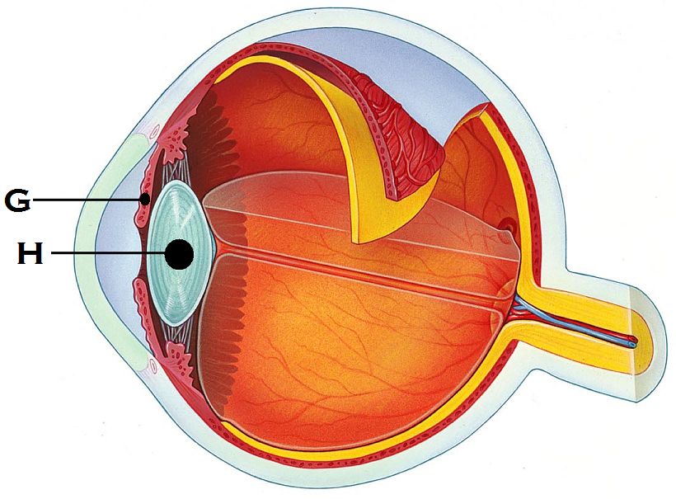

1. Identify “G”
   1. Iris
   2. Pupil
   3. Suspensory ligament
   4. Choroid
   5. Sclera
2. Identify “H”
   1. Suspensory ligament
   2. Lens
   3. Aqueous humor
   4. Sclera
   5. Cornea

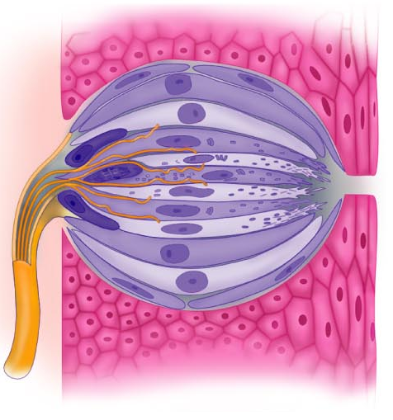

1. The image to the right represents
   1. Olfactory epithelium
   2. Taste bud
   3. Pacinian corpuscle
   4. Saccule and utricle
   5. Basilar hairs in cochlea
2. Which muscles move the **eyebrows** medially?
   1. Palpebral muscles
   2. Superior rectus muscle
   3. Corrugator muscle
   4. Medial rectus
   5. Orbicularis oculi muscle
3. Which of the following glands are **not** accessory structures to the eye?
   1. Meibonian glands
   2. Ciliary glands
   3. Lacrimal glands
   4. Canthi glands
   5. All of the above are glands associated with the eye
4. Which is the **drainage site** for the lacrimal gland? (takes tears away from the eye)
   1. Lateral epicanthus
   2. Conjunctival meatus
   3. Lacrimal puncta
   4. Inferior lacrimal canthus
   5. Canal of Schlemm
5. Which two muscles will be responsible for making the left eye look down?
   * + 1. Lateral rectus
       2. Inferior oblique
       3. Superior oblique
       4. Inferior rectus
       5. Superior rectus
   1. 1 and 2
   2. 3 and 5
   3. 2 and 4
   4. 3 and 4
   5. 2 and 5
6. 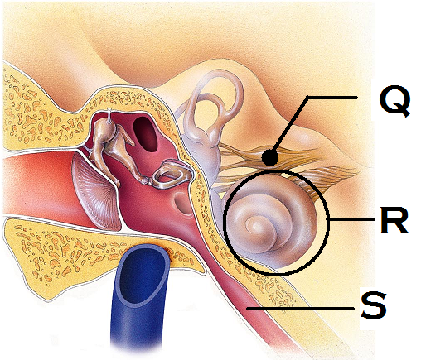Identify the structure “Q”
   1. Auditory nerve
   2. Tympanic nerve
   3. Cochlear nerve
   4. Vestibular ganglion
   5. Vestibulocochlear nerve
7. Identify the structure “R”
   1. Vestibule
   2. Cochlea
   3. Semilunar canal
   4. Ossicles
   5. Tympanic membrane
8. Identify the structure “S”
   1. Otic foramina
   2. Hypotympanic recess
   3. Vestibular tube
   4. Pharyngotympanic tube
   5. External auditory meatus
9. Which portion of the vascular tunic of the eye is responsible for supplying blood to all eye tunics?
   1. Sclera
   2. Conjunctiva
   3. Choroids
   4. Iris
   5. Ciliary body
10. Rods respond to ____ while cones respond to ___
    1. Light waves of short wavelength; light waves of high frequency
    2. Dim light; bright light
    3. Bright light; dim light
    4. Light waves of high frequency; light waves of short wavelength
    5. Pitch; volume
11. The orbicularis oculi muscle will be responsible for which of the following movements?
    1. Looking left
    2. Looking up
    3. Depressing the eyebrow
    4. Elevating the eyebrow
    5. Elevating the eyelid
12. Which structure in the anterior chamber of the eye is responsible for draining the aqueous humor?
    1. Anterior foramina
    2. Canal of Schlemm
    3. Orbital sinus
    4. Lacrimal puncta
    5. Ocular aqueduct
13. Jacob shifts his eyes from looking at a tree on the distant horizon to looking at his watch. What changes would you expect to see if you were observing his eyes?
    1. Activation of the lacrimal gland
    2. The effects of the contraction of the lateral rectus muscles
    3. Pupils get larger
    4. Iris changes color
    5. The effects of the contraction of the medial rectus muscles
14. What is the name for the change you noticed in Jacob’s eyes? (Your answer from #15 is called…)
    1. Ocular divergence
    2. Pupillary constriction
    3. Pupillary dilation
    4. Accommodation
    5. Convergence
15. This vision deficit results in the light’s focal point not landing on the retina because the eye is too short. It can be corrected by convex lenses.
    1. Emmetropia
    2. Hyperopia
    3. Myopia
    4. Superopia
    5. Utopia
16. The ____ fibers of the optic nerve **decussate** at ___
    1. Lateral: Occipital lobe
    2. Lateral; optic tracts
    3. Medial; optic radiation
    4. Lateral: geniculate nucleus
    5. Medial; optic chiasm
17. What is the function of the lacrimal caruncle?
    1. Produces and releases tears
    2. Produces and oily, whitish secretion
    3. Produces enzymes to break down proteins
    4. Produces granzymes to destroy pathogens
    5. Releases IgM to protect the surface of the eye
18. The function of the lateral geniculate nucleus is
    1. To relay information regarding movement
    2. To sharpen contrast
    3. To assist in depth perception
    4. To accentuate cone input
    5. All of the above
19. Why does a small amount of odor information cause a large response in terms of perception?
    1. Release of enzymes inhibit adaptation
    2. First messenger system amplifies the response
    3. Second messenger system amplifies the response
    4. Huge cortex regions associated with smell
    5. Due to the proximity of the olfactory receptors to the brain itself
20. Which of the following cells would you expect to see in a taste bud?
    1. Otoliths
    2. Sustentacular cells
    3. Areolar cells
    4. Gustatory cells
    5. Photoreceptor cells
21. Which cranial nerves carry taste information to the brain?
    1. Vagus and hypoglossal
    2. Glossopharyngeal and hypoglossal
    3. Facial and trigeminal
    4. Vagus and spinal accessory
    5. Glossopharyngeal and facial
22. The helix and lobule are part of the
    1. Olfactory epithelium
    2. Semicircular canals
    3. Posterior tongue
    4. Anterior eye
    5. Outer ear
23. The saccule and utricle are associated with
    1. Balance
    2. Taste
    3. Vision
    4. Smell
    5. Hearing
24. Which structure in the ear houses the receptors for hearing?
    1. Ampulla
    2. Tympanic membrane
    3. Vestibule
    4. Organ of Corti
    5. Otoliths
25. Elizabeth has been having difficulty hearing things lately. When observed with an otoscope, she was found to have an abundance of earwax that affected her hearing. What type of diagnosis would she receive?
    1. Menier’s disease
    2. Upper motor neuron damage
    3. Sensorinerual deafness
    4. Tinnitus
    5. Conduction deafness
26. Which muscle in the list below is **not** controlled by the Oculomotor nerve?
    1. Inferior oblique
    2. Superior rectus
    3. Inferior rectus
    4. Medial rectus
    5. Lateral rectus
27. Which of the following **does not contribute** to our sense of balance?
    1. Gestation
    2. Proprioception
    3. Vision
    4. 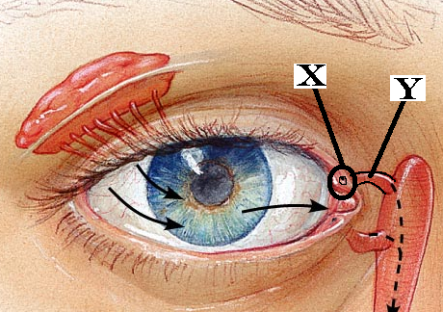Vestibule
28. Identify “X”
    1. Nasolacrimal gland
    2. Inferior canaliculi
    3. Haversian canaliculi
    4. Nasolacrimal duct
    5. Superior lacrimal puncta
29. Identify “Y”
    1. Lacrimal gland
    2. Lateral canthus
    3. Superior canaliculi
    4. Epiploic appendage
    5. Inferior lacrimal puncta
30. What are the tiny stone-like structures that are responsible for moving the cilia in the vestibular system?
    1. Otoliths
    2. Coproliths
    3. Rhodopsins
    4. Stereoliths
    5. Monoliths
31. If a person has an emmetropic eye, what type of vision would you expect?
    1. Red/Green color blindness
    2. Peripheral vision only
    3. 20/20 vision
    4. 20/15 vision
    5. 20/40 vision
32. The structure labeled at “N” is responsible for connecting the scala tympani and scala vestibule
    1. 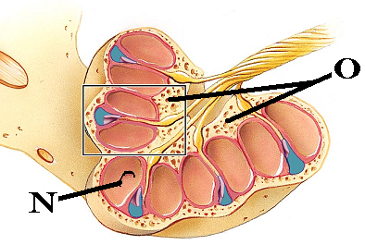Modiolus
    2. Saccule
    3. Maculae
    4. Helicotrema
    5. Membranous labrynth
33. Identify “O”. This structure is the bony pillar that the cochlea is wound around
    1. Saccule
    2. Maculae
    3. Bony labrynth
    4. Modiolus
    5. Helicotrema
34. The differing frequencies between 20 and 20,000 Hz gives us a sense of
    1. Amplitude
    2. Discord
    3. Loudness
    4. Volume
    5. Pitch
35. Which structure is not part of the visual pathway?
    1. Pretectal nucleus
    2. Optic chiasm
    3. Supraolivary nucleus
    4. Lateral geniculate nucleus
    5. Superior colliculus
36. What is the crista ampullaris?
    1. Region in the tongue innervated by cranial nerve VII
    2. Region in the eye with the greatest concentration of cones
    3. Region in the taste bud in which the taste cells are housed
    4. Region in the nasal cavity where the perforated bone allows access to the brain
    5. Region in the ear that is sensitive to dynamic equilibrium
37. Which structure is **not** part of the auditory pathway?
    1. Superior olivary nuclei
    2. Inferior colliculus
    3. Superior gentian nucleus
    4. Spiral ganglion
    5. Cochlear nuclei
38. This structure in the eye becomes less elastic and responsive as we age
    1. Rods
    2. Cornea
    3. Lens
    4. Retina
    5. Optic nerve
39. Which of the following terms can be objectively measured in terms of decibels?
    1. Frequency
    2. Amplitude
    3. Pitch
    4. Loudness
    5. Discord
40. The olfactory neurons will be what shape?
    1. Unipolar
    2. Multipolar
    3. Pyramidal
    4. Star-shaped
    5. Bipolar
41. Which structures are located in the middle ear?
    1. Otoliths
    2. Ossicles
    3. 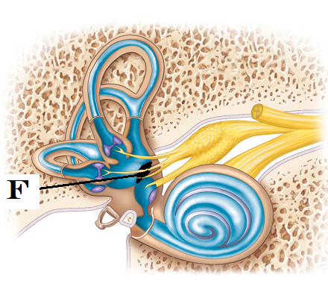Saccule
    4. Semicircular canals
    5. Helix
42. Identify “F”
    1. Macula of Utricle
    2. Bony labyrinth
    3. Crista Terminalis
    4. Macula of Saccule
    5. Spiral ganglion
43. Which disorder results in loss of balance, vertigo, nausea, and hearing loss?
    1. Tinnitus
    2. Meniere’s disease
    3. Bell’s Palsy
    4. Conduction deafness
    5. Acoustic neuroma
44. Which option best describes where the utricle and maculae are housed (where are they located)
    1. Within the epitympanic recess
    2. Within the ciliary body
    3. Within the scala media
    4. Within the vestibule
    5. Within the cochlea
45. Which of the structures listed is filled with endolymph?
    1. Epitympanic recess
    2. Middle ear
    3. Scala vestibule
    4. Scala tympani
    5. Scala media
46. Which part of the fibrous tunic is clear and allows light to enter the eye?
    1. Cornea
    2. Sclera
    3. Lens
    4. Ciliary body
    5. Macula densa
47. Where in the eye is the blind spot located?
    1. Canal of Schlemm
    2. Macula lutea
    3. Fovea centralis
    4. Fossa ovale
    5. Optic disc
48. In a myopic eye, where does the light come to a focal point?
    1. Directly on the retina
    2. At the fovea centralis
    3. In front of the retina
    4. Behind the retina
    5. At the lens

**Still can’t get enough?**

Below are several questions from previous exams. These next questions are **entirely optional**. If you miss them, there will be **no penalty**. If you get a question correct, **one point** will be added into your lecture grade.

1. The end result of **mitosis and cytokinesis** is
   1. Four daughter cells with half of the chromosome number in each cell
   2. Two daughter cells that are unique
   3. Two daughter cells that have identical DNA
   4. One daughter cell whose DNA is identical to the parent cell
   5. One daughter cell that has DNA different from the parent cell
2. 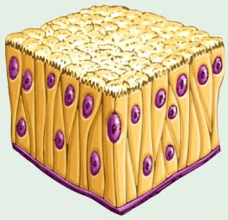 Which type of tissue fits this description?

* **A single layer of cells that appears to be layered**
* **has nuclei at several levels**
* **may have cilia or goblet cells.**

1. transitional
2. pseudostratified columnar
3. simple cuboidal
4. simple squamous
5. stratified columnar

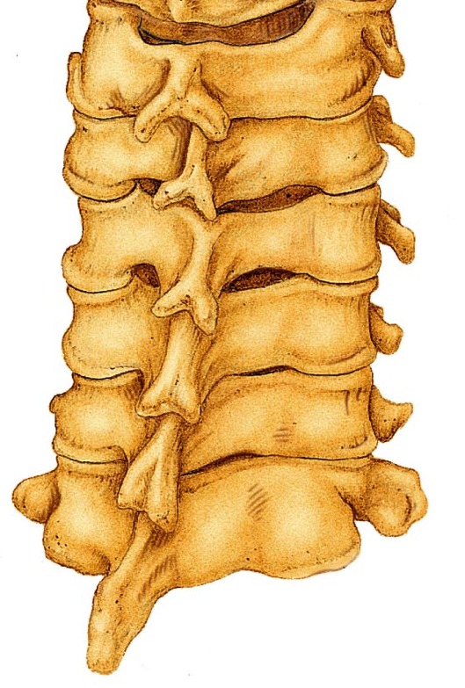

1. Chondroblasts are responsible for
   1. Production of red blood cells
   2. Production of fibers
   3. Production of chondrates
   4. Production of bone
   5. Production of cartilage
2. Which **region** are these vertebrae from?
   1. Cervical
   2. Thoracic
   3. Lumbar
   4. Sacral
   5. Coccygeal
3. The periosteum is
4. tissue that covers the medullary cavity
5. closely associated with yellow bone marrow
6. the cartilage that covers the articular surface of a bone
7. a layer of epithelium that covers bone
8. a layer of connective tissue that covers bone
9. Which type of ossification starts with a thin, fibrous tissue that gets filled in with bone: seen in the skull
10. synchondesmal ossification
11. syndesmosis ossificiation
12. chondrocartilaginous ossification
13. endochondral ossification
14. intramembranous ossification

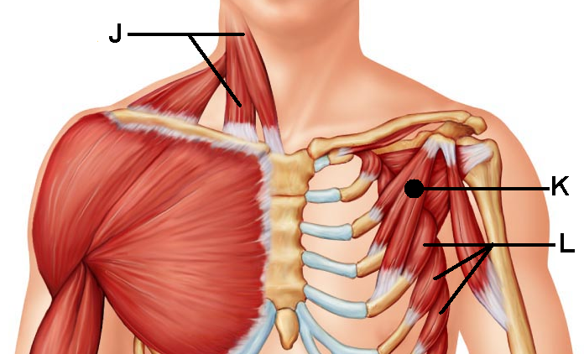

1. This muscle “K” shares its   
   name with a larger counterpart
2. Omohyoid
3. Pectoralis minor
4. External intercostals
5. Deltoid
6. Subscapularis
7. This muscle “L” can help to stabilize the scapula as well as pull the scapula forward. Its jagged appearance contributes to its name.
8. Internal intercostals
9. Subscapularis
10. Teres minor
11. Serratus Anterior
12. Stylohyoid
13. This highly branched glial cell has a star-shaped appearance. It is associated with capillaries and help with neuron nutrition.
    1. Astrocyte
    2. Schwann cell
    3. Oligodendrocyte
    4. Ependymal cell
    5. Microglial cell
14. In the PNS, the ______ produces the myelin surrounding an axon while in the CNS, the _____ produces it.
    1. Schwann cell; Schwann cell
    2. Schwann cell; Nissl body
    3. Nissl body; Microglia
    4. Oligodendrocyte; Schwann cell
    5. Schwann cell; Oligodendrocyte

**Grades:**

I will try to have your exams graded in the next few days and your scores posted on ReggieNet. You will be able to find your exam six score as well as your class grade there.

**Well wishes:**

Congratulations on making it through BSC 181! I enjoyed working with you as a class. I look forward to seeing you around on campus or in BSC 182 next semester. Good luck during Finals Week. Have a happy, healthy, and safe semester break.

**C:\Users\bawargo\AppData\Local\Microsoft\Windows\Temporary Internet Files\Content.IE5\BPC3IWU3\MC900383566[1].wmf** ~Dr. Wargo

Turn in opscan

Turn in exam