181 Lab Handout: Addition to Cranial Nerves

Cranial Nerve VIII: Vestibulocochlear

Sound localization:

- Have your lab partner sit comfortably with eyes closed.
- Click your fingernails, or snap your fingers to create a sound within the audible range of your lab partner’s ears.
- Ask your lab partner to point to where the sound from.
- Move the noise to a new location and repeat the process.
- Record your results

 | Actual Location | Reported location
First noise
Second noise
Third noise

Rinne’s Test:
Rinne’s tests bone conduction (vibrations passing through bone) versus air conduction (vibrations passing through air).
- Lab partner sits comfortably
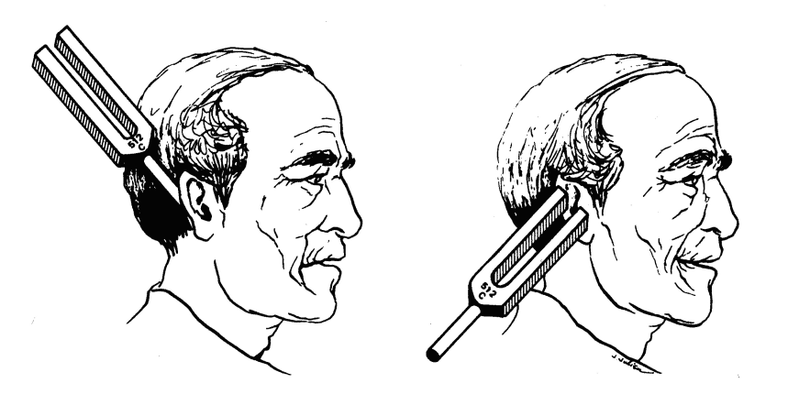
- Palpate behind the ear to locate the mastoid process
- Strike a tuning fork. Hold it by the stem, never the tines.
- Place the stem of the tuning fork on the mastoid process
- Ask your lab partner if they hear it.
- Ask your lab partner to tell you when the noise stops.
- Immediately remove the stem of the tuning fork from the mastoid process and bring the tines of the tuning fork directly in front of the ear canal.
- Ask your partner if they can hear the tone
- Repeat the process for the opposite ear.
- Record your results on the table below

Normally, the air conduction should be louder than the bone conduction (it takes a lot more energy for the vibrations to push through bone rather than air.)
If bone conduction is greater that air conduction, or in other works, if the sound is heard longer on the mastoid process than in front of the ear, then it indicates a conductive hearing deficit. Conductive deficits involve the outer and the middle ear.

Test | Left Ear: Normal or Impaired? | Right ear: Normal or Impaired?
Rinne’s Test
Weber’s Test
Repeated Weber’s With Cotton

Weber’s test
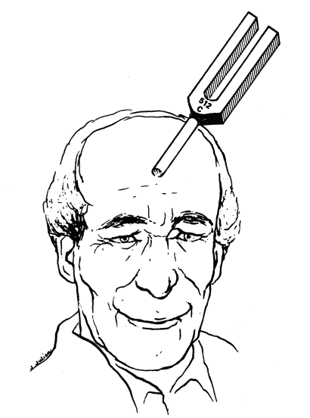
Weber’s test tries to distinguish between conduction deafness versus sensory deafness.

- Lab partner sits comfortably
- Strike the tuning fork
- Place the tuning fork on a midline feature: middle of the forehead or along the middle of the top of the head.
- Ask your lab partner if they can hear/feel the vibrations
- Ask your lab partner if the sound/vibrations can be felt/heard equally between the left and right sides, or if one side is louder than the other.

In a normal test, the sound should be heard evenly between left and right ears. In an abnormal test, the sound will be louder in one ear than the other.
Conductive impairment: sound is louder in affected ear
Sensory deafness: sound is louder in unaffected (normal) ear
This test is not diagnostic, but it’s a good starting point to further evaluate hearing abnormalities.

To reproduce the conductive impairment, do the following:
- Lab partner sits comfortably
- Pack one ear with a cotton ball
- Strike the tuning fork
- Place the tuning fork on a midline feature: middle of the forehead or along the middle of the top of the head.
- Ask your lab partner if they can hear/feel the vibrations
- Ask your lab partner if the sound/vibrations can be felt/heard equally between the left and right sides, or if one side is louder than the other.

