181 Lab
Mitosis and Epithelium

Part One: Intro
Part Two: Onion Root tip slides
Part Three: Epithelium Intro
Part Four: Epithelial slides

Please Note: Today’s lab deals with viewing several slides. Be sure to use appropriate microscope technique. Drop the stage to the lowest position before adding or removing a slide. Use the scanning power to locate and center an image before moving to a higher magnification. Use the course adjust knob ONLY with the scanning power, never with the low or high power lenses. Once you’ve upgraded to the low power (100X) or the high power (400X) be sure to use the fine adjust knob. If you have any questions regarding microscope usage, ask your TA.

Mitosis:
Mitosis is part of the cell cycle in which the contents of the nucleus are redistributed into two new nuclei. In a human body cell, there are 46 chromosomes. Following a mitotic division, there will be two cells, each having 46 chromosomes. In order to have a successful mitosis, there needs to be a successful interphase. During interphase, the cell prepares for the upcoming division process by doubling the amount of the DNA within the nucleus.

Part Two:
Using the onion root tip slides, you’ll be able to see and identify all of the stages below. Use the high power lens to best see the features (400X). The first cell stage (and most abundant) is interphase. Interphase is NOT part of mitosis, but includes a necessary preparation stage in which DNA duplication (replication) takes place.
Below is an illustration of interphase. Notice that the nucleus is intact and the nuclear contents are in the chromatin shape. Find a cell in interphase and draw it in the space provided. Label as many features as you can identify.

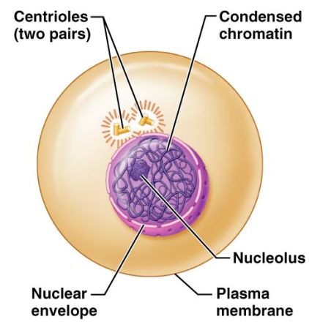

Mitotic stages: Prophase
The illustration below represents a cell in phophase (late prophase.) The nucleus has already broken down and the chromatin has all condensed into chromosomes. The spindle fibers are formed, and the centrioles have moved to the poles of the cell.
Identify a cell in prophase and draw it in the space provided. Label as many features as you can identify.

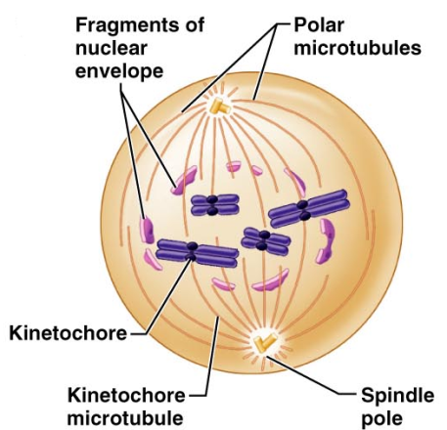

Mitosis: Metaphase:
During metaphase, the chromosome will line up with the centromeres (kinetochore) on the metaphase plate. The spindle fibers (microtubules) are attached to both the chromosomes and to the centriole (spindle pole) This stage is very brief, but visually distinct. Find a cell in metaphase and draw it in the space provided. Label as many features as you can identify.

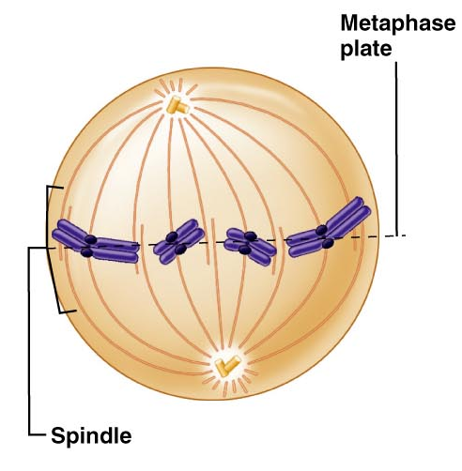

Mitosis: Anaphase
During Anaphase, the chromosomes start to split apart. The centromere (kinetochore) rips in two, allowing the now daughter chromosomes to move towards the poles. Also during anaphase, many animal cells start to demonstrate the “cleavage furrow” which is the beginning of cytokinesis. Since the slides you have are plant cells, you’ll not see this process. You may notice the beginnings of a new cell plate/cell wall used to separate the one cell into two. Find a cell in anaphase and draw it in the space provided. Label as many features as you can identify.

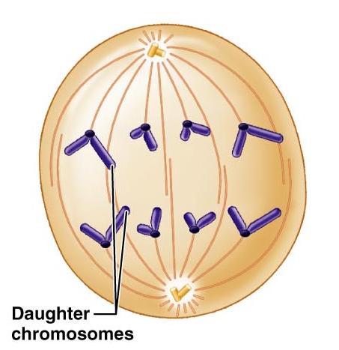

Mitosis: Telophase
In Telophase of mitosis, the daughter chromosomes have reached their destination. The nuclear membrane begins to reform and the spindle fibers start to break down. The chromosomes begin to relax back into chromatin. The nucleolus is replaced. Again, the illustration at the left is an animal cell in which the cleavage furrow can be seen. The plant cells (onion root tip) will not have a cleavage furrow. Find a cell in telophase and draw it in the space provided. Look for two smaller cells side by side, and you’ll likely have telophase. Label as many features as you can identify.

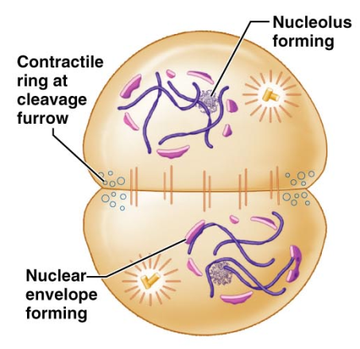

Part Three: Epithelium
Epithelia are tissues that create linings or coverings. When looking at epithelia, you may see several cell types arranged to create a tissue.

Find a slide labeled Simple Squamous: Lung Tissue
In simple squamous tissue, there is one layer (simple) of flattened tile-like cells. Simple squamous tissues can be found in the alveoli of lungs and in the capillaries. In the image below, the alveoli of the lungs demonstrate this very thin layer of cells. Locate the alveolar tissue on your microscope and compare it to the photomicrograph.
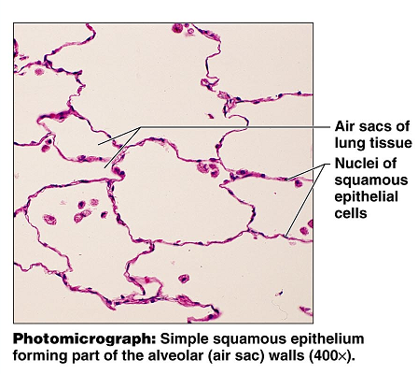

Find a slide labeled Simple Cuboidal: Kidney Tissue
The cuboid (square-ish) cells have the nuclei located in the center of the cell. In the photomicrograph below, the round glands are made up of a single layer of these square shaped cells. Even though there are several cuboid cells in each gland, there is only one layer of cells, making it simple cuboidal. Draw the simple cuboidal cells as you see them under the microscope (400X)

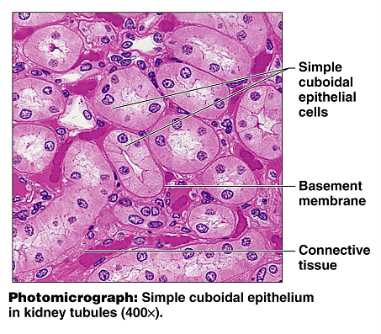

Find a slide labeled Simple columnar: Duodenum

Look for cells at the edge of the tissue selection that are longer than they are wide. They should have a round or oval nuclei located near their attachment to the basement membrane. The image below is of the stomach, and is at a greater magnification than what you’ll use for the duodenum. The duodenal tissue will also contain smooth muscle and other tissue types, so be aware that the simple columnar cells will be at the edge of the tissue selection. Draw and label the simple columnar cells that you see in the field of view. You may also see goblet cells. They are responsible for the production of mucus, and they have a flask-like shape.

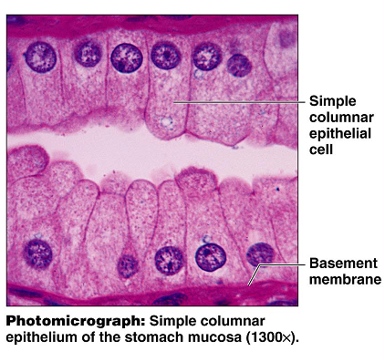

Find a slide labeled pseudostratified epithelium: Trachea
The pseudostratified epithelium is a single layer of cells that appears to have several layer based on the location of the nuclei. This tissue may be ciliated and have goblet cells, as seen in the image below. Locate the pseudostratified tissue in your field of view, and label the features.

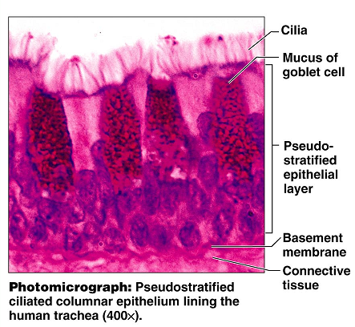

Locate the slide: Stratified squamous epithelium
This tissue is stratified (has multiple layers) of the squamous type cell. The basal cells (cells near the attachment site at the basement membrane) tend to have more of a cuboid appearance than the typical flattened appearance associated with the squamous cells. On the skin, the stratified squamous epithelium is keratinized. The protein keratin provides a toughness and water-proofing to protect the underlying layers. Stratified squamous is prevalent in areas that are likely to experience wear and abrasions. Draw the stratified squamous as you see it in the field of view (400X)
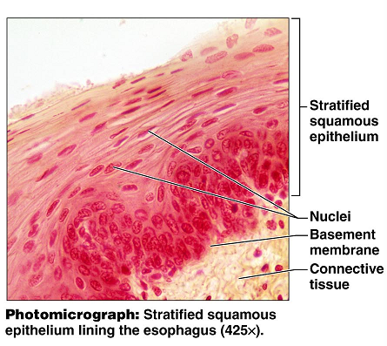
Locate the transitional epithelium: urinary bladder
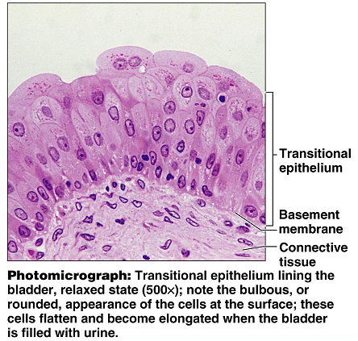
Transitional epithelium is designed to stretch as the bladder and other urinary organs fill and empty. The basal cells (near the basement membrane) tend to have a cuboid appearance, while the surface cells can have a domed appearance or a squamous appearance, depending on the amount of stretch the tissue is under. Draw the transitional epithelium as viewed in the field of view under high power (400X).

Note: Before leaving, make sure the microscopes are stored properly.
- Turn off the light
- Drop stage to lowest position
- Remove slide from stage. Make sure all slides are returned.
- Place the scanning lens in position
- Carefully return the microscopes to their cabinets
- Check and clean your work space

