181 Lab
Supplemental Handout for Muscles

Recall that there muscle tissue is divided into three categories: skeletal, smooth, and cardiac. Review each of the three types of tissues under a microscope.

Cardiac Muscle
Cardiac muscle is found only in the heart. It is involuntary. The control for the cardiac muscles comes from within the heart: the SA node. The cardiac tissue is also striated. When viewed under a microscope, you should be able to observe the bands or striations. Notice the branching shape of the cells. They have a “Y” appearance to them. Also note the intercalated discs. These discs help form the gap junctions that allow for rapid communication within the heart tissue. View and draw cardiac muscle.
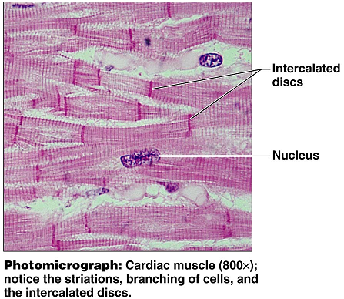

Smooth muscle:
Smooth muscle is located in organs and vessels. It is responsible for propelling food through the digestive tract as well as constricting blood vessels to raise blood pressure. The smooth muscle cell does not have striations, giving it a smooth appearance under the microscope. Smooth muscles have a tapered appearance, are shorter than skeletal muscle fibers, and have only one nucleus for each cell. View and draw smooth muscle.

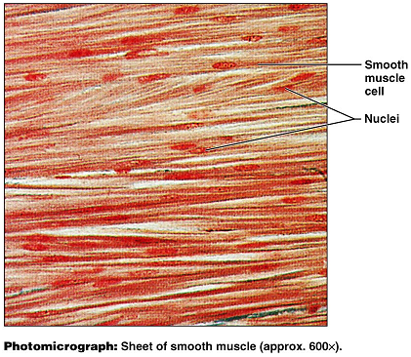

Skeletal Muscle:
Skeletal muscle is voluntary and striated. Skeletal muscle cells (muscle fibers) are multinucleate. In addition to being able to see the banded appearance under high power, we can also observe the areas where it receives signals from nerves. View and draw skeletal muscle.
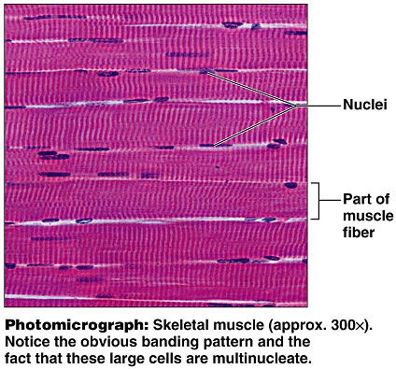

Motor Units:
A motor unit contains the nerve that runs to the muscle, and all of the muscle fibers that are innervated. Some motor units have one nerve fiber that runs to hundreds of muscle fibers. This type of arrangement gives us gross or bulky control. We see this type of arrangement in the low back muscles. Other motor units have one nerve fiber that innervates just a few muscle fibers. This is how we get our fine motor control. We see this in the eye muscles and in the fingers. View and draw a motor unit.

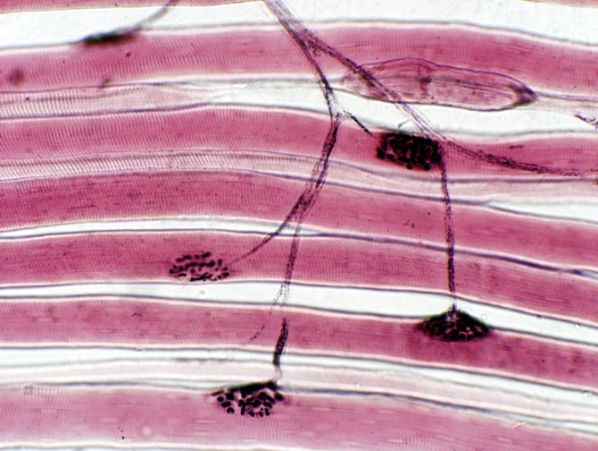

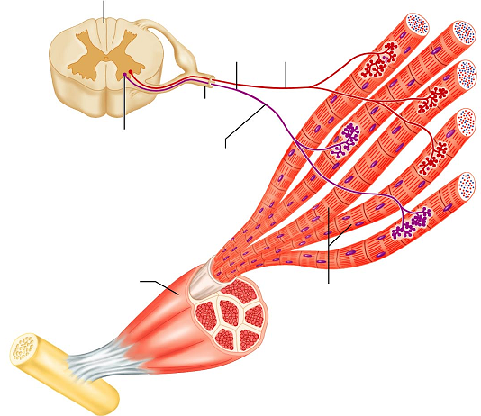

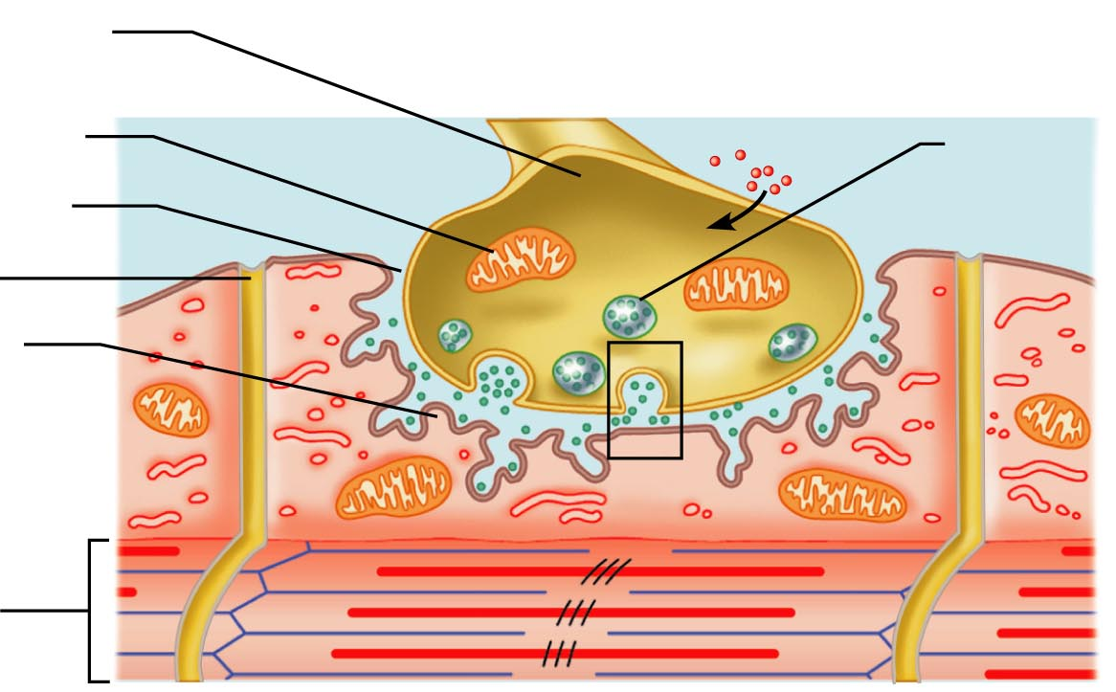

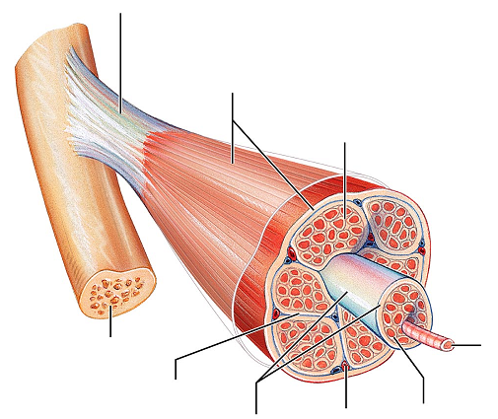

Questions:
- In which type of tissue (cardiac, smooth, or skeletal) would neuromuscular junction be located?

- What is the function of the gap junctions (intercalated disks) present in cardiac muscle tissue?

- Which protein fibers in skeletal muscle act together to cause contractions?

- Describe the process that takes place at a neuromuscular junction. Try to put it into your own words.
Include the following terms: vesicle, neurotransmitter, synaptic cleft

- How does the shape and appearance of smooth muscle differ from skeletal muscle?

Skeleton muscle contracts rapidly. However, it also fatigues quickly as well. Compare this to smooth muscle and cardiac muscles that have a slower response, and little to no fatigue. To demonstrate rapid muscle contractions and fatigue, we’ll perform the following exercise.

- Work in pairs. One person from your group will perform the exercise and the other person can record data and keep an eye on the time.
- Get a clothes pin
- To isolate the muscle activity, hold the clothespin with the thumb and index finger, but keep your remaining fingers straight (extended).
- The timekeeper will announce the beginning of a 20 second interval.
- The person with the clothespin with try to rapidly and repeatedly squeeze the clothespin open. Count the number of times you were able to open the clothespin within 20 seconds.
- The timekeeper will note the end of the 20 seconds and IMMEDIATELY announce the beginning of another 20 second interval.
- Do not rest or relax between intervals
- Keep track of the number of pinches in each 20 second interval and record them below.
- Record your results for a 3 minute span of time (complete nine 20-second rounds)

Time (20 seconds each) | Pinches per round
1
2
3
4
5
6
7
8
9

Answer the following questions:

Did the skeletal muscles used show signs of fatigue?

What physical symptoms, other than your results, did you notice?

What type of movement was being performed by the index finger?

Which muscles were causing that movement to take place?

Isotonic muscle contractions:
As the tension on a muscle increases, the muscle will respond by changing length.
If you do a biceps curl holding a weight, you are performing an isotonic contraction. The biceps muscle changes length, and the forearm flexes at the elbow. Because the weight of your object remains the same, your muscle remains isotonic (same tone) even though the length of the muscle is changing.

Concentric contractions: A concentric contraction is a type of isotonic contraction. If you lift a 10 lb weight to do a biceps curl, you are performing a concentric contraction as you flex the forearm. The muscle is able to overcome the weight or resistance and shorten the muscle fibers.

Eccentric contractions: An eccentric contraction is also a type of isotonic contraction. Eccentric contractions are often times described as “braking” contractions. With an eccentric contraction, the strength of the contraction is weaker than the amount of force being applied to it. Imagine that same bicep curl from above. As the forearm flexes, the biceps undergoes a concentric contraction, shortens, and brings the weight up. However, as the forearm extends, the triceps are activated. The triceps, plus the weight act to pull and lengthen the biceps muscle. The bicep is still contracting (braking) to slow or smooth the movement during the act of extension. If the eccentric contraction were absent, the forearm would flop into extension with no resistance and no control. An eccentric contraction is still an isotonic contraction because the length of the muscle is changing as the forces remain constant.

Isometric contractions:
With isometric contractions, the length of the muscle remains the same, but the forces exerted (tone) may change. As we attempt to move or lift object that exceed our muscles’ abilities, we utilize isometric contractions: trying to lift a car or pushing against a locked door. Our body uses isometric contractions in many of our postural muscles to allow us to maintain our balance.

In the following questions, identify the muscle primarily responsible for the motion, the antagonist, and identify the type of contractions being used.

- In order to walk, we plantarflex at the ankle.
  - Primary muscle used:
  - Antagonist:
  - Contraction used in agonist (primary muscle):
  - Contraction used in the antagonist (opposing muscle):

- Extension at the knee
  - Primary muscle (group) used:
  - Antagonists:
  - Contraction used in agonists:
  - Contraction used in antagonists:

- Flexion at the hip:
  - Primary muscles used
  - Antagonists:
  - Contraction used in agonists:
  - Contraction used in antagonists:

- Extension at the elbow (assume you are pushing against something that won’t budge)
  - Primary muscle used:
  - Antagonist
  - Contraction used in agonist:

Label the following images:

