181 Lab Handout

We will not be doing the endocrine lab found in the lab manual. Instead, the lab will focus on the cranial nerves and some of the special senses. For this lab you’ll be working with a lab partner to test some of the cranial nerves. Please be respectful of your partner when physical contact is called for.

Cranial Nerves

Pair up and test your lab partner on the following motions. Use your text book and your lecture notes to determine which muscles and which cranial nerves were used.

Action | Present | Absent | Muscle activated | Cranial nerve used
Smile
Close eyes tightly
Raise eyebrows
Puff cheeks
Open mouth
Clench teeth
Raise shoulders

Hold your finger about a foot in front of your partner’s nose. Draw an “H” pattern in the air and ask your partner to follow the tip of your finger without moving his/her head.

Indicate below if the activity was observed and which eye muscles were used

Action | Present | Absent | Eye muscle used | Cranial nerve
Both eyes look up

Both eyes look down
Right eye looks right
Left eye looks right
Right eye looks left
Left eye looks left

Pupillary response
Hold your hand vertically at the bridge of your lab partner’s nose. Your goal is to shield one eye from the light shining in the other.
- Shine a pen-light into the left eye. Observe the pupil of the left eye.
- Shine a pen-light into the left eye. Observe the pupil of the right eye.
- Shine a pen-light into the right eye. Observe the pupil of the right eye
- Shine a pen-light into the right eye. Observe the pupil of the left eye.

Action | Response of left pupil | Response of right pupil
Light in left eye
Light removed from left eye
Light in right eye
Light removed from right eye

Which cranial nerve is conveying the light information to the brain?

Which cranial nerve is responsible for the pupillary response?

Based on what you know of the pathway of the optic tract, why would light shining in one eye result in a change in both pupils?

Accomodation
Have your partner focus on a distant object within the room for one minute. Observe the pupil. While your partner is focusing on the distant object, prepare an object to be nearby. Hold a pen about six inches away from his/her face. At the end of the minute ask your partner to switch the focus from a distant object to the near one. Observe the pupil.

Describe the changes you are seeing.

Why would these changes be taking place?

What could you do to test Cranial Nerve I?

Place your hand lightly on your lab partner’s throat. You want to gently contact the throat at about the level of the larynx. Ask your lab partner to swallow.
Did the left and right sides of the throat feel as if they were moving symmetrically?

Which cranial nerve are you testing?

Have your partner stick out his or her tongue. Observe the tongue. Does it protrude along the midline, or does it move to one side?

Which cranial nerve are you testing?

Have your lab partner open his or her mouth and say “Aahhh”. Observe the uvula and the soft palate.

Which cranial are you testing?

Have your partner sit with his/her eyes closed. While standing behind him/her, rub your thumb and index finger together to make a light scratching noise. Start making the noise immediately next to the ear, and then move your hand away. Ask your lab partner to indicate when the noise can no longer be heard. Repeat this on the opposite side.

Which cranial nerve are you testing?

For this next test, be sure to be in a cleared area. Stay near your partner and be prepared to support them if necessary. Ask your lab partner to stand. Observe their equilibrium. Do they sway or are they stable? Now ask them to close their eyes. Be in a position to support or stabilize your partner if needed. Can your partner stay balanced? Do they sway to one side?

Which cranial nerve are you testing?

Have your lab partner face you. Lightly and evenly stroke the following regions on the face. Be sure to test the right and left sides at the same time: use both of your hands to perform the test. Ask your lab partner if the sensations can be felt evenly on both sides.

Region | Present | Absent | Cranial Nerve responsible
Forehead
cheeks
jawline

Answer the following questions about the ear

What is the cochlea?

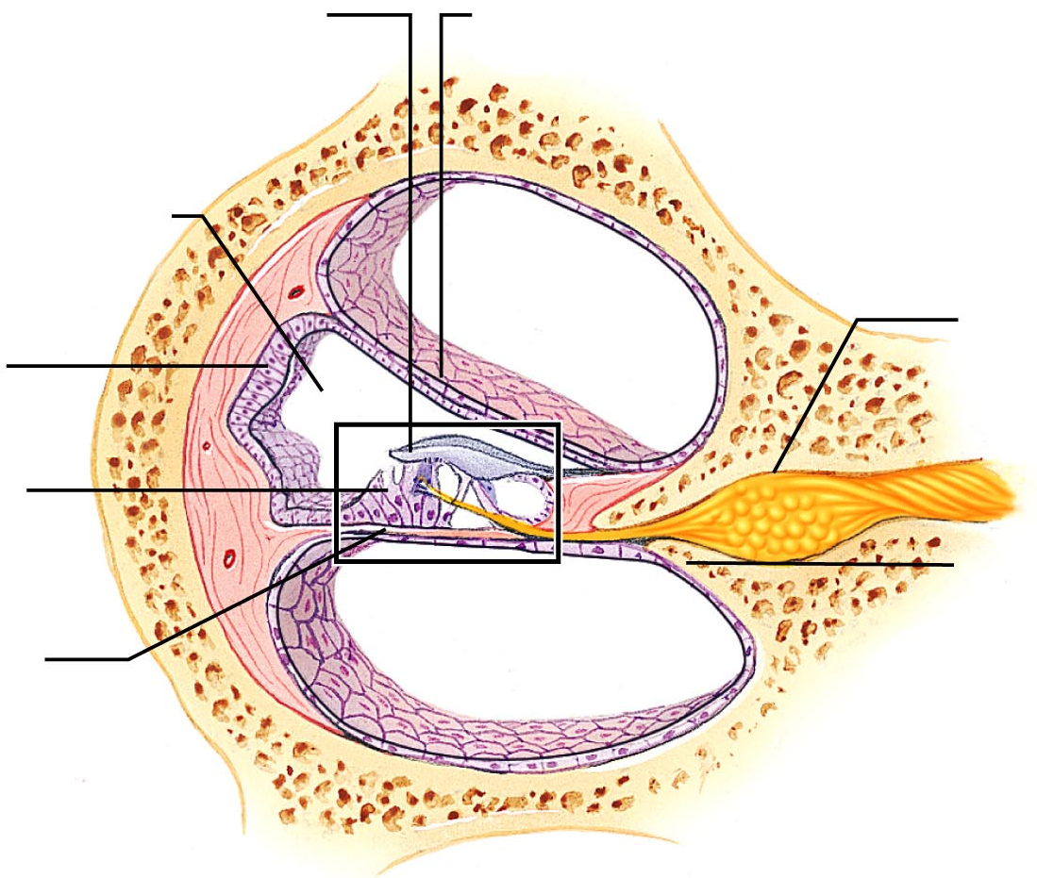

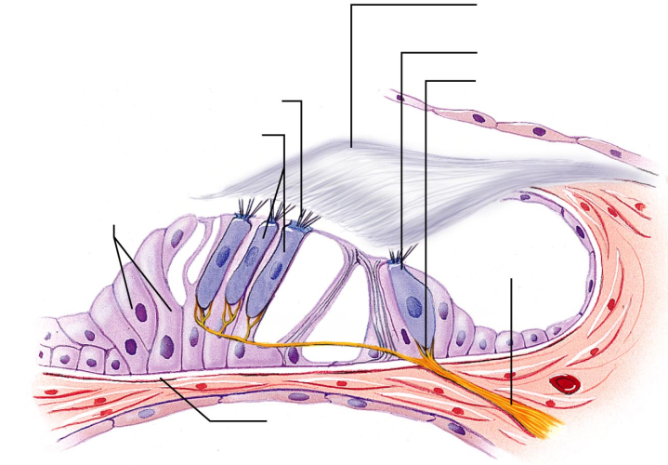

What is the auditory pathway to the brain?

What is the function of the semicircular canals?

What are the ossicles?
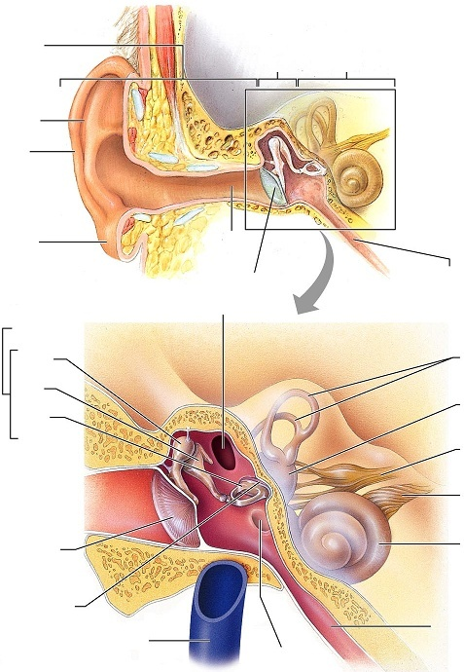

Define the following terms: saccule, utricle, otoliths (Where are they and what do they do?)

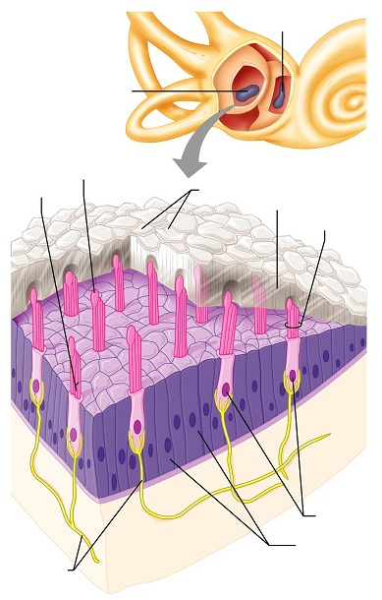

Your last lab quiz will cover eye anatomy, ear anatomy, and the cranial nerves found on this handout as well as the previous one.

