Cranial Nerves

Pair up and test your lab partner on the following motions. Use your text book and your lecture notes to determine which muscles and which cranial nerves were used.

Action | Present | Absent | Muscle activated | Cranial nerve used
Smile |  |  | Risorius muscle, zygomaticus muscles | Facial VI
Close eyes tightly |  |  | Orbicularis oculi | Facial VI
Raise eyebrows |  |  | Frontalis muscle | Facial VI
Puff cheeks |  |  | Buccinators muscle | Facial VII
Open mouth |  |  | Lateral pterygoid | Trigeminal V
Clench teeth |  |  | Masseter | Trigeminal V
Raise shoulders |  |  | Trapezius | Spinal accessory XI (the only cranial nerve to activate skeletal muscles outside of the face)

Hold your finger about a foot in front of your partner’s nose. Draw an “H” pattern in the air and ask your partner to follow the tip of your finger without moving his/her head.

Indicate below if the activity was observed and which eye muscles were used

Action | Present | Absent | Eye muscle used | Cranial nerve
Both eyes look up |  |  | Superior rectus,  Inferior oblique | Oculomotor III
Both eyes look down |  |  | Inferior rectus  Superior oblique | Oculomotor III  Superior oblique is Trochlear IV
Right eye looks right |  |  | Lateral rectus | Abducens VI
Left eye looks right |  |  | Medial rectus | Oculomotor III
Right eye looks left |  |  | Medial rectus | Oculomotor III
Left eye looks left |  |  | Lateral rectus | Abducens VI

Pupillary response
Hold your hand vertically at the bridge of your lab partner’s nose. Your goal is to shield one eye from the light shining in the other.
- Shine a pen-light into the left eye. Observe the pupil of the left eye.
- Shine a pen-light into the left eye. Observe the pupil of the right eye.
- Shine a pen-light into the right eye. Observe the pupil of the right eye
- Shine a pen-light into the right eye. Observe the pupil of the left eye.

Action | Response of left pupil | Response of right pupil
Light in left eye | Constricts | Constricts
Light removed from left eye | Dilates | Dilates
Light in right eye | Constricts | Constricts
Light removed from right eye | Dilates | Dilates

Which cranial nerve is conveying the light information to the brain? CN II: Optic

Which cranial nerve is responsible for the pupillary response? CN III: oculomotor controls the iris/pupil

Based on what you know of the pathway of the optic tract, why would light shining in one eye result in a change in both pupils?
From the right eye, some of the tracts decussate at the chiasma and cross to the left brain. Other fibers remain on the right. Both hemispheres of the brain process the incoming optic impulses and respond to them. So from the right eye being stimulated with a penlight, both eyes will experience pupil constriction.

Accommodation
Have your partner focus on a distant object within the room for one minute. Observe the pupil. While your partner is focusing on the distant object, prepare an object to be nearby. Hold a pen about six inches away from his/her face. At the end of the minute ask your partner to switch the focus from a distant object to the near one. Observe the pupil.

Describe the changes you are seeing.

Why would these changes be taking place?
With a distant focus we want the pupil as open as possible to have the best vision. When we look at near objects, the pupil will constrict to let in less light and ensure that the light entering the eyes is directed back to the fovea centralis on the retina.

What could you do to test Cranial Nerve I? Offer someone something to smell. They would need to be able to both acknowledge that they are smelling something AND identify what the smell is.

Place your hand lightly on your lab partner’s throat. You want to gently contact the throat at about the level of the larynx. Ask your lab partner to swallow.
Did the left and right sides of the throat feel as if they were moving symmetrically?

Which cranial nerve are you testing?
Both cranial nerves IX and X are responsible for the muscle of swallowing
Glossopharyngeal: stylopharyngeal muscle
Vagus: laryngeal muscles
Damage to the vagus nerve can result in dysphagia, difficulty swallowing

Have your partner stick out his or her tongue. Observe the tongue. Does it protrude along the midline, or does it move to one side?

Which cranial nerve are you testing? Hypoglossal XII

Have your lab partner open his or her mouth and say “Aahhh”. Observe the uvula and the soft palate.

Which cranial are you testing? Glossopharyngeal IX

Have your partner sit with his/her eyes closed. While standing behind him/her, rub your thumb and index finger together to make a light scratching noise. Start making the noise immediately next to the ear, and then move your hand away. Ask your lab partner to indicate when the noise can no longer be heard. Repeat this on the opposite side.

Which cranial nerve are you testing? Auditory portion of Vestibulocochlear VIII

For this next test, be sure to be in a cleared area. Stay near your partner and be prepared to support them if necessary. Ask your lab partner to stand. Observe their equilibrium. Do they sway or are they stable? Now ask them to close their eyes. Be in a position to support or stabilize your partner if needed. Can your partner stay balanced? Do they sway to one side?

Which cranial nerve are you testing? Vestibular portion of Vestibulocochlear VIII

Have your lab partner face you. Lightly and evenly stroke the following regions on the face. Be sure to test the right and left sides at the same time: use both of your hands to perform the test. Ask your lab partner if the sensations can be felt evenly on both sides.

Region | Present | Absent | Cranial Nerve responsible
Forehead |  |  | CN V: Trigeminal: Opthalmic branch
cheeks |  |  | CN V: Trigeminal: maxillary branch
jawline |  |  | CN V: Trigeminal: mandibular branch

Answer the following questions about the ear

What is the cochlea? The cochlea is the structure that houses the receptors for hearing: the Organ of Corti. It is responsible for transforming incoming vibrations into electrical impulses.

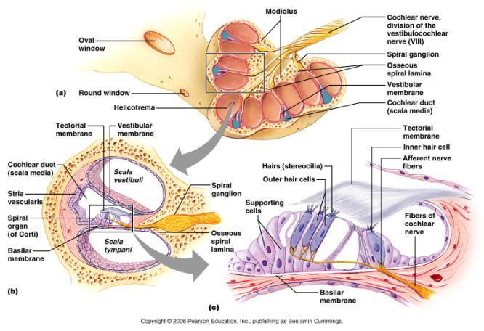

What is the auditory pathway to the brain?
Organ of Corti
Spiral ganglion of cochlear nerve
Cochlear nuclei in the medulla oblongata
Fibers cross (decussate) and travel to superior olivary nucleus
Inferior colliculus (where some fibers cross back over to their original side)
Thalamus (medial geniculate nucleus)
Primary auditory cortex: temporal lobe

What is the function of the semicircular canals?
Contributes to our sense of balance. The semicircular canals deal with “dynamic” equilibrium, most often rotation or angular movements.
(Compare that to the macula that respond to linear acceleration/deceleration. The macula can sense changes in speed and direction, but not to rotation)
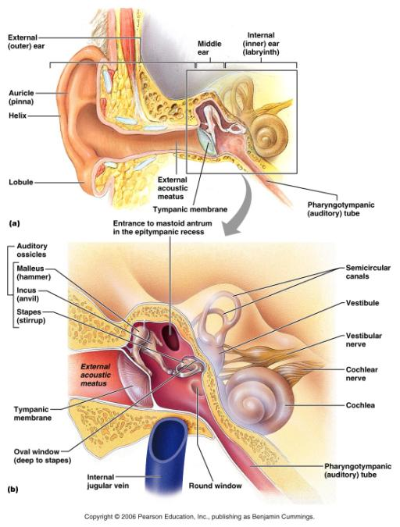

What are the ossicles?

The ossicles are the three smallest bones in the body. They transmit the vibrations from the tympanic membrane to the cochlea.
Malleus: against the tympanic membrane. Also known as “Hammer”
Incus: between malleus and stapes. Also known as “Anvil”
Stapes: pressed against the oval window of the cochlea. Also known as “Stirrup”

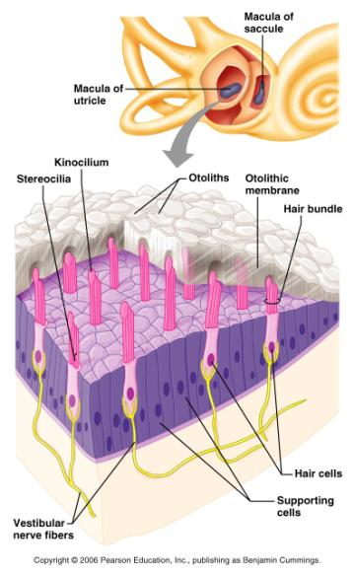

Define the following terms: saccule, utricle, otoliths (Where are they and what do they do?)

Saccule: Within the vestibular apparatus (of which the semicircular canals is a part) is a the saccule. The saccule is a small membranous “sac” that houses the macula. The saccule connects with the cochlear duct. The macula has a vertical orientation in the saccule ; it is sensitive to vertical acceleration. (Think of being in an elevator)

Utricle: The utricle is another membranous “sac” that houses another macula. The utricle is continuous with the semicircular canal ducts. Its orientation is horizontal. It is sensitive to horizontal acceleration and head-tilting.

The macula house the receptors for the sense of balance/equilibrium.

Otoliths: tiny calcium carbonate stones that shift as we move. As they shift, they strike the hair cells and trigger the depolariziation of the attached nerve fibers.

The hair cells in the macula are a type of mechanoreceptor. They will generate a response when they are pushed or pressed by the otoliths.

Your last lab quiz will cover eye anatomy, ear anatomy, and the cranial nerves

