Instructor Copy
181 Lab Supplement: Brain and Spinal Cord

Materials for lab:
Sheep brain
Spinal cord slide

You will primarily be using your lab manual for the brain and spinal cord lab.
When observing the sheep brain, locate the following structures:
Before making any cuts, view the brain and locate
Longitudinal fissure
Transverse cerebral fissure
Frontal lobe
Parietal lobe
Temporal lobe
Occipital lobe
Cerebellum
Pituitary gland
Olfactory bulbs
Optic chiasma
Pons
Medulla oblongata

After making your sagittal section, locate
Arbor vitae
Medulla oblongata
Thalamus
Mammillary body
Pineal body
Ventricles
Corpus callosum

After making your coronal section locate
Longitudinal fissure
Gray/white matter
Fornix
Lateral and third ventricles
Thalamus
Hypothalamus
After sectioning the spinal cord locate
Pia mater
Posterior median sulcus
anterior median sulcus
Gray and white matter

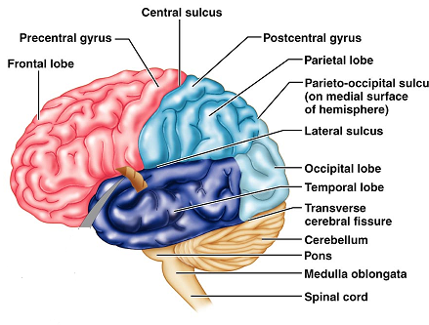

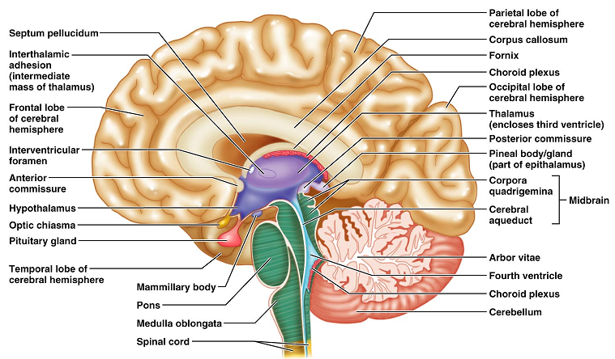

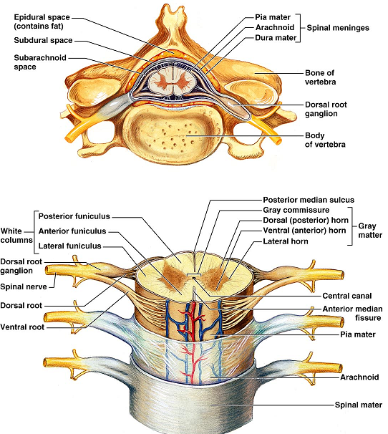

Questions:
What are the three meningeal layers that cover the brain and spinal cord?
Dura mater
Arachnoid mater
Pia mater

What is a sulcus?
The groove formed by the convolutions of the external brain. The “valley” between the hills.

What is a gyri?
The protrusion formed by the convolutions. The “hills”.

Which three regions make up the diencephalon?
Thalamus
Epithalamus
hypothalamus

What function does the thalamus have?
Acts as a relay station for the nerves entering the brain

Where is the choroid plexus found and what does it do?
Located in the epithalamus, functions to produce CSF.

In the medulla, what are the pyramids? What does it mean to “decussate”
Ridges located on the ventral surface of the medulla. They are composed of the motor neurons leaving the CNS. The cross or decussage, and the fibers from the right brain run to the left side of the body.

What is the optic chiasma?
The region in which the optic nerve crossed from one side of the brain to the other. Not all fibers cross, so we perceive visual information in both sides of the brain.

What are the ventricles? How many are there?
The ventricles are spaces in the brain that house and circulate CSF. There are four ventricles.

What is the function of the corpus callosum?
The corpus callosum connects the right and left cerebral hemispheres.

What’s the difference between the white matter and the gray matter?
White matter is myelinated axons. Gray matter contains the cell bodies of the nerve cells and the neuroglial cells.

