Eye and Vision

Before starting the dissection, take a look at the slide of the retina.
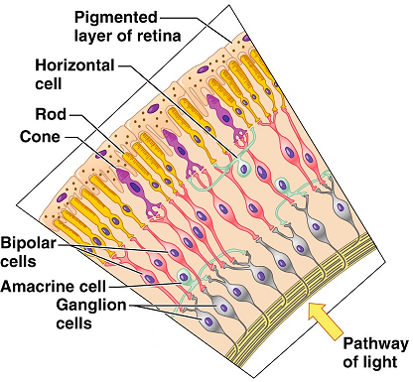
View “monkey retina” slide at 400X
Using the image to the right to get your bearings, try to find the following features on the slide:

Ganglion cells layer
Bipolar cell layer
Cones/rod layer

Eye Dissection:

View the external structures of the eye.

You’ll find that most eyes have a thick layer of fatty tissue (adipose tissue). Before making your incisions later on, you may wish to remove this layer.
If you look at the posterior aspect of they eye, you’ll see the optic nerve. You’ll also see the extrinsic eye muscles. The extrinsic eye muscles are responsible for moving the eyeball.

From your text book or from your lecture notes, list the six extrinsic muscles and indicate the function of each. Indicate the cranial nerve that controls it.
Eye muscle | Function | Cranial nerve

Observe the sclera and the cornea.

The cornea is the clear portion at the front of the eye. Often times with the preservation, they cornea takes on a cloudy appearance. Look through the cornea to see the iris, which is the colored portion of the eye. Observe the pupil.

The sclera (sclera means “tough”) is the white of they eye. It is very durable, so as you begin your dissection, use care; the eye can be slippery and tough. This makes for a potentially dangerous combination.

Recommendation: Use the scalpel to make an incision in the eye. Start your incision at about the half-way point between the front and the back of the eye. After creating a space, use the scissors to cut the sclera and separate the eye into anterior and posterior portions.

Anterior half:
This section of the eye will contain the lens and iris and cornea. Use the scissors to remove the cornea. You’ll notice a thin watery fluid that leaks out. This is the aqueous humor. Look through the cornea and set it aside. Observe the iris and lens from both the front and the back. Locate the ciliary body

What is the function of the ciliary body?

Remove the lens. Place it on a paper with writing and try to look through it.

Set the anterior half aside and turn your attention to the posterior half of the eye. The thick, jelly-like fluid that was inside the posterior compartment is called the vitreous humor.

What is the function of the vitreous humor?

Identify the retina. It is the thin tissue along the posterior aspect of the eye that falls easily away from the walls of the eye. The location where the retina remains anchored to the eye is the optic disc. This is the location where all of the nerves accumulate to leave the eye as the optic nerve.

Why would the optic disc create a blind spot in our eyes?

Observe the iridescent coloration of the wall of the eye behind the retina. This layer is the tapetum lucidum. This layer is found in many mammals, but not in humans. This is the layer of the eye that gives it a reflective quality. This is what makes your cat’s eyes appear to glow in the flash of a camera. It allows these animals to see in low light, but the clarity of their vision is compromised. Our eyes contain the choroid layer located between the sclera and the retina. Instead of the glowing eyes seen in animals with a tapetum lucidum, we get the red-eye effect when pictures are taken.

What is the function of the choroid layer?

Follow the optic disc through to the outside of the eye where it becomes the optic nerve. Try to squeeze the optic nerve. You may notice some whitish material that oozes out. This is the myelin that covers the axons running in that nerve.

What is the pathway the optic nerve impulses will follow to get to the visual cortex of the brain?

Answer the questions above and complete the labeling below before leaving lab.
