Instructor Set-up:

Station One:

Slide of simple squamous epithelium (alveoli)
  - Identify the tissue
Station Two:

Slide of pseudostratified columnar epithelium (trachea)
- Identify the tissue

Station Three
Slide of Areolar Connective Tissue
- Identify the tissue

Station Four
Slide of Dense Regular Connective Tissue
- question
- question
Station five:

Slide of Onion Root Tip: Anaphase
- Identify the stage of mitosis
Station six:

Slide of onion root tip: Interphase
- Identify the stage

Station seven
Slide of Adipose tissue
- Identify the tissue

Station eight
Microscope: Indicate the low power objective lens
- Identify this structure of the microscope
- What is the magnification of this lens alone?

Station nine
Microscope: Indicate the coarse adjust knob
- Identify this structure on the microscope
Question based on coarse adjust knob
- At which magnification(s) can the above adjustment knob be used?
Station ten:
Provided Image: Anatomical region: (femoral)
- Identify this anatomical region
- Question
Station Eleven:
Provided Image: Anatomical region: (pectoral)
- Identify this anatomical region
- Question

Station Twelve
Provided image: Section: (Transverse)
- Identify the type of section
- Question

Station Thirteen
Provided image: Anatomical region: (coxal/hip)
- Identify this anatomical region
- Question

Station Fourteen
Provided image: Anatomical region: (Lumbar)
- Identify this anatomical region
- Question

Station Fifteen
Slide of blood. Please try to have only RBCs in the field of view (no white cells) If you do have white cells present, be prepared to accept leukocytes, white cells or any of their names as a correct response.
- Identify this tissue
- Question

Station Sixteen
Provided image: Anatomical region: (olecranal)
- Identify this anatomical region

Answer Key:

  - Simple squamous epithelium. They must have “simple” and they must have “squamous”.
  - Pseudostratified columnar epithelium. (Look for pseudostratified and be forgiving with the spelling”
  - Areolar Connective tissue Also accept “loose connective tissue”
  - collagen
  - Lymph organs: spleen, lymph nodes
  - Anaphase
  - Interphase
  - Adipose .
  - Low power (10X) lens
  - 10X
  - Coarse adjust knob.
  - Scanning power (4X lens) only. Do not accept “low power”.
  - E femoral
  - B Inferior
  - D thoracic
  - B interphase
  - Transverse plane. Also accept “cross section”
  - C Intervertebral Discs
  - D. coxal
  - B medial
  - B tarsal
  - D lateral
  - Blood.
  - Accept Erythrocyte, red blood cells (not RBCs) red blood corpuscles,
  - C olecranal

Name:_______________________________________

- ___________________________________________________________
- ___________________________________________________________
- ___________________________________________________________
- ___________________________________________________________
- ___________________________________________________________
- ___________________________________________________________
- ___________________________________________________________
- ___________________________________________________________
- ___________________________________________________________
- ___________________________________________________________
- ___________________________________________________________
- ___________________________________________________________
- Circle one: a b c d e
- Circle one: a b c d e
- Circle one: a b c d e
- Circle one: a b c d e
- ___________________________________________________________
- Circle one: a b c d e
- Circle one: a b c d e
- Circle one: a b c d e
- Circle one: a b c d e
- Circle one: a b c d e
- __________________________________________________________
- __________________________________________________________
- Circle one: a b c d e

Station One

- Identify the tissue in the field of view

Description: The cells of this tissue are often described as “pancake-like” or “flat.” This tissue is found in capillaries

Station Two

- Identify the tissue in the field of view

Description: This tissue demonstrates nuclei that are not aligned. This gives them an uneven appearance. This tissue type may have cilia and goblet cells.

Station Three

- Identify the tissue in the field of view

Description: This tissue can be found throughout the body. It is one of the tissues that we use as “packaging”.

Station Four

Observe the tissue in the field of view and answer the following questions based on it

- What is the type of fiber that has the parallel arrangement specific to this tissue type?

- Where is reticular connective tissue most commonly found?

Station Five

- Identify the stage of mitosis seen on the slide

Station Six:

- Identify the stage of the cell cycle seen on the slide

Station Seven

- Identify the tissue in the field of view

Description: This tissue provides a space to store fat

Station Eight

- Identify the structure indicated on the microscope

- What is the magnification of this lens alone?

Station Nine

- Identify this structure on the microscope

- At which total magnification can the above adjustment knob be used?

- 10X
- 40X
- 100X
- 400X
- 1000X

Station Ten
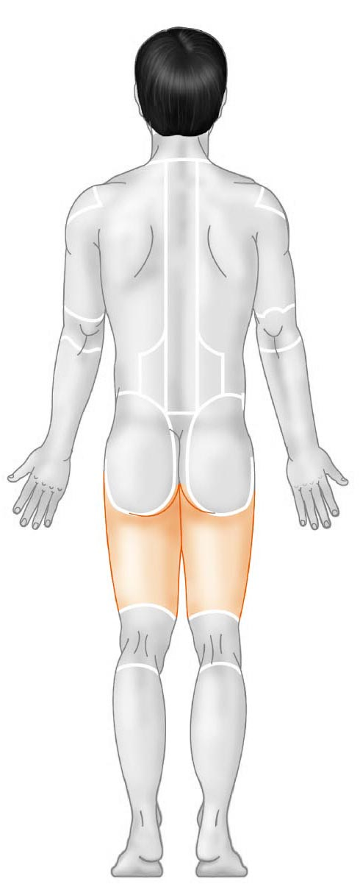

- Identify the anatomical region shown
- popliteal
- gluteal
- crural
- tarsal
- femoral

- The bladder is ____________ to the diaphragm
- Superior
- Inferior
- Lateral
- Medial
- Distal

Station Eleven

- Identify the anatomical region shown
- Clavicular
- Axillary
- Antebrachial
- thoracic
- Carpal

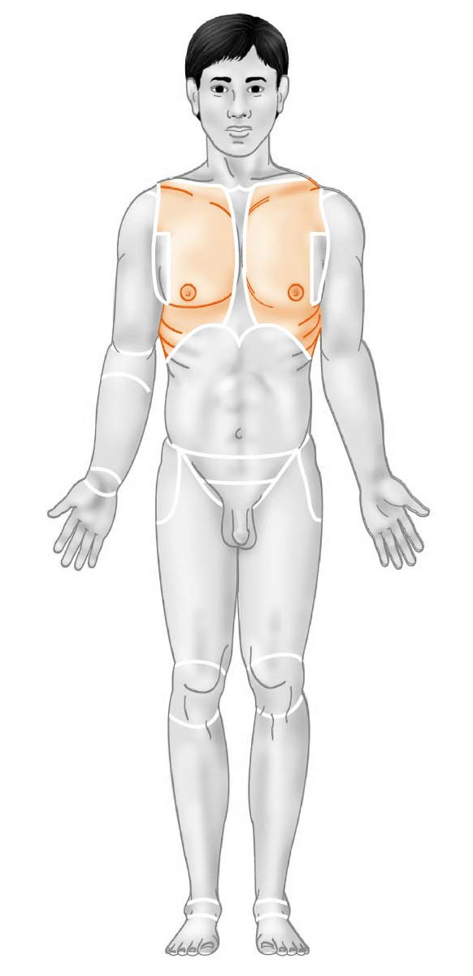
- Consider the cell cycle.
At what stage does DNA replication take place?
- Metaphase
- Interphase
- Telophase
- Cytokinesis
- Prophase

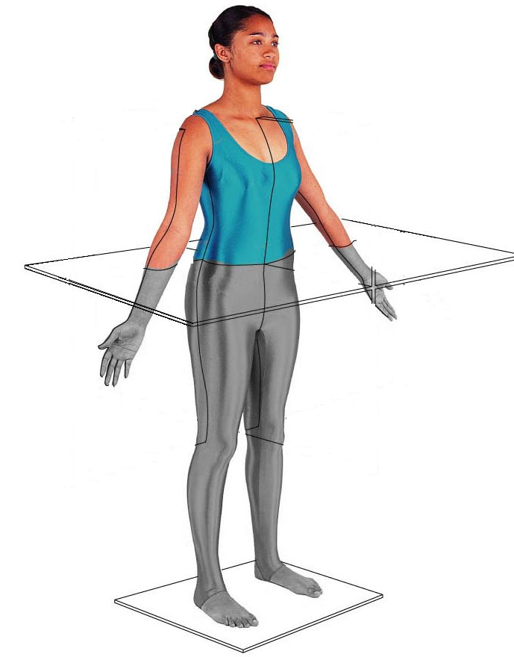
Station Twelve

- Identify the section (plane) in the image

- Where is fibrocartilage located?
- In the nose
- Pinna of the ear
- Intervertebral disks
- Epiglottis
- Small intestine

Station Thirteen
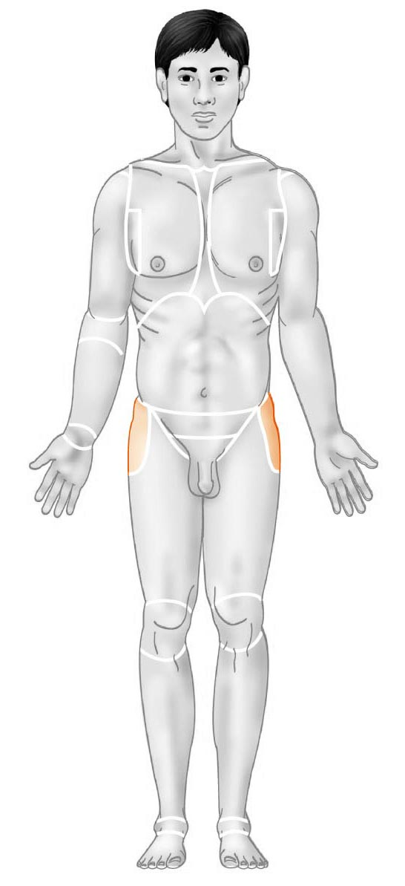
- Identify the anatomical region
- Hamstring
- Lumbar
- Groin
- coxal
- Posterior

- The elbow is __________ to the wrist
- Inferior
- Proximal
- Medial
- Distal
- Deep

Station Fourteen

- Identify the anatomical region:
- Carpal
- Tarsal
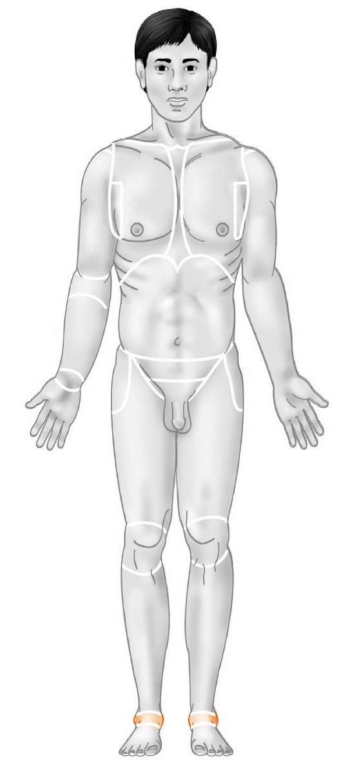
- Gluteal
- Sural
- Hypodorsal

- The lungs are ________ to the heart
- Proximal
- Deep
- Inferior
- Lateral
- Medial

Station Fifteen

- Identify the tissue in the field of view

- Give the name of one of the cells in the field of view. Use the proper terminology (no common names or abbreviations)

Station Sixteen

25. Identify this anatomical region
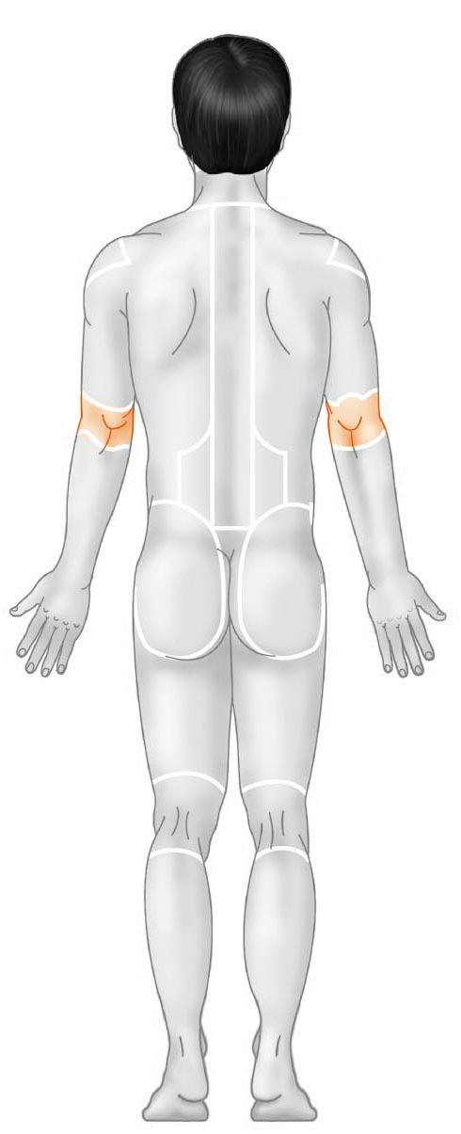
a. apical
b. acromial
c. olecranal
d. antebrachial
e. antecubital

