181 Lab
Axial Skeleton

The human skeleton is divided into two main regions: axial and appendicular. The axial skeleton contains the skull, vertebrae, ribs, and sternum. The appendicular skeleton contains the bones of the upper and lower extremities, and the girdles that attach them to the axial skeleton.

For the purposes of this lab, we will not be spending a great deal of time on the skull. Be aware, though, that the skull has two divisions to it. It contains the facial bones as well as the cranial bones.

Skull: Observe the bones of the skull.

Vertebral column
On page 8 of your lab manual (axial skeleton), you will find descriptions of the vertebrae based on their locations. While each vertebrae has common features, those features can vary from region to region, allowing us to identify the level from which the vertebra came.

From your text book, label the following images:
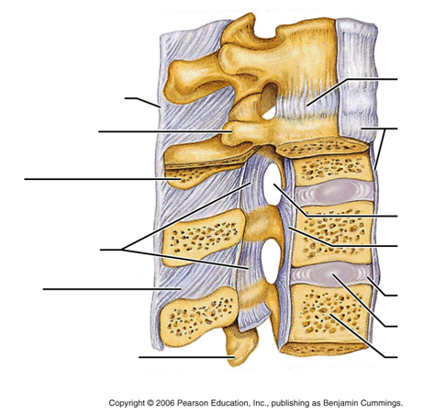

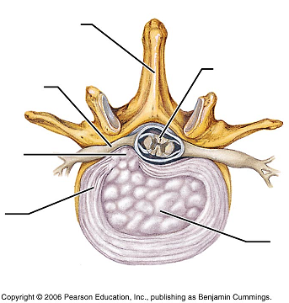

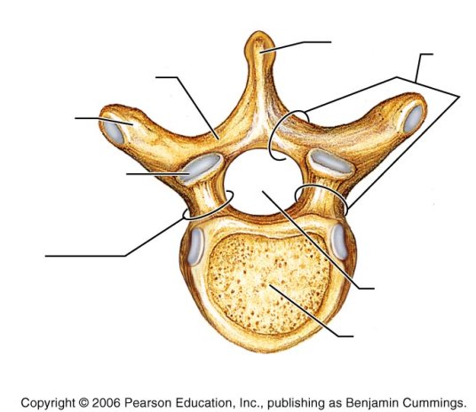

Observe the first cervical vertebra: C1
This structure varies from the other vertebra in that it has a modified body. The shape of C1 allows rotation to take place with the skull, as well flexion and extension. Look at the smooth articular surfaces that form the joints with the occipital regions of the skull.

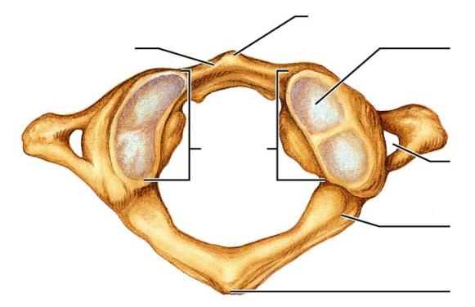

Observe the second cervical vertebra: C2
Notice on the superior aspect is a bony protrusion called the dens or odontoid process. This process articulates with C1 and allow us to have a great deal of rotation at this level. Find a C1 and a C2 vertebra and fit them together properly to observe how their articulation allows for this pivoting to take place.

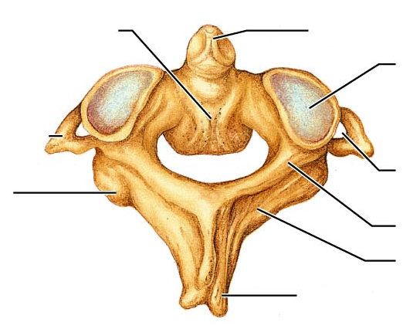

Observe the remaining cervical vertebrae. Notice the presence of the transverse foramina, which allow the arteries to run through a protected environment on their way to the brain.

Compare the bodies of the cervical vertebra to those of the thoracic vertebrae and those of the lumbar vertebra.

What do you notice in terms of shape?

What do you notice in terms of size?

Compare the cervical, thoracic, and lumbar vertebrae.
What do you notice about the spinous processes for each region? (indicate distinctions about shape, size, and orientation of the SP)

Compare the cervical, thoracic and lumbar vertebrae.
What do you notice with regards to the transverse processes for each region?

What feature do the thoracic vertebrae have to accommodate the ribs?

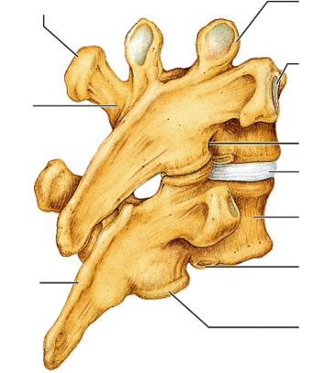

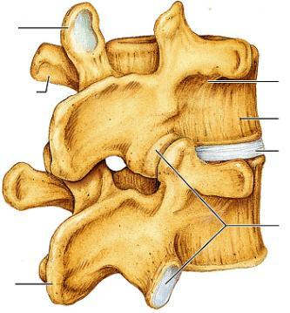

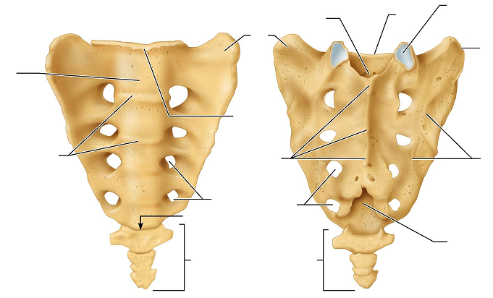

Thoracic Cage:
The thoracic cage is the protective environment that houses the delicate organs of the chest. It is composed of the sternum, the ribs, and the thoracic vertebrae, as well as the costal cartilage. As we breathe, our chest needs to be able to expand and contract. The articulations of the ribs at the vertebrae allow this to happen, as does the costal cartilage attachments to the sternum.

Observe the features of the thoracic cage and complete the labeling on the diagrams below.

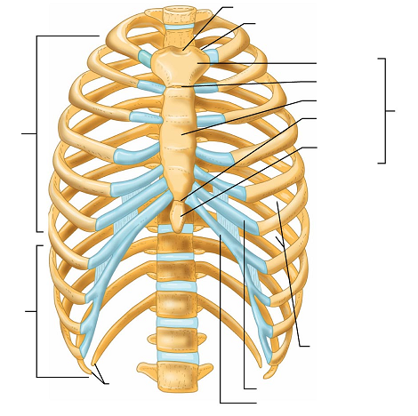

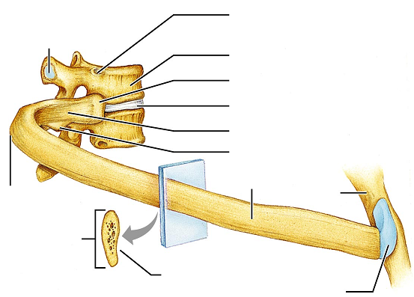

Before leaving lab, be sure that you can find and identify each of the features on the axial skeleton bones that you were asked to label in the above images.

