181 Lab Supplement: Brain and Spinal Cord

You will primarily be using your lab manual for the brain and spinal cord lab.

When observing the sheep brain, locate the following structures:
Before making any cuts, view the brain and locate
Longitudinal fissure
Transverse cerebral fissure
Frontal lobe
Parietal lobe
Temporal lobe
Occipital lobe
Cerebellum
Pituitary gland
Olfactory bulbs
Optic chiasma
Pons
Medulla oblongata

After making your sagittal section, locate
Arbor vitae
Medulla oblongata
Thalamus
Mammillary body
Pineal body
Ventricles
Corpus callosum

After making your coronal section locate
Longitudinal fissure
Gray/white matter
Fornix
Lateral and third ventricles
Thalamus
Hypothalamus

After sectioning the spinal cord locate
Pia mater
Posterior median sulcus
Anterior median sulcus
Gray and white matter

Microscope: View the prepared slide of the spinal cord and draw it. Identify white and gray matter, anterior and posterior horns, gray commisure, central canal

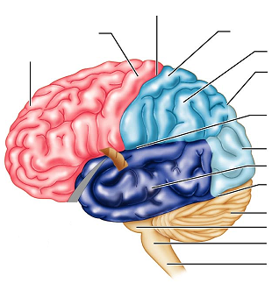
Label the images below and answer the questions before leaving lab

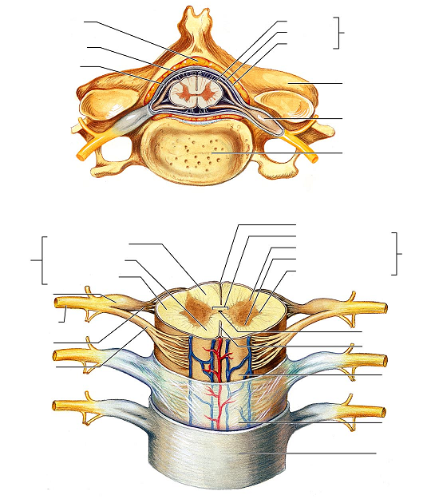
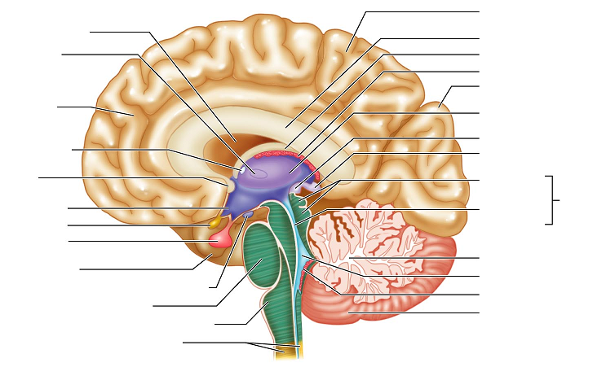

Questions: Answers can be found in your lab manual and text book.
What are the three meningeal layers that cover the brain and spinal cord?

What is a sulcus?

What is a gyri?

Which three regions make up the diencephalon?

What function does the thalamus have?

Where is the choroid plexus found and what does it do?

In the medulla, what are the pyramids?

What is the optic chiasma?

What are the ventricles? How many are there?

What is the function of the corpus callosum?

Lab Quiz: Will cover information from your lab manual, sheep brain structures, diagrams provided in this handout, and topics covered by the questions.

