Microscope
Part One: Microscope anatomy and use
Part Two: Preparing slides
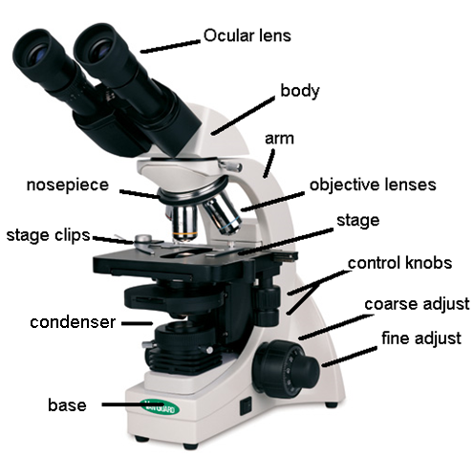

There will be many instances in BSC 181 and 182 where you will be asked to use a microscope. We’ll start off with the anatomy of a microscope, how to use one properly, and how to correctly stow one.

Features:

- Ocular lenses: These are the lenses that you’ll put your eye to. These lenses have a magnification factor of 10. Most of the microscopes in our lab have two ocular lenses. Some people find it more comfortable to look through both lenses with both eyes; others will look through only one lens. Do what works best for you. You’ll have less strain on your eyes if both eyes stay open.

- Nosepiece:
  - The nosepiece is the portion of the microscope to which the objective lenses are attached. The nosepiece rotates to allow the objective lenses to be used.

- Objective lenses: You will have three objective lenses that you’ll be using.
  - Scanning lens: this lens has a magnification of 4. However, since we need to take into account the magnification of the ocular lens as well, the total magnification for this lens will be 40X (4 X 10 = 40). This is the lens that you will start with to view your slides.
  - The scanning lens is the ONLY lens that you are able to use the coarse adjustment knob with. All other objective lenses will use the fine adjust knob.
  - Low power lens: The low power lens has a magnification of 10X, a total magnification of 100X (10 X 10 = 100) Use the fine adjust knob with the low power lens.
  - High power “High and dry” lens: The high power lens is the top magnification we’ll be using for this course. It has a magnification of 40X and a total magnification of 400X (40 X 10 = 400). Us the fine adjust knob with the high power lens
  - Oil immersion lens: We will not be using this lens in lab.

- Adjustment knobs
- Coarse adjust is the larger of the two wheels on the side. It moves the objective lenses up and down in order to focus. It is to be used ONLY with the scanning lens. Use with the low power or high power lenses can result in breaking both the glass on the objective lens as well as the slide itself.
- Fine adjust is the smaller of the two. It can safely be used with the low power and scanning lenses.

- Stage
- The stage is the platform on which your glass slide will rest. On the stage you will find a set of stage clips that will anchor the slide. Make sure your slide is securely fastened before moving the stage.

- Stage adjusting knobs
- You will find a set of knobs that will move the stage. One moves it forwards/backwards. The other moves it left/right.

- Light
  - Your microscope has a light at the bottom that shines up through the specimen. Under scanning power, the light may appear very bright, but as you increase magnification by using stronger objective lenses, the light appears to dim. The quality of the light can be modified using the microscope.
  - Abbe condenser: this condenser can intensify the light coming from the light source. It can be moved by using the knob below the stage. Use the Abbe condenser to improve contract in your field of view.

- Arm and Base
  - The arm is the backbone of the microscope. It attaches the body to the base. It is the arm that is used to transport the microscope. Always carry the microscope by holding both the arm and the base. The base is the bottom.

Tips for focusing and finding what you’re looking for:

- Before beginning, drop the stage down to its lowest position using the coarse adjust knob. Have the scanning objective lens in place. This gives you room to add the slide in later.
- Before you even put your slide on the stage, look at it to see where the specimen is on the slide. Position the slide so the specimen sits in the pool of light. This should help you line things up more easily when looking through the ocular lens.
- Focus using coarse adjust and scanning lens. Once you’ve got the image mostly focused with the coarse adjust, use the fine adjust to perfect it.
- In order to go from scanning power to low power, move the nosepiece and click the low power lens into position. You should not have to re-focus too much. At this point, use the fine adjust to bring the image back to clarity.
- The microscopes are parfocal scopes. This means when you focus at one magnification, the image stays mostly in focus as you move to the next level.
- Hint: As you go from scanning to low to high powers, you lose some of your field of view. Always center the structures that you are looking at so when you go from scanning to low power, it remains in the center of your field of view. This will prevent you from having to search for the structure on the slide.
- Hint: if you think you’ve found something on the slide, but you’re not sure, start by moving the stage to the left or right just a tiny bit. If the image in your field of view moves, you’re focused at the level of the slide. If you can move the stage, but the field of view stays the same, you’re focused on oil/debris on the objective lens and will need to refocus.

Part Two: Preparing slides
Exercises with the microscope

Create a slide using newspaper print

Find a newspaper (the Vidette works nicely) and tear/cut a letter out. The classic example for microscope exercises is “e”.
Place the letter “e” on the slide and cover it with a cover slip. Be sure to orient the letter so that it appears right side up.
Place the slide on the stage and view using the scanning lens. Draw what you see in the circle below.

Letter viewed with scanning lens (40X total)

Use the stage controls to move the slide to the right.
Which direction does the image move?

Use the stage controls to move the slide away from you.
Which direction does the image move?

- Increase the magnification to the low power lens (100X) and draw the letter again. Remember once you leave the scanning lens, you will no longer use the coarse adjust knob.

- Increase the magnification to the high power (high and dry) objective (400X). Again draw the field of view.

Create a slide using some of your own cells

Materials:
Clean slide
Cover slip
Methylene blue
Toothpick
Paper towels

- Spread several paper towels down on your work surface. On the center of your clean slide, place one small drop of Methylene Blue Dye. (It stains fingers and clothes, so be careful.)

- Take a toothpick, and lightly scrape along the inside of your cheek. The goal is to obtain cheek cells (epithelial cells, squamous) not blood cells, so just scratch lightly.

- Place the end of the toothpick with the cells on it in the stain, and swirl it around for 10 seconds. The goal is to get the cells that have clumped together to spread out and be evenly distributed through the dye.

- Put the cover slip on.

- Often, the excess fluid will start to seep out from the edges. Take a paper towel, and touch the corner of it to the fluid on the slide. This will pull some of the extra stain away, and leave the stained cells behind.

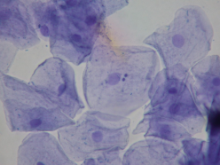
The image to the left is of cheek cells. If your specimen has been prepared correctly and the cells are evenly distributed, the cells have a “sunny-side-up egg” appearance. Look for roundish cells with a pale blue cytoplasm. Look for a darkly staining and centrally located round nucleus.

- View the slide under scanning power, low power, and then high power. Draw the cells at high power. (400X)
- Identify and label the plasma membrane, the cytoplasm, and the nucleus of a cell.

When you are done with the microscope for the day, complete the following checklist:

_____ turn off the light
_____ remove the slide
_____ drop the stage to the lowest position
_____ put the scanning objective lens in place
_____ secure the cord
_____ stow the microscope carefully

Be familiar with the “anatomy” of the microscope, proper usage, and the function of its parts as this information will be included for your first quiz.

Anatomical Regions and Terminology

Part One: Anatomical position
Part Two: Anatomical regions
Part Three: Terminology

During the course of the semester, you’ll be referring to the regions and relationships seen below. With all of the positions and relationships discussed, the standard frame of reference is a stance called anatomical position. In anatomical position, the individual stands upright, facing forward, with palms facing forward as well. The woman in the image below is standing in anatomical position.

In the image below, the body has been divided into sections.
- Transverse section divides the body into upper and lower portions
- Frontal sections divides the body into anterior and posterior (front and back) sections
- Sagittal sections divides the body into left and right sections.
  - Midsagittal divides the body evenly into left and right, so in half.
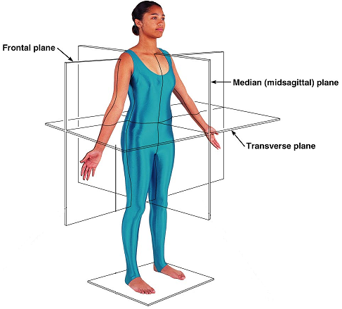

Fill in the images on the following pages. Complete this section during lab. You are welcome to discuss the terms and locations with your lab partners.

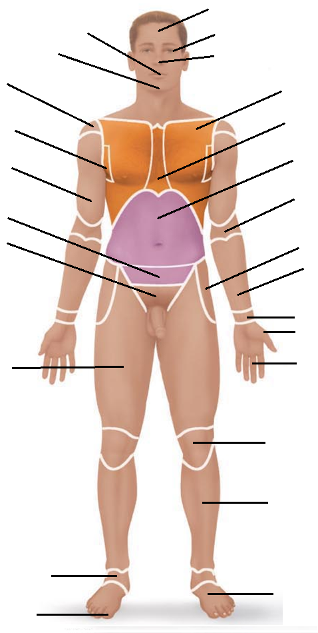

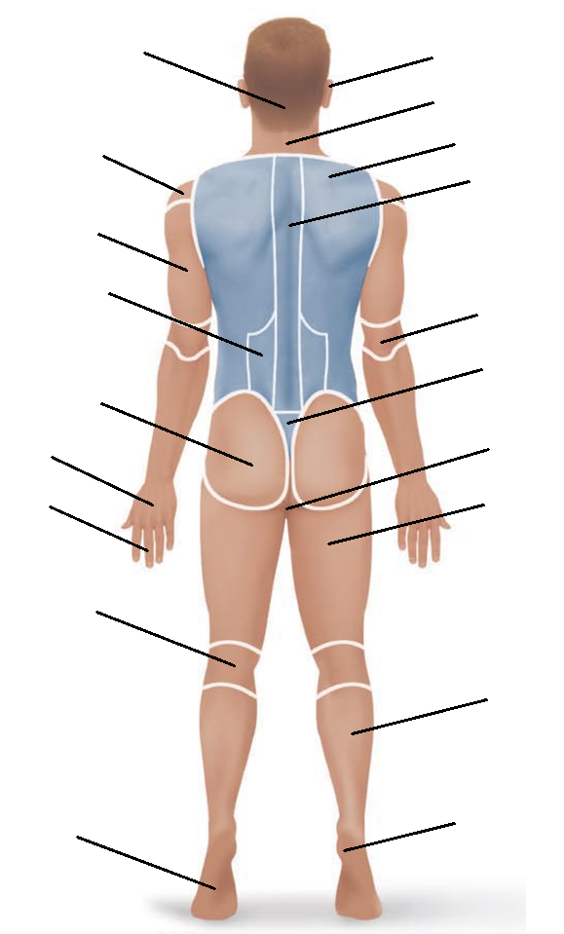

Part Three: Terminology

In anatomy and physiology, we use reference points and directional terms that relate to the anatomical position. Review the terms below and give examples based on the definitions.

Superior: Towards the head end of the body, above
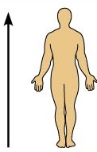
The occipital region is superior to __

The patellar region is superior to ___

Create your own:

Inferior: Away from the head, towards the lower part of the body
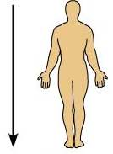
The navel is inferior to ___

The mental region is inferior to ____

Create your own:

Anterior: Towards the front of the body, in front of
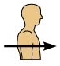
The heart is anterior to _____

The esophagus is anterior to ____

Create your own:

Posterior: Towards the back of the body, behind.

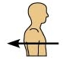
The vertebral column is posterior to ___

The heart is posterior to ___

Create your own:

Lateral: Away from the midline, towards the sides
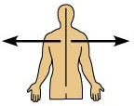
The ears are lateral to _____

The antecubital region is lateral to ____

Create your own:

Medial: Towards the midline, on the inner side of
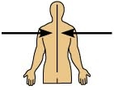
The navel is medial to ___

The mental region is medial to ____

Create your own:

Proximal: closer to the origin of the body part or closer to the trunk.
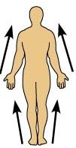
The wrist is proximal to ____

The knee is proximal to ____

Create your own:

Distal: farther from the origin of the body part, farther from the trunk.
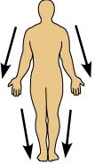
The sural region is distal to ___

The carpal region is distal to ___

Create your own:

Proximal and distal can often times cause confusion. If it helps, think of it in this way:
The elbow is proximal to the wrist: The elbow is closer to the trunk than the wrist is to the trunk.
The ankles are distal to the knees: The ankles are farther from the trunk than the knees are from the trunk.
**The terms proximal and distal are specific to the extremities. We do not use the terms “superior” or “inferior” when dealing with the relationships between structures on the extremities. So, the wrist will always be distal to the elbow, not inferior to it.

Superficial: closer towards the surface, external
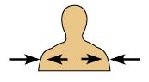
The dermis is superficial to ___

Deep: Away from the surface, more internal
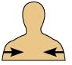
The lungs are deep to ___

The femur is deep to ___

