BSC 182 Anatomy and Physiology
Examination II

Please indicate all answers on your OpScan sheet. Remember that each question will have ONLY one best response. If you have a conflict with a question, go into detail on the back of this exam form. Please remember to set it aside in a separate pile if you’d like me to read your comments.

- What is cardiac tamponade
  - An excess of fluid built up with in the ventricles
  - Excessive pressure produced during atrial diastole
  - Excessive fluid within the pericardial space
  - Embolitic occlusion of the coronary sinus
  - The silence heard between “lub” and “dub”

- The valve present between the right atrium and the right ventricle is the
- aortic semilunar valve
- tricuspid valve
- bicuspid valve
- pulmonary semilunar valve
- mitral valve

- A Foramen ovale is an opening that allows fetal blood to bypass the lungs. In which structure is it located?
- Aortopulmonary septum
- Interatrial septum
- atrioventricular septum
- Articulated septum
- Interventricular septum

- What are the structures that anchor the semilunar valves to the ventricular walls?
- chordae tendinae
- papillary muscles
- microvilli
- carina
- the semilunar valves do not anchor to the ventricular walls

- Which of the following arteries are responsible for the blood supply to the heart?
- Iliac artery
- Posterior Interventricular artery
- Right Marginal artery
- Splanchic artery
- Right lobar artery

  - 1 and 3 are correct
  - 1, 2, and 5 are correct
  - 2, 3, and 4 are correct
  - 2 and 3 are correct
  - 3 and 5 are correct

- Identify “X”
  - Superior Vena Cava
  - Pulmonary Trunk
  - Right Pulmonary Vein
  - Aorta
  - Inferior Vena Cava

- Identify “Y”
  - Left Atrium
  - Coronary Sinus
  - Left Posterior Interventricular Vein
  - Circumflex Vein
  - Azygous Vein

- The “LUBB” sound is in part created from
- the closing of the aortic semilunar valve
- the closing of the mitral valve
- blood regurgitating back into the atria
- the opening of the tricuspid valve
- the opening of the mitral valve

- The myocardium
  - Is the innermost layer of the pericardium
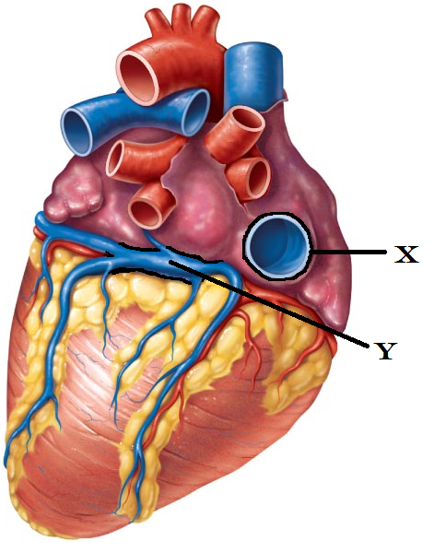
  - Is the middle layer of the heart
  - Is the innermost layer of the heart
  - Is continuous with the pericardial space
  - Is the middle layer of the pericardium

- An EKG is
- a means of monitoring brain waves
- a reading of the muscular contraction in the heart
- a reading of the blood perfusion of the heart
- a reading of the electrical activity of the heart
- a reading of the nervous stimulation to the diaphragm

- Where would one be most likely to find vasa vasorum?
  - In the tunica media of large veins
  - Associated with the valves of veins
  - In the tunica externa of large arteries
  - In fenestrated capillaries
  - Associated with the precapillary sphincters

- Viscosity (is)
- increased with anemia
- the “stickiness” of the blood
- decreased with polycythemia
- defined as the heat produced with blood flow
- defined as the ease/difficulty with which the lungs expand with inhalation

- Identify “Z”
  - Fossa Ovale
  - Ligamentum Arteriosum
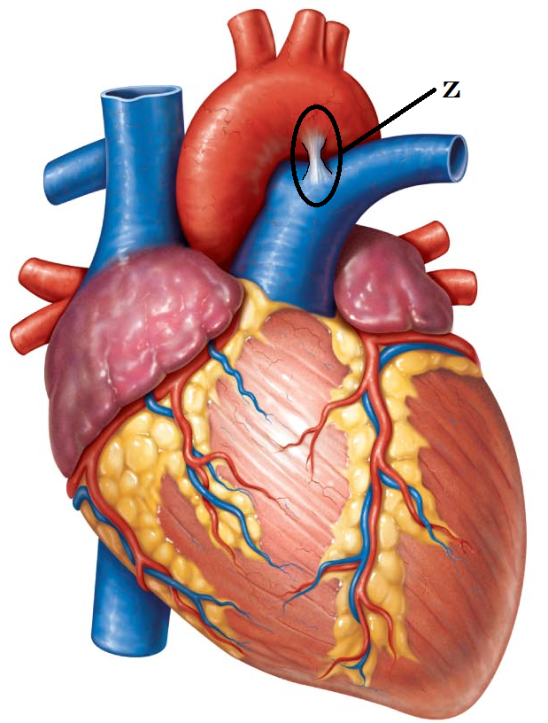
  - Intervascular coronary Artery
  - Crista Terminalis
  - Aortic Pulmonary Fistula

- Which type of vessel structure is referred to as a “capacitance vessel” and can hold up to 65% of the blood supply?
- artery
- lacteal
- vein
- precapillary sphincter
- capillary

- If you were to listen to a heart beat with a stethoscope, where would you best hear the Mitral Valve? Where is the PMI (PMI = Point of Maximum Intensity)?
  - Right sternal border, 5th intercostal space
  - Right sternal border, 2nd intercostal space
  - Left sternal border, 2nd intercostal space
  - Left sternal border, 5th intercostal space
  - Left Midclavicular line, 5th intercostal space

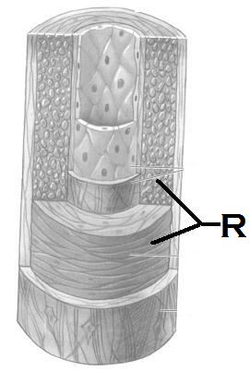
- In capillaries, biochemicals cross in the following means. Which of the following is the most important?
- filtration
- perfusion
- osmosis
- diffusion
- endocytosis

- Identify the “R”
  - Tunica intima of a vein
  - Tunica inima of an artery
  - Tunica media of a vein
  - Tunica media of an artery
  - Tunica externa of a vein

- These capillaries are the least common type and are exceptionally permeable.
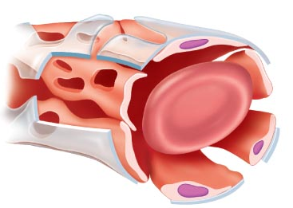
  - Fenestrated
  - Continuous
  - Muscular
  - Sinusoidal
  - Squamousal

- How does the Autonomic Nervous System affect the heart
- Parasympathetic system tempers the sinoatrial rate
- Presence of Acetylcholine causes increased heart rate
- Sympathetic system is referred to as Vagal tone
- Norepinephrine causes an increased force of contraction
- Results in changes to the blood viscosity

  - 1,2, and 4 are correct
  - 2 and 4 are correct
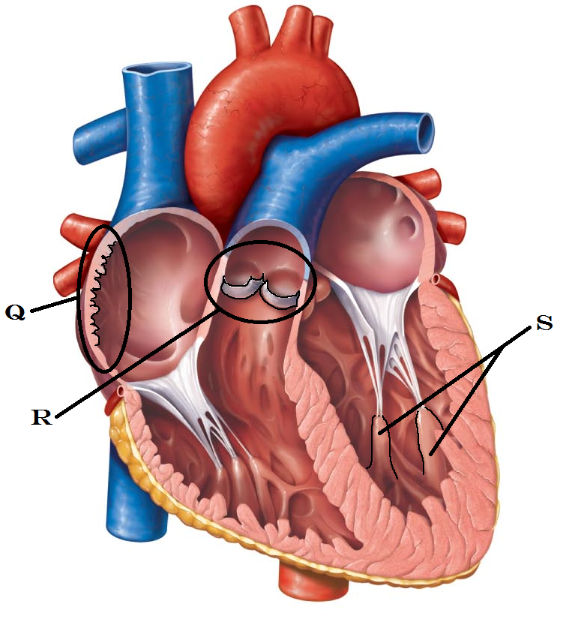
  - 3 and 5 are correct
  - 2 and 5 are correct
  - 1 and 4 are correct

- Identify Q
  - Crista terminale
  - Pectinate muscles
  - Trabeculae carnae
  - Left auricle
  - AV node

- Identify “R”
  - Aortic semilunar valve
  - Pulmonary semilunar valve
  - Mitral Valve
  - Tricuspid Valve
  - Chordae tendinae

- Identify “S”
  - Trabeculae carnae
  - Pectinate muscles
  - Crista terminalis
  - Papillary Muscles
  - Coronary Sinus

- Indicate which two options represent arterial blood pressure (Identify the correctly numbered responses and find them in the five lettered options below. You will indicate only ONE letter for a correct response.)
- diastolic over systolic
- systolic over diastolic
- the pressure of ventricular contraction over ventricular relaxation
- the pressure of ventricular relaxation over ventricular contraction
- has nothing to do with ventricular contraction or relaxation
  - 1 and 5 are correct
  - 2 and 5 are correct
  - 2 and 3 are correct
  - 1 and 3 are correct
  - 2 and 4 are correct

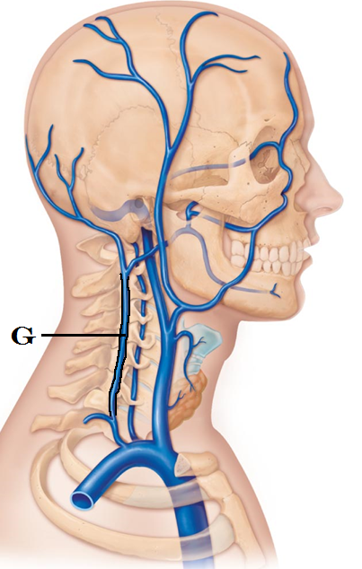
- Identify G
  - Internal Jugular Vein
  - Basilar Vein
  - Vertebral Vein
  - Internal carotid Vein
  - External Jugular Vein

- Angina Pectoris
  - Results in weakened cardiac cells
  - Results in dead cells being restored with fibrotic changes
  - Presents as palpitations
  - Presents as temporary hypertension
  - Causes both right and left sides of the heart to fail

- Vasoconstriction (Identify the correctly numbered responses and find them in the five lettered options below. You will indicate only ONE letter for a correct response.)
- is a response of the sympathetic system
- is a response of the intersplanchnic system
- results in the vessel diameter becoming larger
- results in the vessel diameter becoming smaller
- none of the above are correct
  - 1 and 3 are correct
  - 2 and 4 are correct
  - 1 and 4 are correct
  - 1, 2, and 3 are correct
  - 5 is the only correct statement

- Which pulse can be palpated at “K”
  - Carotid
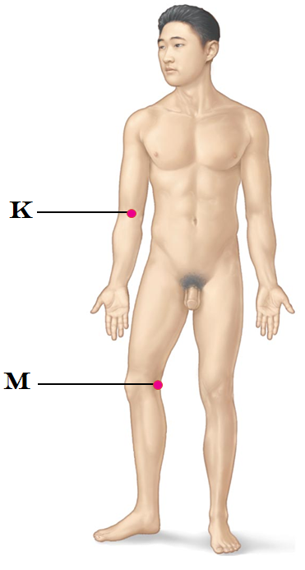
  - Superficial temporal
  - Radial
  - Antecubital
  - Brachial

- Which pulse can be palpated at “M”
  - Posterior Tibial
  - Popliteal
  - Patellar
  - Femoral
  - Anterior tibial

- The neurons of the vasomotor center are located
- In the pons
- In the medulla oblongata
- In the renal medulla
- In the adrenal cortex
- In the cerebral cortex

- Which of the following is true with regards to Hyperkalemia?
- Increases the heart irritability
- Causes spastic heart contractions
- Is a result of elevated calcium in the blood
- Causes a feeble and irregular heartbeat
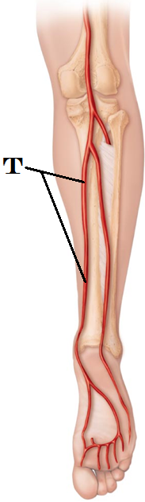
- Interferes with cardiac depolarization and can lead to cardiac arrest

- Identify the artery at T
  - Superficial crural artery
  - Lateral malleolar artery
  - Posterior tibial artery
  - Fibular artery
  - Patellar aretery

- In the EKG image, which wave form is absent? What is the name of this condition?
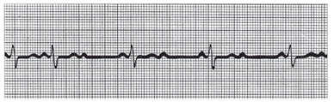
  - P wave is absent; Junctional rhythm
  - QRS wave is absent; Ectopic focus
  - P wave is absent; Extrasystole
  - QRS wave is absent; junctional block
  - All waves are altered; fibrillation

- Renin is responsible for
- Converting angiotensinogen into angiotensin I
- Converting plasminogen into plasmin
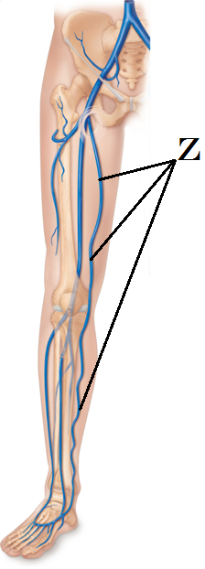
- Converting angiotensin I into angiotensin II
- Converting angiotensin II into Aldosterone
- Converting Aldosterone into ACE

- Identify the structure at Z
  - Femoral Vein
  - Deep Femoral Artery
  - Internal iliac Artery
  - External iliac Vein
  - Great Saphenous Vein

- Margo has been experiencing sustained elevated heart rate at 120 beats per minute. What term is used to describe her condition?
  - Cardiomegaly
  - Bradycardia
  - Tachycardia
  - Orthostatic hypercardia
  - Megalocardia

- Angiotensin II causes changes in the blood (volume) pressure by
      - Increasing thirst
      - Using Aldosterone to retain sodium, which in turn retains water
      - Excretes (loses) sodium, which in turn loses water
      - Altering the blood calcium concentrations
      - Stimulating ADH release
- 1, 2, and 5 are correct
- 2, 3, and 4 are correct
- 1 and 5 are correct
- 2 and 4 are correct
- 3, 4, and 5 are correct

- Which type of circulatory shock occurs when the blood volume is normal and is not related to heart damage?
- Hypervolemic shock
- Intrinsic shock
- Vascular shock
- Cardiogenic shock
- Hypovolemic shock

- The transient (temporary) drop in blood pressure that occurs with a positional change is
- Hypertrophic proprioception
- Hypovolemic shock
- Transient ischemia
- Orthoscopic hypertension
- Orthostatic hypotension

- Which of the following is true with a coarctation of the aorta?
  - The aorta is unexpectedly enlarged
  - The right ventricle becomes hypertrophied
  - The oxygenated and deoxygenated blood will intermingle within the heart
  - The left ventricle becomes overworked
  - Both the left and right ventricles have a direct opening into the aorta

- Given the Right Pulmonary Vein as a starting point, which three structures would the blood flow through next (in order)
  - Pulmonary Trunk Lung Left Pulmonary Artery
  - Left atrium Mitral Valve Left Ventricle
  - Right ventricle Bicuspid valve Left ventricle
  - Right atrium Tricuspid Valve Right Ventricle
  - Lung Left Pulmonary Artery Left Atrium

- In an EKG, which wave(s) immediately follows atrial depolarization
  - ventricular repolarization
  - atrial repolarization and ventricular depolarization
  - atrial repolarization and ventricular repolarization
  - a moment of rest between cycles
  - ventricular hyperpolarization

- Which of the following is going to increase peripheral resistance? (Identify the correctly numbered responses and find them in the five lettered options below. You will indicate only ONE letter for a correct response.)
- Increased viscosity
- Decreased viscosity
- Blood traveling through a very long vessel
- Blood traveling through a very short vessel
- A vessel with a large diameter
- A vessel with a very small diameter

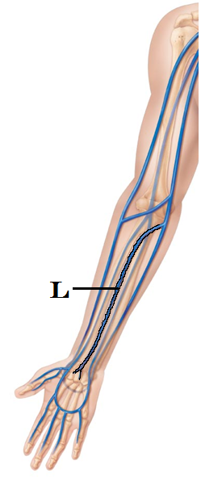
  - 1, 3, and 5 are correct
  - 2, 4, and 5 are correct
  - 1 and 3 are correct
  - 2, 3, and 6 are correct
  - 1, 3, and 6 are correct

- Which statement describes the location of the AV node?
  - inferior interatrial septum
  - carotid bodies
  - superior interventricular sulcus
  - right atrium near the opening of the Superior Vena Cava
  - medullary rhythmicity center

- Identify the vein at L
  - Median Antebrachial vein
  - Brachial vein
  - Antecubital vein
  - Median cubital vein
  - Basilic vein

- Reggie has a blood pressure of 132/82. What statement below is true?
  - His systolic pressure is normal
  - His pulse pressure is 50
  - His diastolic pressure is low
  - His pulse pressure is 1.6
  - Reggie’s blood pressure is dangerously high and he is in need of immediate medical intervention

- Which statement is true regarding right sided heart failure
  - It is the primary cause of pulmonary congestion
  - It is the primary cause of peripheral congestion and edema
  - It results in exceptionally low arterial blood pressure
  - The lub/dub heart sounds separates into a lub-lub/dub-dub as the atrial and ventricular contractions lose their coordination
  - It results in rapid heart rates and low central venous pressure

- Which statement below is true regarding preload?
  - It refers to combination of cardiac muscle cell stretch and venous return
  - It refers to the contractile strength at given muscle length
  - It refers to the openness of the AV valves
  - It refers to the pressure ventricles must overcome to eject blood
  - It refers to the elasticity of the distributing arteries

- What is the coronary sinus?
  - A space for coronary venous blood on its way to the right atrium
  - A space for coronary arterial blood on its way to the left atrium
  - The site at which the papillary muscles are anchored
  - The space surrounding the heart in which fluid can be found
  - The lymphatic tissue of the heart
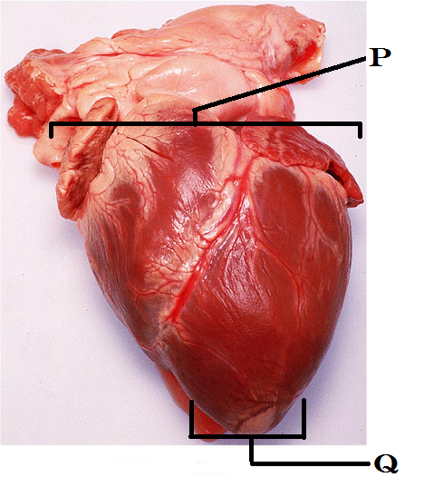
- Identify “P”
  - Apex
  - Base
  - Mediastinum
  - Coronary sinus
  - Interatrial septum

- Identify “Q”
  - Apex
  - Base
  - Mediastinum
  - Chorda tendinae
  - Pectinate muscles

Please turn in your OpScan form and Exam packet. If you have made a comment/question for me on your exam, please remember to place it in a separate pile at the front desk. Grades should be posted through ReggieNet within 2 days. Enjoy the rest of your day.

