BSC 182
Exam Four

- The only external visible part of the respiratory system is the
  - Glottis
  - True vocal folds
  - Oropharynx
  - Nose
  - Thyroid cartilage

- Dyspnea means ____, and apnea means _____
  - fast breathing; slow breathing
  - slow breathing; fast breathing
  - no breathing; difficulty breathing
  - controlled breathing; uneven breathing
  - difficulty breathing; no breathing

- Which of the following are true
- External respiration takes place at a body cell
- Internal respiration takes place at the alveoli
- External respiration takes place at the alveoli
- Internal respiration takes place at a body cell
- External respiration is the movement of air in to and out of the lungs
  - 1 and 4
  - 2 and 3
  - 3 and 5
  - 1 and 2
  - 3 and 4

- This tube of skeletal muscle runs from the base of the skull to the sixth cervical vertebra. It connects to the nasal cavity and mouth superiorly and to the esophagus and larynx inferiorly
  - Pharynx
  - Hyoid
  - Trachea
  - Strap muscles
  - Paranasal sinuses

- Which the following is not a paired laryngeal cartilage?
  - Corniculate cartilage
  - Arytenoids cartilage
  - Epiglottic cartilage
  - Cuneiform cartilage

- The left lung is separated into __________ by the ________.
  - Superior, Middle, and Inferior lobes; horizontal and oblique fissures
  - Superior and Inferior lobes; oblique fissure
  - Medial and Lateral lobes; corniculate fissure
  - Medial, Intermediate, and Lateral lobes; corniculate and arytenoid fissures
  - Superior and Inferior lobes; horizontal fissure

- The medial opening between the true vocal cords is called
  - Glottis
  - Tracheal foramen
  - Epiglottis
  - Fauces
  - Laryngeal vestibule

- “Structure 1” indicates which of the following features?
  - Supralingual salivary gland
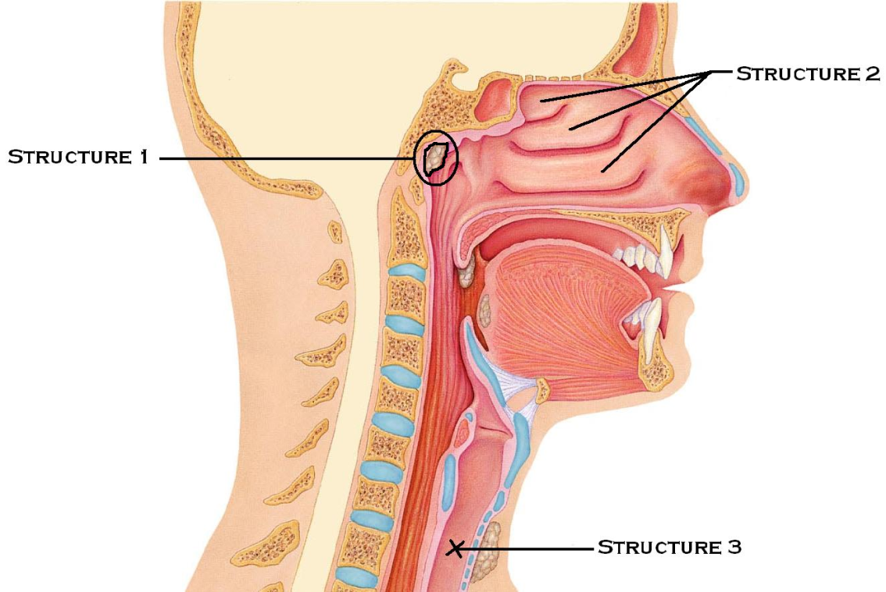
  - Palatine tonsil
  - Lingual tonsil
  - Carina
  - Pharyngeal tonsil

- “Structure 2” indicates which of the following?
  - Paranasal sinuses
  - Nasal conchae
  - Nasal vestibule
  - Nasopharynx
  - Nasolabial fold

- “Structure 3” is
  - Oropharynx
  - Esophagus
  - Trachea
  - Nasopharynx
  - Laryngopharynx

- ________ is determined by the length and tension of the vocal folds, whereas _____ is determined by the force of the air passing across them.
  - Projection; loudness
  - Pitch; loudness
  - Volume; frequency
  - Speech; pitch
  - Loudness; pitch

- Which of the following is true with regards to the bronchioles within the conducting zone?
  - Produces large amounts of mucus
  - Composed of stratified columnar epithelium
  - Composed of cuboidal epithelium
  - Lacks smooth muscle
  - Composed mainly of cartilage

- Within the alveolar walls, one would expect to find
  - Stratified squamous epithelium
  - An osmosis-driven exchange of gasses
  - Transitional epithelium
  - Surfactant-secreting cuboidal cells
  - Basophils

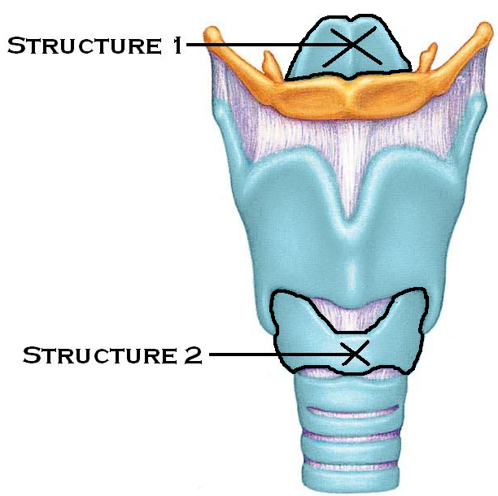
- “Structure 1” is
  - Glottis
  - Cricoid cartilage
  - Hyoid bone
  - Epiglottis
  - Thyroid cartilage

- “Structure 2” is
  - Cricoid cartilage
  - Epiglottis
  - Thyroid cartilage
  - Hyoid bone
  - Glottis

- Emphysema results in
- improved alveolar gas exchange
- decreased surface area for gas exchange
- blockage of bronchioles
- increase lung flexibility
- increased lung compliance

- Which two factors encourage the lungs to collapse/recoil?
- A negative intrapulmonary pressure
- The elastic nature of the lungs
- Surfactant
- Surface tension at the alveoli
- The rigidity of the thoracic wall

  - 2 and 4
  - 1 and 5
  - 3 and 5
  - 1 and 3
  - 4 and 5

- What is atelectasis?
  - The ability for the lung to remain inflated due to its Residual Volume
  - Lung collapse due to collapsed bronchioles or plugged alveoli
  - The entrance/exit site for large blood vessels, lymphatics, and bronchi
  - Low CO₂ levels due to hyperventilation
  - The superior-most region of the lung

- _________ describes the pressure within the alveoli
  - Intrapleural pressure
  - Interpleural pressure
  - Intrapulmonary pressure
  - Intracostal pressure
  - Interpulmonary pressure

- _______ is always a negative pressure which helps to ______
  - Intrapulmonary pressure; promote lymphatic drainage
  - Intracostal pressure; build lung volume
  - Interpulmonary pressure; prevent lung collapse
  - Intrapleural pressure; prevent lung collapse
  - Interpleural pressure; encourage lung elasticity

- Which muscles are responsible for the elevation of the rib cage?
  - Internal intercostal muscles
  - Pulmonary muscles
  - External intercostal muscles
  - Digastric muscle
  - Diaphragm

- An inhalant such as Primatine or Albuterol can be used during an asthma attack to promote ______ in order to ______
  - Bronchospasm: increase bronchial airway resistance
  - Vasodilation; increase peripheral resistance
  - Bronchodilation; reduce bronchial airway resistance
  - Bronchodilation: reduce lung compliance
  - Vasoconstriction; reduce peripheral resistance

- Which of the following factors would increase lung compliance? (make it easier for the lung to expand)
  - Ossification of costal cartilage
  - Decreased surfactant
  - Scar tissue
  - Increased surfactant
  - Increased mucus production

- __________ is the amount of air able to be forced out following the deepest inspiration possible.
- residual volume
- tidal volume
- vital capacity
- inspiratory reserve volume
- inspiratory capacity

- ____________________ is the amount of air taken into the lungs with a normal inspiration and blown out during a normal expiration
- residual volume
- inspiratory reserve volume
- vital capacity
- inspiratory capacity
- tidal volume

- After a resting exhalation, what is the term for the air remaining in the lungs?
  - Residual capacity
  - Residual Volume
  - Functional Residual Volume
  - Functional Residual Capacity
  - Anatomic dead space volume
- Healthy alveolar dead space and anatomic dead space have this in common
  - Type II cells producing angiotensin
  - No gas exchange taking place
  - Filled with mucus
  - Efficient gas exchange
  - Flexible compliance

- What parameters would be best for increasing hemoglobin’s affinity to oxygen.
- Other O₂ molecules attaching to hemoglobin
- Other O₂ molecules detaching from hemoglobin
- Elevated C0₂ levels
- Decreased temperature
- Low BPG

  - 1 and 5
  - 2 and 3
  - 1, 4, and 5
  - 3 and 5
  - 2, 4, and 5

- This enzyme helps to convert carbon dioxide and water into carbonic acid. The enzyme _________ is present in _________.
  - Carbonic anhydrase: cytoplasm of RBCs
  - Cholinesterase: plasma
  - Oxyhemoglobinase; hemoglobin
  - Plasmic hydrolase: cytoplasm of WBCs
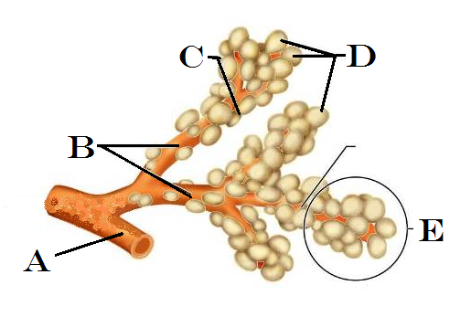
  - Acetylhydrase; liver cells

- Hering-Bruer (The Inflation Reflex) works by
  - Sensing the ratio of oxygen to carbon dioxide within the lungs
  - Sensing tissue temperature to prevent lung damage
  - Sensing lung irritants and coughing to remove them
  - Sensing tissue stretch to prevent over-inflation of the lungs
  - Initiating tissue damage to control oxygen pressure

- In the higher brain centers, which region can alter breathing rates based on emotions
  - Limbic region
  - Prefrontal cortex
  - Thalamus
  - Wernicke’s area
  - Insula of Reil

- Indicate the letter in the image to the right that is a conducting pathway only. No gas exchange.
  - A
  - B
  - C
  - D
  - E

- This type of lung cancer arises in the bronchi and easily metastasizes
  - Bronchosarcoma
  - Type II cell lymphoma
  - Small cell carcinoma
  - Adenocarcinoma
  - Squamous cell carcinoma

- Within the respiratory system, the conducting zone
  - Contains the alveoli
  - Provides the route for ventilation, but no gas exchange
  - Houses the respiratory bronchioles
  - Is the location for gas exchange
  - All of the above

- The inflammatory response in asthma is stimulated by the release of which materials?
  - IgA and IgD
  - Interleukins and Cytokines
  - Substance P and Substance I
  - IgE and Histamines
  - ATP and Ca²⁺

- Consider ventilation/perfusion coupling. If there is increased ventilation and decreased perfusion, what steps will be taken to restore an efficient exchange?
  - Bronchodilation
  - Dilation of pulmonary arterioles
  - Constriction of pulmonary arterioles
  - Dilation of pulmonary venules
  - Constriction of pulmonary venules

- The shallow vertical groove located inferior to the apex of the nose is the
  - Nares
  - Nasolabial fold
  - Phloem
  - Philbert
  - Philtrum

- Bronchial arteries carry ____, while pulmonary arteries carry ____
  - oxygenated blood; oxygenated blood
  - deoxygenated blood; deoxygenated blood
  - deoxygenated blood; oxygenated blood
  - oxygenated blood; deoxygenated blood

- What is the common name for “vibrissae?”
  - Vocal cords
  - Nose hairs
  - Nostrils
  - Alveoli
  - surfactant

- Explain how resting exhalation is a passive process where no muscles are activated to contract.
  - The low abdominal pressure causes air to be removed from the thoracic region
  - As the inspiratory muscle relax, they begin to recoil and increase the pressure in the thoracic cavity
  - The expiratory muscles are activated during a resting exhalation, but need no ATP (energy) to function
  - The diaphragm contracts upward into the thoracic cavity, pushing the air out of the lungs. Skeletal muscle involvement is minimal.
  - The intrapleural pressure becomes positive: higher than the intrapulmonary pressure, and it forces the air out of the lungs because of the pressure difference.

- The purpose of the chloride shift is
- to balance negative ions moving into and out of the alveoli
- to balance positive ions moving into and out of the RBC
- to balance negative ions moving into and out of the capillaries
- to balance positive ions moving into and out of the terminal bronchioles
- to counteract the influx of sodium ions during respiration

- Which of the following are true with regards to Carbon Dioxide?
- It attaches to the same binding site on hemoglobin as oxygen does
- It can undergo a rapid transition into a bicarbonate ion inside the RBC
- As C0₂ increases, the pH increases
- C0₂ stimulates the peripheral osmoreceptors as a primary stimulus for breathing
- C0₂ will diffuse out of body cells and into blood based on its concentration (partial pressure)
  - 1, 2, 3, 5
  - 1, 2, 5
  - 2, 3, 4
  - 2, 4, 5
  - 2, 5

- Which of the following would be considered non-respiratory air movements?
a. sneezing
b. coughing
c. crying
d. hiccupping
e. all of these are non-respiratory air movements

- Which statement is true regarding hemoglobin?
a. found within white blood cells
b. carries oxygen and carbon dioxide at the same location
c. delivers about 25% of its oxygen during one circulatory event
d. creates a strong and stable bond with oxygen
e. degrades into two heme groups and biliverden

- What is the carina?
  - The midpoint of the nasal septum
  - The term for the largest of the conchae
  - The location where nerves and large blood vessels enter the lungs
  - The site where conduction pathways transition to respiratory pathways
  - The point at which the trachea splits into bronchi

- This type of lung cancer originates in the peripheral lung tissues at the glandular areas of the bronchioles as well as the alveoli. It makes up about 40% of lung cancer cases.
  - Small cell carcinoma
  - Basal cell carcinoma
  - Adenocarcinoma
  - Bronchocarcinoma
  - Lobar carcinoma

- Which of the following symptoms are associated with Tuberculosis?
      - Frequent nosebleeds
      - Jaundice
      - Hacking cough
      - Night Sweats
      - Muscle spasms
- 1, 3, 5
- 2 & 3
- 2, 4, 5
- 3 & 4
- 1 & 5

- Which of the following hypoxias is due to impaired or blocked circulation?
  - Anemic hypoxia
  - Ischemic hypoxia
  - Histotoxic hypoxia
  - Hyperplastic hypoxia
  - Venous hypoxia

- What structures compose the Respiratory Membrane?
  - alveolar squamous cell and alveolar cuboidal cell
  - capillary squamous cell and capillary cuboidal cell
  - alveolar cuboidal cell and capillary cuboidal cell
  - alveolar squamous cell and capillary squamous cell
  - terminal bronchial epithelium and capillary cuboidal cell

- Reggie and Regina are having a breath-holding competition. As they prepare, Reggie takes several deep breaths in and out, but Regina does not. What do you predict about Reggie’s chances? Will he be able to hold his breath for longer and why?
  - Reggie will win because the increased oxygen will inhibit the central chemoreceptor response
  - Reggie will win because the decreased carbon dioxide levels will not trigger his central chemoreceptors, making it longer before he has an urge to breathe
  - Reggie will lose because taking several deep breaths will cause his blood vessels to dilate, causing him to pass out and resume his breathing automatically
  - Reggie will lose because his excessive exhaling will have depleted his system of oxygen and he will reflexively breath sooner
  - Reggie will lose because the increased oxygen in his system will trigger the activation of the peripheral chemoreceptors, restoring a normal breathing rate

