**BSC 182**

**Exam Six**

1. The location of the testes in a male **fetus** at **8½ months** is
   1. In the retroperitoneal cavity
   2. In the scrotum
   3. In the abdomen
   4. In the pelvic cavity
   5. In the penile cavity
2. Sperm are produced in the testes. What is the name of the **undifferentiated cell** from which they come?
   1. Spermatozoa
   2. Spermatids
   3. Semenologues
   4. Spermatogenesis
   5. Spermatagonia
3. The seminal **vesicle secretions**
   * 1. are acid fluid
     2. are alkaline fluid
     3. Contain fructose
     4. Contain estrogen
     5. Will stimulate female musculature to contract
4. 1, 3, 5
5. 2, 3, 5
6. 1, 2, 4
7. 2, 3
8. 3, 4, 5
9. The Bulbourethral gland secretions
   1. Is only found in females
   2. Lubricates the end of the penis
   3. Are a thin milky fluid
   4. Neutralizes the acidity of the vagina
   5. Protect and nourishes the sperm
10. What is **capacitation**
    1. The sperm tail detaches from the mid-piece and head
    2. The mitochondria give energy to the zona pellucida
    3. The acrosome releases enzymes
    4. The acrosome releases starches
    5. The sperm head detaches from the mid-piece and tail.
11. Which are **correct** with regards to the penis
    * 1. Composed of a pair of corpora spongiosa
      2. Composed of a single corpora spongiosa
      3. Composed of a pair of corpora cavernosa
      4. Composed of a single cavernosa
12. 1 and 3
13. 3 and 4
14. 2 and 3
15. 2 and 4
16. 1 and 4
17. GnRH Gonadotropin releasing hormone
    1. Released from the interstitial cells
    2. Released from the hypothalamus
    3. Released from the anterior pituitary
    4. Released from the follicle
    5. Directly causes the release of estrogen
18. Which statement about **meiosis** and its events is **false**?
    1. telophase restores the nucleus and allows the chromosomes to relax back into chromatin
    2. the daughter cells are identical to the parent cell
    3. during prophase the nuclear membrane disappears
    4. during metaphase I the chromosomes pair up along the metaphase plate
    5. there are half as many chromosomes involved in a metaphase II cell as there were in metaphase I
19. How does the hormone Inhibin help control the amount of testosterone secreted?
    1. Encourages the production of relaxin
    2. Prevents the hypothalamus from releasing Gonadotropin Releasing Hormone
    3. Causes Androgen Binding Protein to block testosterone binding sites.
    4. Prevents the sustentacular cells from releasing testosterone
    5. Prevents the posterior pituitary gland from releasing FSH and LH
20. Which of the statements are true regarding testosterone
    * 1. Testosterone is produced at the anterior pituitary
      2. Testosterone is produced at the interstitial cells
      3. Testosterone is produced in response to GHRH
      4. Testosterone is transported in the blood
      5. Testosterone is the least abundant androgen
21. 1 and 2
22. 1 and 5
23. 2 and 3
24. 3 and 4
25. 2 and 4
26. In the ovary, the follicles develop
    1. In the ovarian medulla
    2. In the ovarian ampulla
    3. In the ovarian pyramids
    4. In the tunica albuginea
    5. In the ovarian cortex
27. Ovulation is
    1. The release of the oocyte from the follicle in the ovary
    2. The secretion of high levels of progesterone
    3. The oocyte completing the second meiotic division
    4. The development of the mature follicle
    5. The uterus sloughing its lining
28. Which of these is **NOT** correct with regards to the female orgasm?
    1. Muscles of the perineum contract
    2. Muscles of the uterus contract
    3. Orgasm is not essential for fertilization to take place
    4. The vaginal canal engorges with blood and elongates
    5. Muscle contractions prevent sperm from traveling through the reproductive tract.
29. 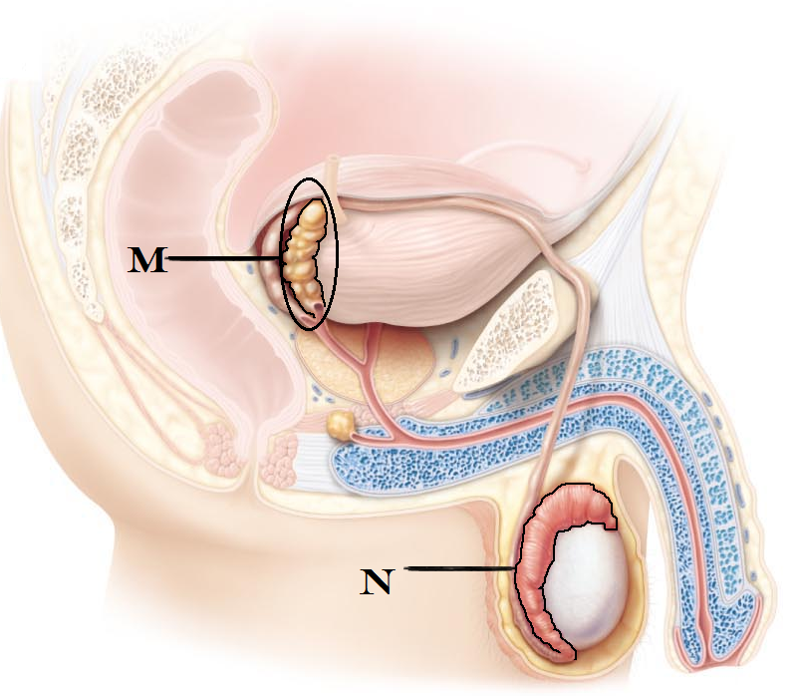Identify M
    1. seminal vesicle
    2. epididymis
    3. bulbouretheral gland
    4. prostate gland
    5. ejaculatory duct
30. Identify Structure N
    1. ovary
    2. vas deferens
    3. seminal vesicle
    4. glans penis
    5. epididymis
31. Which structure is located within the **vestibule**?
    1. Mons pubis
    2. Urethral opening
    3. Seminal glands
    4. Fornix
    5. External os
32. In an **non-pregnant** female, most of the **estrogen** comes from
    1. Anterior pituitary
    2. Uterus
    3. Cervix
    4. Fallopian tube
    5. Follicle
33. Identify 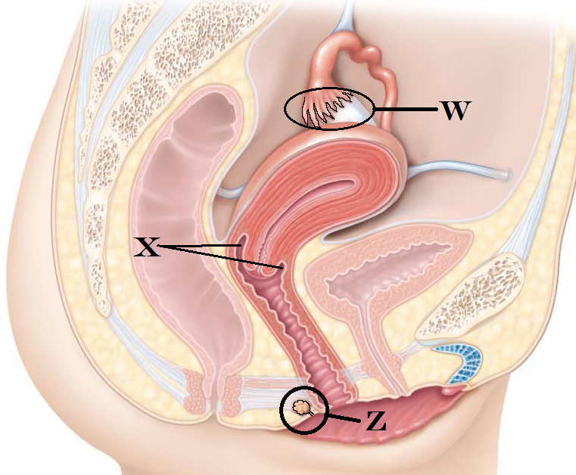**W**
    1. Crista Ampularis
    2. Cervix
    3. Round Ligament
    4. Fimbriae
    5. Cilia
34. Identify the space indicated by **X**
    1. Vestibular gland
    2. Hymen
    3. Fornix
    4. Internal Os
    5. Vestibule
35. Identify **Z**
    1. Vestibular gland
    2. Ampulla
    3. Clitoris
    4. Mons pubis
    5. External Vaginal Sphincter
36. Which structures are **analogous** (homologous tissues) in **male and female** systems
    * 1. Penis and ovary
      2. Testes and ovaries
      3. Glans clitoris and Glans penis
      4. Labia majora and scrotum
      5. Seminiferous tubule and fallopian tube
37. 1, 4
38. 2, 4, 5
39. 2, 4
40. 2, 3, 4
41. 1, 3, 5
42. The onset of the first menstrual cycle is
    1. Menopause
    2. Menorrhagia
    3. Menstruation
    4. Menarche
    5. Magical
43. Assuming an average 28 day cycle, on approximately which day of a woman’s cycle will the **follicle become mature**?
    1. Day One
    2. Day Eight
    3. Day Fourteen
    4. Day Twenty one
    5. Day Twenty eight
44. Which of the following structures allows the penile urethra to remain open while the penis is in its erect state?
    1. corpora spongiosum
    2. corpora cavernosum
    3. crura
    4. tunica albugenia
    5. tunica vaginalis
45. The abundance of which hormone will cause the release of the egg?
    1. Luteinizing Hormone
    2. Progesterone
    3. Relaxin
    4. Estrogen
    5. Inhibin
46. The function of the corpus luteum is
    1. To surround and protect the developing oocyte
    2. To continue the secretion of ICSH and testosterone
    3. To continue the secretion of LH and FSH
    4. To continue the secretion of Estrogen and progesterone
    5. The corpus luteum has no hormonal secretions
47. Assume a female has a 28 day menstrual cycle and ovulates at the midpoint. Given what you know about the life span of the sperm, which day might intercourse lead to fertilization?

a. Day 5

1. Day 12
2. Day 18
3. Day 24
4. It would not be possible for fertilization to occur for any of those dates
5. The hormone responsible for causing the **endometrium** to become more vascular and more glandular is
   1. LH
   2. ICSH
   3. Prolactin
   4. FSH
   5. Progesterone
6. Which **skeletal muscle** is responsible for the **elevating the scrotum**?
   1. Detrussor muscle
   2. urogenital muscle
   3. Dartos muscle
   4. Cremaster muscle
   5. Cowpers muscle
7. Which hormonal events lead to the shedding of the uttering lining?
   1. Increase of LH
   2. Increase of Estrogen
   3. Decrease of testosterone
   4. Increase of progesterone
   5. Decrease of estrogen and progesterone
8. Days 6-12 of the **uterine cycle** are referred to as
   1. proliferative phase
   2. follicular phase
   3. luteal phase
   4. secretory phase
   5. endometrial phase
9. Which structure is formed in the **first week** following fertilization
   1. Margola
   2. Gametophyte
   3. Plastocyte
   4. Morula
   5. Amyloplast
10. One of the functions of HCG Human chorionic Gonadotropin is
    1. To maintain the corpus luteum, allowing estrogen and progesterone production
    2. To encourage development of a new follicle
    3. To promote glandular development of the breast
    4. To promote uterine contractions
    5. To transition the corpus luteum into the corpus albicans
11. Brandeen and Cletus are in their early 20s and sexually active (with each other.) Cletus has begun to complain of a pus-like discharge from his penis. He also complains that it is painful to urinate. Brandeen has no vaginal discharge or discomfort, although she suspects she has a urinary tract infection. Which of the following statements are true:
    * 1. Cletus has syphilis and Brandeen is healthy
      2. They both show symptoms for Chlamydia
      3. Treating Cletus with an anti-viral medication will help his condition
      4. They both show symptoms for Gonorrhea
      5. They should both be treated with antibiotics and checked for other STDs
12. 3 and 4
13. 3 and 5
14. 2 and 3
15. 1 and 3
16. 4 and 5
17. Which of the following is a true statement?
    1. The stratum corneum is the part of the endometrial lining that is shed on a monthly basis
    2. The Arcuate arteries supply the stratum germinativum
    3. The stratum functionalis is fed by the spiral arteries
    4. The stratum germinativum is fed by the straight arteries
    5. The stratum basalis is the part of the endometrial lining that is shed on a monthly basis
18. Which hormone helps to promote **ligamentous laxity** (allows the ligaments to be somewhat stretchy) in a pregnant female?
    1. Estrogen
    2. Progesterone
    3. Inhibin
    4. Relaxin
    5. Chillin
19. At what week does **parturition** take place?
    1. Week Four
    2. Week Eight
    3. Week Twenty
    4. Week Forty
    5. Week Eighty
20. Peter and Richard are in the locker room comparing penile lesions (don’t ask). Peter notes that his lesions appear to look like blisters while Richard’s lesions are red, firm, and painless. With this information, indicate which statements are correct.
    * + 1. Both Peter and Richard should be treated with an antiviral
        2. Both Peter’s and Richard’s lesions will disappear without treatment
        3. Peter has Gonorrhea while Richard has HPV
        4. Richard has syphilis and Peter has herpes
        5. Neither of them is any danger to their partner(s).
    1. 2 and 3
    2. 1 and 3
    3. 4 and 5
    4. 1 and 2
    5. 2 and 4
21. Which is true with regards to the breasts?
    1. Prolactin stimulates milk secretion
    2. Oxytocin stimulates milk release
    3. Estrogen causes the ducts to grow
    4. Progesterone stimulates the glands
    5. All are correct
22. With endometriosis
    1. it is considered a STD and can be passed to male or female partners
    2. The risk of infertility increases
    3. ovarian tissue grows on the cervix
    4. cervical tissue grows on the fallopian tubes
    5. Pap smears are used to reveal progression of the disorder
23. In the male, the genital tubercle gives rise to the ____, while in the female, it gives rise to the ____
    1. penis; vagina
    2. testis; ovary
    3. penis; clitoris
    4. scrotum; labia majora
    5. urethra; vestibule
24. Which is **false** regarding the **placenta**?
    1. Maternal contribution comes from the endometrium
    2. Embryonic contribution comes from the trophoblasts
    3. It is fully functional by three months
    4. It is considered a temporary organ
    5. Allows the mother’s blood to be distributed to the emybryonic tissues.
25. Which of the embryonic membranes will form part of the digestive system?
    1. allantois
    2. amnion
    3. yolk sac
    4. chorionic villi
    5. hypoblastic
26. Chadwick’s sign
    1. Is pain during sexual activity
    2. Is a purple hue to the vagina during pregnancy
    3. Is an inverted nipple
    4. Is a prolapsed uterus
    5. Is weak uterine contractions towards the end of pregnancy
27. Missy is over nine months pregnant and has begun to have strong contractions. She’s begun to have an urge to push, and her partner times the contractions at 3 minutes apart.
    1. Missy is in the involution stage of labor
    2. Missy is in the effacement stage of labor
    3. Missy is in the dilation stage of labor
    4. Missy is experiencing Braxton-Hicks contractions
    5. Missy is in the expulsion stage of labor
28. Which components can be found in semen?
    * 1. pituitary secretions
      2. prostate secretions
      3. hypothalamic secretions
      4. sperm
      5. seminal vesicle secretions
      6. bulbouretheral secretions
29. 1, 3, 5
30. 1, 3, 4, 6
31. 2, 4, 6
32. 2, 4, 5, 6
33. 2, 3, 4, 5
34. Janine experiences discomfort and pain in the days leading up to her period. Her condition improves the once her period begins. Based on this limited information, she most likely has
    1. Chlamydia
    2. Pelvic Inflammatory disease
    3. Pre-Menstrual syndrome
    4. Dysmenorrhea
    5. Mittelschmerz
35. Allantois
    1. Increases maternal metabolism
    2. Is one of the embryonic membranes that will become the structural base for the umbilical cord
    3. Is responsible for embryonic hematapoesis
    4. Produces large amounts of testosterone
    5. Produces embryonic Cerebrospinal Fluid
36. Which event is NOT evaluated by the APGAR score?
    1. reflexes
    2. breathing
    3. hearing
    4. coloration
    5. muscle tone
37. Which of the following is an advantage of breast milk?
    1. Passive immunity provided by the mother
    2. Natural laxatives to cleanse the bowel of meconium
    3. Amino acids in human breast milk are easier to metabolize than from cow’s milk
    4. Fats and iron are better absorbed
    5. All of the above

**Just can’t get enough?**

The following page has a few more questions from earlier in the semester. These are **purely extra credit** and will go towards your lecture grade; they are not linked to your exam six grade. Each correctly answered question is worth 1 point.

**Grades**: I will try to have your exams and assignments graded in the next few days and your scores posted on ReggieNet. You will be able to find your exam six score as well as your class grade there.

51. **Target cells** for the releasing hormones (CRH, GnRH, etc) are in the

1. hypothalamus
2. anterior pituitary gland
3. posterior pituitary gland
4. thyroid gland
5. thymus

52. A steroid hormone acts on a target cell by

1. promoting phagocytosis
2. causing a second messenger to be formed
3. causing the cell to divide
4. directly causing protein synthesis
5. diminishing mitotic control

53. Indicate which **two options** represent arterial blood pressure

1. diastolic over systolic
2. systolic over diastolic
3. the pressure of ventricular contraction over ventricular relaxation
4. the pressure of ventricular relaxation over ventricular contraction
5. has nothing to do with ventricular contraction or relaxation
   1. 1 and 3
   2. 1 and 4
   3. 2 and 3
   4. 3 and 4
   5. 5 only

54. Which type of circulatory shock occurs when the blood volume is normal and is not related to heart damage?

* 1. Hypervolemic shock
  2. Hypovolemic shock
  3. Intrinsic shock
  4. Vascular shock
  5. Cardiogenic shock

55. Skeletal muscle contraction aids in lymph movement by

a. Causing a decrease in interstitial pressure

b. resulting in the release of epinephrine which results in lympho-constriction

c. increasing heart rate

d. decreasing abdominal pressure and increasing thoracic pressure

e. causing pressure to be placed on the lymph vessels, squeezing lymph from one valved section to the next.

56. Mononucleosis is a great example of a cell mediated response because

a. our infected B cells attack our T cells

b. our plasma cells release antibodies against our infected B cells

c. our T cells attack our infected B cells

d. our NK cells attack our Helper T cells

e. mononucleosis does not demonstrate any kind on cell mediated responses.

57. __________ is the amount of air able to be forced out following the deepest inspiration possible.

1. residual volume
2. inspiratory capacity
3. tidal volume
4. inspiratory reserve volume
5. vital capacity

58. In a scenario where the **pH** of the blood has begun to **drop**, the bicarbonate buffer system will do what to correct it?

* 1. Dissociate carbonic acid to release H+ and bicarbonate ions
  2. Produce more bicarbonate ions
  3. Remove carbon dioxide by transporting it into neighboring cells
  4. Bind excess H+ with bicarbonate ions to form carbonic acid
  5. The buffer system will not be able to handle shifts in pH and the renal system will be the first route for correction.

59. Pepsinogen is an inactive protein-digesting enzyme. What two things will change it from pepsinogen into pepsin?

* + - 1. Pepsinogen
      2. Pepsin
      3. Hydrochloric acid
      4. Gastric lipase
      5. Intrinsic factor

1. 1 and 5
2. 2 and 3
3. 4 and 5
4. 1 and 2
5. 3 and 4

60. Which organ’s secretion result in a **decrease** **of acidity** (causes pH to rise) in the small intestine?

1. Stomach
2. Liver
3. Gall bladder
4. Pancreas
5. Large intestine

Turn in opscan

Turn in Exam

**C:\Users\bawargo\AppData\Local\Microsoft\Windows\Temporary Internet Files\Content.IE5\CWU1F10N\MC900383566[1].wmfC:\Users\bawargo\AppData\Local\Microsoft\Windows\Temporary Internet Files\Content.IE5\CWU1F10N\MC900383566[1].wmfCongratulations on getting through the semester! You’ve done a lot of hard work and should be pleased with your achievements. I enjoyed having you as a class.**

**Have a great break, and best of luck in your future endeavors!**

**~Dr. Wargo**