BSC 182
Exam Five

Reminder: There is one correct answer for each question. All questions are weighted equally. Please read and consider each question carefully.

- Simple columnar epithelium can be found in which layer of the alimentary canal?
- Submucosa
- Serosa
- Mucosa
- Adventitia
- Muscularis

- Which layer of the alimentary canal is also known as the visceral peritoneum?
- Muscularis
- Serosa
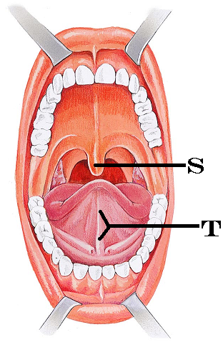
- Submucosa
- Mucosa
- Myomal

- The cells that secrete pepsinogen are the:
- parietal cells
- mucous neck cells
- chief cells
- enteroendocrine cells
- acinal cells

- Identify “S”
  - Palatine tonsils
  - Epiglottis
  - Uvula
  - Hard palate
  - Labial frenulum

- Identify “T”
  - Lingual frenulum
  - Submandibular gland
  - Labial frenulum
  - Hypoglossal septum
  - Stensen’s duct

- The lamina propria is a member of which layer in the digestive tract?
  - Submucosa
  - Serosa
  - Adventitia
  - Mucosa
  - Laminaria

- Within the structure of the tooth, where are the nerves and blood vessels located?
  - Dentin
  - Crown
  - Neck
  - Pulp cavity
  - Enamel

- The calcified plaque that builds up on teeth and contributes to gingivitis is called tartar or
  - Caries
  - Calculus
  - Calmodulin
  - Calcitonin
  - Calcaneous

- This hormone triggers the release of enzyme rich pancreatic juice.
- Gastrin
- Digestin
- Bile
- Renin
- Cholecystokinin

- What are the three phases of Gastric Secretion?
- Ileal, cecal, and haustric
- Primary, secondary, tertiary
- Gastric phase, parietal phase, chief phase
- Cephalic phase, gastric phase, and intestinal phase
- Duodenal phase, jejunal phase, ileal phase

- Pepsinogen is an inactive protein-digesting enzyme. What two things will change it from pepsinogen into pepsin?
    - Pepsinogen
    - Pepsin
    - Hydrochloric acid
    - Gastric lipase
    - Intrinsic factor
  - 1, 4
  - 2, 3
  - 4, 5
  - 1, 3
  - 3, 5

- Where is the pancreas located
- Immediately inferior to the esophageal hiatus
- Nestled within the C shaped curve of the duodenum
- Inferior to the hepatic flexure
- Nestled under the liver
- A retroperitoneal structure near the appendix

- Pancreatic amylase
- Will have a similar function as salivary amylase
- Will help to change the pH of the small intestine
- Will assist in the emulsification of fats
- Will split starch into simple sugars
- Will split triglycerides into fatty acids
- 2, 4, 5
- 2, 5
- 3
- 1, 2, 4
- 1, 4

- Which organ’s secretion result in a decrease of acidity in the small intestine?
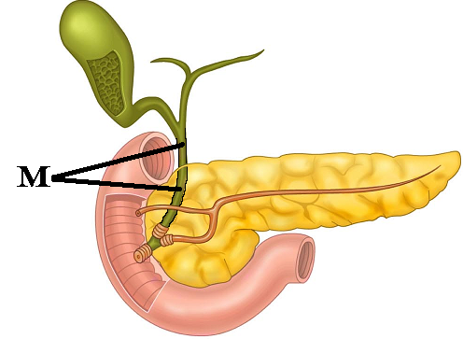
- Gall bladder
- Pancreas
- Large intestine
- Stomach
- Liver

- Identify “M”
  - Common hepatic duct
  - Hepatopancreatic duct
  - Bile duct
  - Right hepatic duct
  - Cystic duct

- The function of the gallbladder is to
- Concentrate bile
- Store bile
- Release bile
- Manufacture bile
- None of the above are correct
  - 1, 3
  - 1, 2, 3
  - 5
  - 2, 4
  - 2, 3

- During the gastroileal reflex, presence of food in the stomach
- Causes the chyme in the large intestine to be released
- Causes the chyme in the ileum to be moved into the cecum
- Causes the stomach to release chyme slowly into the small intestine
- Causes the chyme in the duodenum to be moved into the ileum
- Causes the chyme in the esophagus to be moved into the stomach

- The large intestine is
- Responsible for digesting fats
- Responsible for removal of all bacteria
- Responsible for absorbing fats
- Responsible for water reabsorption
- Responsible for waste storage
  - 1, 4, 5
  - 4, 5
  - 3
  - 2, 4
  - 2, 4, 5

- Identify the incorrect pairing of food type and the region in which it gets digested
  - Fats; small intestine
  - Nucleic acids; small intestine
  - Proteins; stomach
  - Carbohydrates; stomach

- Which materials are absorbed into the lacteals?
  - Polypeptides
  - Lipids
  - Simple carbohydrates
  - Cellulose
  - Nucleic acids

- What type of mucus-producing cells are located within the crypts of the large intestine?
  - MALT
  - Peyers Patches
  - Goblet cells
  - Acinar cells
  - Chief cells

- Which of the following reflexes are we able to voluntarily control?
- gastroileal reflex
- gastrocolic reflex
- gastroenteral reflex
- enterogastric reflex
- defecation reflex

- Which structures are likely to become hemorrhoids?
- Superficial anal arteries
- Superficial rectal veins
- Superficial sigmoid veins
- Deep rectal arteries
- Deep anal arteries

- In addition to breaking down cellulose, what other function do the bacterial flora provide?
  - Produce vitamins C and E
  - Produce vitamin A and K
  - Produce K and B vitamins
  - Produce vitamins E and K
  - Produce vitamins D and B vitamins

- Adult celiac disease is cause by ___, and results in ____.
  - Gluten; malabsorption due to microvilli damage
  - Globulin; autoimmune damage to large intestine
  - Gluten; decreased mucus formation
  - Fatty acid sensitivity; perforated intestines
  - Carbohydrate allergy; inflammation of the serosal linings

- Which of the following empties urine directly into the renal pelvis?
- Ureter
- renal papilla
- major calyx
- nephron loop
- minor calyx

- The ____ is part of the circulatory system, while the ___ is part of the nephron
  - Minor calyx; loop of Henle
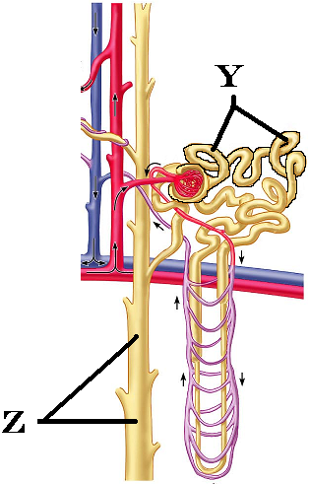
  - Glomerulus; proximal convoluted tubule
  - Distal convoluted tubule; collecting duct
  - Peritubular capillaries; vas recta
  - Ascending loop; Descending loop

- Identify Y
  - nephron loop
  - Proximal convoluted tubule
  - Distal convoluted tubule
  - Glomerulus
  - Collecting duct

- Identify Z
  - Descending nephron loop
  - Proximal convoluted tubule
  - Distal convoluted tubule
  - Glomerulus
  - Collecting duct

- The collecting ducts are _____ to water when the hormone _____ is present.
  - permeable, ADH
  - permeable, aldosterone
  - impermeable, ADH
  - impermeable, aldosterone
  - permeable, sodium

- Which are the two components of the juxtaglomerular apparatus?

- Juxtaglomerular cells and fovea centralis
- Jejunum and densa deferens
- Basiar hairs and stereocilia
- Juxtaglomerular cells and macula densa
- Cortical and Medullary nephrons

- Which type of nephrons can extend deep into the medulla?
- Distal convoluted nephron
- Macromedullary nephron
- Cortical nephron
- Juxtamedullary nephron
- Pyramidal nephron

- Which of the following is true?
- As filtration pressure increases, glomerular filtration rate (GFR) increases
- As filtration pressure decreases, GFR increases
- As filtration pressure increases, GFR decreases
- GFR is controlled solely by the vasa recta
- Filtration pressure has nothing to do with the GFR
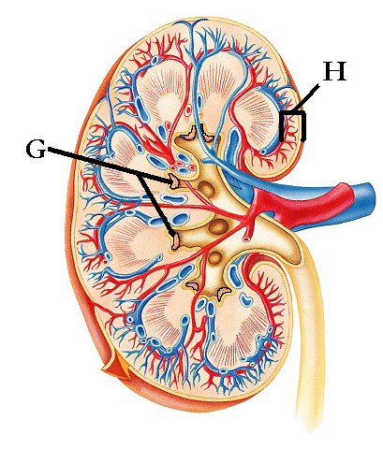
- Identify “G”
  - Major calyx
  - Renal pelvis
  - Renal papilla
  - Renal column
  - Renal cortex

- Identify “H”
  - Renal cortex
  - Major calyx
  - Renal papilla
  - Renal column
  - Renal pelvis

- Atrial natriuretic peptide
- Stimulates potassium absorption
- Causes the release of Renin
- Produced due to changes sensed at the heart
- Produced due to changes sensed at the kidney
- Will not affect blood pressure

- ______ is the term for swallowing and ______ is the term for urination
- Mastication; deglutition
- Deglutition; mastication
- Micturition; mastication
- Deglutition; micturition
- Micturition; deglutition

- Antidiuretic Hormone
- Is released from thyroid
- Is produced in response to increased water volume in body
- Increases the permeability of the proximal convoluted tubule
- Increases the permeability of the collecting duct
- Is responsible, when present, for the production of dilute urine

- The trigone of the bladder is composed of
- Glomerular capsule, left ureter, right ureter
- Renal pyramid and transitional epithelium
- The opening of the left ureter, right ureter, and the urethra
- The entrances of the left renal pelvis, right renal pelvis, and the calyx
- Papillae and seminal vesicle

- What type of specialized epithelium does the bladder have that allows it to stretch?
- Keratinized squamous
- Transitional
- Simple Squamous
- Pseudostratified columnar
- Cuboidal

- Which of the following is true with regards to the urethra
- Male and female urethra pass through the prostate gland
- Male and female urethra are the same length
- Male and female urethra have both urinary and reproductive functions
- Male and female urethra end as external urethral orifice
- The urethra enters the bladder superiorly

- Which option reflects the correct sequence for urine formation
  - Tubular secretion; tubular filtration; capillary filtration
  - Tubular filtration; tubular secretion; tubular reabsorption
  - Glomerular filtration; tubular reabsorption; tubular secretion
  - Glomerular filtration; tubular secretion; tubular reabsorption
  - Glomerular transmission; tubular relocation; tubular secretion

- The afferent arteriole ________, and has a ______ diameter than the efferent arteriole
  - Approaches the loop of Henle; larger
  - Approaches the hilus; smaller
  - Approaches the vasa recta; smaller
  - Approaches the glomerulus; larger
  - Approaches the glomerulus; smaller
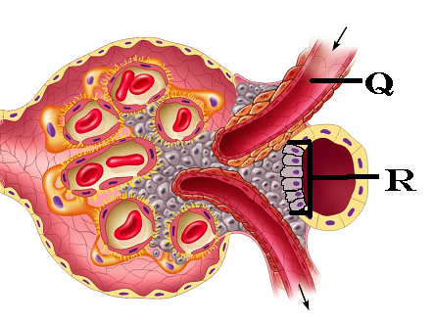
- Identify “Q”
  - Efferent arteriole
  - Glomerular capillary
  - Proximal renal tubule
  - Distal renal tubule
  - Afferent arteriole

- Identify “R”
  - Macula densa cells
  - Juxtaglomerular cells
  - Podocytes
  - Granular cells
  - Juxtamedullary cells

- Consumption of caffeine will cause an increase in urinary output because
  - Na+ reabsorption is stimulated
  - It pushes glucose into the filtrate which draws water
  - ADH is stimulated
  - ADH is inhibited
  - Na+ reabsorption is inhibited

- Consumption of alcohol will cause an increase in urinary output because
  - ADH is stimulated
  - ADH is inhibited
  - Na+ reabsorption is inhibited
  - Na+ reabsorption is stimulated
  - It pushes glucose into the filtrate which draws water

- Which substance causes the adrenal cortex to release Aldosterone directly?
  - Renin
  - Angiotensinogen
  - Angiotensin I
  - Angiotensin II
  - Angiotensin Converting Enzyme

- Ureters link
  - Aorta to the kidney
  - Bladder to the outside of the body
  - Digestive system to urinary system
  - Kidney to bladder
  - Urinary bladder to gall bladder

- The male urethra is named for the regions it passes through. Which region listed below is not correct?
  - Prostatic urethra
  - Glans urethra
  - Membranous urethra
  - Penile urethra
  - Spongy urethra

Please turn in both your Opscan forms and your exam packet.
If you have comments on a question, set your exam in a separate pile.

Enjoy the rest of your day.
.

