TA instructions
Station One: Microscope
Choose one of the options indicated in the multiple choice answers to place a marker.
Station Two
For the oxyphil/chief cells question, choose a section of the parathyroid gland to display
For the chromaffin/sympathetic question, display the adrenal medulla
Station Three
Choose one of the following to set up on a microscope:
- Posterior pituitary
- Anterior pituitary
- Thyroid: focus on the follicles since they are easily identifiable
- Pancreas
- Thymus
- Ovary
- Testis
Station Four
Multiple choice questions and image to identify
Station Five
Multiple choice question and short answer
Station Six
One pages asks about the portal (b correct) and the other asks about the tract (e correct).
For question 11, choose either the sickle cell anemia slide or the leukemia slide
Station Seven
Prepare one well that has A+ OR one that has B-. Choose one to display.
Station Eight
Prepare one well that has AB- (c. no antibodies) OR one that has O+ (e. both antibodies). Choose one to display
Microscope: display either a neutrophil (granulocyte)or a lymphocyte (agranulocyte)
Station Nine
Image and multiple choice question
Station Ten
Microscope: display a monocyte or an eosinophil
Station Eleven
Multiple choice, one of two images to choose from
Station twelve
Questions
Station thirteen
Microscope: Pointer at platelets or at erythrocytes. (try not to have leukocytes in the f.o.v if you can) I’ve included an image for both of these in case it’s too difficult to set up with the scopes.

Your answer keys will change depending on which options you choose for your questions. If you have any questions, please email and ask Dr. Wargo

Name_____________________________________________

- Circle one: A B C D E
- Circle one: A B C D E
- _______________________________________________________________________
- _______________________________________________________________________
- Circle one: A B C D E
- Circle one: A B C D E
- _______________________________________________________________________
- Circle one: A B C D E
- _______________________________________________________________________
- Circle one: A B C D E
- _______________________________________________________________________
- _______________________________________________________________________
- Circle one: A B C D E
- Circle one: A B C D E
- _______________________________________________________________________
- Circle one: A B C D E
- Circle one: A B C D E
- Circle one: A B C D E
- Circle one: A B C D E
- Circle one: A B C D E
- Circle one: A B C D E
- Circle one: A B C D E
- Circle one: A B C D E
- Circle one: A B C D E
- Circle one: A B C D E
Station One
- Which part of the microscope is indicated by the marker?
- Ocular lens
- Scanning lens
- Objective lens
- Oil immersion lens
- Nosepiece

- What is the total magnification on the field of view if the scanning lens is used?
  - 10X
  - 40X
  - 100X
  - 400X
  - 4000X

Station One
- Which part of the microscope is indicated by the marker?
  - Scanning lens
  - Low power lens
  - High power lens
  - Oil immersion lens
  - Ocular lens

- What is the total magnification on the field of view if the low power lens is used?
- 10X
- 40X
- 100X
- 400X
- 4000X

Station One
- Which part of the microscope is indicated by the marker?
  - Abbe condenser
  - Coarse adjust knob
  - Fine adjust knob
  - Nosepiece
  - Light source

- What is the total magnification on the field of view if the high power lens is used?
- 10X
- 40X
- 100X
- 400X
- 4000X

Station One
- Which part of the microscope is indicated by the marker?
  - Stage controls
  - Condensor
  - Light source
  - Nosepiece
  - Stage clips

- What is the total magnification on the field of view if the scanning lens is used?
- 10X
- 40X
- 100X
- 400X
- 4000X

Station Two

- The tissue in the field of view has chief cells and oxyphil cells. Identify the gland

- Name one (only one) hormone produced by the adrenal cortex

Station Two

- The tissue in the field of view has chromaffin cells and is stimulated by the sympathetic system. Identify the gland

- Name one (only one) of the hormones produced by the pancreas

Station Three

- Identify the gland in the field of view
  - Posterior pituitary gland
  - Parathyroid gland
  - Thyroid gland
  - Pancreas
  - Ovary

Station Three

5. Identify the gland in the field of view
  - Anterior Pituitary gland
  - Thyroid gland
  - Thymus
  - Testes
  - Adrenal Cortex

Station Four

- Which cells in the testis are responsible for the production of testosterone?
  - Spermatagonia
  - Spermatid
  - Interstitial cells
  - Oxyphil cells
  - Parietal cells

- Identify the gland indicated in the image
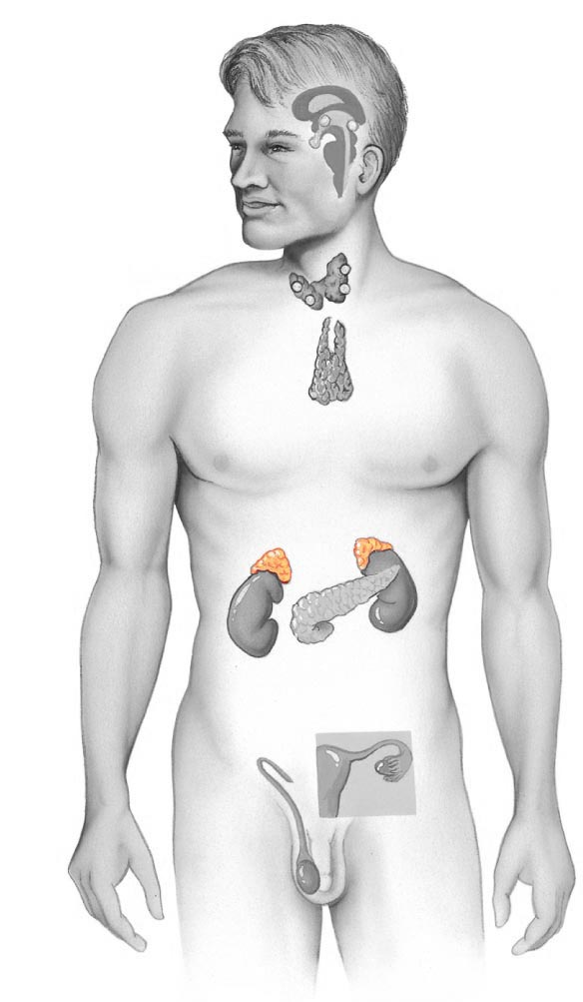

Station Four

6. Which cells in the testis are responsible for the production of testosterone?
  - Spermatagonia
  - Spermatid
  - Interstitial cells
  - Oxyphil cells
  - Parietal cells

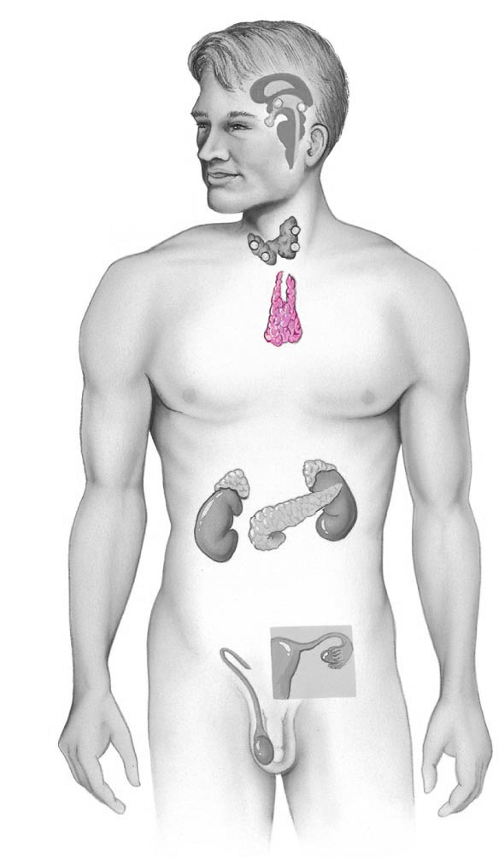
7. Identify the gland indicated in the image

Station Four

6. Which cells in the ovaries are responsible for the production of estrogen?
- Oocyte
- Oogonia
- Antrum
- Zona pelucida
- Follicle

7. Identify the gland indicated in the image
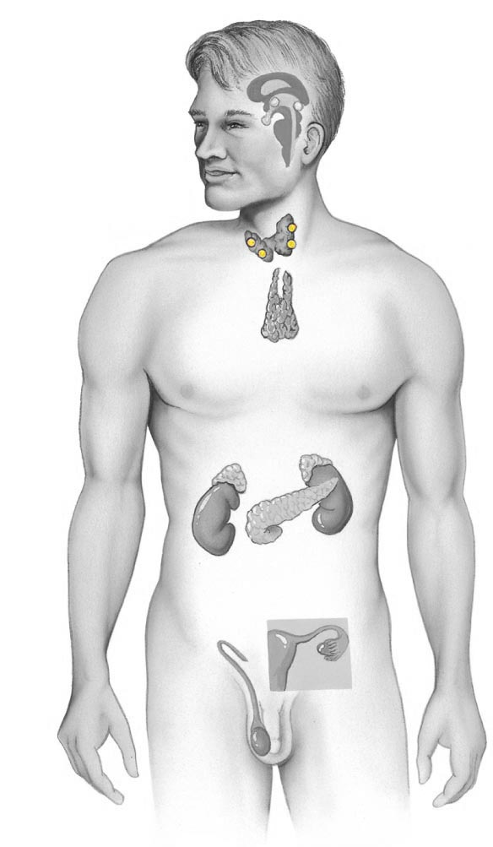
Station Four

6. Which cells in the ovaries are responsible for the production of estrogen?
- Oocyte
- Oogonia
- Antrum
- Zona pelucida
- Follicle

7. Identify the structure in the image
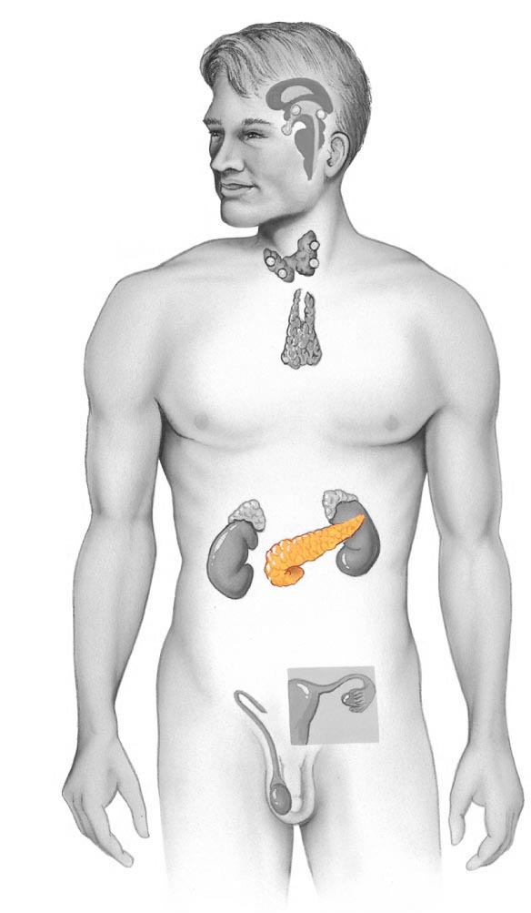

Station Five
- Which cell type in the anterior pituitary gland releases Growth Hormone?
  - Somatotroph
  - Thyrotroph
  - Gonadotroph
  - Lactotroph
  - Corticotroph

- Identify one (only one) hormone from the posterior pituitary. (No abbreviations. Use the full name.)

Station Five
8. Which cell type in the anterior pituitary gland releases Follicle Stimulating Hormone?
  - Somatotroph
  - Thyrotroph
  - Gonadotroph
  - Lactotroph
  - Corticotroph

- Identify one (only one) hormone from the posterior pituitary. (No abbreviations. Use the full name.)

Station Five
8. Which cell type in the anterior pituitary gland releases ACTH?
- Somatotroph
- Thyrotroph
- Gonadotroph
- Lactotroph
- Corticotroph

- Identify one (only one) hormone from the posterior pituitary. (No abbreviations. Use the full name.)

Station Six

- Which of the following statements is CORRECT regarding the hypothalamic-hypophysial portal.
  - It connect the anterior pituitary with the posterior pituitary
  - It connects the hypothalamus to the anterior pituitary
  - It connects the hypothalamus to the thalamus
  - It connects the posterior pituitary gland to the pineal gland
  - It connects the hypothalamus to the posterior pituitary gland

- Which blood disorder is indicated in the field of view?

Station Six

10. Which of the following statements is CORRECT regarding the hypothalamic-hypophysial tract.
  - It connect the anterior pituitary with the posterior pituitary
  - It connects the hypothalamus to the anterior pituitary
  - It connects the hypothalamus to the thalamus
  - It connects the posterior pituitary gland to the pineal gland
  - It connects the hypothalamus to the posterior pituitary gland

11. Which blood disorder is indicated in the field of view?

Station Seven

- Is this blood Rh+ or Rh- ?

- Which antigen would be on the surface of the blood cell in this sample?
  - A
  - B
  - A and B
  - No antigens present
  - Antigens are not found on the surface, they are found in the plasma

Station Eight

- Which antibodies would be found in the plasma of a person with this blood type?
  - Antibody A only
  - Antibody B only
  - Neither Antibody A nor Antibody B
  - Antibody O
  - Both Antibody A and Antibody B

- Is the leukocyte at the pointer a granulocyte or an agranulocyte?

Station Nine

- Identify the colored cell.
  - Hemocytoblast
  - Megakaryoblast
  - Megakaryocyte
  - Normoblast
  - Myeloid cell
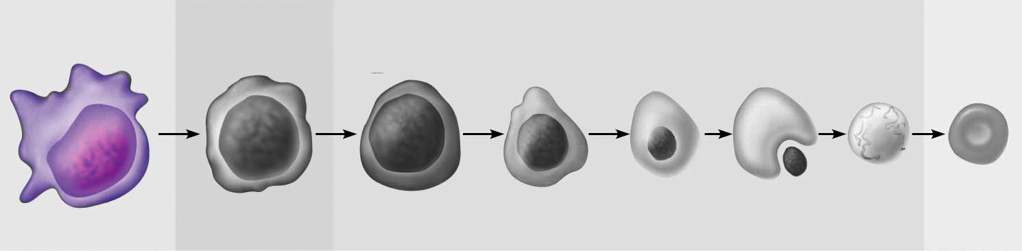

- This cell line will eventually produce which type of specialized cell?
  - Platelet
  - Eosinophil
  - Basophil
  - Erythrocyte
  - Neutrophil

Station Nine

- Identify the colored cell.
  - Hemocytoblast
  - Megakaryoblast
  - Megakaryocyte
  - Normoblast
  - Myeloid cell

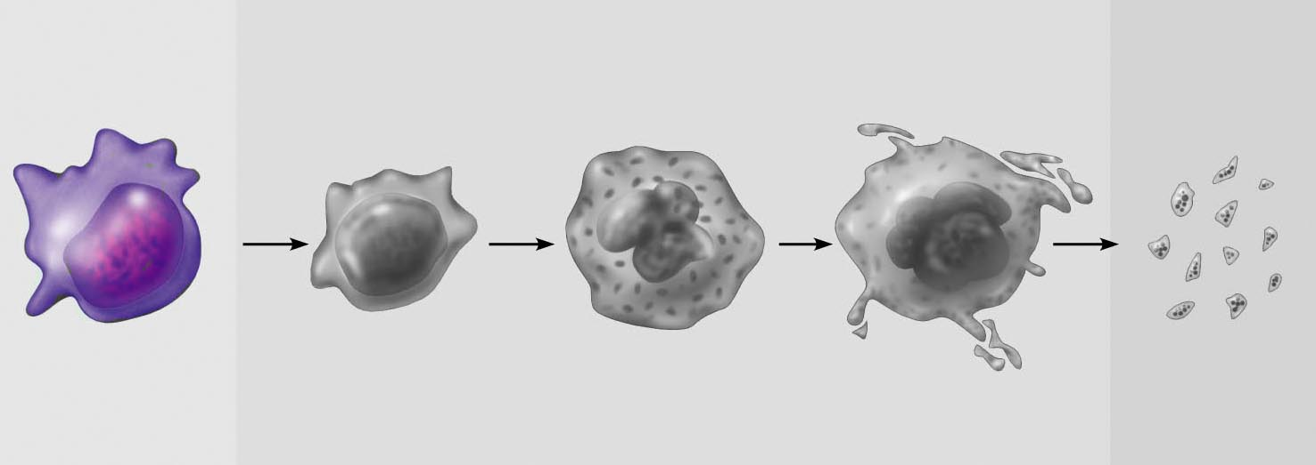

- This cell line will eventually produce which type of specialized cell?
  - Platelet
  - Eosinophil
  - Basophil
  - Erythrocyte
  - Neutrophil

Station Ten

- Identify the leukocyte in the field of view
  - Basophil
  - Monocyte
  - Lymphocyte
  - Eosinophil
  - Neutrophil

- Which cell will be produced?
  - Basophil
  - Monocyte
  - Lymphocyte
  - Eosinophil
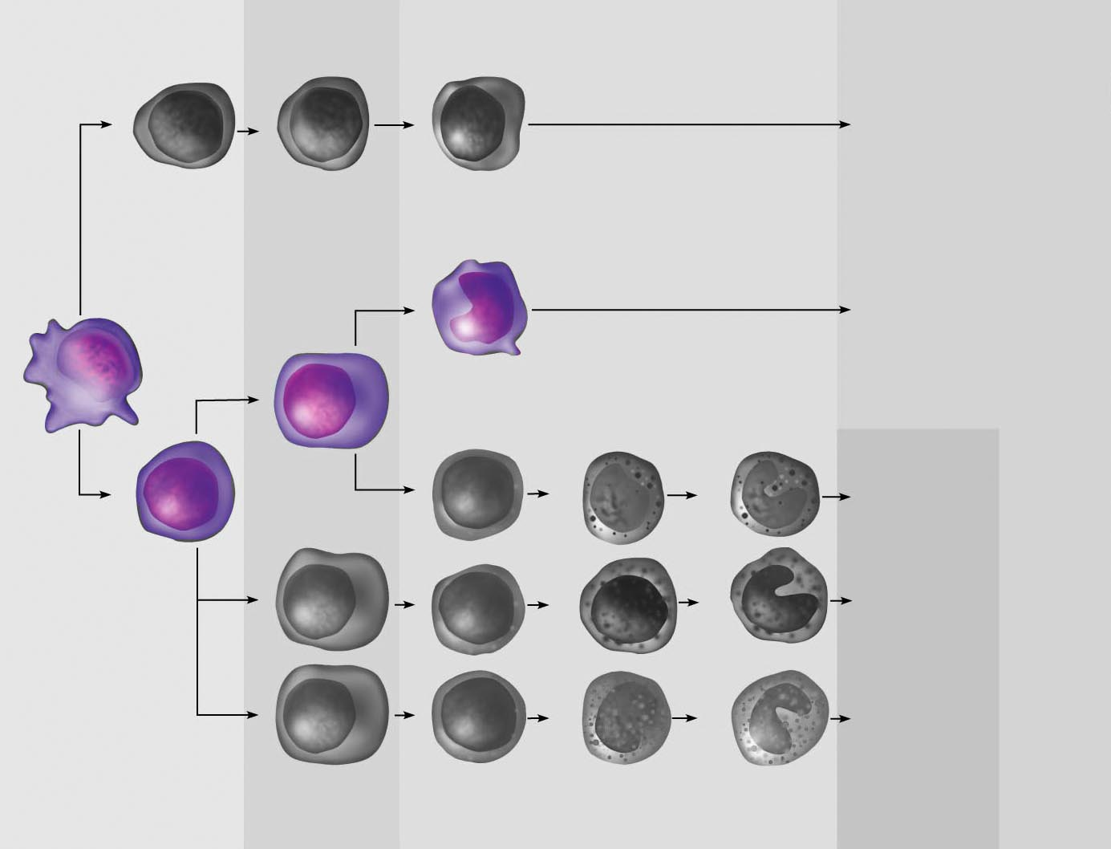
  - Neutrophil

Station Ten

- Identify the leukocyte in the field of view
  - Basophil
  - Monocyte
  - Lymphocyte
  - Eosinophil
  - Neutrophil

- Which cell will be produced?
  - Basophil
  - Monocyte
  - Lymphocyte
  - Eosinophil
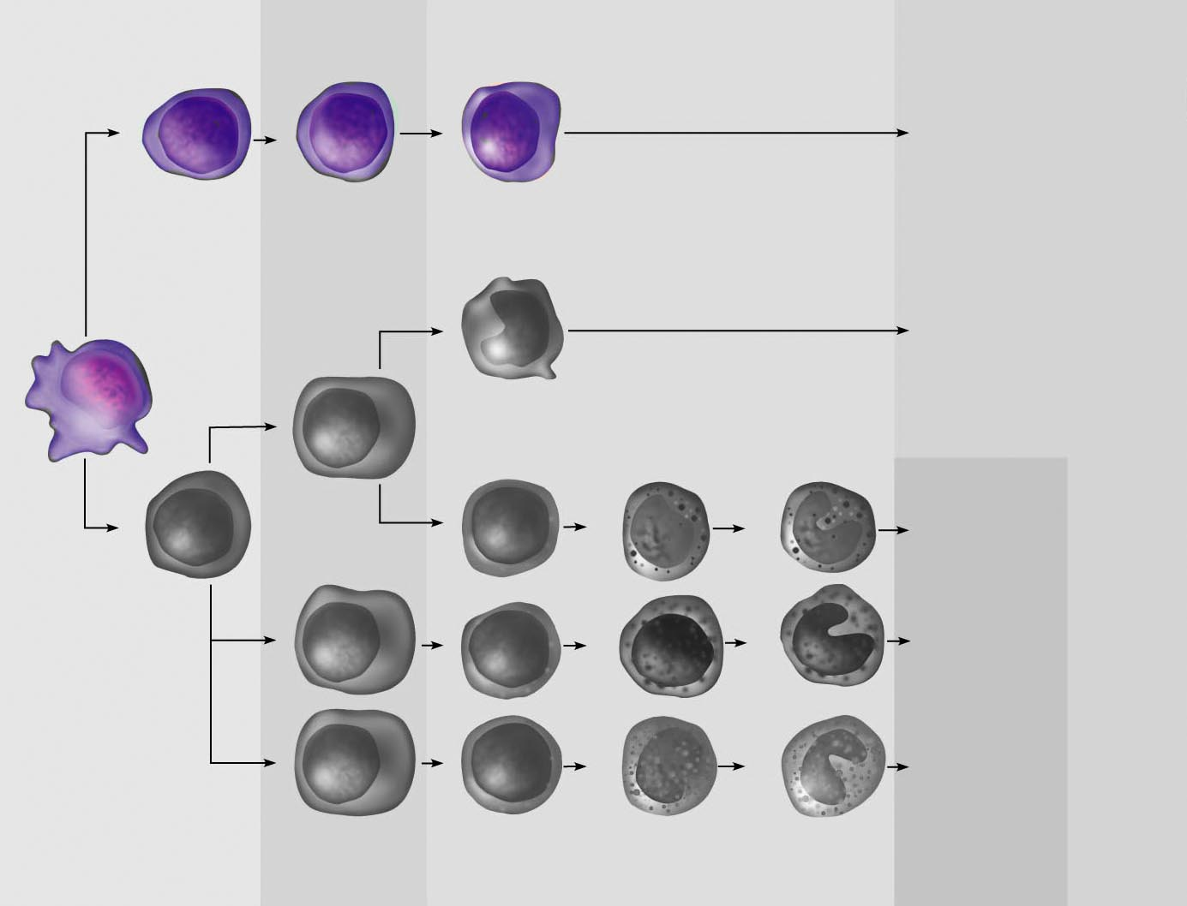
  - Neutrophil

Station Eleven

- If an individual has acute myelogenous leukemia, which leukocytes would be overproduced?
  - All of the agranulocytes
  - All of the granulocytes
  - Neutrophils only
  - Lymphocytes only
  - Neutrophils, eosinophils, basophils and monocytes

- Identify the colored cell indicated below
  - Megakaryocyte
  - Erythroblast
  - Erythrocyte
  - Normocyte
  - Reticulocyte

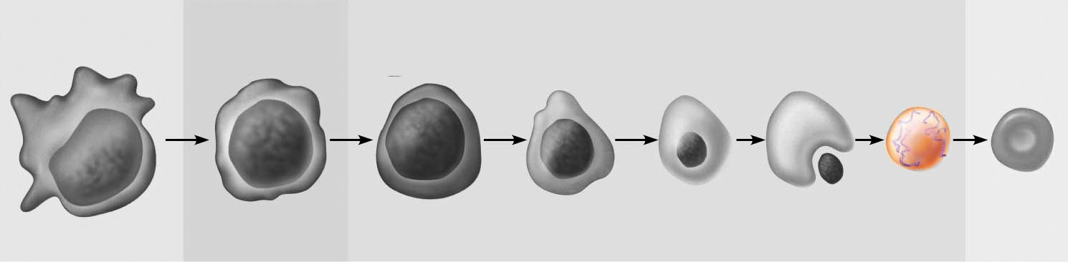

Station Eleven

- If an individual has acute myelogenous leukemia, which leukocytes would be overproduced?
  - All of the agranulocytes
  - All of the granulocytes
  - Neutrophils only
  - Lymphocytes only
  - Neutrophils, eosinophils, basophils and monocytes

- Identify the colored cell indicated below
  - Megakaryocyte
  - Erythroblast
  - Erythrocyte
  - Normocyte
  - Reticulocyte
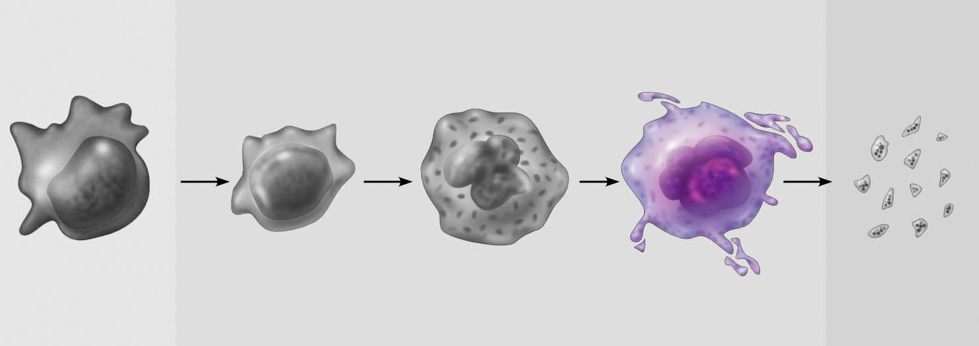

Station Twelve

- At what stage in erythrocyte production does the nucleus leave the cell?
  - Normoblast
  - Reticulocyte
  - Erythroblast
  - Proerythroblast
  - The nucleus is present in all stages of maturity

- A mother has Rh+, the fetus is Rh -. Is there a danger?
  - After a second exposure the Rh antibodies can cross the placenta and damage the fetus
  - After an initial exposure, the antibodies can cross the placenta and damage the fetus
  - After a second exposure, the Rh antigens will detach from the maternal cells and attack.
  - If mom is + and fetus is -, there is no threat following any exposure
  - Any exposure will cause the Rh antibodies to attach to the Rh antibodies in the fetus.

Station Thirteen

- Identify the cell type in the field of view
  - Erythrocyte
  - Megakaryocyte
  - Platelet
  - Basophil
  - Monocyte

- This person’s blood contains antibody A in the plasma. What would their blood type be?
  - Type A
  - Type B
  - Type AB
  - Type O
  - Can’t tell based on the antibody presence

Station Thirteen

- Identify the cell type in the field of view
  - Erythrocyte
  - Megakaryocyte
  - Platelet
  - Basophil
  - Monocyte

- This person’s blood contains antibody B in the plasma. What would their blood type be?
  - Type A
  - Type B
  - Type AB
  - Type O
  - Can’t tell based on the antibody presence

