Instructor Set up

Station One: Fetal pig specimen
Question 1: Male
Question 1: Female

Question 2: Question: d. kidney
Question 2: Question: c. Nephron

Station Two:
Question 3: Image: Proximal Convoluted Tubule
Question 3: Image: Distal Convoluted Tubule
Question 3: Image: Collecting Duct

Station Three:
Question 4: Image: lobule of testis
Question 4: Image: rete testis
Question 4: Image: seminiferous tubules

Question 5: Question: ejaculatory duct
Question 5: Question: prostatic urethra
Question 5: Question: penile (or spongy) urethra

Station Four
Question Six: Microscope: Ovarian Cortex
Question Six: Microscope: Interstitial cells

Question Seven: Image: directional terms
Snout: b. anterior
Umbilicus: b. ventral
Tail: e. caudal
Spine: a. dorsal

Station Five
Fetal pig specimen
Question Eight: marker at stomach
Question Eight: marker at duodenum
Question Eight: marker at colon

Question Nine: Image: c. clitoris
Question Nine: Image: b. External Urethral Orifice
Question Nine: Image: c. Vestibular (Bartholin’s) Glands

Station Six
Question Ten: Microscope: Urinary bladder slide, transitional epithelium in view

Question Eleven: Image: Testis
Question Eleven: Image: Ovary

Station Seven
Question Twelve: Kidney: marker at a. renal pyramid
Question Twelve: Kidney: marker at c. column

Question Thirteen: Image: a. primordial follicle
Question Thirteen: Image: e. corpus albicans
Question Thirteen: Image: c. corpus luteum

Station Eight
Question Fourteen: Microscope: Kidney cortex @ 400X for (a) renal corpuscle

Question Fifteen: Image: d. Areola
Question Fifteen: Image: b. Lactiferous duct
Question Fifteen: Image: b. Lactiferous sinus

Station Nine

Question Sixteen: Human Torso Model: Marker at renal artery
Question Sixteen: Human Torso Model: Marker at renal vein

Question Seventeen: Question: b. cilia
Question Seventeen: Question: d. fertilization

Station Ten

Question Eighteen: Fetal Pig: Marker at thymus
Question Eighteen: Fetal Pig: Marker at thyroid gland

Question Nineteen: Image: e. bulbourethral gland
Question Nineteen: Image: c. prostate gland
Question Nineteen: Image: a. seminal vesicle

Station Eleven

Question Twenty: Kidney: Marker at cortex
Question Twenty: Kidney: Marker at medulla

Question Twenty one: Image: b. trigone
Question Twenty one: Image: c. Detrusor muscle

Station Twelve
Question Twenty two: Image: d. cavernosum
Question Twenty two: Image: c. spongiosum

Question twenty three: Fetal pig: Marker at Aorta (near heart)
Question twenty three: Fetal pig: Marker at Right Ventricle

Station Thirteen
Question twenty four: Fetal pig: Marker at Liver
Question twenty four: Fetal pig: Marker at Lung

Question twenty five: Image: d. fimbriae
Question twenty five: Image: b. infindibulum

Name_________________________________________
- Circle one: male female
- Circle one: a b c d e
- _____________________________________________________________________
- Circle one: a b c d e
- _____________________________________________________________________
- _____________________________________________________________________
- Circle one: a b c d e
- _____________________________________________________________________
- Circle one: a b c d e
- _____________________________________________________________________
- _____________________________________________________________________
- Circle one: a b c d e
- Circle one: a b c d e
- Circle one: a b c d e
- Circle one: a b c d e
- _____________________________________________________________________
- Circle one: a b c d e
- _____________________________________________________________________
- Circle one: a b c d e
- Circle one: a b c d e
- Circle one: a b c d e
- Circle one: a b c d e
- _____________________________________________________________________
- _____________________________________________________________________
- Circle one: a b c d e

Station One

- Is this fetal pig male or female?

- Which is the primary organ of the renal system?
  - Adrenal gland
  - Glomerulus
  - Juxtaglomerular apparatus
  - Kidney
  - Urinary bladder

Station One

- Is this fetal pig male or female?

- Which structure acts as the functional unit within the kidney
  - Fovea centralis
  - Macula profunda
  - Nephron
  - Renal pelvis
  - Collecting duct

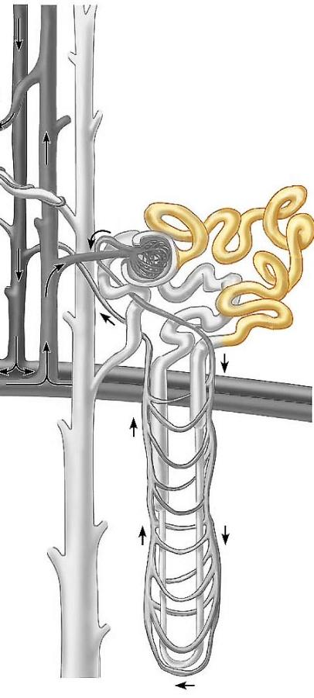
Station Two

- Identify the structure. Write the full name (no abbreviations) on your answer sheet.

Station Two

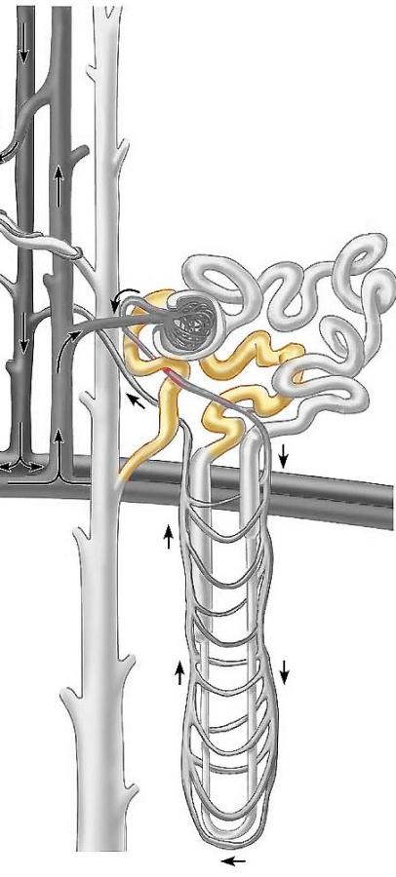
3. Identify the structure. Write the full name (no abbreviations) on your answer sheet.

Station Two

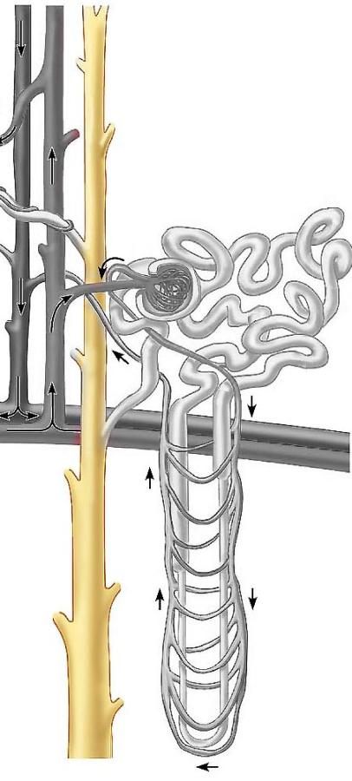
3. Identify the structure. Write the full name (no abbreviations) on your answer sheet.

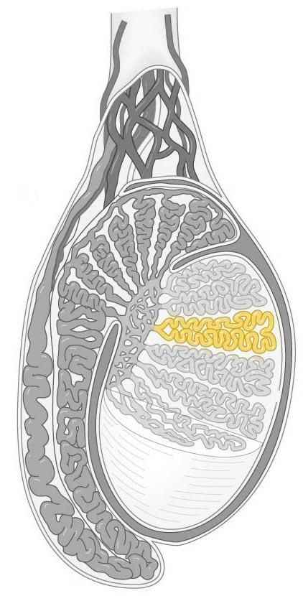
Station Three

- Identify the image
  - Ovarian cortex
  - Rete testis
  - Lobule of testis
  - Adrenal medulla
  - Interstitial tubules

- Identify the structure missing in the sequence below

Vas deferens _____________ prostatic urethra membranous urethra penile urethra

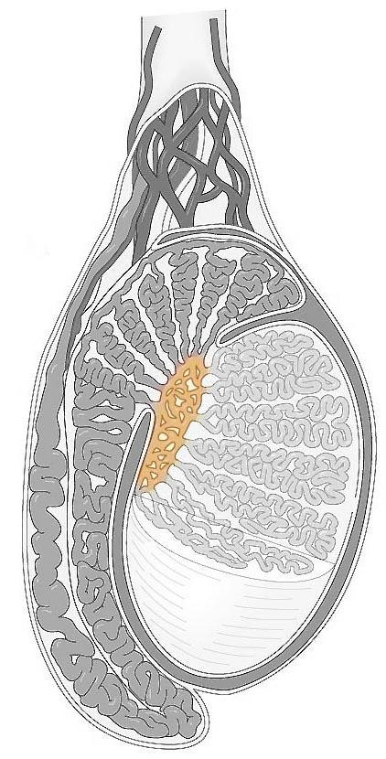
Station Three

4. Identify the image
  - Ovarian cortex
  - Rete testis
  - Lobule of testis
  - Adrenal medulla
  - Interstitial tubules

- Identify the structure missing in the sequence below
Vas deferens ejaculatory duct ______________ membranous urethra penile urethra

Station Three

4. Identify the image
  - Ovarian cortex
  - Rete testis
  - Seminiferous tubules
  - Adrenal medulla
  - Interstitial cells

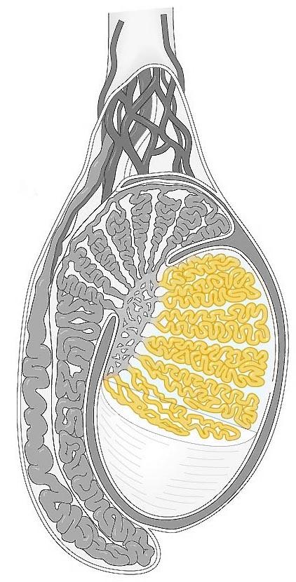

5. Identify the structure missing in the sequence below
Vas deferens ejaculatory duct prostatic urethra membranous urethra _______

Station Four

6. Identify the image in the field of view

7. Use the star on the fetal pig as your starting point. If you locate a structure in the direction of the arrow, for example, the snout, which directional term is most appropriate?

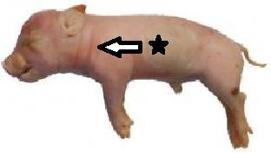
- Dorsal
- Ventral
- Anterior
- Posterior
- Caudal

Station Four

6. Identify the image in the field of view

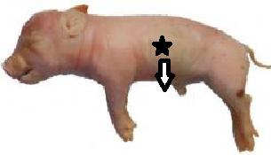
7. Use the star on the fetal pig as your starting point. If you locate a structure in the direction of the arrow, for example, the umbilicus, which directional term is most appropriate?

- Dorsal
- Ventral
- Anterior
- Posterior
- Caudal

Station Four

6. Identify the image in the field of view

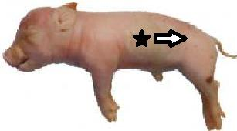
7. Use the star on the fetal pig as your starting point. If you locate a structure in the direction of the arrow, for example, the tail, which directional term is most appropriate?

- Dorsal
- Ventral
- Anterior
- Cranial
- Caudal

Station Four

6. Identify the image in the field of view

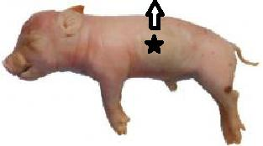
7. Use the star on the fetal pig as your starting point. If you locate a structure in the direction of the arrow, for example, the spine, which directional term is most appropriate?

- Dorsal
- Ventral
- Anterior
- Cranial
- Caudal

Station Five

- Identify the structure on the fetal pig

- Identify the structure in the image
  - Labia minora
  - Mons pubis
  - Clitoris
  - Fornix
  - External os

Station Five

- Identify the structure on the fetal pig

- Identify the structure in the image

- Labia majora
- External urethral orifice
- Vaginal canal
- Peroneal apex
- Prepuce

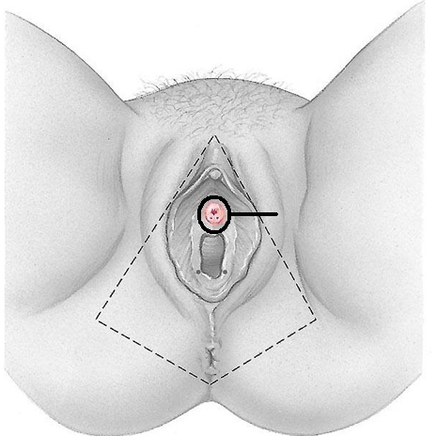
Station Five

- Identify the structure on the fetal pig

- Identify the structure(s) in the image

- Fornix
- Anal glands
- Vestibular glands
- Mons pubis
- Internal os

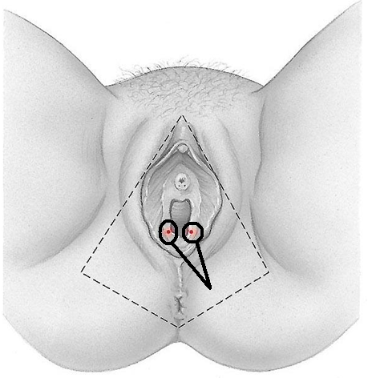
Station Six

- Identify the image in the field of view

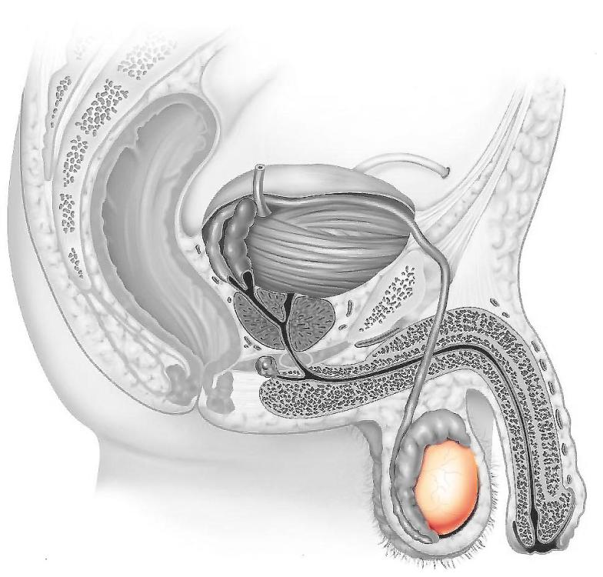
- Identify the structure

Station Six

10 Identify the image in the field of view

11. Identify the structure

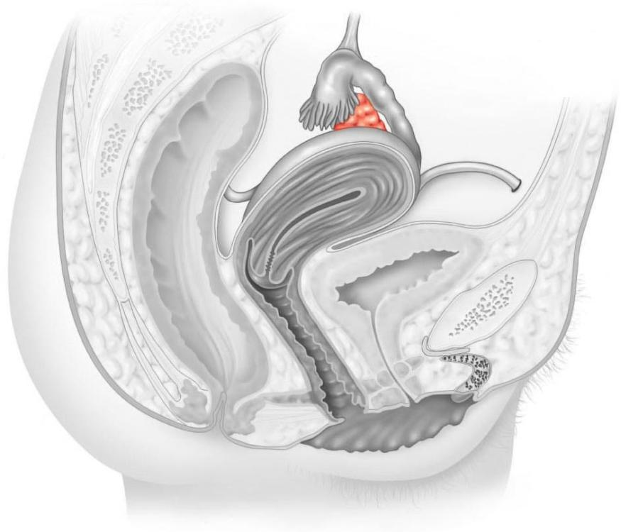

Station Seven

- Identify the structure at the marker

- Renal pyramid
- Renal pelvis
- Renal Column
- Renal papilla
- Renal capsule

- Identify the structure on the image

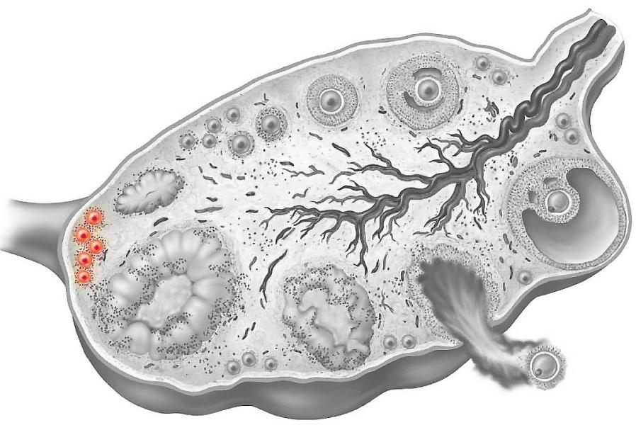
- Primordial follicle
- Primary follicle
- Secondary follicle
- Secondary oocyte
- Corpus albicans

Station Seven

- Identify the structure at the marker

- Renal pyramid
- Renal pelvis
- Renal Column
- Renal papilla
- Renal capsule

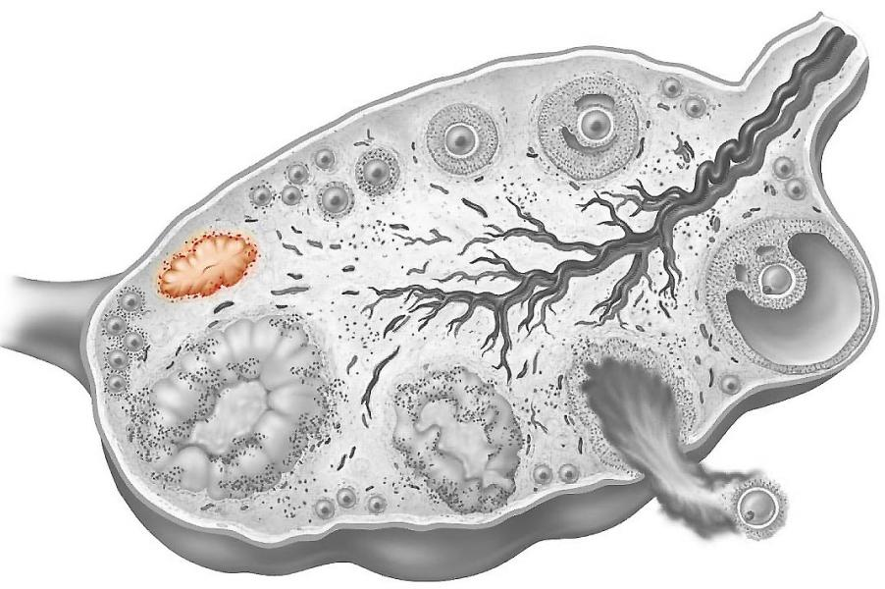
- Identify the structure on the image

- Primordial follicle
- Secondary oocyte
- Corpus luteum
- Graafian follicle
- Corpus albicans

Station Seven

- Identify the structure at the marker

- Renal pyramid
- Renal pelvis
- Renal Column
- Renal papilla
- Renal capsule

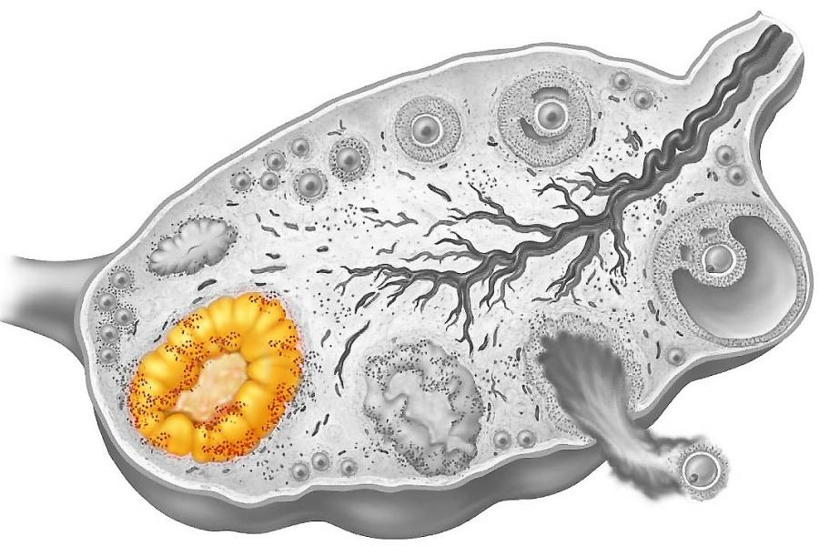
- Identify the structure on the image

- Primordial follicle
- Secondary oocyte
- Corpus luteum
- Graafian follicle
- Corpus albicans

Station Eight

- Identify the structure in the field of view
  - Renal corpuscle
  - Secondary follicle
  - Graafian follicle
  - Seminiferous tubule
  - Transitional epithelium

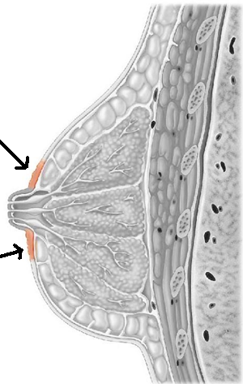
- Identify the structure

  - Nipple
  - Lactiferous duct
  - Alveolar lobe
  - Areola
  - Adipose layer

Station Eight

14. Identify the structure in the field of view
- Renal corpuscle
- Secondary follicle
- Graafian follicle
- Seminiferous tubule
- Transitional epithelium

15. Identify the structure

- Nipple
- Lactiferous duct
- Alveolar lobe
- Areola
- Adipose layer
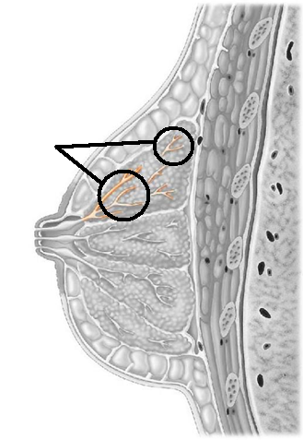

Station Eight

14. Identify the structure in the field of view
- Renal corpuscle
- Secondary follicle
- Graafian follicle
- Seminiferous tubule
- Transitional epithelium

15. Identify the structure

- Gubernaculum
- Lactiferous sinus
- Alveolar lobe
- Areola
- Adipose layer

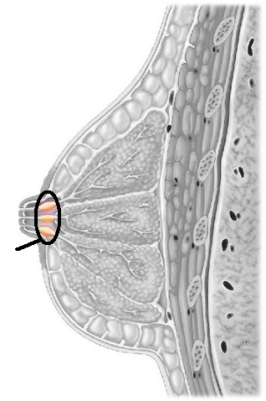

Station Nine

- Identify the image at the marker

- Which structure in the lining of the fallopian tube assists with the transportation of the oocyte?
  - Flagella
  - Cilia
  - Microvilli
  - Mucus
  - Papillae

Station Nine

- Identify the image at the marker

- Which event is necessary for the final meiotic division of the oocyte?
  - Elevated FSH
  - An acrosomal reaction
  - Depressed progesterone levels
  - Fertilization
  - Gastrulation

Station Ten

- Identify the region at the marker

- Identify the structure

  - Seminal vesicle
  - Vestibular gland
  - Prostate gland
  - Epididymis
  - Bulbourethral gland
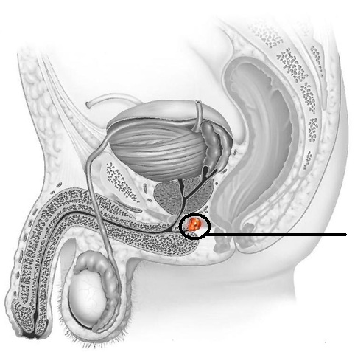

Station Ten

- Identify the region at the marker

- Identify the structure

  - Seminal vesicle
  - Vestibular gland
  - Prostate gland
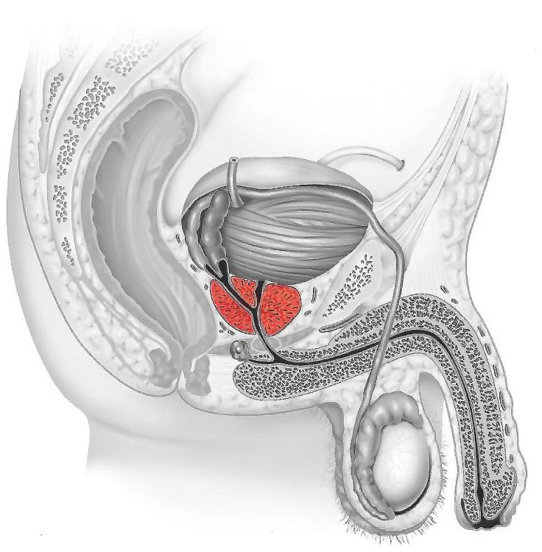
  - Epididymis
  - Bulbourethral gland

Station Ten

- Identify the region at the marker

- Identify the structure

  - Seminal vesicle
  - Vestibular gland
  - Prostate gland
  - Epididymis
  - Bulbourethral gland

Station Ten

- Identify the region at the marker

- Identify the structure

  - Seminal vesicle
  - Vestibular gland
  - Prostate gland
  - Epididymis
  - Bulbourethral gland

Station Eleven

- Identify the region in which the marker is located
  - Capsule
  - Glomerulus
  - Cortex
  - Hilum
  - Medulla

- Identify the structure
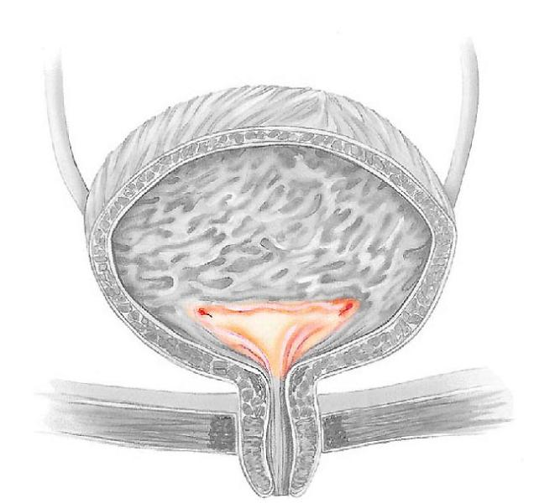
  - Internal urethral sphincter
  - Trigone
  - Internal os
  - External os
  - External urethral sphincter

Station Eleven

- Identify the region in which the marker is located
  - Capsule
  - Glomerulus
  - Cortex
  - Hilum
  - Medulla

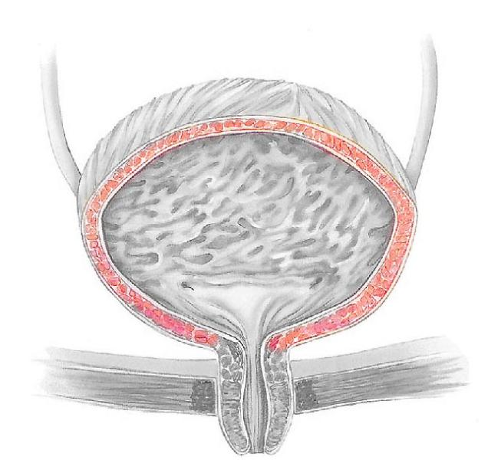

- Identify the structure
  - Internal urethral sphincter
  - Trigone
  - Detrusor muscle
  - External urethral sphincter
  - External adventitia

Station Twelve

- Identify the structure
  - Prepuce
  - Glans penis
  - Corpus spongiosum
  - Corpus cavernosum
  - Gubernaculums
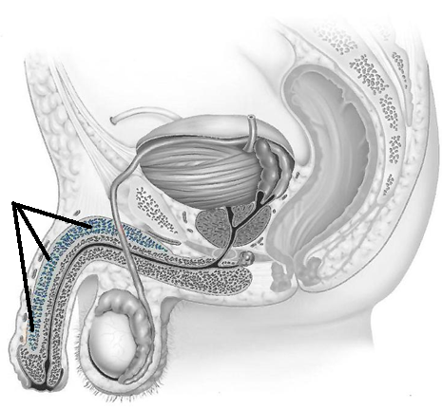

- Identify the structure at the marker

Station Twelve

- Identify the structure
  - Prepuce
  - Glans penis
  - Corpus spongiosum
  - Corpus cavernosum
  - Gubernaculum

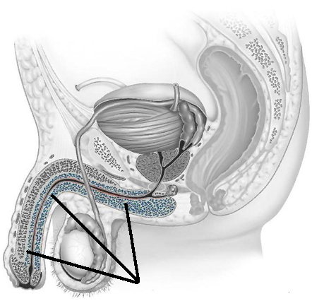

- Identify the structure at the marker

Station Thirteen

- Identify the organ at the marker

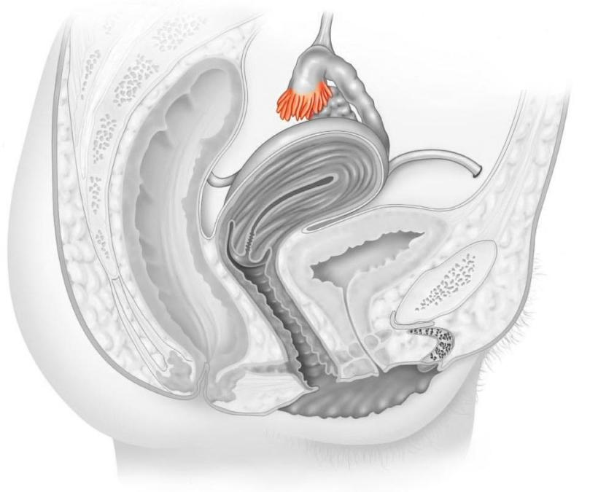
- Identify the structure
  - Round ligament
  - Infindibulum
  - Gubernaculum
  - Fimbriae
  - Ampulla

Station Thirteen

- Identify the organ at the marker

- Identify the structure
  - Round ligament
  - Infindibulum
  - Gubernaculum
  - Fimbriae
  - Ampulla
