Fetal Pig Dissection
Handout

Step One: Prep
Make sure you have the following materials:
    - Dissecting tray
    - Paper towels spread out on the dissecting tray
    - Tools: scissors, probes, scalpel
    - Gloves
    - Fetal pig

Step Two: Observe the external anatomy of the fetal pig
- Determine the anatomical orientation of your specimen.
  - dorsal: toward the back (dorsum)
  - ventral: toward the belly
  - anterior (cranial): toward the head end of the body
  - posterior (caudal): toward the tail end of the body
  - lateral: to the side of the body
  - median: toward the center of the body
  - right and left: the pig's right and left
  - proximal: closer to the trunk
  - distal: farther from the trunk
  - superficial: lying closer to the body surface
  - deep: lying under or below
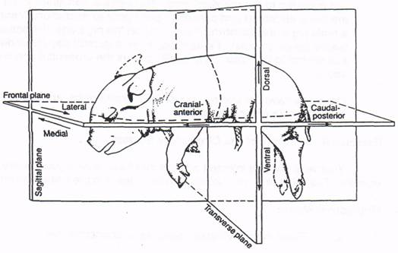

- Identify the regions of the body
  - head (cranial) region
  - neck (cervical) region
  - trunk region (thoracic region)
  - tail (caudal) region (abdomoninal region)

- Determining the sex of your pig:
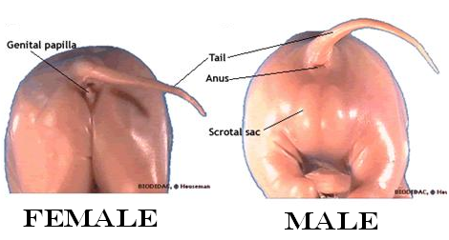
  - Male:
  - Look for the scrotum located ventral to the anus.
  - The male urogenital opening is faintly visible just posterior to the umbilicus.
    - Note that males mammary papillae (nipples) as well as females.

  - Female:
  - Look for a single urogenital opening just ventral to the anus.
  - A prominent genital papilla projects from the urogenital opening.

Step Three: System Review

- Digestive System

The cavity behind the teeth and gums is the oral cavity.

Note the papillae on the tongue.

These provide friction for food handling and contain taste buds
With scissors, carefully cut through the tissue and bone starting at the corners of the mouth and back toward the ears (keeping the roof of the mouth intact) until the lower jaw can be dropped and the oral (buccal) cavity exposed

.
- Find the following structures:
- hard palate:
  - has ridges; separates the oral cavity from the nasal cavities
- soft palate:
  - nasopharynx lies above it
- buccal cavity:
  - from the opening of the mouth to the base of the tongue
- pharynx:
  - common passageway for digestive and respiratory system
- esophagus:
  - tube connecting oral cavity to stomach
- glottis:
  - the opening to the larynx
- epiglottis:
  - the flap that covers the glottis during swallowing
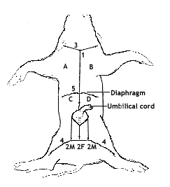
Begin your incision at the small tuft of hair on the upper portion of the throat (1) and continue the incision posteriorly to approximately 1.5 cm anterior to the umbilicus. You should cut through the muscle layer, but not too deeply or you will damage internal organs.
Whether your pig is male or female, make the second incision (2M) as a half circle anterior to the umbilicus and then proceed with two incisions posteriorly to the region between the hindlimbs. Do not make the 2F incision. If you have a male, be careful not to cut deeply into the scrotum.
Deepen incisions 1 and 2 until the body cavity is exposed. Make incisions 3 and 4 to produce lateral flaps that can be folded back. Pour off excess fluid and rinse out the body cavity.
Just below the lower margin of the rib cage, make a fifth (5) incision laterally in both directions. This should expose the diaphragm, which separates the thoracic and abdominal cavities. Using your scalpel, free the diaphragm, but do not remove it.
Carefully peel back flaps A, B, C, and D and pin them beneath your pig. It may be necessary to cut through the ventral part of the rib cage (very carefully) with a pair of scissors to separate flaps A and B.

Identify the following:
Thymus gland
Thyroid gland
Trachea
Esophagus
Note the relationship of the diaphragm to the esophagus and stomach
Stomach
Make an insicion along the stomach and look inside
View Rugae
Locate lower esophageal sphincter (cardiac sphincter) and pyloric sphincters
Duodenum
Jejunum and ileum (remainder of small intestine. Jejunum and ileum can be difficult to tell apart.)
Cecum
Look for the junction of small intestine to large intestine to locate the cecum
Colon

Accessory digestive structures:
Liver
Gall bladder
Pancreas

- Circulatory System

Remove as much thymus as you need to in order to view the heart.
Carefully remove the pericardial sac from the heart

Identify the following:
coronary artery and coronary vein lying in the diagonal groove between the ventricles.
Right and left atria and auricles.
Right and left ventricles
Superior vena cava
Inferior vena cava
Pulmonary trunk
Pulmonary arteries
Aorta

Make an incision into the heart, much like you did for the heart dissection earlier this semester. Create a cut along the anterior heart at the ventricle to view
Mitral valve
Tricuspid valve
AV orifice(s)
Chordae tendinae

- Respiratory System
Slit the larynx longitudinally to expose the vocal cords

Identify the following:
Trachea
Bronchi
Right/left lungs
Diaphragm
- Urogenital system
Identify the following
Kidney
Adrenal gland
Ureter
Urinary bladder
Recall this is a fetus. The bladder will hold urine and then send it through the umbilicus and placenta rather than into the amniotic fluid. After birth, the bladder will empty through the urethra.

Remove one of the kidneys. Make an incision longitudinally to open the kidney and view the cortex and medulla.

- Reproductive Systems
  - Female
In the female, the opening of the urogenital sinus/vaginal vestibule lies directly ventral to the anus. It is bounded laterally by the labia, which come together ventrally to form a protruding genital papilla.

The clitoris, a small body of erectile tissue on the ventral portion of the urogenital sinus, may be visible.
The clitoris is homologous (similar in structure and developmental origin) to the male penis
In the female the urethra opens posteriorly to the clitoris

To view the reproductive structures in both male and female fetal pigs, the pelvis needs to be cut to allow you access. Cut the pelvic bone to the left or to the right of center and expose the area.

Identify the following
Uterus
Uterine horns
Ovary
Vagina
Cervix
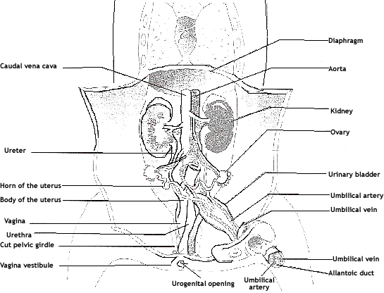
Fallopian tube (oviduct)

  - Male
Remember that as the male fetus ages, the testes descend. They travel from the pelvic cavity into the scrotum.
Make your incision along the scrotum. Do not cut too deep.
Expose a testis and an epididymis

Identify the following:
Testis
Epididymis
Penis
Prostate gland
Seminal vesicle
Vas deferens

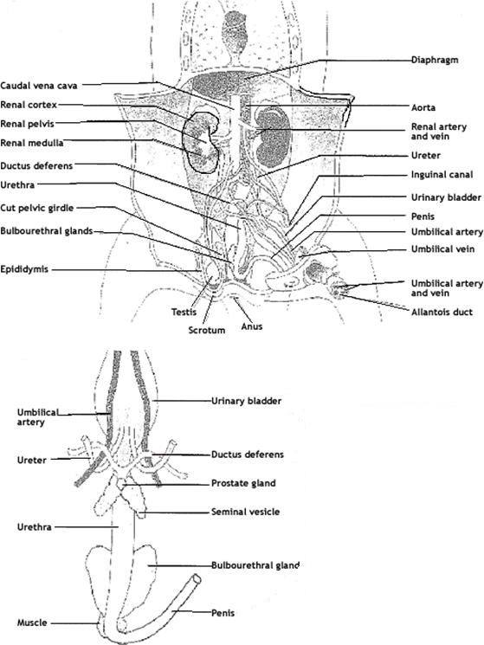

- Step Four: Clean Up
- Discard all materials in the appropriate trash.
- Discard paper towels and gloves
- Clean up your materials: dissecting tray and tools
- Wipe down your bench tops
- Wash your hands

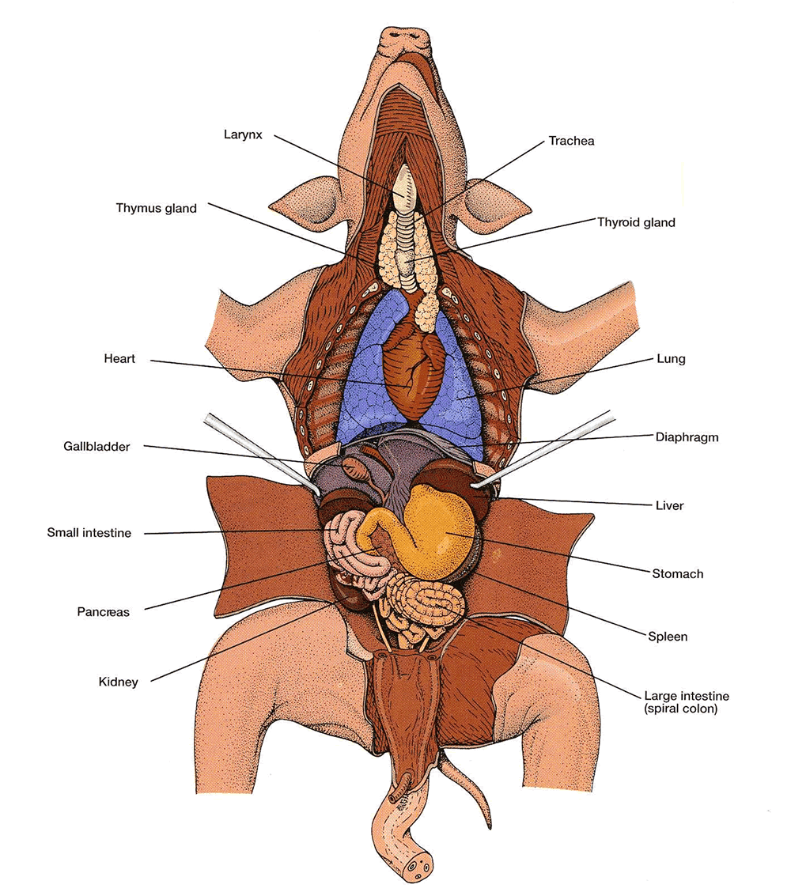

The fetal pig will be incorporated into your last lab quiz. You will be asked to identify structures that have been listed on this handout.

Acknowledgements: Dr. Mark Stanback

