Instructor Set up: Lab Quiz Two, 182

Station One:
Microscope: Cardiac Muscle
- Cardiac Muscle
- (A) cardiac muscle is multinucleate
Station Two
Choose one of the images for question three. There are four version to choose from.
- Each of the four valves are represented by an image. Add the correct valve to your key.

Station Three: heart specimen
Choose one of the locations for station three:
- Heart with marker at left ventricle. Please use a cut specimen so the students can see the thickness of the left ventricle.

Or

- Heart with marker at right auricle.
- Left ventricle or Right auricle, depending on which specimen you have
- Apex = (d), Base = (a)

Station Four: Heart specimen
Choose one of the following for station four:
- Chordae tendinae (try to position the marker not too close to the valve, and not too close to the papillary muscle)

Or

- Papillary muscle
- Chordae tendinae or papillary muscle, depending on the specimen you have
- “Lubb” = (b), “Dubb” = (c)

Station Five:
Image. Choose AV node or SA node to display
- They have been asked not to use abbreviations. Look for Atrioventricular node or Sinoatrial node. Be forgiving on the spelling.

Station Six
Microscope:
- Center an artery in the field of view
Or
- Center a vein in the field of view

- Artery or vein, depending on the field of view
- Blood pressure = (d), pulse = (c)

Station Seven:
Choose one of the three EKG wave form images
- There are three waves to choose from. If students have “P” rather than “Pwave” that’s fine. Also give credit if they tell you the state of deplolarization/repolarization, as long as it is correct for that wave. If they mention “contraction”, then they’ve missed the point and get no credit.

Station Eight: Heart specimen Two markers (choose one AV valve and one semilunar):
- Marker at tricuspid valve
Or
- Marker at mitral valve

And
- Marker at pulmonary semilunar valve
Or
- Marker at aortic semilunar valve
- Tricuspid valve or Mitral valve, depending on the specimen
- Pulmonary semilunar or aortic semilunar. If the students put “aortic” without semilunar, give them credit. Same applies for pulmonary.

Station Nine: Human/heart model. Two markers (choose between aorta/pulmonary trunk for one and pulmonary artery/pulmonary vein for the second)
- Marker at aorta
Or
- Marker at pulmonary trunk
And

- Marker at pulmonary artery
Or
- Marker at pulmonary vein
- Aorta or pulmonary trunk.
- Pulmonary artery or pulmonary vein.

Station Ten
Image and questions (provided). Two versions available
- Radial artery 17. (c)
16. Ulnar artery 17. (c)
Station Eleven
Image and questions (provided). Two versions available
18. (c) external carotid 19. (b) occipital artery
18. (b) internal carotid 19. (b) vertebral

Station Twelve
Questions only, one version
20. (b) towards the nose
21. (c) when listening for blood pressure

Station Thirteen
Image and questions (provided). Two versions
22. Carotid artery (Common carotid also acceptable) 23. (a) gonadal
22. Femoral artery 23. (c) external iliac

Station Fourteen
Image and questions (provided). Two versions
24. systolic = (a) 25. Femoral artery
24. diastolic = (b) 25. Tibialis anterior artery (Anterior tibial artery)

Because this quiz format is more “mix and match” in being able to set it up, I am not providing a formal answer key. Build your key based on the images and anatomy you choose.
Name_____________________________ Date___________________ Sec# _______

- ________________________________________________________
- Circle one: a b c d e
- Circle one: a b c d e
- ________________________________________________________
- Circle one: a b c d e
- ________________________________________________________
- Circle one: a b c d e
- ________________________________________________________
- Circle one: a b c d e
- Circle one: a b c d e
- ________________________________________________________
- ________________________________________________________
- ________________________________________________________
- ________________________________________________________
- ________________________________________________________
- ________________________________________________________
- Circle one: a b c d e
- Circle one: a b c d e
- Circle one: a b c d e
- Circle one: a b c d e
- Circle one: a b c d e
- ________________________________________________________
- Circle one: a b c d e
- Circle one: a b c d e
- ________________________________________________________

Station One:

- Identify the tissue type in the field of view.

- Which of the following statements below is false?
  - Cardiac muscle is multinucleate
  - Cardiac muscles use intercalated discs to increase communication speed.
  - Cardiac muscles are branched
  - Cardiac muscles are involuntary
  - Cardiac muscles are striated

Station Two

Question 3:

This valve is auscultated at the right sternal margin and at the 2nd intercostals space
- Aortic valve
- Pulmonary valve
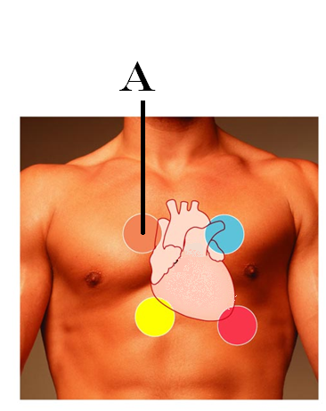
- Tricuspid valve
- Mitral valve

Station Two

Question 3:

This valve is auscultated at the second intercostals space and the left sternal margin
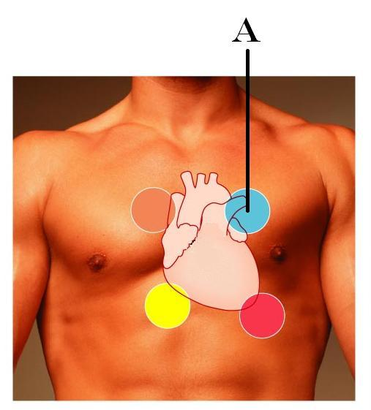
- Tricuspid
- Mitral
- Pulmonary semilunar
- Aortic semilunar

Station Two

Question 3:

This valve is auscultated at the 5th intercostals space, mid clavicular line
- Pulmonary semilunar
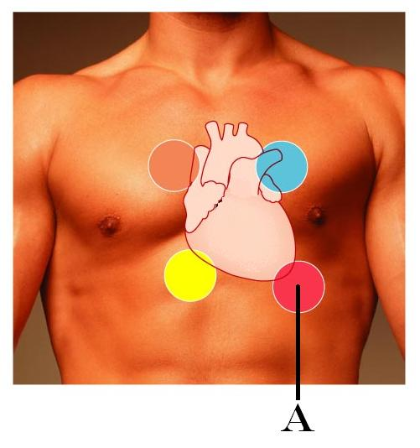
- Aortic semilunar
- Bicuspid
- Tricuspid

Station Two

Question 3:

This valve is auscultated at the 5th intercostals space, right sternal margin
- Mitral valve
- Tricuspid valve
- Aortic semilunar valve
- Pulmonary semilunar valve
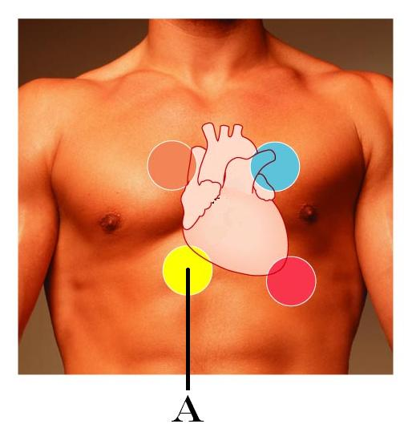

Station Three

4. Identify the structure at the marker

5. The apex of the heart is located
- 2nd intercostals space
- 3rd intraclavicular space
- Deep to the manubrium
- 5th intercostals space
- 4th intercostals space

Station Three

4. Identify the structure at the marker

5. The base of the heart is located at
- 2nd intercostals space
- 3rd intraclavicular space
- Deep to the manubrium
- 5th intercostals space
- 4th intercostals space

Station Four

6. Identify the structure at the marker

7. The “lubb” sound is caused by
a. the opening of the interventricular foramen
b. the closing of the atrioventricular valves
c. the closing of the semilunar valves
d. the collapse of the aorta
e. the firing of the sinoatrial node

Station Four

6. Identify the structure at the marker

7. The “dubb” sound is caused by
a. the opening of the interventricular foramen
b. the closing of the atrioventricular valves
c. the closing of the semilunar valves
d. the collapse of the aorta
e. the firing of the sinoatrial node

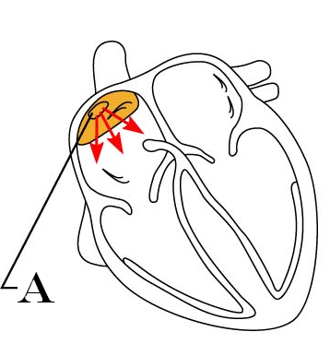
Station Five

8. This structure is associated with the conductive system of the heart. What it is? If there is an abbreviation for it, please do NOT use it.

Station five

8. This structure is associated with the conductive system of the heart. What it is? If there is an abbreviation for it, please do NOT use it.
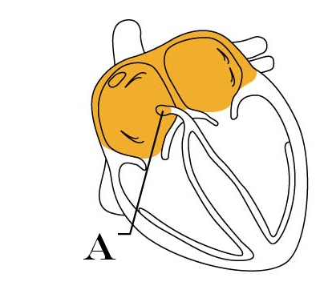

Station Six:

9. Identify the image in the field of view

- Lymphatic capillary
- Vein
- Artery
- Cardiac muscle tissue
- Skeletal muscle tissue

10. Which artery is most often used when determining blood pressure?
a. radial artery
b. carotid artery
c. vertebral artery
d. brachial artery
e. femoral artery

Station Six:

9. Identify the image in the field of view

- Lymphatic capillary
- Vein
- Artery
- Cardiac muscle tissue
- Skeletal muscle tissue

10. Which artery is commonly used to determine pulse?

- Deep femoral artery
- External iliac artery
- Radial artery
- Brachial artery
- Axillary artery

Station Seven

11. Identify this wave of the EKG (indicated by the arrow)

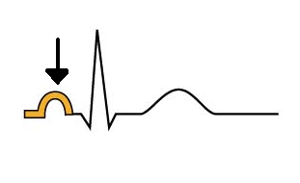

Station Seven

11. Identify this wave of the EKG (indicated by the arrow)

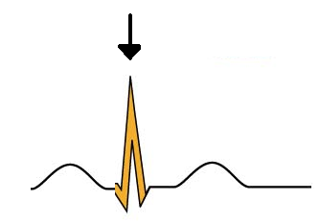

Station Seven

11. Identify this wave of the EKG (indicated by the arrow)

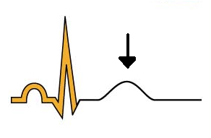

Station Eight

12. Identify the structure at the marker

13. Identify the structure at the marker

Station Nine

14. Identify the marked structure

15. Identify the marked structure
Station Ten

16. Identify the artery on the image

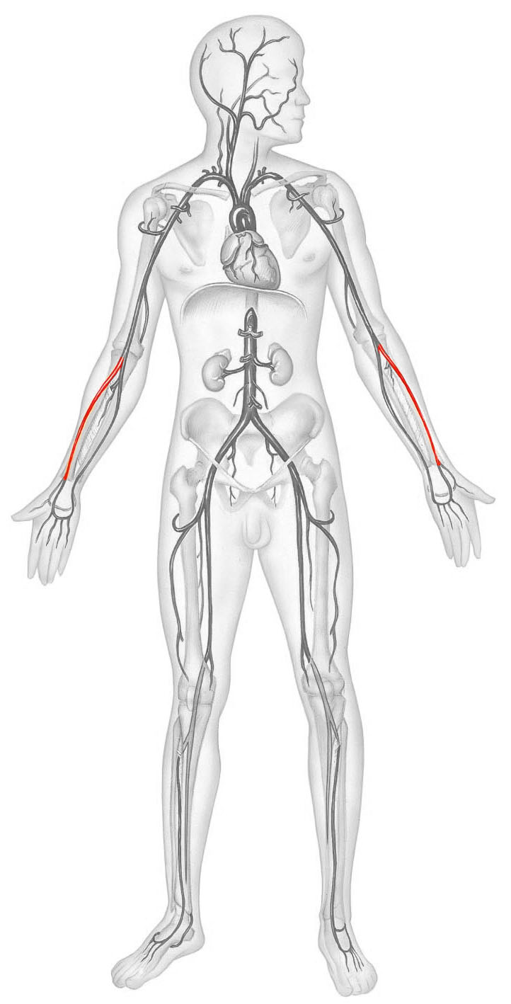

17. Which of the following arteries carries deoxygenated blood?
a. Subclavian artery
b. Pleural artery
c. Pulmonary artery
d. Coronary artery
e. all arteries carry oxygenated blood

Station Ten

16. Identify the artery on the image
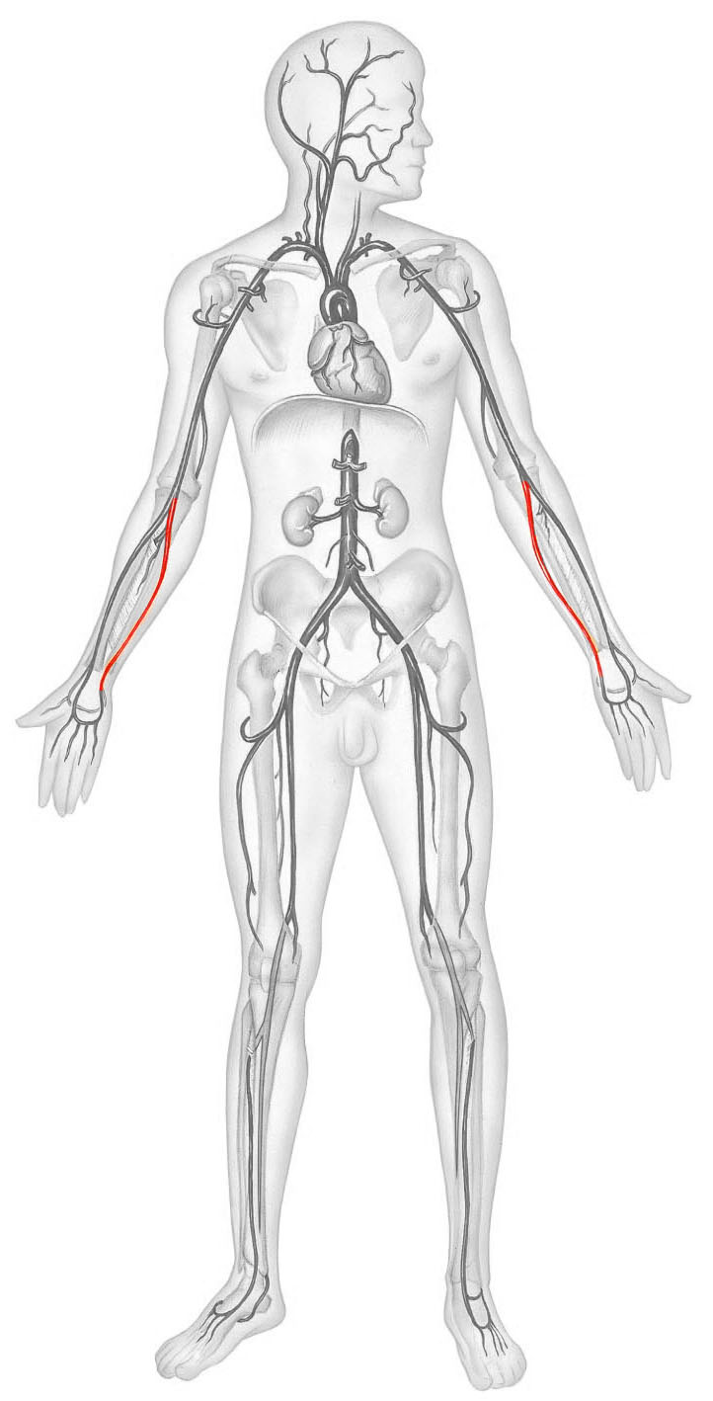

17. Which of the following veins carries oxygenated blood?
a. Subclavian vein
b. Jugular vein
c. Pulmonary vein
d. Coronary sinus
e. all veins carry deoxygenated blood

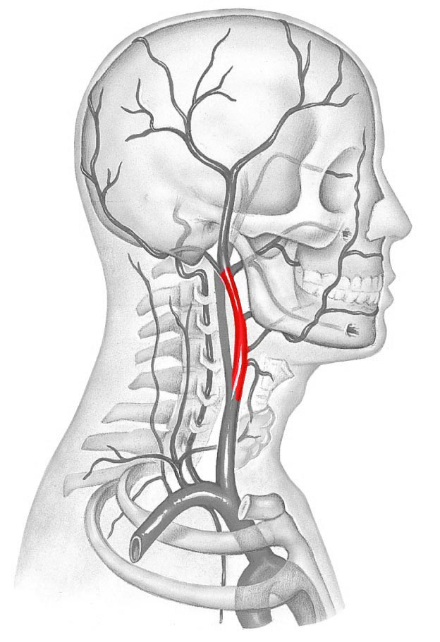
Station Eleven

18. Identify the artery on the image to the right

- Thyrocervical artery
- Internal carotid artery
- External carotid artery
- Common carotid artery
- Facial artery

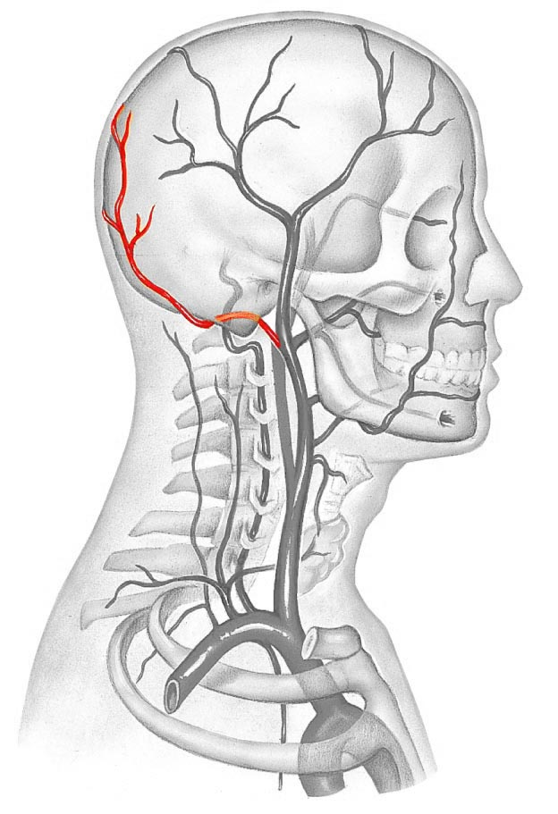

19. Identify the artery on the image to the left

- Craniosacral artery
- Occipital artery
- Basilar artery
- Inferior vertebral artery
- Posterior cranial artery

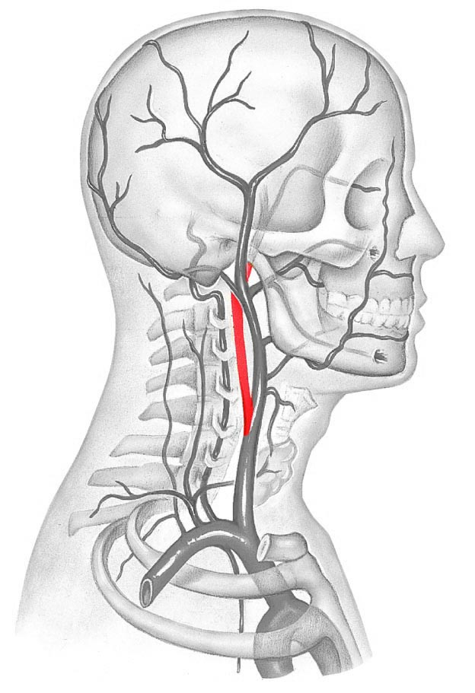
Station Eleven

18. Identify the artery on the image to the right

- Thyrocervical artery
- Internal carotid artery
- External carotid artery
- Common carotid artery
- Facial artery

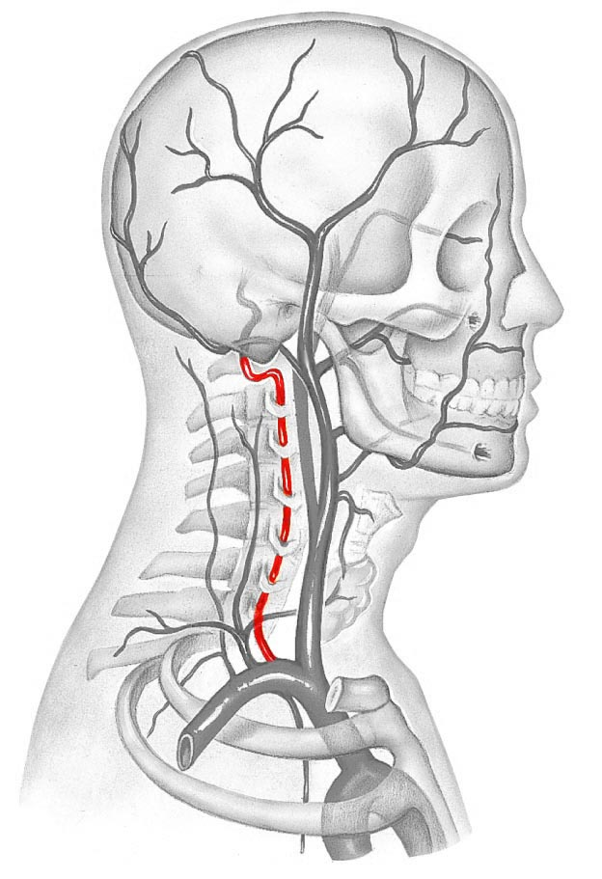
19. Identify the artery on the image to the left

- Basilar artery
- Vertebral artery
- Internal carotid artery
- Occipital artery
- Posterior cranial artery

Station Twelve

20. When using a stethoscope, which way should the ear pieces be directed?
a. towards the back of the head
b. towards the nose
c. straight in to the ear
d. angled slightly up
e. it will not make a difference

21. When do you expect to hear the Karotkoff sounds?
a. when using a stethoscope to listen to the mitral valve
b. when using a stethoscope to listen to the aortic valve
c. when using a stethoscope to determine blood pressure
d. When using a stethoscope to listen to radial pulse
e. When using a stethoscope to determine lung sounds

Station Thirteen

22. Which artery is being palpated at the location indicated in order to determine pulse?
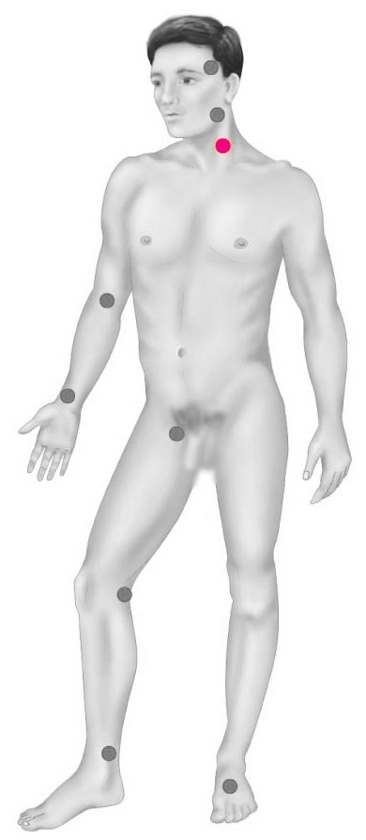

23. The abdominal aorta branches into the _______ before entering the ovary.
a. gonadal artery
b. fallopian artery
c. uterine artery
d. feminine artery
e. medullary artery

Station Thirteen

22. Which artery is being palpated at the location indicated in order to determine pulse?

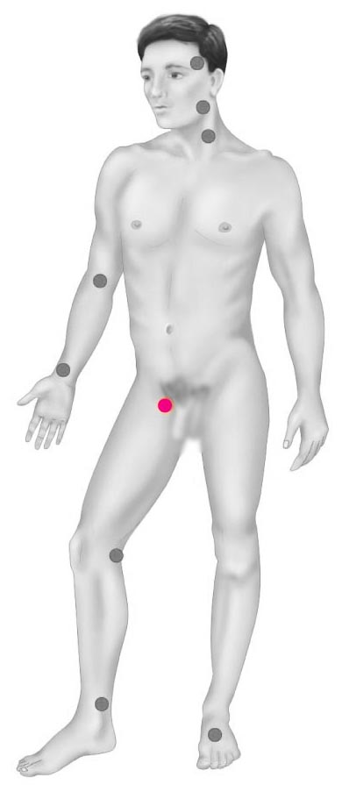

23. The common iliac artery branches into the _______ before becoming the femoral artery.
a. common gonadal artery
b. internal iliac artery
c. external iliac artery
d. common tibial artery
e. great saphenous artery

Station fourteen

24. Systole pressure is
a. the pressure in the arteries during ventricular contraction
b. the pressure in the arteries during ventricular relaxation
c. the pressure in the veins during ventricular contraction
d. the pressure in the veins during ventricular relaxation
e. the sum of the pressures in the arteries and the veins during the cardiac cycle

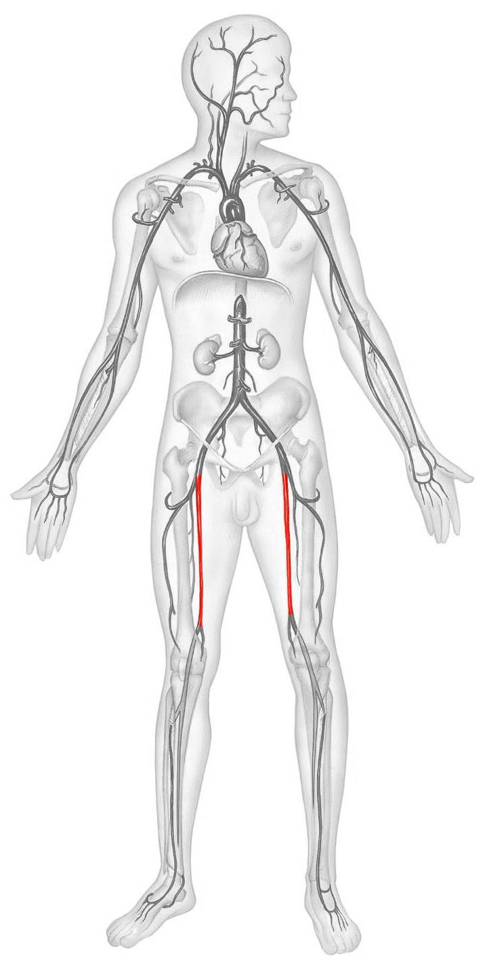
25. Identify the artery in the image.

Station fourteen

24. Diastolic pressure is
a. the pressure in the arteries during ventricular contraction
b. the pressure in the arteries during ventricular relaxation
c. the pressure in the veins during ventricular contraction
d. the pressure in the veins during ventricular relaxation
e. the sum of the pressures in the arteries and the veins during the cardiac cycle

25. Identify the structure in the image.
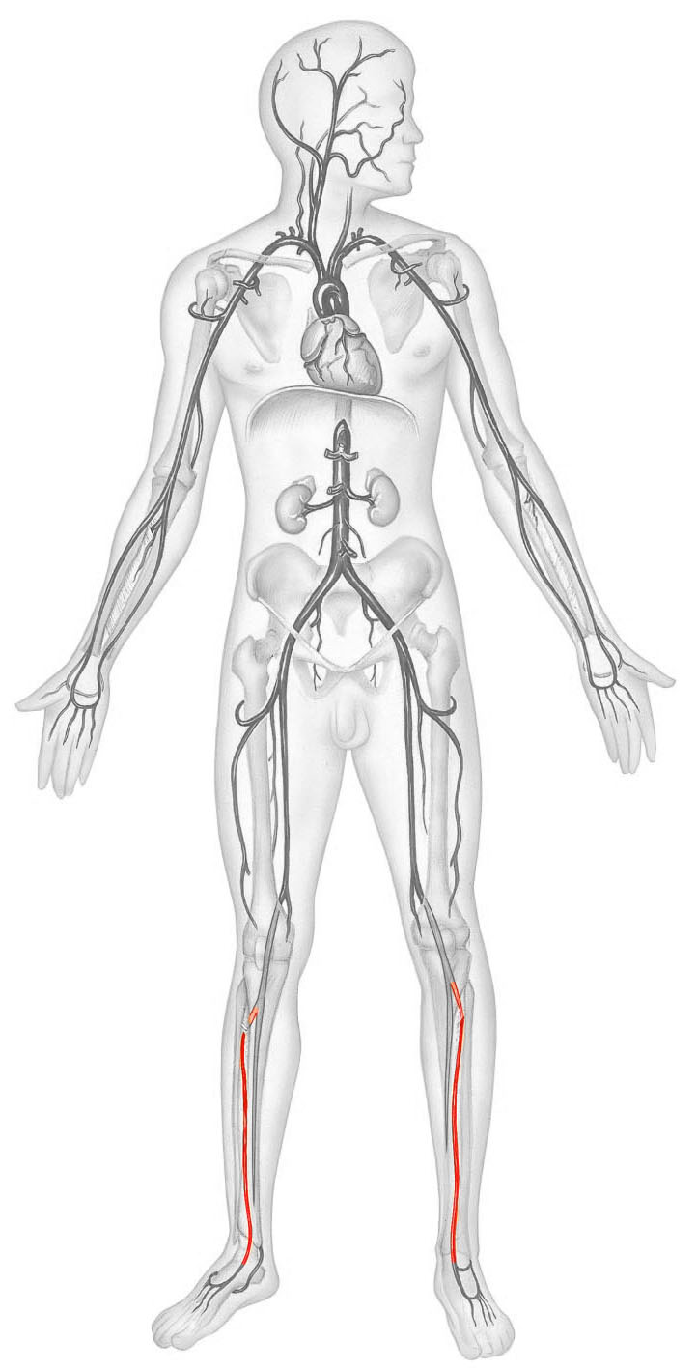

9. Identify the image in the field of view

- Lymphatic capillary
- Vein
- Artery
- Cardiac muscle tissue
- Skeletal muscle tissue

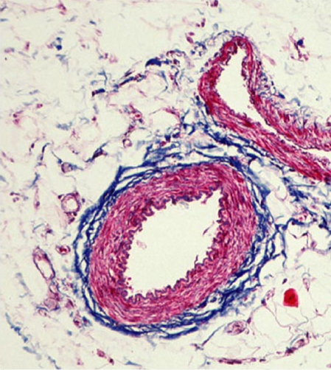

- Identify the tissue type in the field of view.

