Lab Quiz 182_1a
Instructor Set-up
Station One:
- Microscope. Place a marker on the scanning lens
- Question
Station Two
- Microscope: Thyroid slide showing follicle. (No parathyroid tissue)
- Question
Station Three
- Microscope: Posterior pituitary
- Question
Station Four
- Microscope: Marker at Neutrophil
- Question
Station Five
- Use the blood typing wells show an agglutination reaction: B+ blood type
- Question
Station Six
- Image: Megakaryocyte
- Question
Station Seven
- Image/Question
- Question
Station Eight
- Blood typing wells: O- blood type
- Question
Station Nine
- Microscope: Monocyte
- Question
Station Ten
- Microscope: Ovary, try to have a mature follicle in the field of view

Station One

- Which part of the microscope is indicated by the marker?
  - Ocular lens
  - Scanning lens
  - Low power lens
  - High power lens
  - Oil immersion lens

- What is the total magnification when the lens indicated is used?
  - 1000X
  - 400X
  - 100X
  - 40X
  - 4X

Station Two

- Identify the tissue.

- Indicate one of the three cortical hormones produced at the adrenal cortex. (List ONLY one.)

Station Three

- The material on the slide is responsible for the release of Oxytocin and which other hormone?

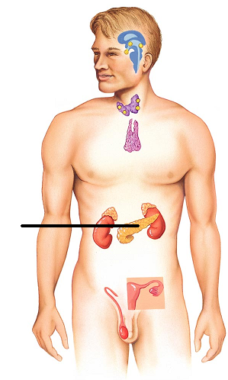
- Name one hormone produced by the gland indicated below

Station Four

- Identify the structure indicated in the field of view.

- What is the function of this cell?
  - Transportation of gasses
  - Engulf bacteria
  - Promote inflammation
  - Produce antibodies
  - Fight parasitic worms

Station Five

- What blood type is this?

- Which antibodies would be in the plasma of a person with this blood type?

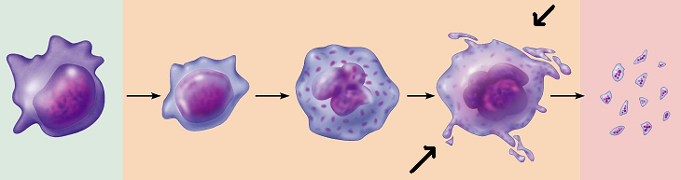
Station Six

- What is the name of the cell indicated?
  - Promyeloblast
  - Megakayrocyte
  - Thrombocytoblast
  - Normoblast
  - Hemacytoblast

- What does the cell from #11 turn into?

Station Seven
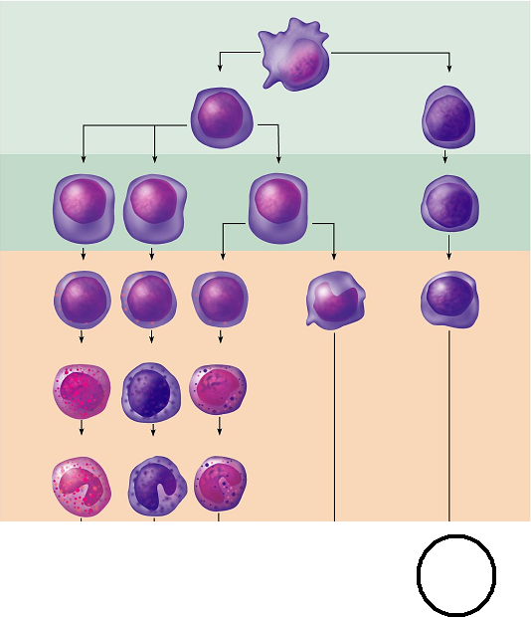

- The cell line on the far right of the image will produce which type of cell?
  - Monocyte
  - Macrophage
  - Erythrocyte
  - Lymphocyte
  - Basophil

- What is the term for the immature red blood cell that has lost its nucleus, but not some of the membranes in the cytoplasm?

Station Eight

- What is the blood type?

- Which blood type(s) could this person safely receive?

Station Nine

- Identify the cell

- What name is the antigen given in Rh+ groups?
  - Rho
  - B
  - C
  - D
  - There are no antigens in Rh+ groups

Station Ten

- Identify the image on the slide
  - Seminiferous tubule
  - Thymus
  - Spleen
  - Thyroid
  - Ovary

- In a female, where is testosterone made?
  - Seminiferous tubules
  - Hypothalamus
  - Pineal gland
  - Adrenal cortex
  - Ovary

Station Eleven

- The pancreas is a heterocrine gland. What does heterocrine mean?
  - Produces more than one type of hormone
  - Produces local hormones only
  - Dependent on a third messenger system
  - Has both acidic and basic secretions
  - Has both endocrine and exocrine secretions

- The tissue in the image below belongs to the
  - Thyroid
  - Parathyroid
  - Spleen
  - Thymus
  - Adrenal gland
