Identify the following prefixes, roots, and/or suffixes:

Peri
Epi
Endo
Cardia
Inter
Septum
Sulcus
Papilla
Fossa
Foramen

Pages 658 – 668 Heart Anatomy and layers
- What does “pulmonary” mean?

- Which side of the heart is the pulmonary circuit? Where does the blood go?

- What does “systemic” refer to?
  - Which side of the heart is part of the systemic circuit? Where does the blood go?

- What are the receiving chambers of the heart?

- What are the pumping chambers called?

- The heart is located in the mediastinum. Where and what is the mediastinum?

- What are the borders of the heart?
  - Anterior border:
  - Lateral borders:
  - Posterior border:

- Is the “base” of the heart the superior aspect or the inferior aspect of the heart?
  - Where is the apex?

- The pericardium is the sac that covers the heart. There are three layers. What are they?

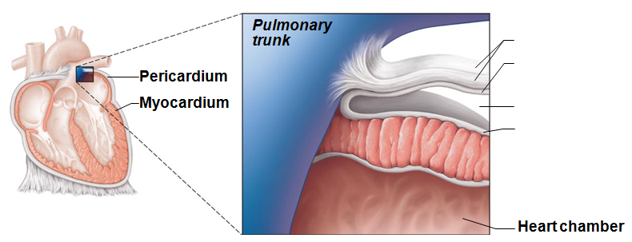

- The image above represents the pericardial sac. Label the layers that are indicated.

- What does “visceral” refer to for visceral pericardium?

- What does “parietal” refer to for parietal pericardium?

- What is the advantage of having the pericardial fluid present in the pericardial cavity?

- When can you hear a “pericardial friction rub”? What condition/pathology needs to be present?

- What is cardiac tamponade? How is it relieved?

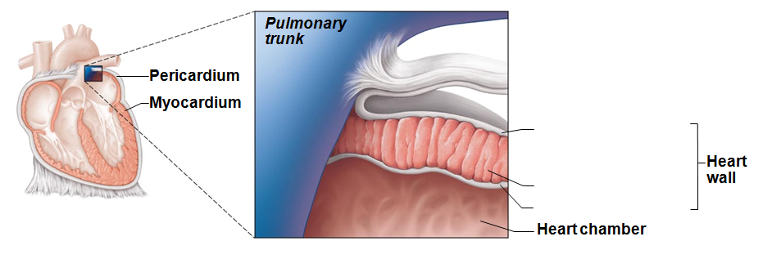
- The image above represents the heart wall. Label the layers in the spaces indicated.

- You’ll notice that the epicardium and the visceral pericardium are the same structure. When do we use “epicardium” and when do we use “visceral pericardium”?

- Which of the cardiac layers is designed for contraction?

- What is the cardiac skeleton made up of, and what is its function?

- What type of epithelium composes the endocardium?

- The two upper heart chambers are the ______________________________________________ and the two lower heart chambers are the ______________________________________________________________.

- Septum/Septa is a divider. Identify the following

  - Interatrial septum
  - Interventricular septum
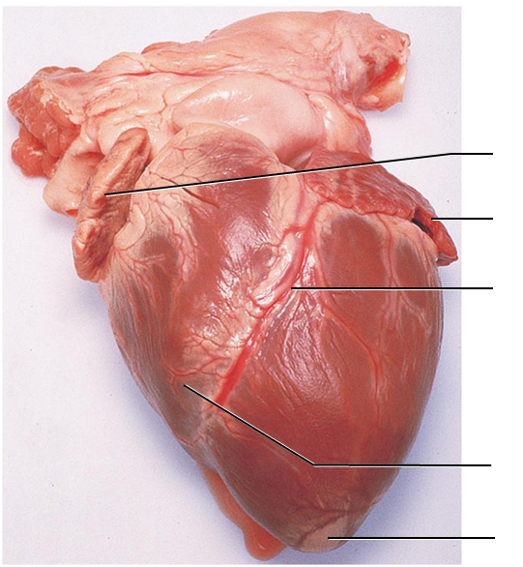
- Label the external structures on the anterior heart. Draw an arrow to where you’d expect to see the coronary sulcus

- What is the function of the atria?

- What three structures open into the right atrium? What type of blood do they carry?

- What is the function of the ventricles?

  - What is the pathway/vessel that leads out of the right ventricle?

  - What is the pathway/vessel that leads out of the left ventricle?

- Label the external structures of the anterior heart

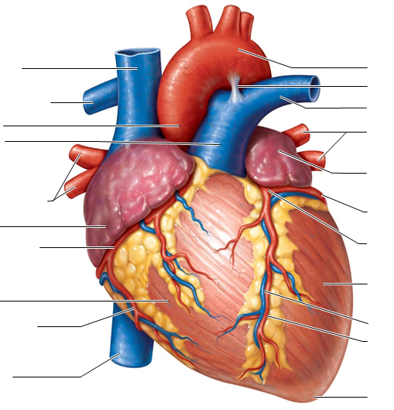

- Label the external structures of the posterior heart
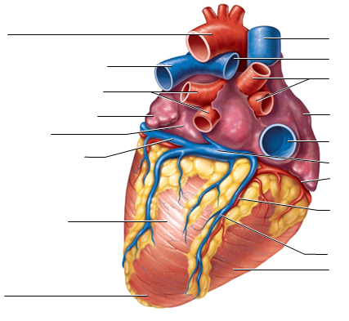

- The tricuspid valve is an atrioventricular valve. Where is it located?

- The mitral valve is an atrioventricular valve. Where is it located?

- The Pulmonary Valve is a semilunar valve. Where is it located?

- The Aortic valve is a semilunar valve. Where is it located?

- What differences can you see between the AV valves (atrioventricular) and the semilunar valves?

- Label the internal structures of the heart
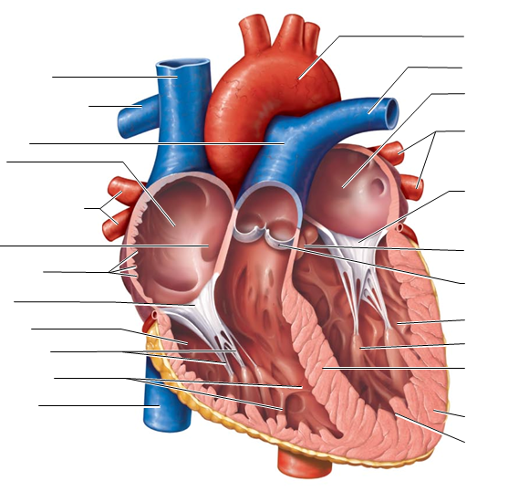

- What causes the AV valves to close?

- What causes the semilunar valves to close?

- What causes the AV Valves to open?

- What causes the semilunar valves to open?

- Why is the left ventricular wall larger than the right ventricular wall?

- How do the chordate tendineae function?

Pages 668 – 670 Coronary Circulation
- Start with the right atrium. What is the pathway of blood through the heart? Include all chambers and valves.

- The coronary circulation is responsible for taking oxygenated blood to the tissues of the heart itself. The coronary arteries branch immediately from the Aorta.

  - What are the branches from the left coronary artery?

  - What are the branches from the right coronary artery?

- After the arteries feed into the capillaries to make the gas exchange, the returning blood is through cardiac veins. What is the coronary sinus?

- Compare Angina Pectoris to a Myocardial Infarction

Pages 671, 674 – 678 Cardiac Muscle, innervations, and conduction
- Describe the shape and some features of a cardiac muscle fiber (cell).

- What are some some functions of an intercalated disc?

- What is a “functional syncytium” Why does this arrangement work to the advantage of the heart?

- The intrinsic cardiac conduction system includes the structures within the heart that are responsible for generating the electrical signals that eventually lead to muscle contraction.
  - Where is the SA node located?

  - How many impulses does it generate all on its own in one minute?

  - What is the common term for this structure?

  - Where is the AV node?

  - Without the SA node, how many impulses per minute would the AV node generate on its own?

  - What function does the AV node have?

  - Where is the AV Bundle located? What is its other name?

  - What is the function of the AV Bundle?

  - Without the SA node or the AV node, how many impulses per minute can the AV Bundle generate on its own?

  - Where are the Bundle Branches located?

  - What is the function of the Bundle Branch?

  - Where are the Purkinje fibers located?

  - What is the function of the Purkinje fibers?

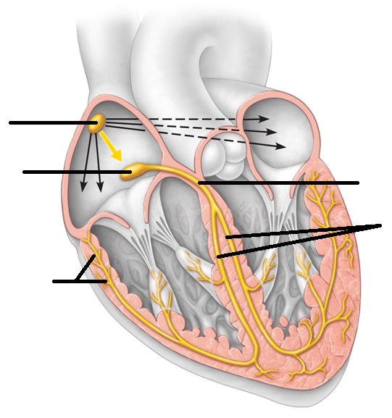

- What is an arrhythmia?

- Why is a fibrillation dangerous?

- What is an ectopic focus?

- Extrinsic innervations of the heart means that the influence on the heart’s contraction comes from outside the heart. (Also read page 684 Autonomic Nervous System Regulation of the Heart to give you a more complete answer for the following questions.)
  - How does the sympathetic system influence the heart?

  - How does the parasympathetic system influence the heart? Which cranial nerve carries this input?

- When the electrical impulses are measured and recorded, they are known as an EKG (or ECG). Successful depolarization through the conductive pathways will result in some of the wave forms produced. What are the waves in an EKG named?

  - What major event is happening in each wave?

- Label the waves in the image below. They repeat, so you can label for just one cardiac cycle. (circle one complete cardiac cycle.)
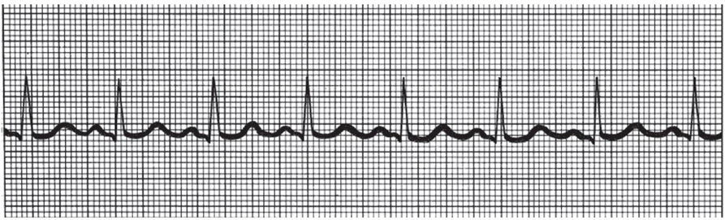
Pages 678 - 685 Heart sounds, Cardiac Cycle, and Cardiac Output

- The heart sounds are often referred to as “lubb dubb” or in some cases as “lub – dup”.
  - The first heart sound is “lubb”. The closing of which valves create the noise?

  - The second sound is “dubb.” The closing of which valves creates the noise?

- Label the areas below in which each of the four heart valves can be best auscultated
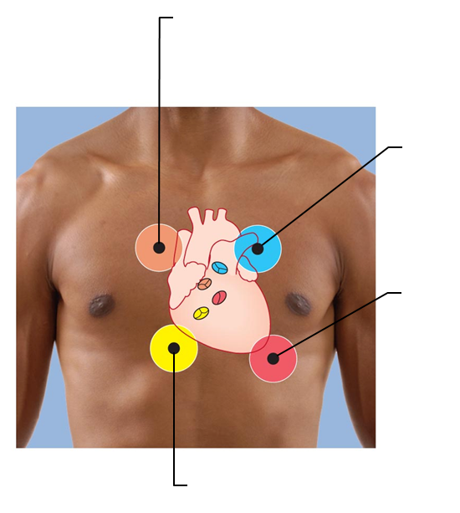

- What produces a heart murmur?

- What sound can be heard with a stenotic valve? (What’s a stenotic valve?)

- The conductive system within the heart allows for the electrical signals to be passed through the cardiac structures. The eventual outcome of this is cardiac muscle contraction.
  - What is systole?
  - What is diastole?

- What are the events that take place within the cardiac cycle?

- What happens to the AV valves during
  - Atrial systole
  - Ventricular systole
  - Atrial diastole
  - Ventricular diastole

- What happens to the semilunar valves during
  - Atrial systole
  - Ventricular systole
  - Atrial diastole
  - Ventricular diastole

- What is the quiescent period?

- What is Cardiac Output?

  - What is stroke volume?
- What is preload with regards to cardiac output?

- What is afterload with regards to cardiac output?

- What type of stimulation is provided with Vagal tone? What is the outcome?

- What does epinephrine do to the heart?

- What does thyroxine do to the heart?

- Heart Rate
  - What is considered a normal range for heart rate (HR)

  - What is tachycardia and what can cause it?

  - What is bradycardia and what can cause it?

- What is the premise of Congestive Heart Failure (CHF)?

  - What symptoms/signs are seen if there is right-sided heart failure?

- What is the function (and translation) of foramen ovale? What does it transition into?

- What is the location and function of the ductus arteriosus? What does it transition into?

- Congenital heart defects are pathological changes in the heart that one is born with. Describe the pathology and the outcomes/symptoms of the following

  - Ventricular Septal Defect

  - Coarctation of the Aorta

  - Tetralogy of Fallot

- What are some structural changes seen in an aging heart

- Identify the congenital heart issues seen below.

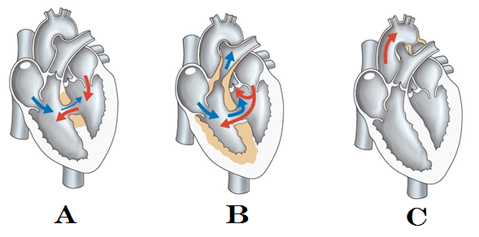

Page 690
- What are heart palpitations and what might cause them?

- What happens in Mitral Valve Prolapse?

- What is myocarditis? What can cause it?

- What is endocarditis?

