Page 693 -699 Vessels

- What are the three vessel types?

- How does an arteriole differ from an artery? How does a venule differ from a vein?

- What is a lumen? Which has a larger lumen, an artery or a vein of the same size

- What are the three layers (tunics) present in both vessel types? How does the middle layer compare in artery versus vein?

- What is the advantage of having a vasa vasorum in a large blood vessel?

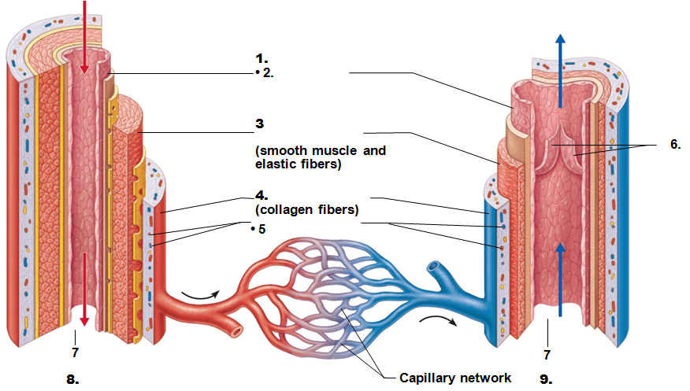
- When a vessel opens (lumen become wider), what is the term called? What is it called when the vessel narrows (lumen becomes smaller)?

- Where are Elastic Arteries found and how do they provide an advantage?

- Where are Muscular (aka Distributing) Arteries found?

- How do the arterioles control blood flow into capillaries?

- What is the function of the capillary?

- What are the three types of capillaries?

- Compare the epithelium of each type (3) of capillaries. What are the differences and how does that change their function?
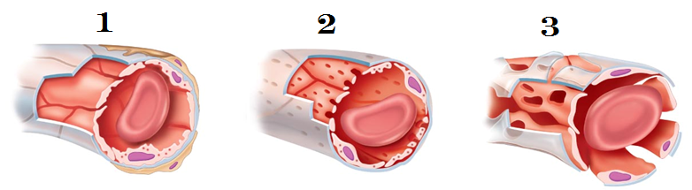

- Postcapillary venules are the venules on the “exit” side of the capillary. In what ways are they (the venule and a capillary) similar?

- Why, on a prepared slide of a vein, does the lumen appear as a slit rather than a circular opening?

- What causes varicose veins?

- What is a venous sinus?

- What is the advantage of a collateral channel? What’s another term for it?

Pages 701 - 709 Circulation and Regulation
- When our body needs to alter our blood pressure quickly and temporarily, it alters the peripheral resistance by causing a vasoconstriction (blood vessel lumen size diminished) or vasodilation (blood vessel lumen size increased). List and summarize the three sources of resistance mentioned in your text book.

- Compare systolic pressure to diastolic pressure.

- What is pulse pressure?

- List and describe the three adaptations our bodies use to return the venous blood to the heart, often times against gravity

- Which division of the autonomic system is responsible for vasomotor tone?

- What is a baroreceptor?

- Increased blood pressure triggers the barorecepter to initiate what type of reaction?

- Decreased blood pressure triggers the baroreceptor to initiate what type of action?

- Can a baroreceptor deal with sustained/long term changes in blood pressure?

- What triggers the chemoreceptors to alter cardiac output or peripheral resistance?

- Which hormones contribute to short term control of blood pressure?

- Which of these hormones cause elevation of blood pressure?

- Which of these hormones cause a decrease in blood pressure?

- If there is an increased blood pressure, what changes would a Direct Renal Mechanism have
  - On the blood volume

  - On the urine

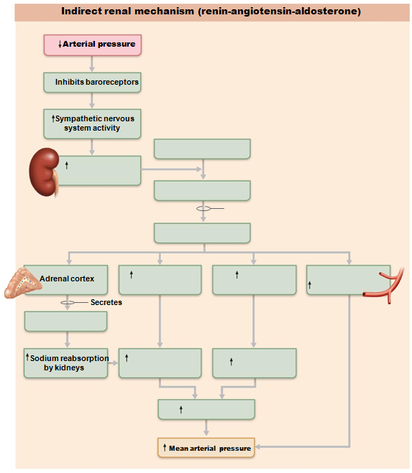

Pages 710 - 711 Pulse and Imbalances

- Why do we feel a pulse?

- Which artery is most commonly used to measure blood pressure?

- Blood pressure is taken using an auscultatory method. What does auscultatory mean?

- The first Korotkoff sound indicates the ____________________________________________ pressure while the last Korotkoff sound indicates the ___________________________________________________________ pressure

- Hypertension is a blood pressure above what values?

- What range is considered pre-hypertensive

- Why is hypertension considered a “silent killer”?

- Is hypotension always a pathology? When is it desirable?

Pages 716 – 717 Capillary dynamics and Shock
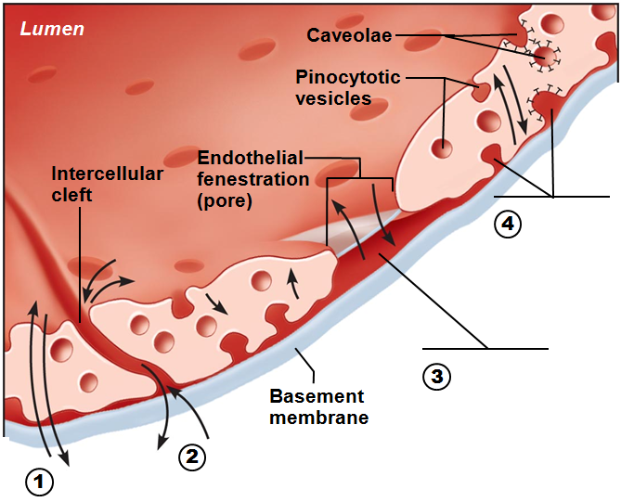

- The image above represents a capillary. There are four possible pathways to move material from inside to outside (and vice versa). What are they? Label the numbers indicated above

- List and define the different types of shock.

