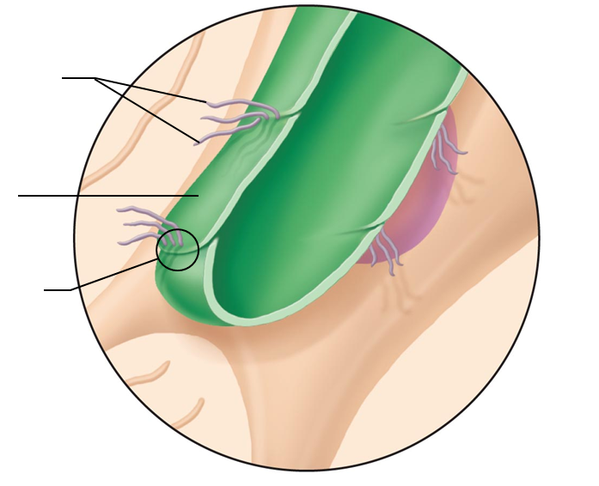
Pages 751 -761
- Label the structures on the lymphatic capillary

- What’s the difference between the lymphatic system and the lymphoid organs and tissues?

- What is lymph?

- How do the lymphatic capillaries differ from the cardiovascular capillaries?

- If a protein is in the interstitial space, what options do we have for returning it to the circularory system?
  - Can it go directly into the bloodstream?
  - What is a benefit of the route it will take?

- How do the Collecting Lymphatic Vessels compare to the veins?

- Label the structures on the next page:

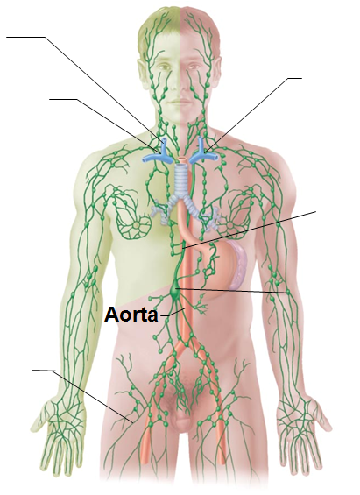

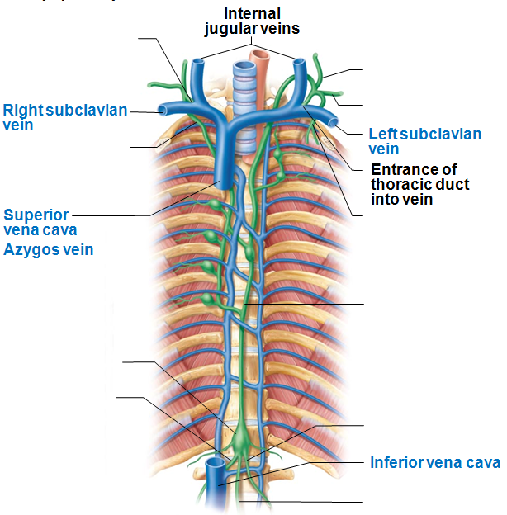

- Lymph needs a lot of the same assistance to circulate as the venous blood did. What techniques help to move the lymph towards the thorax?

- What is the cisterna chyli and where is it located?

- Do the lymphatic ducts demonstrate an equal distribution of the lymphatic system? Which duct drains which regions?

- Lymphocytes have two categories. What are they and what is an overview of the function of each?

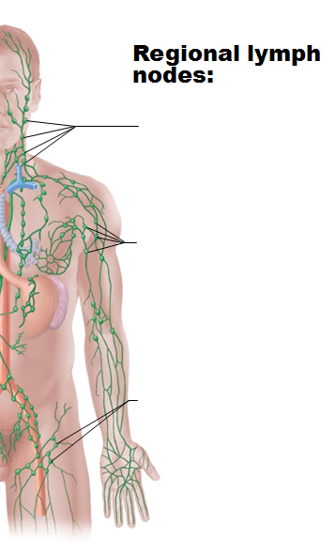

- What is a germinal center?

- What are the functions of the lymph nodes?

- Where are the Peyers Patches located? What is their function? (more info on them on p 759)

- The lymph nodes have a capsule surrounding the outside, and have a structure called trabeculae. What does the trabeculae do?

- Label the structures and the regions of a lymph node
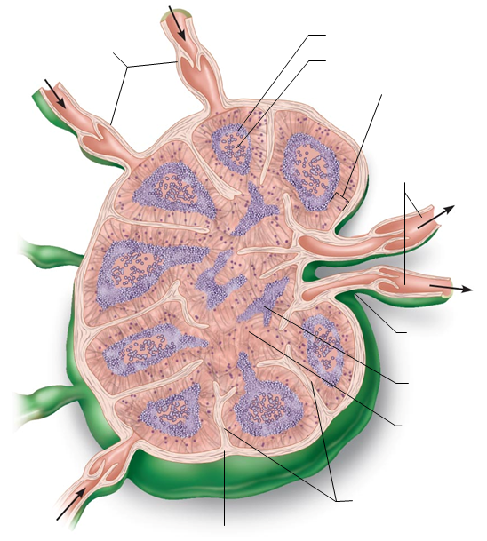

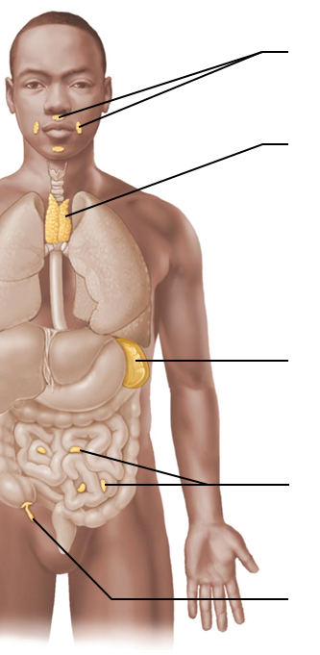
- What is the result of having afferent vessels that are more numerous than efferent vessels?

- Indicate the lymphatic structures on the image below

- The spleen is primarily responsible for “cleaning” the blood… filtering out the non-functional red blood cells. What lymphatic properties does it have?

- Compare the red pulp of the spleen to the white pulp of the spleen. What functions take place within the locations?

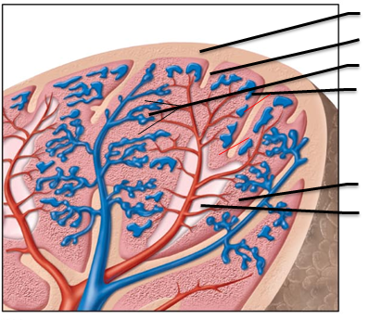
- Identify the structures associated with the spleen:

- We can survive without a spleen. When the spleen is removed
  - What the procedure called
  - Which organ(s) take over

- How many lobes does the thymus have?

- What is the function of the thymus?

- What does MALT stand for?

  - What/where is the mucosa?

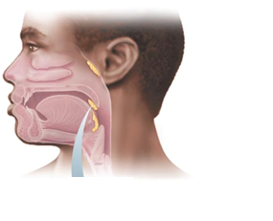
- Identify the different regions in which the tonsils are located. There is one that is not viewed in the image below. Which one is it?

- What is the function of the tonsilar crypts?

- Where is the appendix located and what is its function?

System Connections, p 671: Read to review the relationships between the lymph and
Skeletal system
Muscular system
Nervous system
Endocrine system
Cardiovascular system
Respiratory system
Digestive System
Urinary System
Reproductive System

