Pages 764- 772 Innate Defenses

- The innate or “nonspecific” defense system is design to function in what way?

- How does the adaptive defense compare to the innate defense?

- Fill in the spaces that represent the divisions of the innate and adaptive defenses.
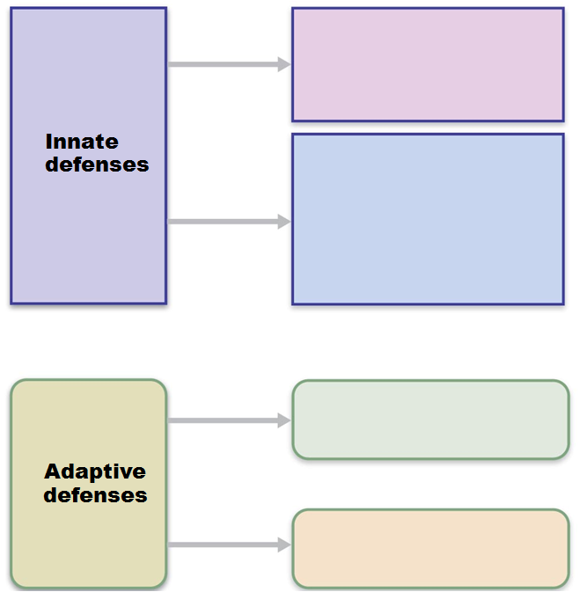

- What is a pathogen?

- What features to the skin have that allows it to act as a part of the innate system?

- Which cells act as phagocytes? What does it mean to be phagocytic?

- What are opsonins? And what is opsonization?

- What does “NK” stand for in the NK cells? How do they differ from regular lymphocytes?

- What types of events trigger inflammation?

- What is hyperemia? How does it relate to inflammation?

- How can edema be helpful?

- There are four steps to phagocytic mobilization. Describe what’s happening in each of the stages
  - Leukocytosis

  - Margination

  - Diapedesis

  - Chemotaxis

- Antimicrobial proteins are part of the innate defenses. Give a general description of what the following chemicals do:

  - Interferon

  - Complement

- How does fever benefit the body?

Pages 773 778- Adaptive Defenses

- Review the three important aspects of the adaptive immune system as outlined by your textbook.

- What is a “humour”?

- Compare humoral immunity to cell mediated immunity

- How did the word “antigen” come about? How does it relate to the immune system?

- Discuss “immunogenicity” and “reactivity” Put them in terms that make sense to you.

- How does a hapten become immunogenic?

- What does MHC stand for? What are they?

- As a review, list the five types of white blood cells. Indicate the sub-categories of the lymphocytes, and the functions of those two sub-types. Also indicate where each of those subtypes develop and mature

- What is immunocompetence?

- For Positive Selection of T cells, what does the T cell need to recognize?

  - What happens if it does recognize it?

  - What happens if it doesn’t?

- For Negative Selection of T cells, what does the T cell need to be able ignore?

  - What happens if it can not ignore it?

  - What happens when it can ignore it?

- What does it mean to have a naïve lymphocyte?

- What do the letters APC stand for? Which cells act as APCs?

- Where do we find dendritic cells and what do they do?

Pages 779 - 787

- Where do plasma cells come from?

- What is the advantage of the memory cell?

- Compare the time to respond for a primary exposure to a secondary exposure. Also compare the antibody levels for a primary exposure and a secondary exposure. Lastly, compare the duration of the response for a primary exposure to a secondary exposure.

- Compare and Active Immunity to a Passive Immunity

- Compare a Naturally Acquired response to an Artificially Required response.

- What does “Ig” stand for in abbreviations like IgG or IgA?

- What is the general shape of an antibody?

- Where are the Antigen Binding Sites (ABS) located?

- How do the antibodies interact with the materials they attach to?

- List the Five Antibody classes and fill in the chart below
Name | shape | Location/General Function

Pages 784 –789 Cellular Immune Response

- CD4 and CD8 are designations for receptors on the surface of the T cell. The type of receptor present can determine the type of function that the cell has. How will cells with the CD4 receptor function? What will the CD8 cells transition into? How do their approaches differ?

- Earlier we mentioned MHC. In lecture, I’ll refer to it as the “silver platter.” What is the difference between MHC Type I and MHC Type II? (discuss cell locations and types of antigens)

- Your textbook makes an analogy using a car starting. The T cells finding the MHC and identifying the non-self antigen is step one (key in ignition). It this point, the car is started, idling, but not moving. Same is true of the T cell interaction. The T cell has bound to the APC but has not been triggered to function. Which events act like “putting the car into gear?”

- What are cytokines?

- What does Interleukin 1 do? What does Interleukin 2 do?

- What cells do the T_{H} (Helper T cells) help?

- How do the T_{C} (Cytotoxic T Cells) function? What other cell type destroys cells in much the same way?

- What do T_{REG} (Regulatory T cells) do?

- What are the four varieties of grafts? List and describe.

Pages 794-796

- What is an autoimmune reaction?

- What are the theories as to how autoimmunity arises?

- What happens during an anaphylactic shock?

- What is contact dermatitis? What category does it belong to?

