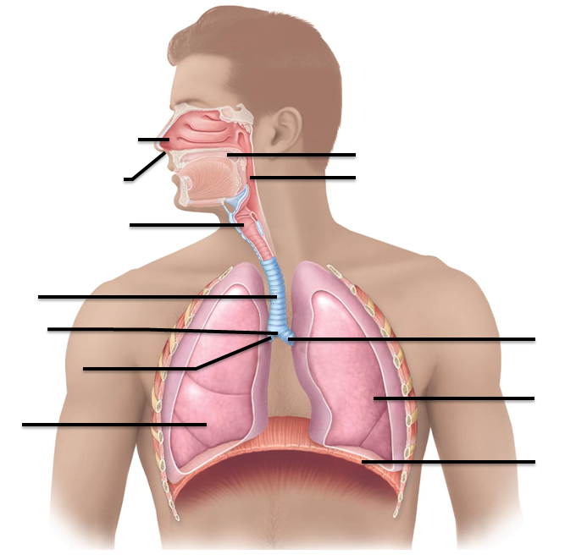
Pages 802 –809 Respiratory Anatomy

- Label the structures indicated

- Compare internal respiration to external respiration. What’s the difference?

- Compare the respiratory zone to the conducting zone. What’s the main, significant difference between them?

- What are the regions of the nose?

- What does “choanae” mean?

- What are the two types of membranes within the nasal cavity? How do they differ?

- Indentify the structures indicated:

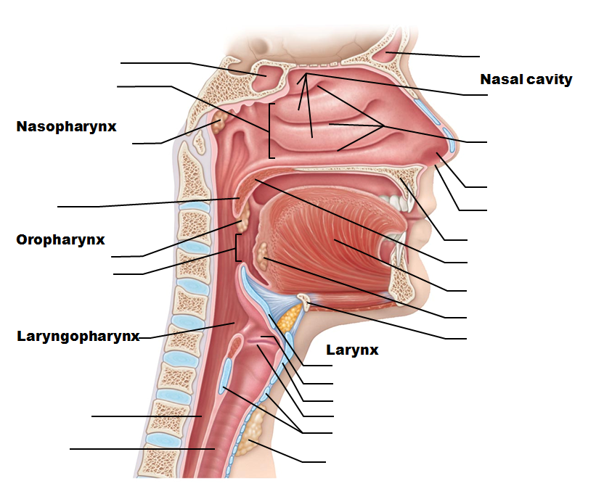

- What are the conchae? What benefit do they provide?

- What are the three regions of the pharynx?

- What is the function of the uvula? In which pharyngeal division is it located?

- What is the “isthmus of the fauces”?

- What are the three functions listed for the larynx?

- Identify the structures indicated:

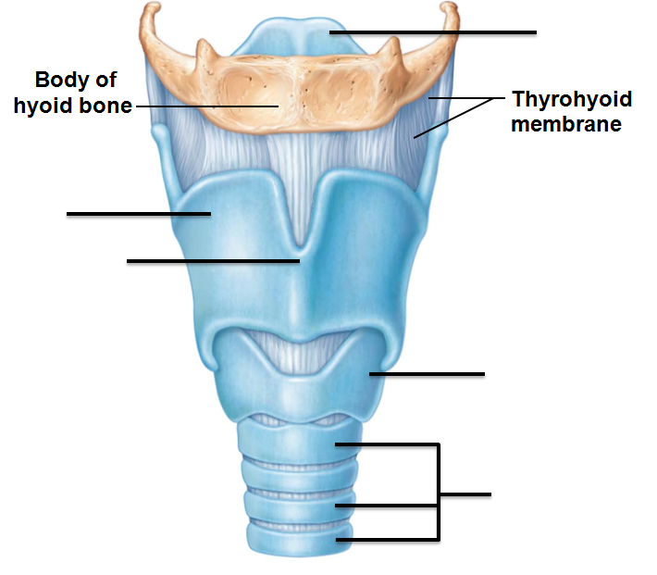

- Identify the structures indicated:

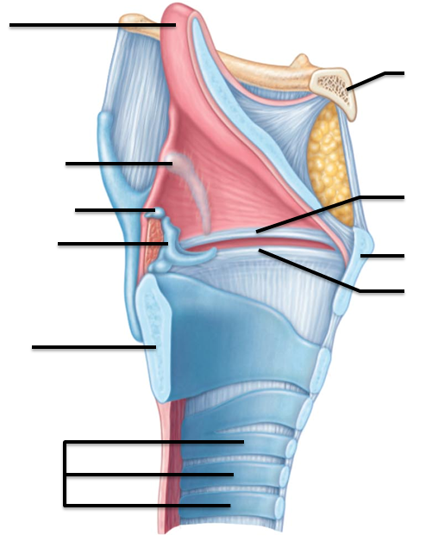

- Which of the laryngeal cartilages are paired? Singular?

- Which is the ONLY laryngeal structure made of elastic cartilage rather than hyaline?

- What structure makes the “Adam’s Apple”?

- Compare the true vocal folds to the false vocal folds. What are some of the functions of each?

- What is the Valsalva Maneuver?

- What advantage does the C-shaped rings of cartilage provide for the larynx? For the esophagus?

Pages 810-816 Bronchi and subdivisions

- What is the bronchial tree?

- Based on the orientation of the bronchi, which lung is more likely to receive an inhaled foreign object? Why?

- As the bronchi branch and eventually transition into bronchioles, what (3) structural changes can be seen?

- What structures make up the respiratory membrane?

- What’s the difference between the alveoli and alveolar sacs?

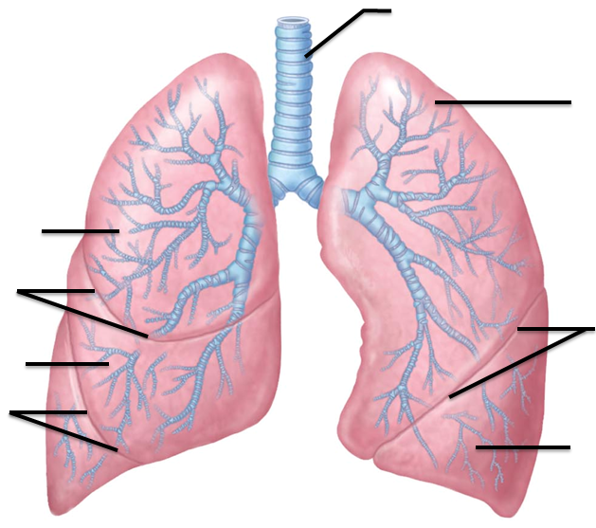
- Identify the structures indicated.

- Indentify the structures indicated

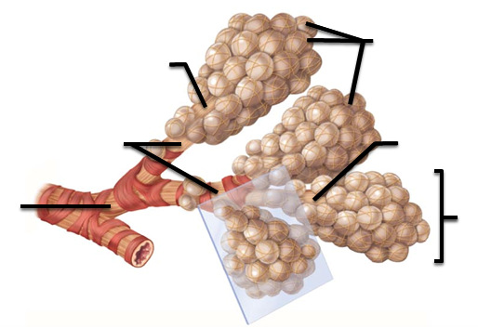

- How do the right and left lungs differ structurally?

- Pulmonary arteries come from which side of the heart? And carry what type of blood?

- What’s the difference between a pulmonary artery and a bronchial artery?

- What does the name
  - Visceral pleura tell you?

  - Parietal pleura?

- What’s the function of the pleural fluid?

- What is pleurisy?

Pages 816 – 819 Mechanisms of breathing

- What is our reference pressure for breathing? (Which pressure are we comparing the changing lung pressures to?)

- Describe and compare intrapulmonary pressure to intrapleural pressure.

- How does a negative intraplerual pressure help to keep the lungs open?

- What is atelectasis?

- Discuss the events of inspiration. Which muscles are involved? What movement is seen in the thorax? How does that alter the pressure within the lungs?

- Discuss the events of expiration. Which muscles are involved? What movement is seen in the thorax? How does that alter the pressure within the lungs?

Pages 820-823 Pulmonary ventilation and volumes
- What changes take place during an asthma attack?

- How would surface tension affect the alveoli in the absence of surfactant? Which cells produce surfactant and how does this help?

- What does “lung compliance” mean?

- What are the four respiratory volumes? Give a description of each(not calculations or volumes, but put it in common terms how the volumes are determined)

- What are the four capacities? Describe how they are determined. You may want to include which respiratory volumes are used to determine them.

- What contributes to “dead space?”

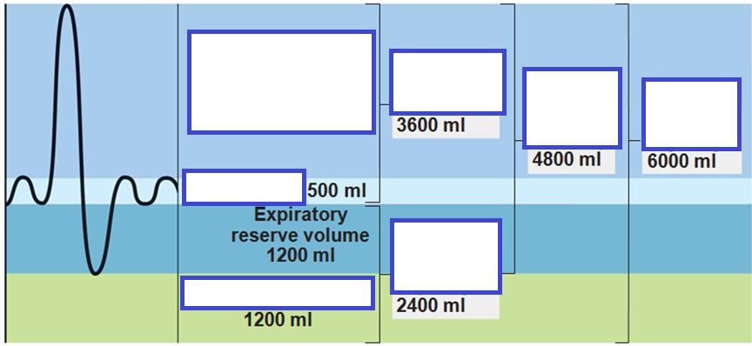

Pages 825 – 834 Gas Exchange
- During pneumonia and left heart failure, the respiratory membrane changes. How does it change and how do those changes alter their functions?

- Which gas has a steeper partial pressure gradient in the lungs? Oxygen or Carbon Dioxide?

  - What makes the oxygen diffuse quickly?

  - What makes the carbon dioxide diffuse quickly?

- What does perfusion mean?

- During internal respiration, where is the oxygen partial pressure higher? The blood or the cells? Which way do you expect the O₂ to diffuse?

- What two means do we use to transport O₂ in the blood?

- What is BPG? Where does it form, and what does it do to O₂ affinity to hemoglobin?

- How does Carbon Monoxide cause hypoxia? (What is hypoxia?)

- What are the three ways in which Carbon Dioxide is transported in the blood?

- Where is the most efficient place to transform CO₂ into a bicarbonate ion? What enzyme makes this possible?

- What is the point of the chloride shift?
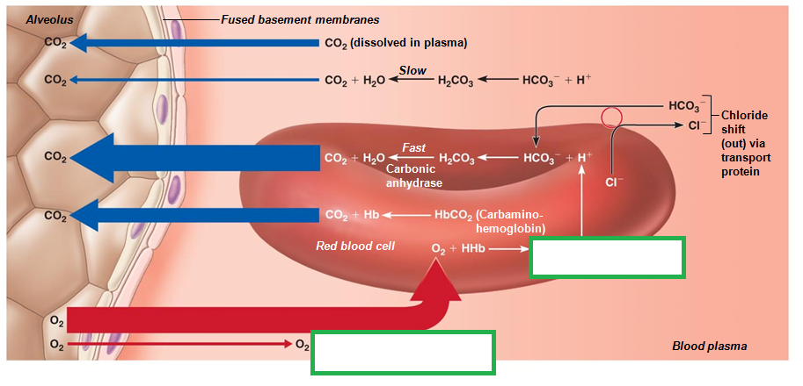

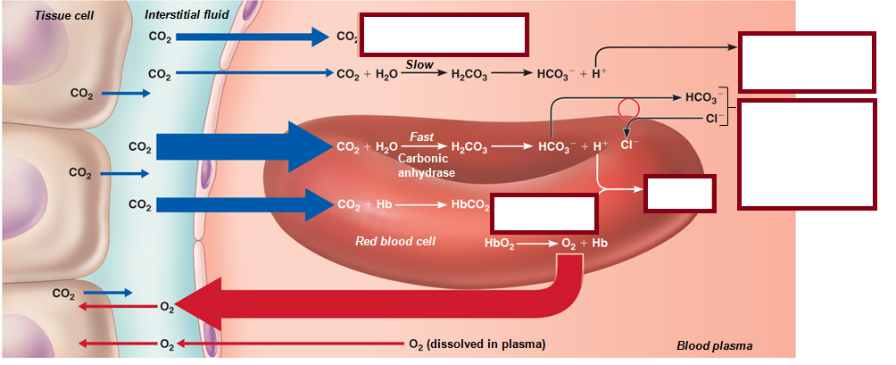

Pages 835 - 841 Factors that control respiration

- Where are the central chemoreceptors located?

  - What are they most sensitive to?

- Where are the peripheral chemorecptors located?

  - What are they most sensitive to?

- What is hyercapnia?

- What is the relationship between elevated CO₂ levels and H⁺ ions?

- Outline the sequence of events that happens when a person with anxiety hyperventilates. How do the changing gas levels trigger which changes?

- What is “apnea”

- The Limbic System includes the hypothalamus as well as other brain regions; it gives us some of our emotional responses. How does the hypothalamus/Limbic region cause us to alter our breathing?

- What is hyperpnea? How does it differ from hyperventilation?

- Which disorders are included in COPD? (What does COPD stand for?)

- What is dyspnea?

- What symptoms are seen with Asthma? What contributes to those symptoms?

- List the three types of lung cancers. Identify where and how they form.

Review/Read p 843 which outlines the interrelationships between the Respiratory system and the other body systems.

