Pages 850 - 854 Overview

- Label the structures indicated.

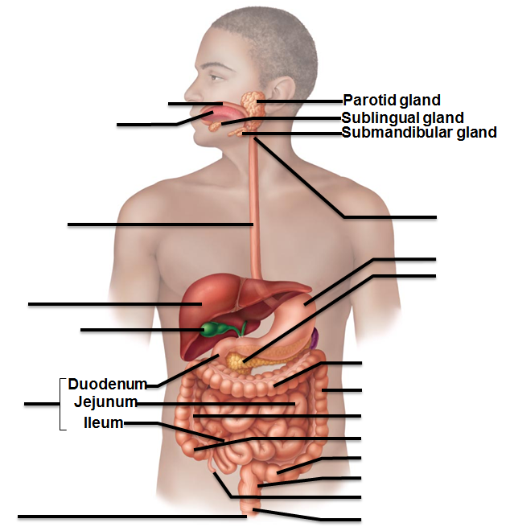

- What is the alimentary canal?

- Why is a “living” alimentary canal shorter than one from a cadaver?

- Why is the inside of the digestive tract (the lumen) considered an external environment?

- List and give a general summary of the six functions of the digestive tract

- What are the extrinsic controls of the digestive system activity? The intrinsic controls? Which is the “gut brain”?

- Compare the visceral to the parietal peritoneum.

- What is mesentery?

- Which organs are intraperitoneal and which are retroperitoneal?

- What causes peritonitis?

Pages 854 - 860
- What are layers of the alimentary canal?

- The mucosa is not just a layer of cells, but several layers of tissues. What three divisions are found within the mucosa and what do they do?

- How does the muscularis mucosae compare with this muscularis externa? How do their functions differ?

- Compare the locations of the submucosal nerve plexus with the myenteric nerve plexus. What is the function of each?

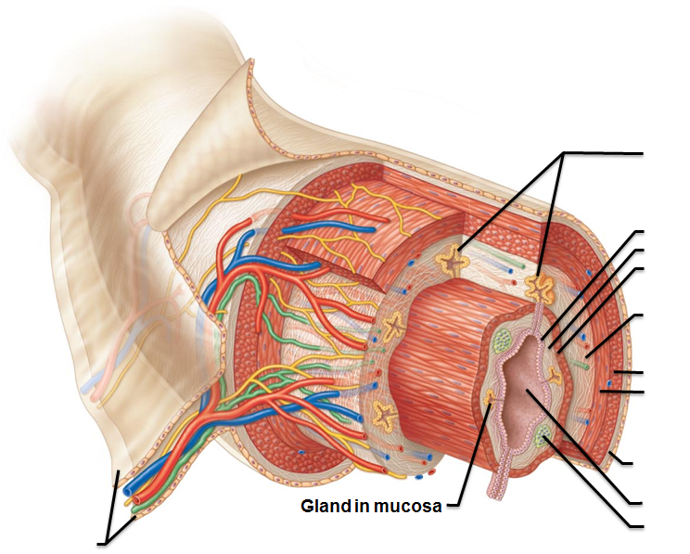
- Label the structures indicated.

- Which division of the autonomic nervous system will enhance digestive function?

- What type of epithelial tissues line the mouth? What advantage does this have?

- What function does the soft palate have?

- What is a bolus?

- Identify the structures indicated

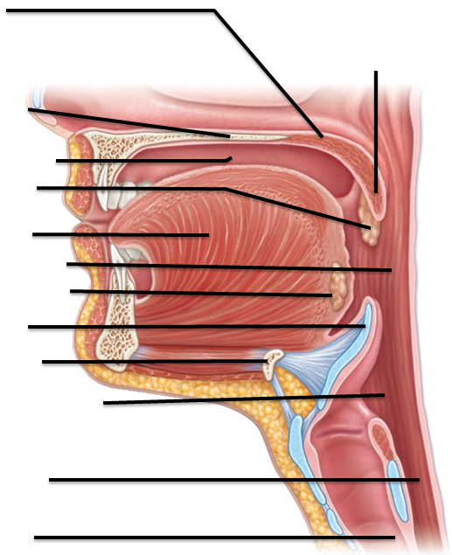

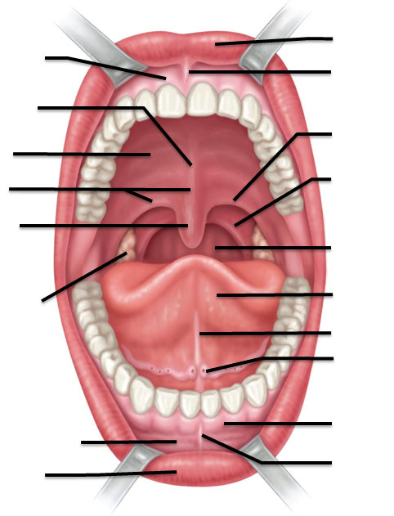

- What’s the difference between the intrinsic and extrinsic tongue muscles?

- Identify and list the various papillae on the tongue and their general function.

- What is lingual lipase and where does it function?

- Label the structures indicated on the image of the tongue.

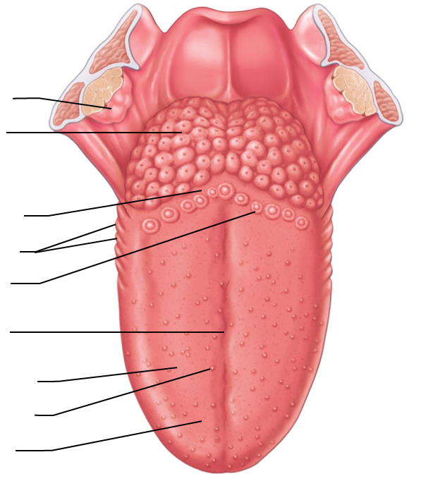

- Where is the parotid gland located? Which cranial nerve is nearby?

- Where is the submandibular gland located?

- What is the difference between serous cell and mucous cell production?

- How is saliva protective?

- What happens to our salivary glands and mouth when we are nervous, anxious, frightened, etc. and the sympathetic nervous system is activated?

- In the respiratory system, we talk about alveoli as the air-filled sacs for gas exchange. In the mouth/jaw, where and what are the alveoli?

- Label the structures indicated in the tooth below:

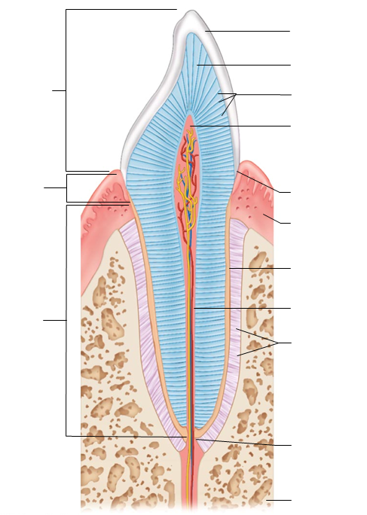

- Why, when our “baby teeth” fall out, do we only see the crown, but if as an adult we have a tooth pulled, it looks much different?

- List the shapes of the adult teeth and a general function:

- What is the gingiva? What is gingivitis?

Pages 862 – 877

- What is the esophageal hiatus?

- What type of secretions are produced in the esophagus and how does this product help?

- What is mastication?

- What is deglutition?

- Which phases are voluntary

- Which phases are involuntary?

- What is chyme

- What are the four regions of the stomach?

- Label the structures and regions of the stomach:
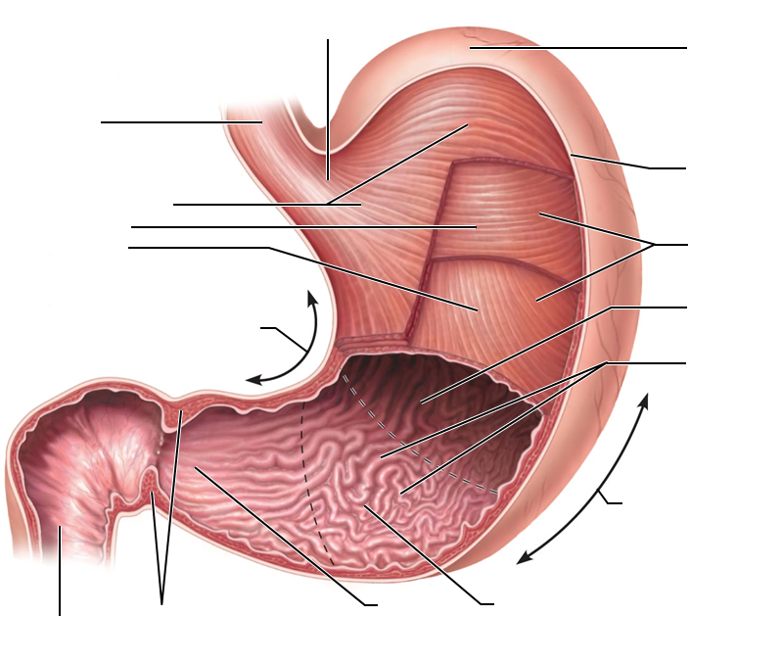

- What’s different about the muscularis layer of the stomach?

- List the cells found in the gastric glands and indicate their general function

- What is the function/advantage of the mucosal barrier?

- What triggers the cephalic reflex and what happens as a result?

- What triggers the gastric phase?

- What triggers the intestinal phase?

- Why is the stress-relaxation response important in the stomach?

- Compare how carbohydrates affect gastric empyting versus fatty foods.

- What is emesis?

As we look at the functions of the stomach, intestines, gall bladder, and pancreas, we will discuss or reference many of the hormones listed below. Hormone: circulated systemically (travels through the blood to the whole body) and Paracrine: (circulated locally through blood or fluids to nearby/neighboring structures. )

Hormone | Function
Cholecystokinin
Gastrin
Intestinal gastrin
Secretin
Somatostatin
Histamine

- What is the main function of the small intestine?

- What are the three regions of the small intestine?

- Where is the hepatopancreatic sphincter and what is its function?

- Compare the following structures: plica circulars, villi, and microvilli

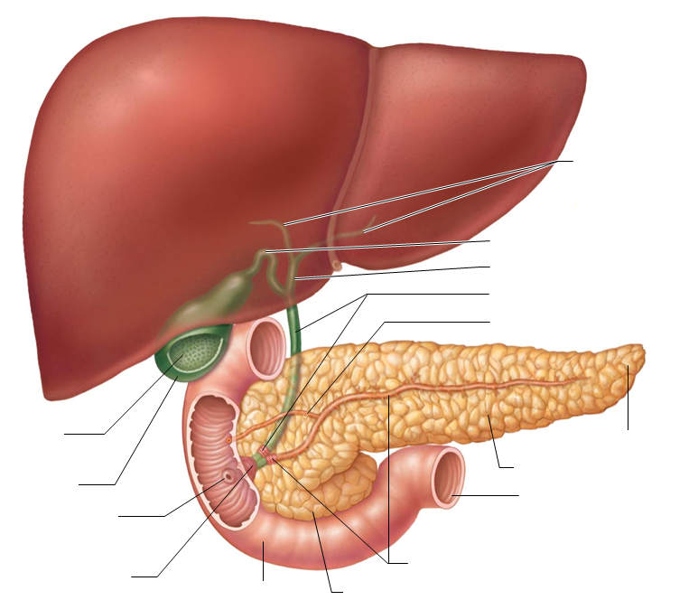

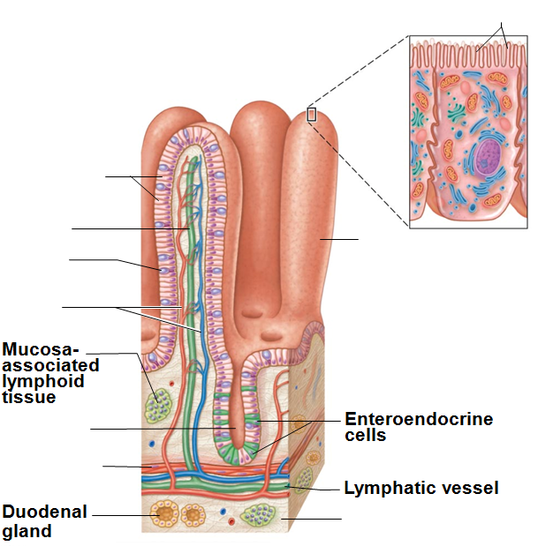

Pages 878 -886 Liver, Gallbladder, and Pancreas

- Review the gross anatomy of the lover on page 878. What is the term used to refer to “liver”?

- What are the bile canaliculi?

- Compare hepatitis to cirrhosis

- What does “caput medusa” translate to, and when it is seen?

- What is bile’s function?

- What does it mean to emulsify fats as opposed to chemically digest them?

- What are the functions of the gallbladder?

- What are biliary calculi?

- What are some complications of blocking the bile duct?

- What are the pathways out of the pancreas and into the duodenum called? List the ducts and the sphincters.

- Compare the endocrine products of the pancreas to pancreatic juice.

- What’s the pH of the pancreatic juice? Is this alkaline or acidic? How does that compare to the pH of the gastric juice?

- What is the effect of CCK (Cholecystokinin) on the gallbladder and neighboring structures?

- How does Secretin compare in function to CCK? (what are their targets and triggers?)

- At the duodenum, which categories (carbohydrates, proteins, nucleic acids, and lipids) are completely digested? Partially digested? Not digested at all?

- Compare segmentation to peristalsis in terms of locations and type of movement.

Pages 886 - 892 Large Intestine

- What is the gastroileal reflex? (what’s the trigger and what’s the result?)

- What are the functions of the large intestine?

- Where is the vermiform appendix located, and what is its function?

- Why can a ruptured appendix be life threatening?

- Increasing intra-abdominal pressure causes gas to be expelled from the body. Increasing the intra-abldominal pressure causes feces to be expelled from the body. Why can gas be expelled independently from the feces? (without feces being expelled at the same time)?

- Label the structures indicated in the image

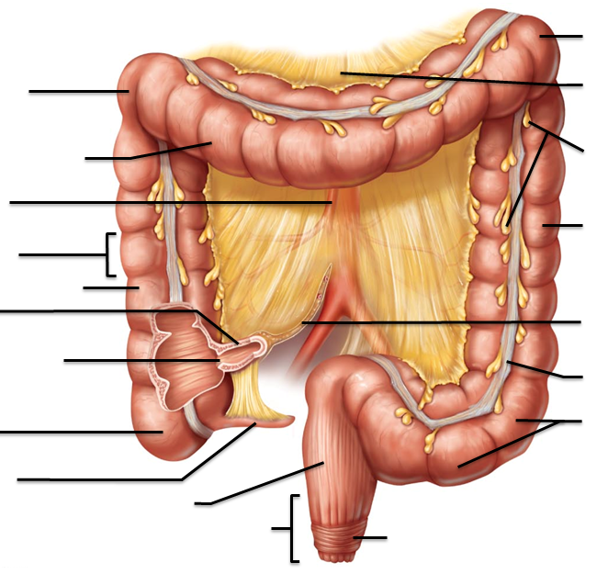

- Compare the internal anal sphincter to the external anal sphincter. What types of muscle are they composed of, and what controls them?

- What is the function of mucus in the large intestine?

- What are the functions of the anal sinuses?

- Which superficial veins can become hemorrhoids? What are hemorrhoids?

- What is “bacterial flora”?

- How is the gastocolic reflex related to Mass movements?

- Identify the structures indicated below:

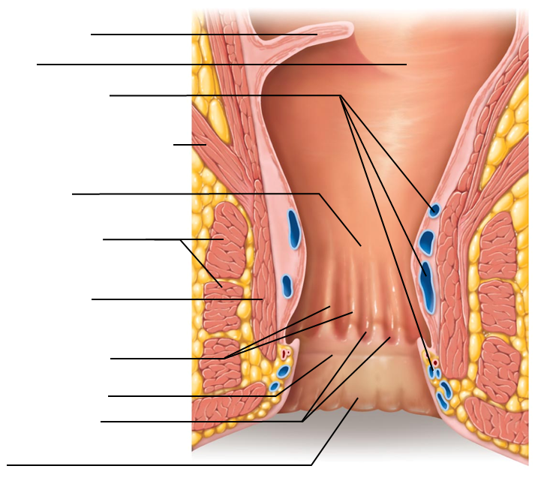

- What’s the difference between diverticulosis and diverticulitis?

- What pathways and structures are involved in the defecation reflex?

- What conditions in the digestive system trigger diarrhea? Constipation?

Page 893 -
Compound | Where is it digested? | Where is it absorbed?
Carbohydrates:
glucose and galactose
Whole proteins
Amino acids
Fats
monoglycerides and fatty acids
Nucleic acids

- What is another term for Celiac Disease?

- How does the gluten sensitivity compromise nutrition absorption?

Pages 904-905, Clinical Terms:

- What is an “ascites” and which conditions is it associated with?

- What is “bruxism?”

- What is “dysphagia:
  - Dys:

  - Phag

- What conditions/disorders are associated with Inflammatory Bowel Disease?

- What is a peptic ulcer?

- What happens with a pyloric stenosis?

- What is a vagotomy and when is it performed?

- What is xerostomia
  - Xer/zer:

  - stom

  - what causes it?

