Pages 954 - 957 Kidney anatomy

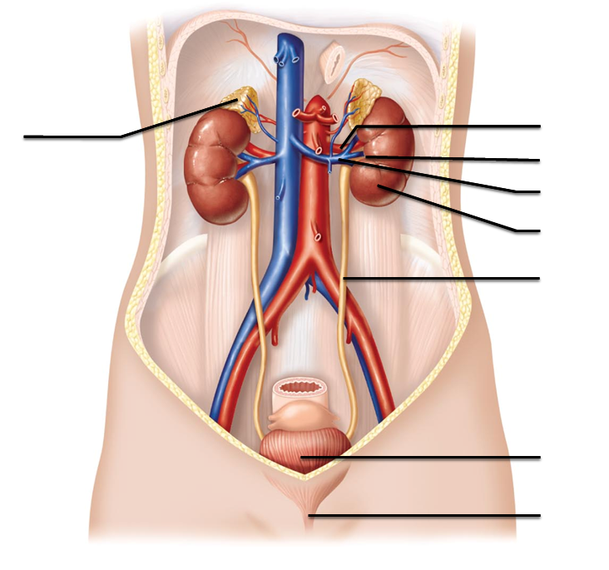
- Label the structures indicated

- One of our kidneys is lower (more inferior) than the other. Which one and why?

- What is the function of the perirenal fat capsule?

- What are the three regions of the kidney seen with a frontal section?

- Identify the structures
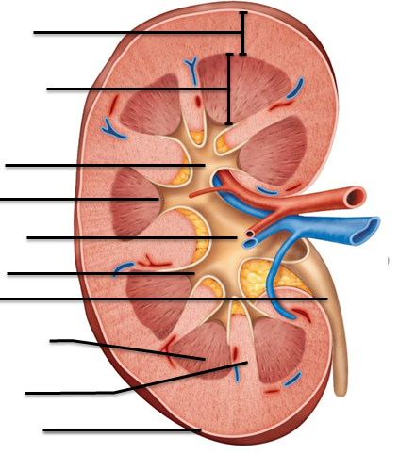

- Describe the location of the cortex. The medulla. And the Pelvis.

- What are the calyces?

- What is the difference between pyelitis and pyelonephritis?

Pages 958 – 963 Nephrons

- What is a nephron?

- What is the glomerulus?

- “glom” =

- The Glomerular capillaries are designed for filtration. What type of capillaries would you expect to find here?

- Identify the structures of the nephron below
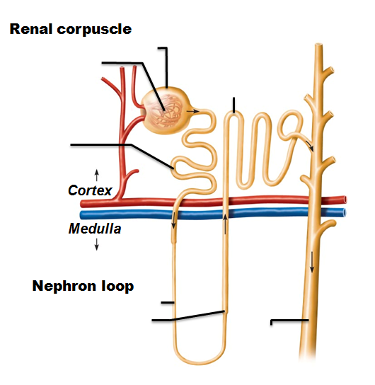

- What are podocytes and where are they found?

- What are the three regions of the renal tubule?

- What advantage does having a brush border/microvilli have in the in proximal convoluted tubule?

- How do the cells of the DCT compare to the PCT?

- The collecting ducts fuse together to become what structure?

- Compare the placement and function of a cortical nephron versus a juxtaglomerular nephron

- The renal tubules are dedicated pathways for the filtrate/urine. What are the capillary structures associated with the nephrons?

- What regions of the nephron are used to make the juxtaglomerular apparatus (complex)?

- What are the three types of cells of the juxtaglomerular apparatus/complex and what are they responsible for?

Pages 963 – 972 Urine Formation

- List and outline the main events of each of the three stages of urine formation

- Compare “filtrate” to “urine”

- What is hydrostatic pressure? How does it affect glomerular filtration?

- Glomerular filtration rate shares a direct relationship (when they go increase, the GFR increases) with which factors?

- What is renal autoregulation? When is it used?

- With what type of blood pressure change does the autoregulation method fail?

- How does the sympathetic nervous system impact nephron function?

- Triggering the Renin-Angiotensin mechanism causes what type of change with blood pressure and blood volume?

- The second stage of urine formation is tubular reaborption. What is “reabsorption?”

- What are aquaporins? What is the relationship between aquaporins and ADH?

- What happens when the transport maximum is reached/exceeded?

- Discuss how the following hormones affect the Distal Convoluted Tubule and the Collecting Duct
Hormone | Affect on Tubule? | Outcome?
ADH
Aldosterone
ANP

- How does tubular secretion deal with K⁺ and H⁺?

Pages 976- 985
- What steps are taken in the nephron if we have too much water in our system? Too little?

- What does a diuretic do?

- Why would renal clearance test be performed?

- What happens to filtrate formation during Chronic Renal Disease?

- What is “uremia”?

- What is urochrome, and where does it originate?

- What is the pH range for urine?

- What is specific gravity? What does a specific gravity test tell us about urine?

- What layers do the ureters have?

- What are “renal calculi” and what triggers their formation?

- What is the condition called if red blood cells are in the urine? White Blood cells? Glucose?

- What is the “trigone” and how is it important clinically?

- Identify the structures indicated:

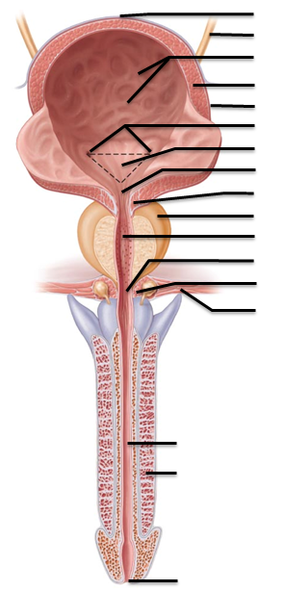

- Identify the following structures:
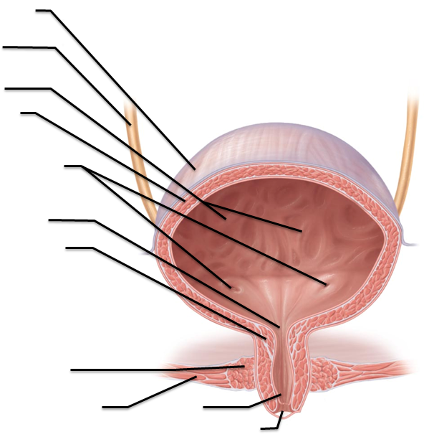

- What is “dysuria”?

- Why are women more prone to urinary tract infections than men? What factors increase the risk of infection?

- What is “micturition”

- Compare stress incontinence to overflow incontinence

- What is hypospadias?

- Compare autosomal dominant polycystic kidney disorder to autosomal recessive.

Related Clinical Terms, page 988

- What is a cystocele?

- What is nocturnal enuresis?

- What is a Renal Infarct?

- Label the image below from page 962
