Pages 1018 – 1026 Male Reproductive Structures

- What is the relationship between gonads and gametes?

- What advantage is provided by the location of the scrotum?

- Identify the structures indicated

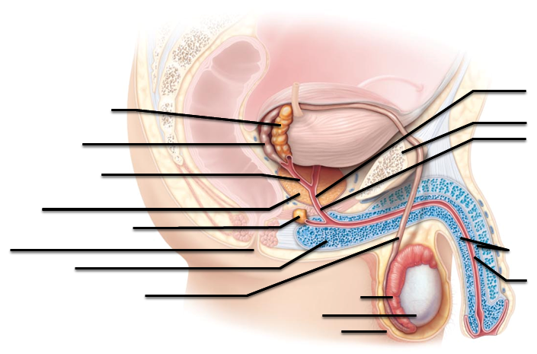

- Compare the Dartos muscle to the Cremaster muscle

- Where does the tunica vaginalis orginate?

- What is the function of the myoid cells?

- Label the structures indicated

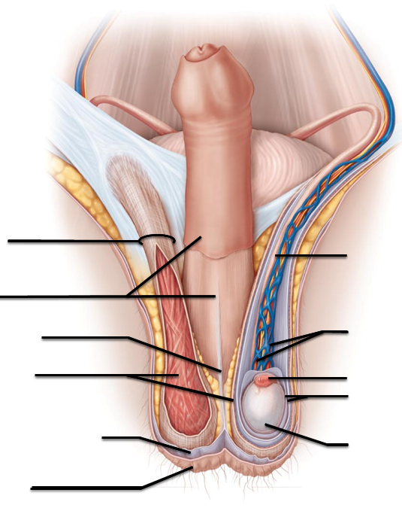

- What is the pathway from the seminiferous tubule to the epididymis?

- What is the function of the interstitial endocrine cells? Where are they located?

- Identify the structures indicated
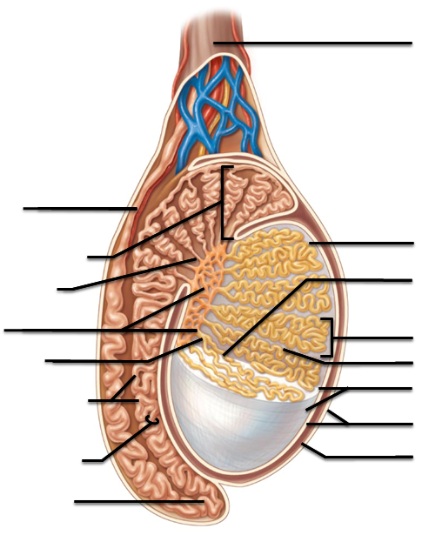

- What is the function of the pampiniform plexus?

- Where is the perineum located?

- Which structures in the male make up the external genitalia?

- What are the erectile tissues in a penis?

- How does the corpora cavernosa compare with the corpus spongiousum?

- Identify the structures indicated
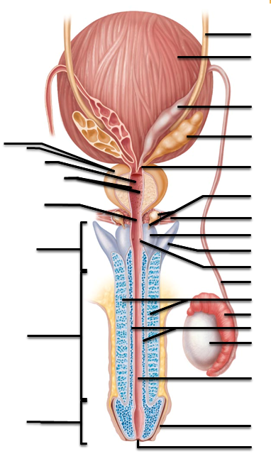

- How long can sperm be stored in the epididymis? What happens to them beyond that point?

- What are the three sections of the urethra?

- Describe the seminal gland (seminal vesicle) secretions? What advantages do they provide for the sperm cells?

- What are the different varieties of prostatitis?

- What does BPH stand for? What do hypertrophy and hyperplasia mean?

- Which populations are at a higher risk for prostate cancer?

- What is the location and function of the bulbourethral gland?

- What is the benefit of semen coagulating upon being deposited in the female reproductive tract?

Pages 1026 - 1033 Male physiology and spermatogenesis
- How is the autonomic nervous system utilized during the male sexual response?

- Following orgasm, what is “resolution”?

- What does it mean for a cell to have a diploid number?

- Compare spermatogenesis to spemiogenesis

- How many functional cells are produced following male meiosis?

- What significant events happen during prophase I only?

- Where in the body are the type B daughter cells located?

- What’s the difference between a primary spermatocyte and a secondary spermatocyte?

- What is the acrosome?

- What are alternate names for the sustenocytes?

- What are “xenobiotics” and what threat might they be providing?

Pages 1033 – 1035 Hormones

Hormone abbreviation | Hormone Name | Where does it come from | Where are the target cells/structures | What is the effect?
GnRH
FSH
LH or ICSH
 | Inhibin
 | testosterone
- What is a primary sex characteristic?

- What are the male secondary sex characteristics?

Pages 1035 – 1041 Female anatomy
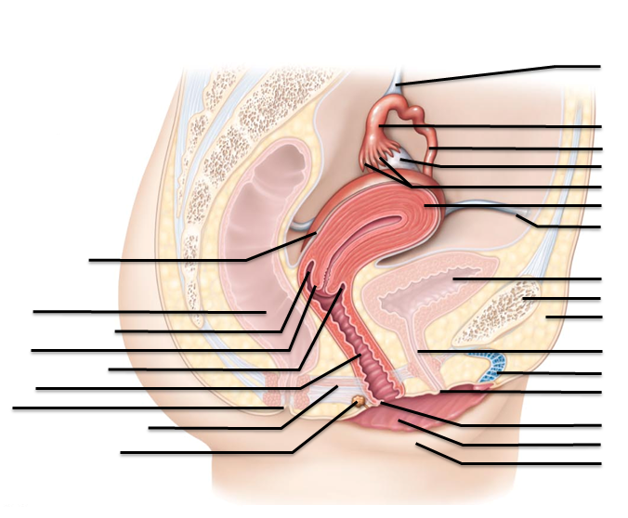
- Identify the structures indicated

- In what region of the ovaries are the follicles located?

- What’s the difference between granulosa cells and follicle cells?

- What does “corpus luteum” translate into?

- What are the parts of the fallopian tubes?

- What function do the cilia have within the fallopian tubes?

- Identify the structures indicated

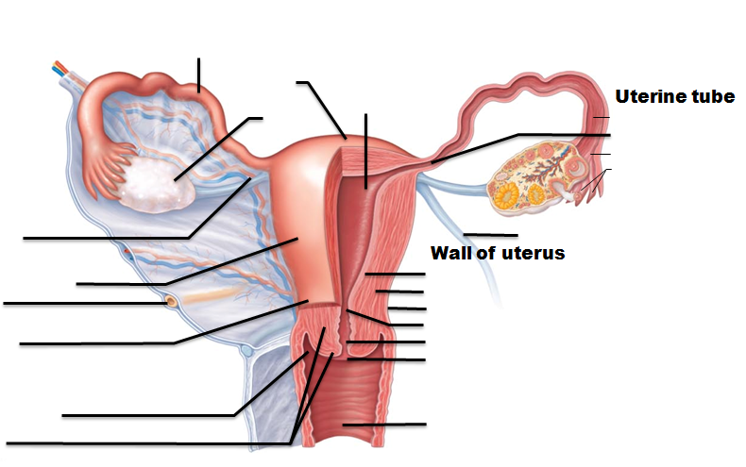

- What are the regions of the uterus?

- What is “prolapsed of the uterus”?

- Compare stratum functionalis to stratum basalis.

- What are the roles of the straight arteries? The spiral arteries?

- What glands are located within the vaginal mucosa?

- How does the vaginal canal promote/maintain its low pH (acidic environment)?

- Why may sexually active adolescent girls be more prone to STDs (STIs)?

- What is the hymen?

- Where is the fornix?

- Which structures are associated with the vulva?

- Where is the fourchette?

- What structure/tissue is shared both by the clitoris and the penis?

Pages 1041 – 1043 Breast

- What are the functions of the sebaceous glands in the areola?

- What are some of the risk factors for breast cancer?

- What’s the difference between a simple mastectomy and a radical mastectomy?

Pages 1043 - 104 Oogenesis and Ovarian Cycl

- What are the oogonia?

- At what stage is the oocyte during ovulation?

- What event needs to take place in order for the secondary oocyte to complete meiosis II?

- When is the follicular phase? When is the luteal phase? Which of them can have variations in the length of time it takes to complete?

- What is the difference between follicular cells and granulosa cells?

- What is an antrum?

- How long is the corpus luteum functional, and what does it secrete?

- What role does leptin play in establishing the ovarian cycle?

- Identify the structures indicated in the image

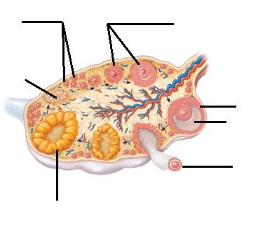

- What is the difference between fraternal twins and identical twins?

- What is menarche?

- What role does GnRH play in establishing the ovarian cycle?

- What is the uterus doing (what stage of the menstrual cycle) during

- Day one of the ovarian cycle?

- Day 7 of the ovarian cycle?

- Day 14 of the ovarian cycle?

- Day 21 of the ovarian cycle?

- What is amenorrhea?

- Why is the female growth spurt rapid, but short-lived?

- What are the metabolic effects of estrogen?

- How does the female sexual response compare to the male sexual response?

- What does “STI” mean? “STD”? “VD”?

- Which STIs discussed in lecture and the textbook are bacterial in origin?

- Which STIs have urethritis as a symptom?

- What is a chancre?

- Which STI is on the rise in the college-age population?

- What are the symptoms of that STI (from 82)

- How many women may be asymptomatic with chlamydia?

- Which STI is caused by a parasite rather than a virus or bacterium?

- Which of the STIs are viral in origin?

- On the Y chromosome, what does the SRY gene do?

- What structure is produced from the genital tubercle in the male? In the female?

- What structure is produced from the urethral folds in the male? In the female?

- What structure is produced from the urethral groove in the male? In the female?

- What structure is produced from the labioscrotal swellings in the male? In the female?

- What is the gubernaculums and what does it have to do with testicular descent before birth?

- What is the term for when the testes fail to descend?

- What physical changes occur in the female body with menopause and the loss of estrogen?

