Microscope Review

There will be many instances in BSC 181 and 182 where you will be asked to use a microscope. We’ll start off with the anatomy of a microscope, how to use one properly, and how to correctly stow one.
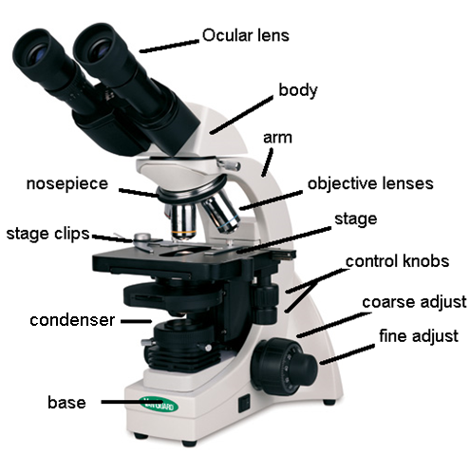

Features:
- Ocular lenses: These are the lenses that you’ll put your eye to. These lenses have a magnification factor of 10. Most of the microscopes in our lab have two ocular lenses. Some people find it more comfortable to look through both lenses with both eyes; others will look through only one lens. Do what works best for you. You’ll have less strain on your eyes if both eyes stay open.
- Nosepiece:
  - The nosepiece is the portion of the microscope to which the objective lenses are attached. The nosepiece rotates to allow the objective lenses to be used.
- Objective lenses: You will have three objective lenses that you’ll be using.
  - Scanning lens: this lens has a magnification of 4. However, since we need to take into account the magnification of the ocular lens as well, the total magnification for this lens will be 40X (4 X 10 = 40). This is the lens that you will start with to view your slides.
  - The scanning lens is the ONLY lens that you are able to use the coarse adjustment knob with. All other objective lenses will use the fine adjust knob.
  - Low power lens: The low power lens has a magnification of 10X, a total magnification of 100X (10 X 10 = 100) Use the fine adjust knob with the low power lens.
  - High power “High and dry” lens: The high power lens is the top magnification we’ll be using for this course. It has a magnification of 40X and a total magnification of 400X (40 X 10 = 400). Us the fine adjust knob with the high power lens
  - Oil immersion lens: We will not be using this lens in lab.
- Adjustment knobs
- Coarse adjust is the larger of the two wheels on the side. It moves the objective lenses up and down in order to focus. It is to be used ONLY with the scanning lens. Use with the low power or high power lenses can result in breaking both the glass on the objective lens as well as the slide itself.
- Fine adjust is the smaller of the two. It can safely be used with the low power and scanning lenses.
- Stage
- The stage is the platform on which your glass slide will rest. On the stage you will find a set of stage clips that will anchor the slide. Make sure your slide is securely fastened before moving the stage.

- Stage adjusting knobs
- You will find a set of knobs that will move the stage. One moves it forwards/backwards. The other moves it left/right.

- Light
  - Your microscope has a light at the bottom that shines up through the specimen. Under scanning power, the light may appear very bright, but as you increase magnification by using stronger objective lenses, the light appears to dim. The quality of the light can be modified using the microscope.
  - Abbe condenser: this condenser can intensify the light coming from the light source. It can be moved by using the knob below the stage. Use the Abbe condenser to improve contract in your field of view.

- Arm and Base
  - The arm is the backbone of the microscope. It attaches the body to the base. It is the arm that is used to transport the microscope. Always carry the microscope by holding both the arm and the base. The base is the bottom.

Tips for focusing and finding what you’re looking for:

- Before beginning, drop the stage down to its lowest position using the coarse adjust knob. Have the scanning objective lens in place. This gives you room to add the slide in later.
- Before you even put your slide on the stage, look at it to see where the specimen is on the slide. Position the slide so the specimen sits in the pool of light. This should help you line things up more easily when looking through the ocular lens.
- Focus using coarse adjust and scanning lens. Once you’ve got the image mostly focused with the coarse adjust, use the fine adjust to perfect it.
- In order to go from scanning power to low power, move the nosepiece and click the low power lens into position. You should not have to re-focus too much. At this point, use the fine adjust to bring the image back to clarity.
- The microscopes are parfocal scopes. This means when you focus at one magnification, the image stays mostly in focus as you move to the next level.
- Hint: As you go from scanning to low to high powers, you lose some of your field of view. Always center the structures that you are looking at so when you go from scanning to low power, it remains in the center of your field of view. This will prevent you from having to search for the structure on the slide.
- Hint: if you think you’ve found something on the slide, but you’re not sure, start by moving the stage to the left or right just a tiny bit. If the image in your field of view moves, you’re focused at the level of the slide. If you can move the stage, but the field of view stays the same, you’re focused on oil/debris on the objective lens and will need to refocus.

Endocrine System

Part 1: Information

Part 2: Histology

Part 3: Questions
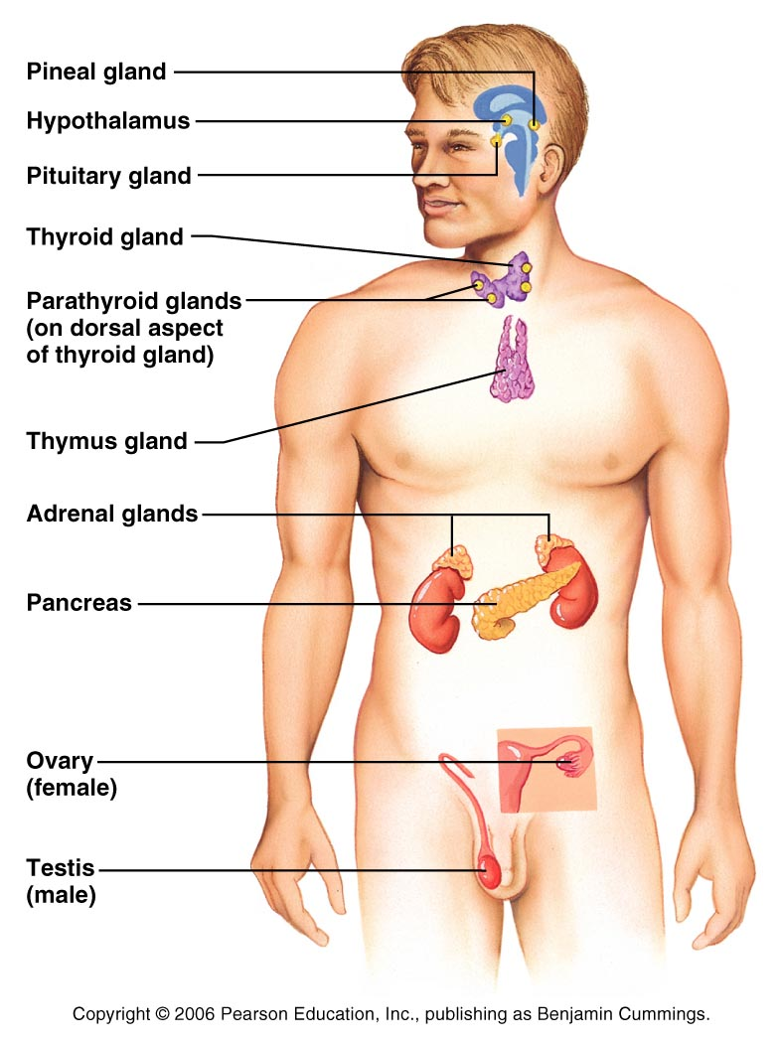

Part 1: Information

The endocrine system functions by releasing hormones into the bloodstream.

Hormones can be made from modified cholesterol or from amino acid building blocks. This separates the hormones into two main categories: steroidal (from cholesterol) and non-steroidal (amino acid/peptide/protein).

The endocrine glands include the pituitary gland, thyroid gland, parathyroid glands, adrenal glands, and pineal glands. These glands have one function: to produce hormones. Other organs have additional functions, and still have endocrine functions as well. These include the hypothalamus, thymus, pancreas, testes, ovaries, kidneys, stomach, liver, small intestine, skin, heart, adipose tissue, and placenta.

Part 2: Histology

Pituitary:

The pituitary gland is divided into anterior and posterior regions. The anterior region is linked to the hypothalamus by the hypophyseal portal. The portal provides a direct circulatory pathway between the hypothalamus and the anterior pituitary. There are a variety of releasing hormones (Ex: CRH, GnRH, GHRH) that come from the hypothalamus and target the anterior pituitary. The releasing hormones flow through the bloodstream to the target cells within the anterior pituitary. The hypophyseal portal goes to the anterior pituitary while the hypothalamic-hypophyseal tract goes to the posterior pituitary. The portal is a circulatory route; the tract is a neural one. The posterior pituitary is linked by a neural adaptation. Instead of the modified neuron releasing neurotransmitters, it releases hormones. The cell body of the neuron is in the hypothalamus while the hormones are released directly into the posterior pituitary.

On the image below, locate the following structures: anterior pituitary, hypophyseal portal, posterior pituitary, hypothalamic-hypophyseal tract

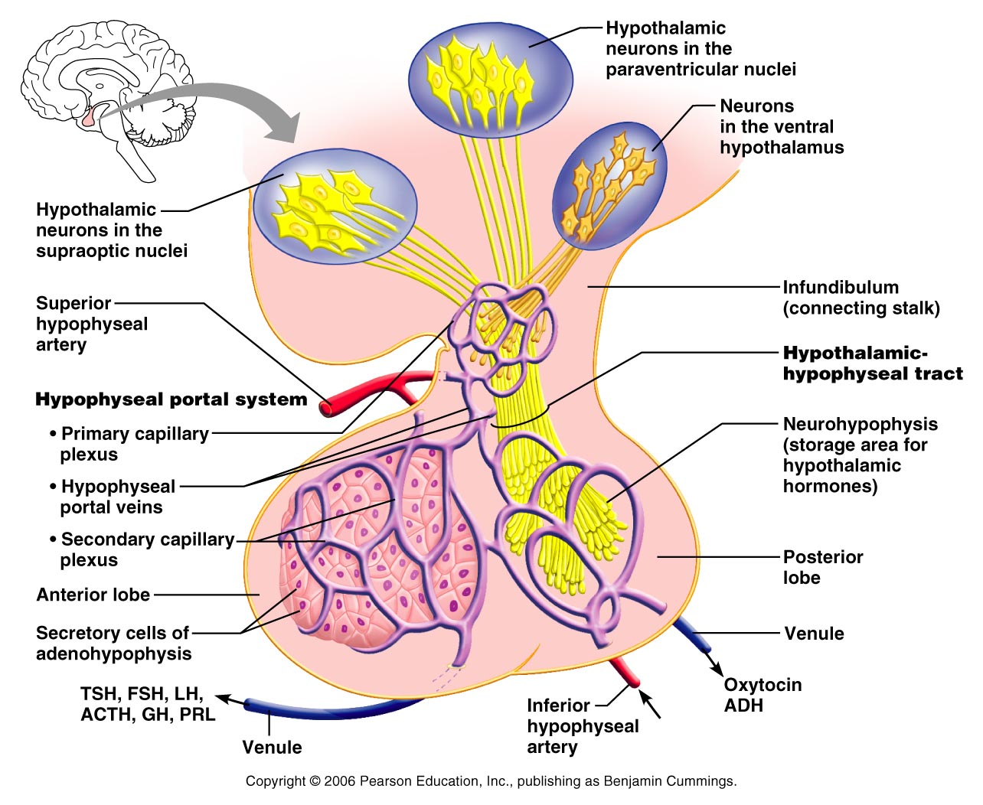

Pituitary gland
The pituitary gland is divided into two lobes: anterior and posterior. They have different appearances since they have different functions. The adenohypophysis (anterior) has a much more cellular appearance to it since it is responsible for manufacturing and secreting hormones. The neurohypophysis has fewer cells and glands and has a smoother appearance.

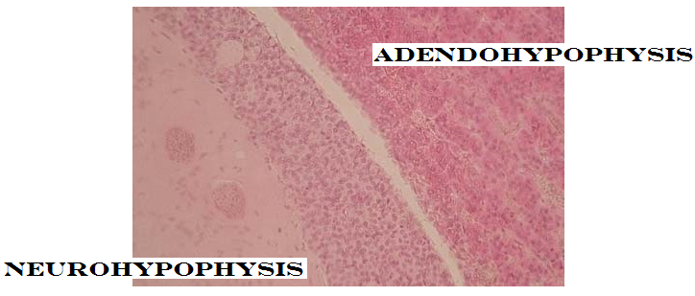

- View the Pituitary gland under scanning power (40X)
- Draw both anterior and posterior portions at 40X
- Identify and label anterior pituitary
- Identify and label posterior pituitary
- View the both anterior and posterior at 100X and then 400X. Look for the cellular arrangements that form glands in the anterior. Look for the neural cell bodies and the tracts in the posterior.

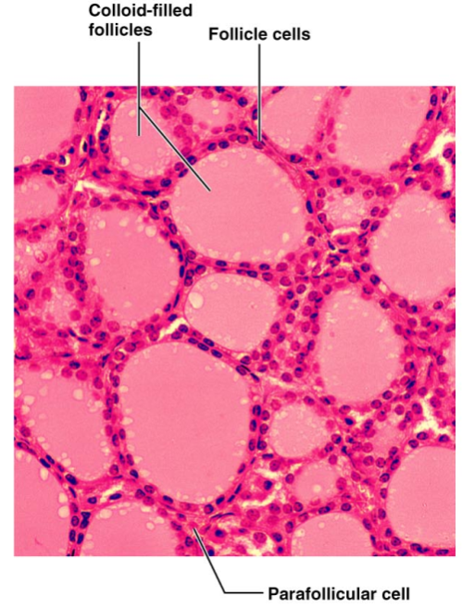
Thyroid

The thyroid gland consists of follicles that produce some of the thyroid hormones, and extrafollicular or parafollicular (outside/surrounding the follicle) regions that produce remaining hormones.

Thyroid:
- View slide under scanning power (40X) and then low power (100X) to observe the layout of the structures
- Go to high power to draw several follicles and extrafollicular cells
- Draw the image from your field of view in the space provided below
- Identify and label a follicle (the entire structure)
- Identify and label the follicular cells
- Identify and label the cavity of the follicle, filled with colloid
- Identify and label the extrafollicular (parafollicular) cells

Parathyroid

The parathyroid glands are located on the posterior surface of the thyroid gland. They house the chief cells and the oxyphil cells. The chief cells are known to produce the parathyroid hormone.
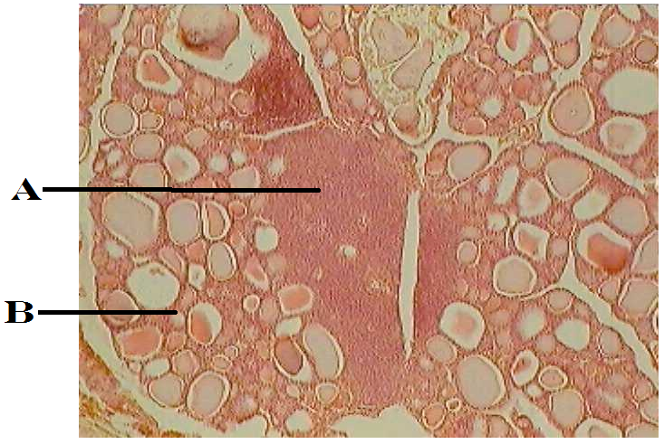

In the image to the right, the thyroid/parathyroid slide is viewed at 100X.

A is pointing to the parathyroid gland embedded within the thyroid gland.

B is pointing to the follicles of the thyroid gland.

Parathyroid
- Recall the parathyroid is embedded within the thyroid gland. You will use the thyroid slide to find the parathyroid.
- View the thyroid/parathyroid slide under scanning power. Look for the follicles of the thyroid gland. Find patches that appear more cellular and have no colloid-filled cavities. This will be the parathyroid gland.
- View the parathyroid gland under high power.
- You will may notice two different types of cells:
  - Parathyroid chief cells are small and darker. They manufacture parathyroid hormone
  - Oxyphil cells: are lighter staining and larger; their function is unknown
- Identify and label the structures of the parathyroid gland

Adrenal Glands

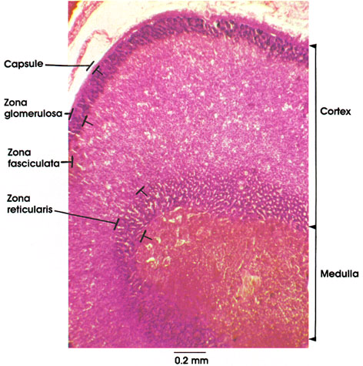
The adrenal glands are located superior to the kidney. Because of this, sometimes you will see them referred to as the “suprarenal” glands. The adrenal gland is divided into two regions: the cortex is the outer region and the medulla is the inner region. Both regions produce hormones

Cortical hormones:

Zoma Glomerulosa: Aldosterone
Zona Fasciculata: Cortisol
Zona Reticularis: Testosterone

Medullary hormones:

Epinephrine
Norepinephrine

The medulla contains cells called chromaffin cells and are directly controlled by the sympathetic fibers of the autonomic nervous system.

Adrenal Glands
- View Adrenal gland under scanning power
- Identify and label the cortex
- Identify and label the medulla

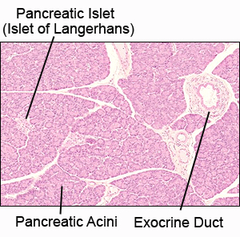
Pancreas

The pancreas releases both digestive enzymes (exocrine) and hormones for the control of glucose (endocrine). It is often referred to as a “mixed” gland or a heterocrine gland since it has both endocrine and exocrine function.

The alpha, beta, and delta cells are part of the pancreatic islets (Islets of Langerhans). These are not cells that you will be able to distinguish one from another on the microscope.

“Acini” is Latin for “berries.” The acinar cells have a clustered, berry-like arrangement. It is these cells that are responsible for the production of the exocrine secretions. These cells are stimulated by the hormones secretin and cholecystokinin to produce enzymes like trypsin, chymotrypsin, pancreatic lipase, and pancreatic amylase.

Pancreas
- View the pancreas slide under scanning power, low power, and then high power.
- Try to get a sense of the Islets and the Acini under scanning and low power before moving to high power
- Draw a section of pancreas as viewed under low power (100X)
- Identify and label the endocrine regions
- Identify and label the exocrine regions

Thymus

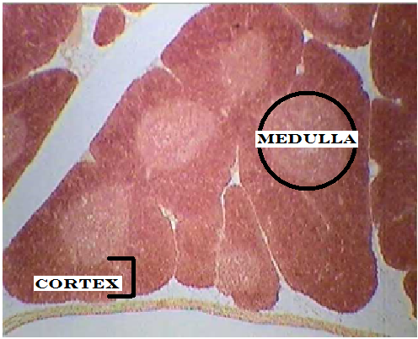
The thymus is a member of the lymphatic system. One of the unique aspects of this gland is its function is elevated in infants and children. As we age, we lose the function of our thymus and it eventually changes to fatty or fibrous tissue. The thymus is one of the locations where our lymphocytes (white blood cells) go to learn how to function. The thymus contributes to the endocrine system by producing thymosins.

The thymus is divided into lobes, and those lobes are divided into lobules. The lobules have follicles. The follicles are organized into a cortex and a medulla. The cortex is located on the outer rim of the follicle (or nodule) and the medulla is the central portion.

Cortex

Stains darker
Lots of lymphoid cells
Lymphocytes start their education here. These cells are called thymocytes. They can eventually become T-cells (a type of lymphocyte) or Natural Killer cells.

Medulla

Stains lighter
Thymocytes continue/finish their education here.
Contain structures called Hassall’s corpuscles

Thymus
- View the thymus under the scanning power (40X) to see the nodules
- Identify and label the cortex
- Identify and label the medulla

Testes
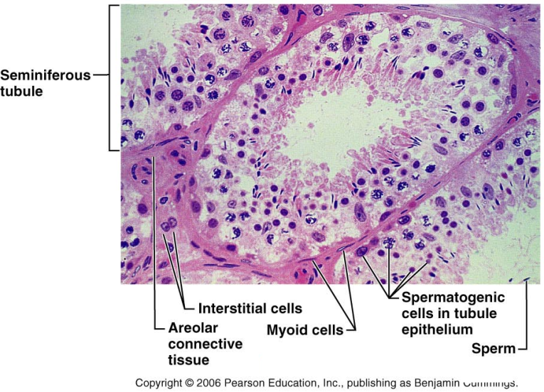
The testes are paired oval glands that are located within the scrotum. They are responsible for the production of sperm as well as the production of testosterone. The seminiferous tubules are responsible for the manufacture of the sperm cells. Between the tubules are the interstitial cells (Cells of Leydig) which are responsible for releasing testosterone.

Testes
- View the testes slide under scanning power. (40X) You should notice a field of view that contains many circular structures. These structures are the seminiferous tubules. It is within these structures that sperm cells are created (spermatogenesis).
- View the slide under low power (100X) and (400X) and look for cells in between the spheres. These are the interstitial cells. They create and release testosterone.
- Identify and label a seminiferous tubule
- Identify and label interstitial cells
- Identify and label the lumen of the seminiferous tubule
- Identify the sperm cells (spermatids)
- Identify and label the spermatagonia (spermatogenic cells)

Ovaries
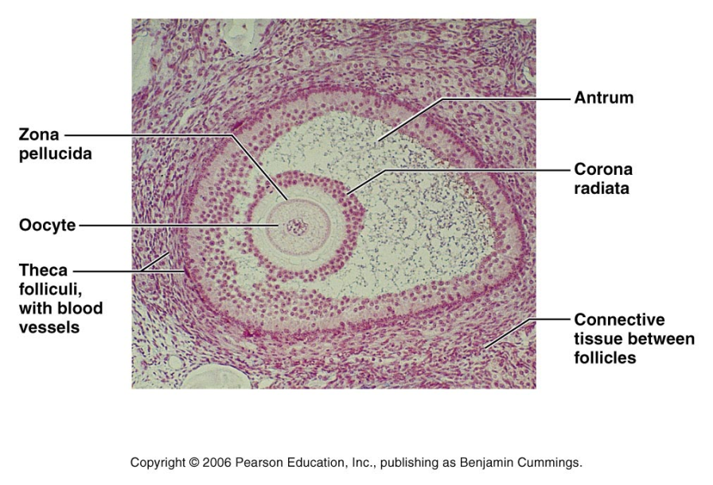
The ovaries are the female gonads. They are located within the pelvic cavity. The ovary, much like the adrenal gland is divided into cortex and medulla. The ovarian cortex is where the egg/oocyte develops. The oocyte is surrounded by cells. When there is a single layer of cells, they are called the follicular cells. When they layers become more numerous, they are called granulosa cells. It is the follicles that are responsible for the production of estrogen.

The ovary is another structure that is divided into a cortex and medulla.

The cortex along the outer surface is the region in which the oocytes (ova) develop. In any slide, you may notice different stages of the follicles.
The medulla is the inner region and can be hard to identify. The medulla does not contain follicles.

Ovary
- View the ovary under scanning power (40X) to see the cortex and follicles
- View the ovary under low power (100X)
- Identify and label the ovarian cortex under
- Identify and label an oocyte
- Identify and label a follicle

Part Four: Questions: Use your lab notes, your lecture notes, and your text book to find the answers to the following questions. Please make sure your questions are complete before leaving lab.

- List the five cell types in the anterior pituitary.

- List the six hormones that are released from the five cell types.

- List the functions of the hormones released from the anterior pituitary

- What are some of the differences between anterior and posterior pituitary?

- Which hormones are released from the posterior pituitary?

- Where are the posterior pituitary hormones made?

- What are the functions of the posterior pituitary hormones?

- Which hormones are produced at the thyroid follicles?

- Which thyroid hormone is extrafollicular?

- What are the functions of the thyroid hormones?

- Which cells produce parathyroid hormone?

- What is the function of parathyroid hormone?

- Which hormones are produced from the adrenal cortex? What are their functions?

- Which hormones are produced from the adrenal medulla? What are their functions?

- Which hormones are released from which cells of the pancreas?

- What does heterocrine mean?

- What are the functions of the hormone release from the pancreas?

- Other than in the testes, where is testosterone produced?

- What are the layers of the ovary? What functions do they have?

- What function does estrogen have?

- Which hormones are produced at the thymus? What functions do they have?

When you are done with the microscope for the day, complete the following checklist:

_____ turn off the light
_____ remove the slide
_____ drop the stage to the lowest position
_____ put the scanning objective lens in place
_____ secure the cord
_____ stow the microscope carefully

