!!Incorporate Nerve/neuron images into updated lab manual
Nerve and Special Senses

Peripheral Nerve
Examine the peripheral nerve cross section at 40X (scanning power). Try to discern the axon bundles/fascicles. Bringing the magnification up to high power (400X) will help you see the individual axons.
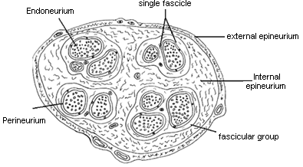

Draw the peripheral nerve at 40X
Label as many features as you can identify

Draw the peripheral nerve at 400X
Label as many features as you can identify

Answer the questions using your lab manual, your text book, and your lecture notes. Answer the questions before leaving lab.

What is the function of the myelin sheath?

What cell type is responsible for the myelin sheath in a peripheral nerve? In a CNS nerve?

Where do we commonly find multipolar neurons?

Where do we commonly find bipolar neurons?

Where do we commonly find unipolar neurons?

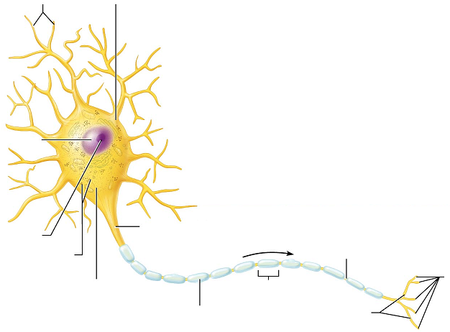

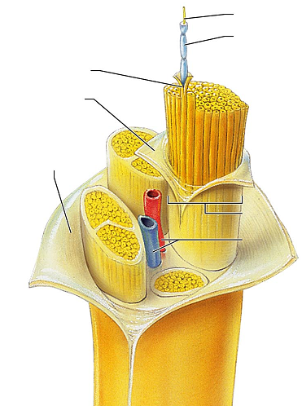

Spinal Cord
Microscope: View the prepared slide of the spinal cord and draw it. Identify white and gray matter, anterior and posterior horns, gray commisure, central canal

40X

400X

View the ox spinal cord slide. View and identify the dendrites, soma, and axons. Also present will be some glial cells.

What type of material composes the gray matter of the spinal cord?

What type of material composes the white matter of the spinal cord?

What is the location and function of the dorsal root ganglion?

Review the illustration of the spinal cord from the brain lab. You will be responsible for that anatomy.

Monosynaptic reflexes
In monosynaptic reflex like the patellar reflex, the impulse has only to cross one synapse (mono = one). We can see this type of reflex arc in the stretch reflexes of our muscles.
The stretch will be caused by the reflex hammer or the hand striking the tendon. This stimulation will cause the afferent fiber to send an impulse towards the CNS. Once at the CNS (note that here the CNS is the lumbar spinal cord… NOT the brain) the afferent fiber will synapse with the efferent fiber. Recall that the efferent fiber is the motor fiber. The motor fiber will run to the effector (the quadriceps) to create the leg extension. There will also be motors running to the antagonists (hamstrings) to keep them relaxed so the quadriceps can extend the leg.
Exercise: tap the patellar reflex
- Have your lab partner sit in a location where they can sit comfortably upright while the lower legs can freely swing.
- Locate the patella. Find the tendinous depression immediately inferior to the patella
- Stand off to the side of your lab partner. Recall that the goal here is leg extension, and you don’t want to be standing in the way.
- With a reflex hammer or with the side of your hand, quickly strike the tendons.
- Note: The strike must be rapid and with a moderate force. Your goal is to see the reflex, not harm your lab partner. Keep in mind that your lab partner will be testing the same reflex on you in a bit.
- Repeat the process on the opposite leg, and then switch so your lab partner can try it on you.
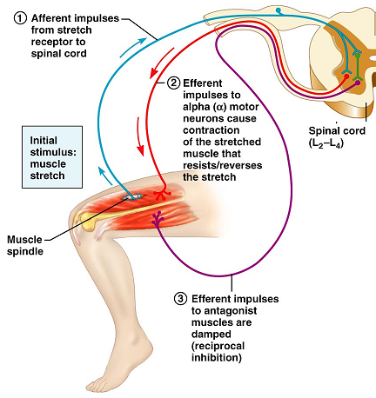

Pacinian Corpuscles
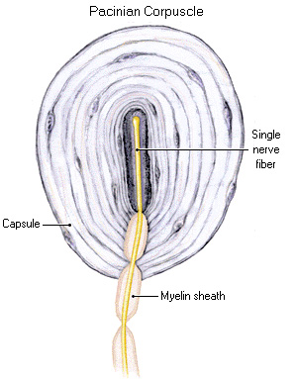
Pacinian corpuscles are exteroreceptors scattered deep in the dermis and subcutaneous tissues. They consist of a sensory dendrite surrounded by layers of flattened cells and layers of collagen fibers that form an egg-shaped capsule. They are receptors for vibration and touch. To locate the Pacinian Corpuscle on the slide, find the yellow curved structure (fingernail on the slide) and look deep to it. The corpuscles are encapsulated by the Schwann cells which creates the layers of the capsule.

Try to identify and label the
following structures in your drawing:

Fingernail
Keratinized epithelium
Schwann cells
Adipose tissue
Sweat glands

Answer the following questions:

Would the fiber that runs from a Pacinian corpuscle be afferent or efferent?

Would it be considered part of the Central Nervous System or the Peripheral Nervous System?

Exercise: Cutaneous Sensation
It is important for the sensory receptors to be able to sense the pressure, vibration, temperature, sharp and dull, but it is also important where in the CNS those impulses get sent. Our sensory receptors are not evenly distributed; some areas are more sensitive than others. Some areas of our bodies are better mapped in the brain than others. We can demonstrate this with the following exercise.

Materials needed:
Lab partner
Pencil or pen. (You’ll be marking on your skin, so make sure it’s an ink that will wash off. )
Ruler/measuring tool

- Ask your lab partner to close his/her eyes.
- Place a mark with the pen or pencil on the anterior forearm
- With eyes still closed, have your lab partner add a mark as close as possible to the original mark.
- Measure the distance between the two marks in millimeters
- Repeat the procedure for each of the following locations:
  - Posterior calf
  - Back of the neck
  - Palm of hand
  - Dorsum of hand (back of hand)
  - Fingertip
  - Anterior thigh (if accessible)

Region | Error of Localization in mm
Anterior forearm
Posterior calf
Palmar surface of hand
Dorsum of hand
Fingertip
Back of neck
Anterior thigh

In which area were you most accurate?

In which area were you least accurate?

What would be the advantage of having some areas more sensitive than others?

To which area of the brain are these impulses being sent?

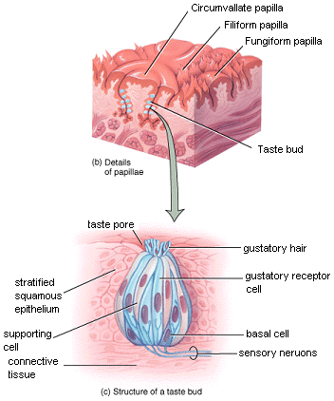

Taste buds
Recall that the term “papillae” means projection. In the tongue’s papillae we will find the gustatory cells or taste cells. When these cells are exposed to food the stimulation results in a signal being sent to the brain.

View the slide of the rabbit tongue.
Try to locate the stratified squamous epithelium, the papillae, and the taste buds.

