Cardiovascular system: Blood Vessels

Part One: Information
Part Two: Images
Part Three: Pulse
Part Four: Blood pressure
Part Five: Cat
Part Six: Questions

Part One: Information
The blood vessels are the roadways of the circulatory system. They are the pathways that the blood takes to get to its destination. The blood vessels that carry blood away from the heart are the arteries. The blood vessels that return blood to the heart are the veins. In terms of the blood, the destination is the capillary. There are capillaries in the lungs (pulmonary capillaries) and there are capillaries in the body (systemic capillaries). It is in these capillaries that gas exchange takes place. Oxygen is picked up and put into the blood stream in the pulmonary capillaries; oxygen is dropped off at the cells at the systemic capillaries.

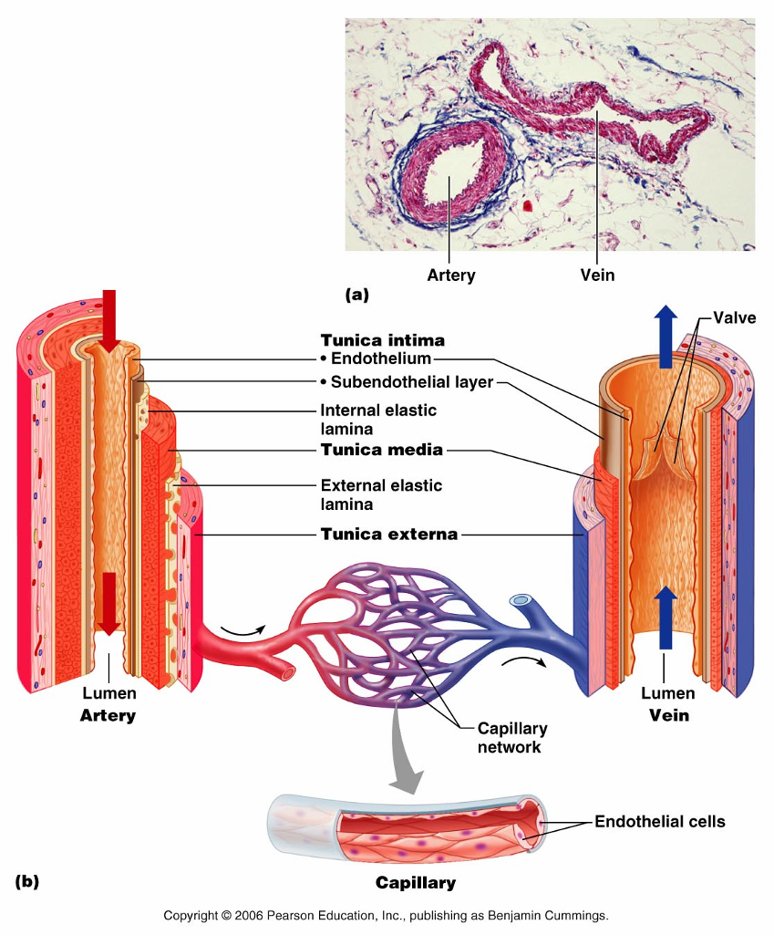
Arteries and veins share similar anatomic layers. Each has three tunics: Tunica intima (interna), tunica media, and tunica externa (adventitia). The main difference is in the amount of smooth muscle in the tunica media. Arteries have a great, thick layer of smooth muscle. This gives them greater integrity, resilience, and firmness. Veins have a thin tunica media, but they also have valves to control the direction of the blood flow.

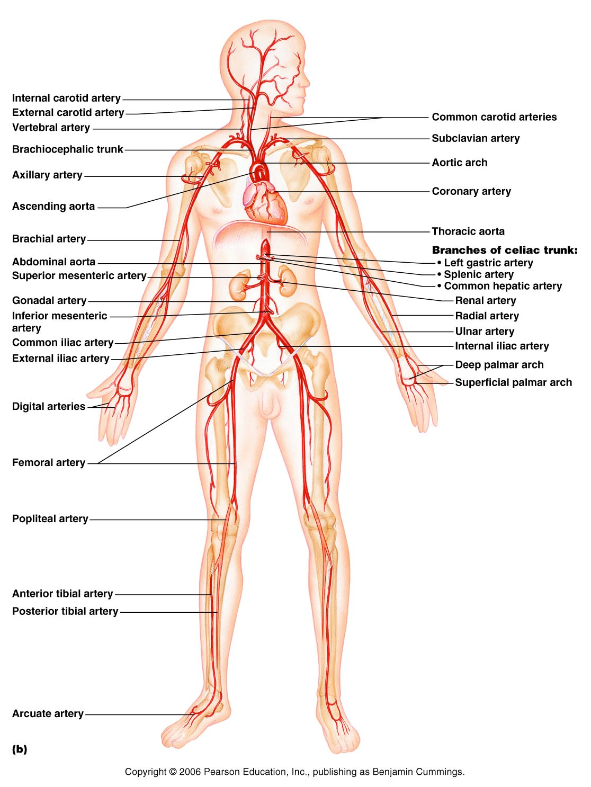
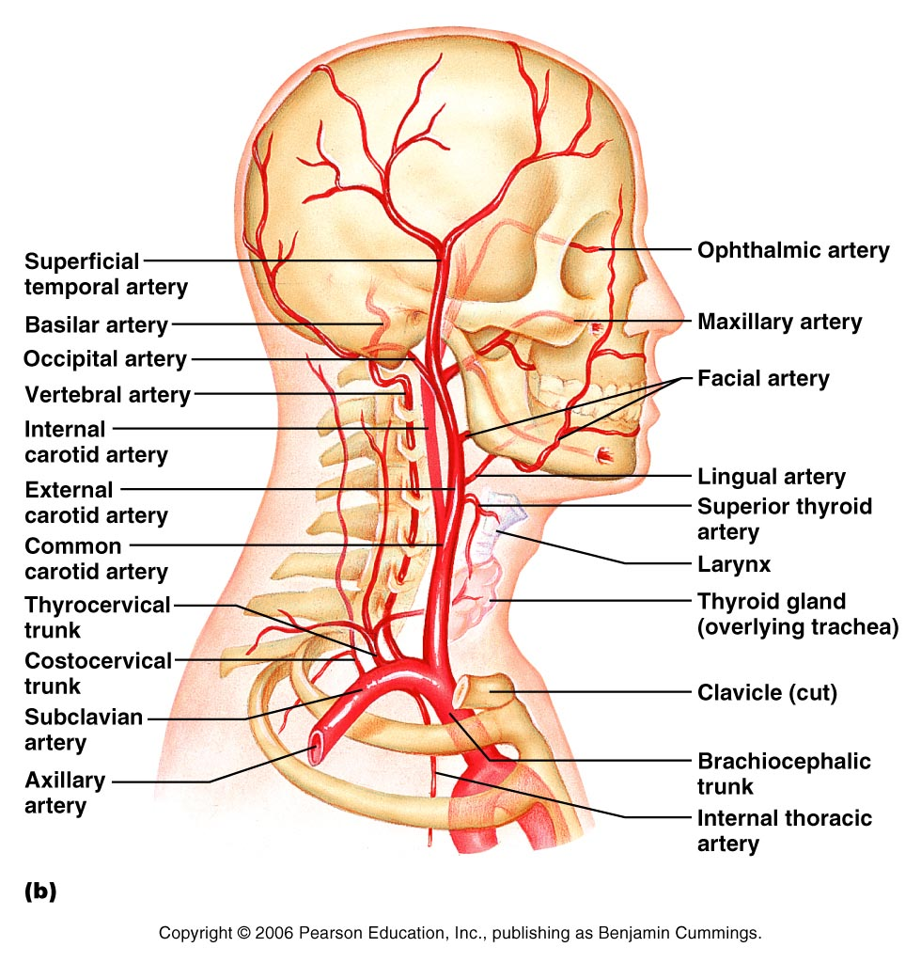

Take a look at the artery slide. View each of the three layers and take note of the thick tunica media.

Artery/Vein

Part Three: Pulse
The pulse is the expansion and recoil of the arterial walls related to the ventricular contraction and relaxation. Pulse can be felt at any superficial artery, although some are easier to find and palpate than others.

Radial Pulse: Place index and middle fingers over the radial artery. Typically, placing three fingers at the site of wrist flexion (radial or lateral aspect) will align the index and middle fingers over the radial artery. Use a light touch. You want to feel the expansion as it pushes against your fingers. Too heavy a pressure will prevent you from feeling the pulse.

Carotid Pulse: Find the voice-box mid-line and slide laterally into a groove/depression where you can feel the carotid pulse. The carotid artery contains baroreceptors (pressoreceptors) so only palpate one carotid at a time.

Calculate the pulse rate by counting for a full minute (or for 30 seconds and multiplying by 2).

Note: You will be recording values for both pulse and for blood pressure under the conditions outlined below. Be sure to read through both sections before beginning. You can economize your time by checking both pulse and blood pressure following the activities.

Pulse while relaxed and seated
Pulse immediately after standing up
Pulse after five minutes of standing
Pulse after 5 minutes of exercise*
Pulse five minutes after exercise has ended

*yes, exercise. Do jumping jacks, find a stairwell and go up and down stairs, speed-walk safely through the hallways. Do something for 3-5 minutes to get your heart pumping.

Part Four: Blood pressure

Obtain a blood pressure cuff and stethoscope.
To determine blood pressure
- Ask your partner to sit quietly and bring one arm out to the side
- Place the blood pressure cuff so that it can align with the brachial artery. The cuff should sit about two finger-widths above the antecubital fossa. Make sure the cuff is snug, but not tight. If your partner has very large or very tiny arms, the cuff will not fit correctly, and the readings may be off.
- Bring your lab partner’s arm into a resting position where they are not using their muscles to support the weight of their arm. Resting it on a desktop is ideal.
- Place the stethoscope ear buds into your ears. Make sure that they point towards your nose (where your eardrums are within the canal) otherwise you’ll not be able to clearly hear.
- Place the diaphragm of the steth at the brachial artery.
- Inflate the BP cuff until it reads about 160. In many health care environments, this number is higher, but also more uncomfortable. For the purposes of our class, 160 is fine.
- Release the pressure valve so the air escapes from the cuff slowly. Listen carefully. Initially you will not hear anything. Eventually, around 120, you’ll start to hear beats. These small thuds are the Karotkoff sounds. When you hear the first sound, make note of the number that it coordinated with. Soon the beats will end. At the last beat, make note of the number.
- The first number (where the beats started) is the systolic pressure. This is when the arteries are under the highest pressure because the ventricles of the heart have contracted and squeezed the blood into them.
- The second number (when the beats stopped) is the diastolic pressure. This is when the arteries are under the lowest pressure. At this stage the ventricle has relaxed.
- When the beats have stopped, open up the valve and release any remaining pressure from the cuff.

Blood pressure while seated
Blood pressure immediately after standing
Blood pressure five minutes after standing
Blood pressure immediately after exercise
Blood pressure 5 minutes after exercise.

Identify the arteries on the image on p 40 that correspond to the locations where a pulse can be taken.
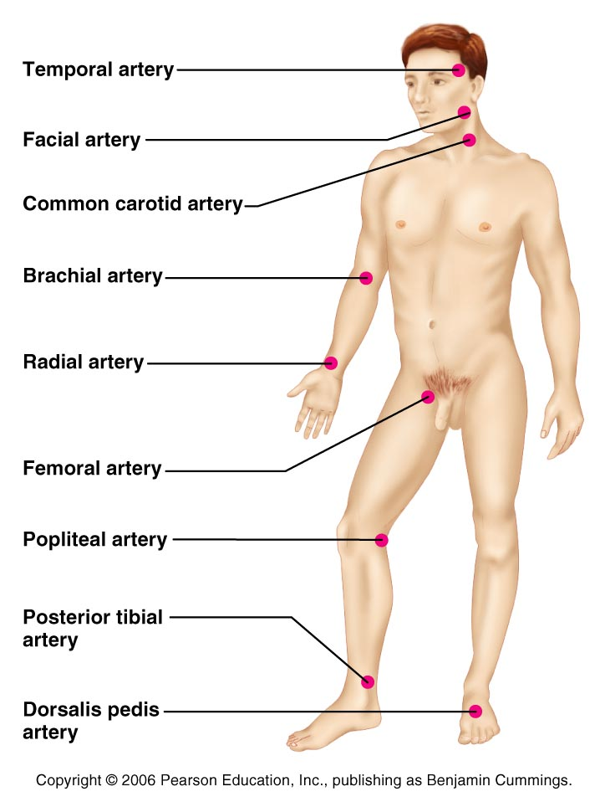

Part Five: Cat
Identify the arteries and veins listed.

Arteries
- Brachiocephalic artery
- Left common carotid artery
- Right common carotid artery
- Left subclavian artery
- Right subclavian artery
- Abdominal aorta
Veins:
- Left external jugular vein
- Right external jugular vein
- Right brachiocephalic vein
- Left brachiocephalic vein
- Right subclavian vein
- Left subclavian vein

On the Human Model, locate
- Brachiocephalic artery
- Left common carotid artery
- Left subclavian artery
- Anterior interventricular artery
- Posterior interventricular artery

For exam purposes, be familiar with the arteries and veins listed here as well as in the images on pages 36 and 37. Many of the veins have been omitted only because many arteries and veins share the same names. With some exceptions, if you know where the artery is, you’ll know where the vein is.

Part Six: Questions

- How do arteries differ from veins? Arteries have a thicker tunica media, while veins have a thinner muscle layer. The thinner muscle layer in the veins allows for the lumen to be larger. Also, veins have valves whereas arteries do not.

- What function does the valve have in veins? Valves encourage a one-way flow. They prevent the blood traveling against gravity from falling back down.

- Where does the coronary artery come from and which branches arise from it? Left and right coronary arteries branch directly from the aorta. Left coronary artery has the anterior interventricular artery and the circumflex artery. Right coronary artery has the right marginal artery and the posterior interventricular artery.

- What are the three main branches that come off of the aorta
Left subclavian artery
Left common carotid artery
Brachiocephalic artery

- How do the human arteries from the aorta differ from the cat arteries from the aorta? Humans have three arteries leaving the aorta, cats have two: brachiocephalic and left subclavian

For the following questions, provide the name of the (human) artery that’s missing from the sequence.
Answers can be found in chapter 19 by looking at the images

Brachiocephalic artery ___right subclavian artery___________________, right axillary artery

Abdominal aorta, __Phrenic arteries (Inferior/superior) ___________________diaphragm

Abdominal aorta, _Gonadal artery (ovarian artery)_____________________, ovary

Aortic arch, _Left common carotid_________________________, left external carotid artery

Axillary artery, _brachial artery_______________________, radial artery

Common iliac artery, _External iliac artery____________________, femoral artery

- What’s the difference between systolic and diastolic pressure?
Systolic pressure occurs in the arteries during ventricular contraction.
Diastolic pressure occurs in the arteries during ventricular relaxation.

- Which artery is used to determine blood pressure when the BP cuff is placed on the arm?
BP is determined using the brachial artery.

Lymphatic System
Part One: Information
Part Two: Images
Part Three: Cat
Part four: questions

Part one: The lymphatic system shares a lot in common with the circulatory system. The lymphatic vessels have a similar arrangement to veins, including the presence of valves. One of the functions of the lymphatic system is to take the fluid that has been squeezed out of the circulatory system and into the tissues, filter and cleanse it, and then return it to the circulatory system. The lymphatic system is also responsible for transporting dietary lipids and aiding in immune responses.

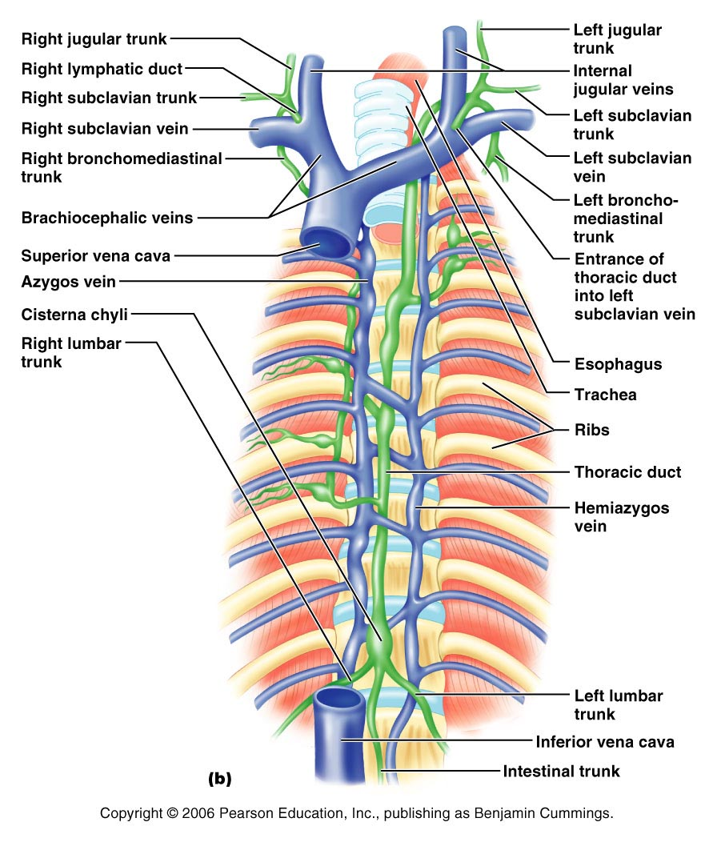

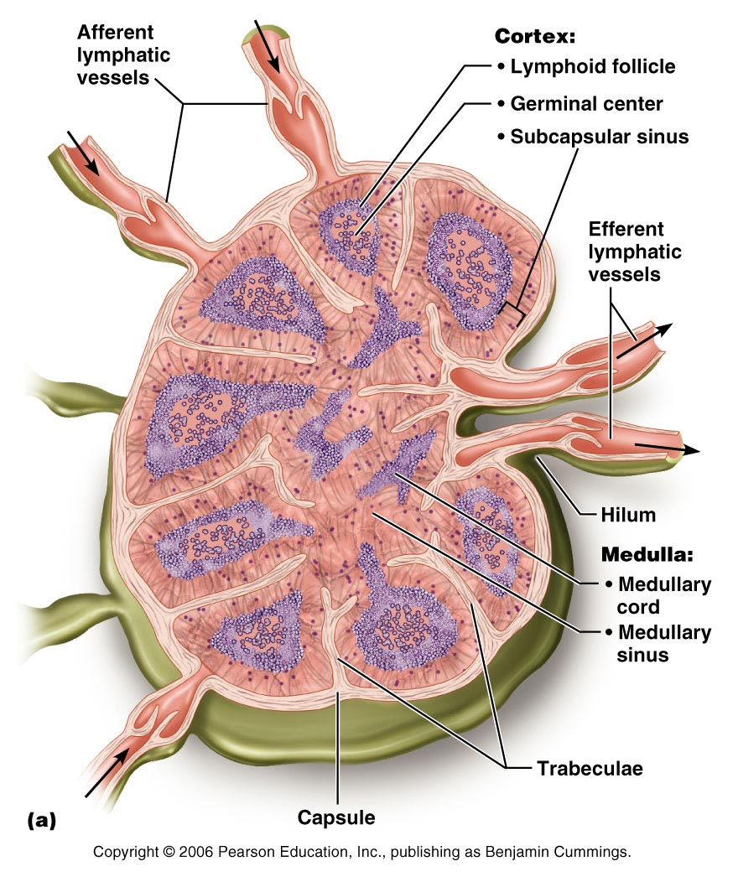

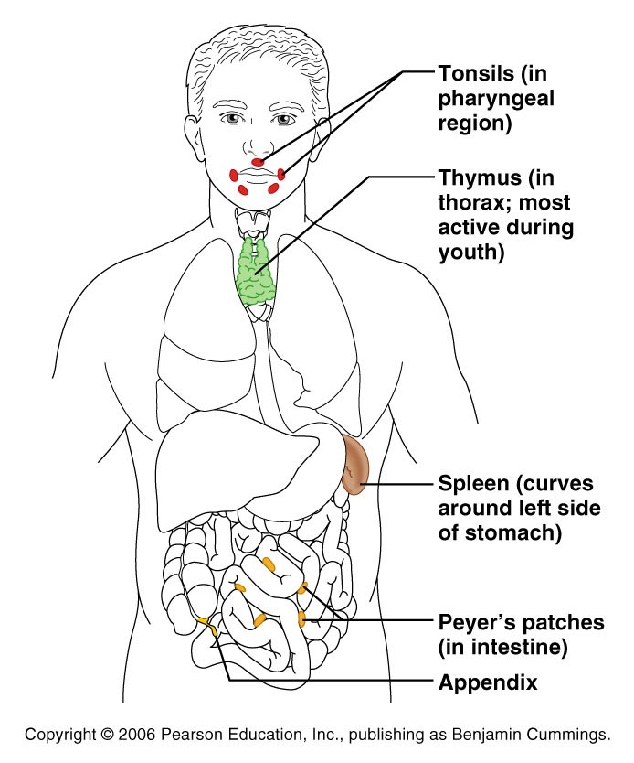

Part Three: Cat
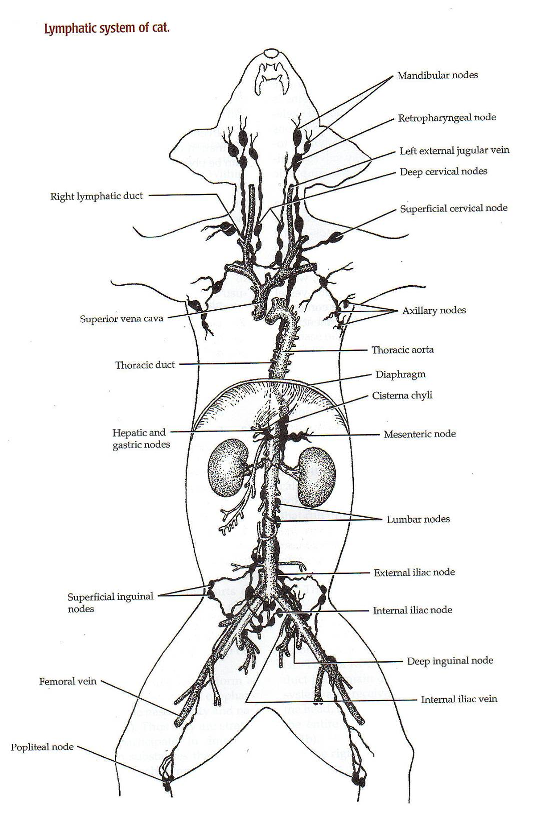
Identify lymphatic structures on the cat: Try to observe lymphatic vessels: Thoracic duct, right lymphatic duct. Also try to observe lymph nodes. Find the lymphatic organs: thymus gland, tonsils, and spleen

Part Four: Questions

- Outline the pathway from a lymphatic capillary all the way back to the subclavian vein.
lymphatic capillary lymphatic vessels lymph nodes lymphatic vessels lymphatic trunks lymphatic ducts (either right lymphatic duct or thoracic duct) subclavian vein brachiocephalic vein superior vena cava right atrium.

- What does MALT stand for?
Mucosa Associated Lymphoid Tissues: lymphoid tissues found in the passages that are open to the environment. Ex: genitourinary or respiratory tracts.

- With a lymph node, compare the afferent vessels to efferent vessels.
The afferent vessels approach the lymph node. There are several of them that approach a single lymph node. The efferent vessels exit the lymph node. There are usually only one or two that exit.

- Where is the pharyngeal tonsil located?
Pharyngeal tonsils are located in the nasopharynx.

- Where are the two palatine tonsils? The palatine tonsils are located bilaterally at the posterior aspect of the oral cavity. (back of the mouth)

- Compare the thoracic duct to the right lymphatic duct.
The right lymphatic duct is smaller and receives lymph from the right upper limb and the right side of the head and thorax.
Thoracic duct is the larger of the two ducts. It receives lymph fluid from most of the body.

- How is the thymus part of the lymphatic system? They thymus produces hormones that stimulate lymphocytes. It is also the location where T-cells get their training.

- Where are the red pulp and the white pulp located? Red and white pulp are located in the spleen.

- The spleen shares both lymphatic and circulatory function. Briefly describe both.
The red pulp of the spleen is responsible for filtering and cleansing blood. The white pulp of the spleen has a lot of lymphocytes that are responsible for immune function.

