Respiratory System

Part One: Information
Part Two: Images
Part Three: lung volumes/spirometry
Part Four: Cat
Part Five: Questions

Part One:
The respiratory system is essential for gas exchange. Breathing helps to bring air and oxygen into the lungs. Once in the lungs, the oxygen can diffuse out of the alveoli and into the capillaries, thereby oxygenating the blood. The blood has brought waste products like CO₂ to the capillaries. This gas will diffuse out of the bloodstream and into the alveoli. As we breathe out, we remove waste products from our system.

The respiratory system includes more than just the lungs. It also includes the nose, nasal cavity, sinuses, pharynx, larynx, trachea, and the bronchial tree
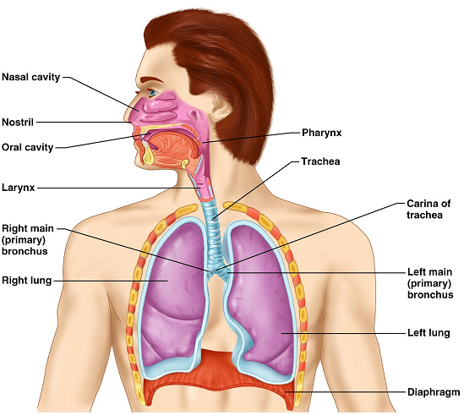

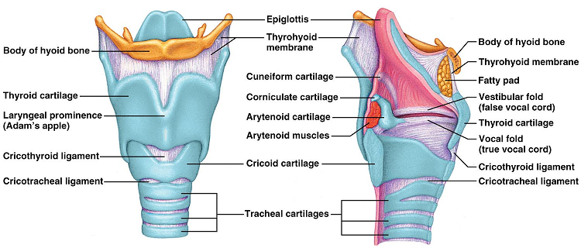

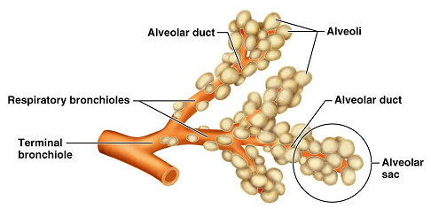

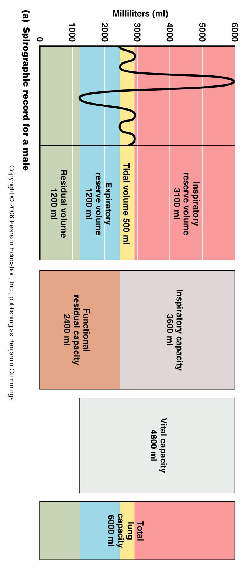

View and draw the trachea slides and alveolar slides

Trachea

Identify the epithelial lining as well as the hyaline cartilage rings.

Alveoli

Identify the cell type that makes up the alveoli

Part Three: lung Volumes/Spirometry
Use the Handout titled “Respiratory Volumes and Capacities” and follow the instructions.
Complete the in-class assignment.

Part Four: Cat
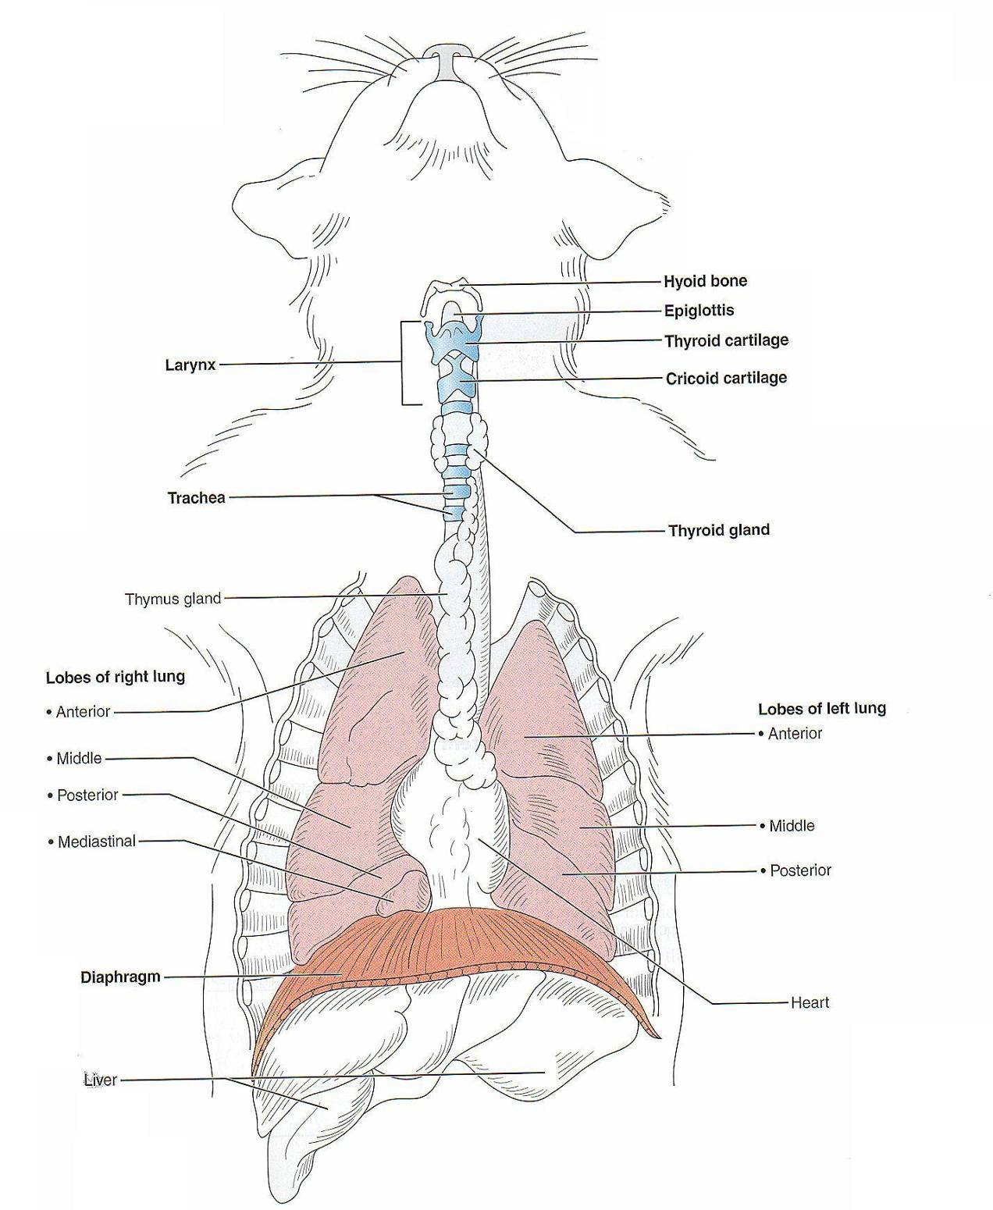

Structures to identify on the cat:
- External nares
- Hard and soft palate
- Tongue
- Epiglottis
- Larynx
- Thyroid cartilage
- Cricoids cartilage
- Trachea
- Esophagus
- Lungs: locate the lobes on both right (4) and left (3)
- Diaphragm

On the classroom human model, locate the following:
- External and internal nares
- Superior, middle, and inferior conchae
- Hard and soft palate
- Tongue
- Epiglottis
- Naso, oro, and laryngopharynx
- Thyroid cartilage
- Thyroid gland
- Cricoids cartilage
- True vocal folds
- False vocal folds
- Glottis
- Trachea
- Bronchi: primary, secondary, tertiary
- esophagus

Part Five: Questions
Define the following terms
- Ventilation: the movement of air into and out of the lungs

- External respiration: the gas exchange that takes place between the capillaries and the alveoli. This exchange takes place in the lungs

- Internal respiration: The gas exchange that takes place between the capillaries and the body cells. This exchange takes place in the tissue of the body.

- Cellular respiration: the use of oxygen at the level of the mitochondria to provide energy (ATP) for the body.

- What’s the difference between a volume and a capacity? A volume is a discrete amount. A capacity is a combination of volumes.

- Which nerve is responsible for innervating the diaphragm? Phrenic Nerve

- As a person inhales, what happens to
  - The size of the thoracic cavity: size increases

  - The pressure within the thoracic cavity: pressure decreases

- Which muscles aid in a moderately forceful exhalation: abdominal muscles contract to force the diaphragm higher and reduce the size of the thoracic cavity. Internal intercostals contract to squeeze the thoracic cavity down even further.

- What is the function of surfactant?: Surfactant has properties like a detergent. It will reduce the surface tension. A reduced surface tension in the alveoli will help them remain open and able to fill with air.

- Describe the pathway from the mouth/nose down to the alveoli: From the nose nasal cavity nasopharynx / From the mouth oropharynx. From this point, the pathways are the same: oropharynx laryngopharynx larynx trachea right or left primary bronchus bronchi change into bronchioles terminal bronchiole (last part of the conduction pathway) respiratory bronchiole (first place gas exchange can take place) alveolar ducts alveolar clusters alveoli.

- This volume stays in the lungs even after the most forceful expiration. What is it? Residual volume

- This is the maximum amount a person can exhale after taking the deepest breath possible. Vital Capacity

- this is the volume in addition to the tidal volume that leaves the lungs during forced expiration: Expiratory Reserve volume

- How do the lobes of the right lung of the cat differ from the human? And on the left? The human has three lobes on the right. The cat has four. The human has two lobes on the left lung; the cat has three. Because the cat walks on all fours, the lobes are labeled anterior/posterior, whereas since a human is upright, our lobes are superior/inferior.

- What is the function of the epiglottis? Aids in blocking food/drink from entering the airways.

