BSC 181
Anatomy and Physiology I

Dr. Betsy A. Wargo
Illinois State University

Fall 2011
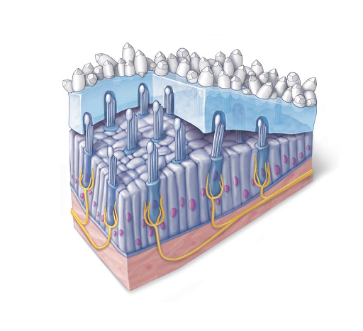

Welcome to 181 Lab
Part One: Points and Attendance
Part Two: Lab format
Part Three: Evaluations
Part Four: Academic Dishonesty

Part One:
Your work in BSC 181 lab will contribute to your 181 grade. Lab is worth 25% of your overall grade; lecture is worth 75%.

You will earn points and be evaluated based on the following:
Participation during lab: 40 points
Article summaries 30 points
Case studies 30 points
Lab Quizzes 200 points
Total: 300 points for lab

Attendance for lab will be noted in terms of participation. Your presence is required, but so is your participation. Excessive absences will result in the student being dropped from lab, and consequently lecture. You will not be able to pass BSC 181 without attending lab. The occasional absence can be discussed with your TA.

Part Two:
These labs are designed to review and illuminate lecture topics. The lab manual will include background information on many topics, questions for you to answer during lab, and illustrations for you to label. You will be asked to bring your text book and lecture notes to lab. However, you are welcome to bring one book per group rather than one book per student. Your TAs will discuss with you the flow of their own lab sections.

Lab can be an enjoyable and very social part of BSC 181. Students are encouraged to work together during lab to discuss questions and review illustrations.

Part Three:
You will be evaluated on your knowledge of the lab material by taking four quizzes. These quizzes are practical in nature. During a practical you will move from station to station in order to identify anatomy from an image, a model, or a dissected specimen. Questions on the practical will also come from the background info provided in the lab manual as well as the questions that you’ve answered. The practicals can be challenging, and are designed to cover the spectrum of topics covered in lab.

Exam/Quiz policy
You will be expected to take your lab exams during the lab times provided. Punctuality is important. If one of your classmates has finished the quiz and has left the lab, no more lab quizzes will be given out. You will not be able to take that quiz. If you have conflicts that you are aware of ahead of time, please discuss options with your TAs.

You will take four lab practicals during the course of the semester. The dates for the quizzes will be posted on the class calendar online. Review images will often be provided to reflect those images that you labeled in lab. The review images will be for your study benefit only. There are no points associated with them, and they are not something that will be turned in.

Academic Dishonesty
The work you do this semester needs to be your own. Your TAs have been asked to look for written work that has been plagiarized as well as any suspicious behavior regarding the quizzes, including discussion of quiz content with classmates that have not yet taken a quiz. Academic dishonesty will not be tolerated in any form.

Sanctions for Academic Dishonesty (first offense)

- Grade of 0 (zero) points on the assignment/exam/quiz in question
- A 10 percent (10%) reduction of the final grade, taken after lecture and lab scores have been tallied.
- Students pursuing a teaching certificate will have a Disposition Concerns document submitted

The Phi Sigma bookstore is open for a short time at the beginning of each semester. Once it closes, you will not be able to easily purchase lab books. Please fill out the information below in case your lab manual is misplaced.

Name:

If this lab manual is found, please contact me by

Phone:

Email:

Other:

You may find it helpful to have a classmate in lab that you can contact for notes or questions. Take a moment to collect some contact information from your lab partners.

Name | Email | Phone

Lastly, take a moment to write down your lab TAs name and any contact info he/she wishes to provide so you can reach him/her when needed.

My TA is

Index

Microscope………………………………………………………………….…..7
Anatomical Regions and Terminology ………………………………….……..13
Meiosis and Mitosis…………………………………………………………….19
Epithelium………………………………………………………………….…...31
Connective Tissue………………………………………………………….…...35
Skeletal System…………………………………………………………………43
Muscle System…………………………………………………………….……59
Brain and Spinal Cord………………………………………………………..…69
Receptors and Neuro exams…………………………………………………….77
Eye Anatomy………………………………………………………………..…..85
Cranial Nerves…………………………………………………………….…….91

Microscope
Part One: Microscope anatomy and use
Part Two: Preparing slides
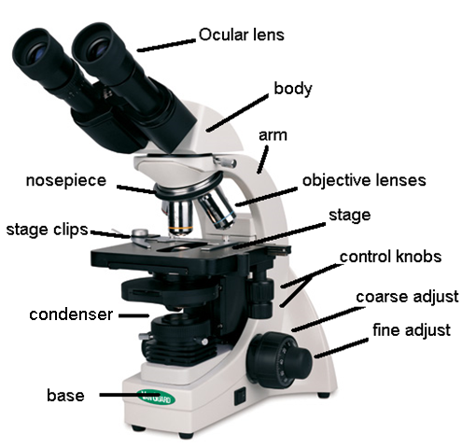

There will be many instances in BSC 181 and 182 where you will be asked to use a microscope. We’ll start off with the anatomy of a microscope, how to use one properly, and how to correctly stow one.

Features:

- Ocular lenses: These are the lenses that you’ll put your eye to. These lenses have a magnification factor of 10. Most of the microscopes in our lab have two ocular lenses. Some people find it more comfortable to look through both lenses with both eyes; others will look through only one lens. Do what works best for you. You’ll have less strain on your eyes if both eyes stay open.

- Nosepiece:
  - The nosepiece is the portion of the microscope to which the objective lenses are attached. The nosepiece rotates to allow the objective lenses to be used.

- Objective lenses: You will have three objective lenses that you’ll be using.
  - Scanning lens: this lens has a magnification of 4. However, since we need to take into account the magnification of the ocular lens as well, the total magnification for this lens will be 40X (4 X 10 = 40). This is the lens that you will start with to view your slides.
  - The scanning lens is the ONLY lens that you are able to use the coarse adjustment knob with. All other objective lenses will use the fine adjust knob.
  - Low power lens: The low power lens has a magnification of 10X, a total magnification of 100X (10 X 10 = 100) Use the fine adjust knob with the low power lens.
  - High power “High and dry” lens: The high power lens is the top magnification we’ll be using for this course. It has a magnification of 40X and a total magnification of 400X (40 X 10 = 400). Us the fine adjust knob with the high power lens
  - Oil immersion lens: We will not be using this lens in lab.

- Adjustment knobs
- Coarse adjust is the larger of the two wheels on the side. It moves the objective lenses up and down in order to focus. It is to be used ONLY with the scanning lens. Use with the low power or high power lenses can result in breaking both the glass on the objective lens as well as the slide itself.
- Fine adjust is the smaller of the two. It can safely be used with the low power and scanning lenses.

- Stage
- The stage is the platform on which your glass slide will rest. On the stage you will find a set of stage clips that will anchor the slide. Make sure your slide is securely fastened before moving the stage.

- Stage adjusting knobs
- You will find a set of knobs that will move the stage. One moves it forwards/backwards. The other moves it left/right.

- Light
  - Your microscope has a light at the bottom that shines up through the specimen. Under scanning power, the light may appear very bright, but as you increase magnification by using stronger objective lenses, the light appears to dim. The quality of the light can be modified using the microscope.
  - Abbe condenser: this condenser can intensify the light coming from the light source. It can be moved by using the knob below the stage. Use the Abbe condenser to improve contract in your field of view.

- Arm and Base
  - The arm is the backbone of the microscope. It attaches the body to the base. It is the arm that is used to transport the microscope. Always carry the microscope by holding both the arm and the base. The base is the bottom.

Tips for focusing and finding what you’re looking for:

- Before beginning, drop the stage down to its lowest position using the coarse adjust knob. Have the scanning objective lens in place. This gives you room to add the slide in later.
- Before you even put your slide on the stage, look at it to see where the specimen is on the slide. Position the slide so the specimen sits in the pool of light. This should help you line things up more easily when looking through the ocular lens.
- Focus using coarse adjust and scanning lens. Once you’ve got the image mostly focused with the coarse adjust, use the fine adjust to perfect it.
- In order to go from scanning power to low power, move the nosepiece and click the low power lens into position. You should not have to re-focus too much. At this point, use the fine adjust to bring the image back to clarity.
- The microscopes are parfocal scopes. This means when you focus at one magnification, the image stays mostly in focus as you move to the next level.
- Hint: As you go from scanning to low to high powers, you lose some of your field of view. Always center the structures that you are looking at so when you go from scanning to low power, it remains in the center of your field of view. This will prevent you from having to search for the structure on the slide.
- Hint: if you think you’ve found something on the slide, but you’re not sure, start by moving the stage to the left or right just a tiny bit. If the image in your field of view moves, you’re focused at the level of the slide. If you can move the stage, but the field of view stays the same, you’re focused on oil/debris on the objective lens and will need to refocus.

Part Two: Preparing slides
Exercises with the microscope

Create a slide using newspaper print

Find a newspaper (the Vidette works nicely) and tear/cut a letter out. The classic example for microscope exercises is “e”.
Place the letter “e” on the slide and cover it with a cover slip. Be sure to orient the letter so that it appears right side up.
Place the slide on the stage and view using the scanning lens. Draw what you see in the circle below.

Letter viewed with scanning lens (40X total)

Use the stage controls to move the slide to the right.
Which direction does the image move?

Use the stage controls to move the slide away from you.
Which direction does the image move?

- Increase the magnification to the low power lens (100X) and draw the letter again. Remember once you leave the scanning lens, you will no longer use the coarse adjust knob.

- Increase the magnification to the high power (high and dry) objective (400X). Again draw the field of view.

Create a slide using some of your own cells

Materials:
Clean slide
Cover slip
Methylene blue
Toothpick
Paper towels

- Spread several paper towels down on your work surface. On the center of your clean slide, place one small drop of Methylene Blue Dye. (It stains fingers and clothes, so be careful.)

- Take a toothpick, and lightly scrape along the inside of your cheek. The goal is to obtain cheek cells (epithelial cells, squamous) not blood cells, so just scratch lightly.

- Place the end of the toothpick with the cells on it in the stain, and swirl it around for 10 seconds. The goal is to get the cells that have clumped together to spread out and be evenly distributed through the dye.

- Put the cover slip on.

- Often, the excess fluid will start to seep out from the edges. Take a paper towel, and touch the corner of it to the fluid on the slide. This will pull some of the extra stain away, and leave the stained cells behind.

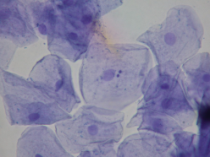
The image to the left is of cheek cells. If your specimen has been prepared correctly and the cells are evenly distributed, the cells have a “sunny-side-up egg” appearance. Look for roundish cells with a pale blue cytoplasm. Look for a darkly staining and centrally located round nucleus.

- View the slide under scanning power, low power, and then high power. Draw the cells at high power. (400X)
- Identify and label the plasma membrane, the cytoplasm, and the nucleus of a cell.

When you are done with the microscope for the day, complete the following checklist:

_____ turn off the light
_____ remove the slide
_____ drop the stage to the lowest position
_____ put the scanning objective lens in place
_____ secure the cord
_____ stow the microscope carefully

Be familiar with the “anatomy” of the microscope, proper usage, and the function of its parts as this information will be included for your first quiz.

Anatomical Regions and Terminology

Part One: Anatomical position
Part Two: Anatomical regions
Part Three: Terminology

During the course of the semester, you’ll be referring to the regions and relationships seen below. With all of the positions and relationships discussed, the standard frame of reference is a stance called anatomical position. In anatomical position, the individual stands upright, facing forward, with palms facing forward as well. The woman in the image below is standing in anatomical position.

In the image below, the body has been divided into sections.
- Transverse section divides the body into upper and lower portions
- Frontal sections divides the body into anterior and posterior (front and back) sections
- Sagittal sections divides the body into left and right sections.
  - Midsagittal divides the body evenly into left and right, so in half.
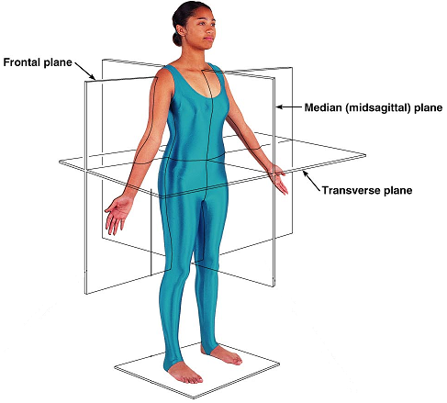

Fill in the images on the following pages. Complete this section during lab. You are welcome to discuss the terms and locations with your lab partners.

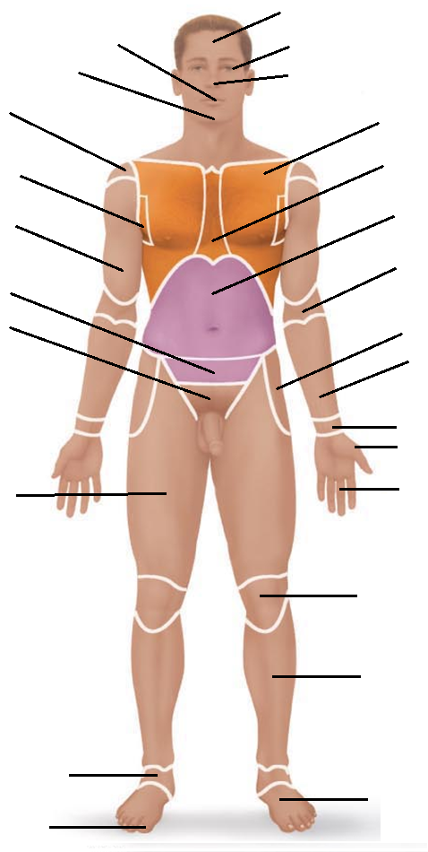

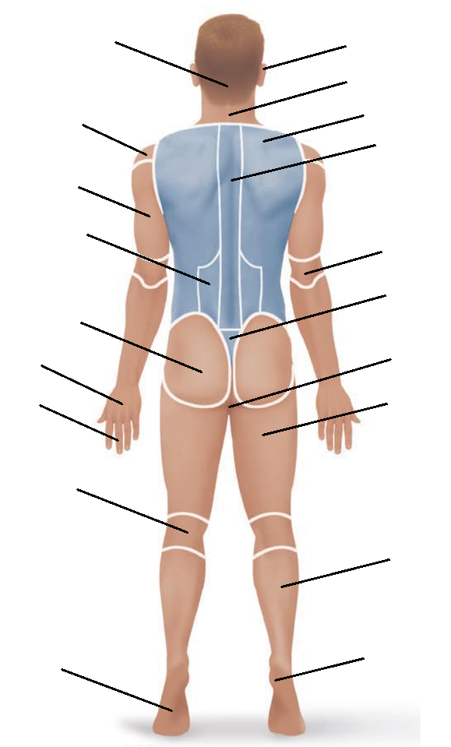

Part Three: Terminology

In anatomy and physiology, we use reference points and directional terms that relate to the anatomical position. Review the terms below and give examples based on the definitions.

Superior: Towards the head end of the body, above
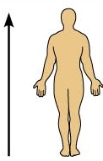
The occipital region is superior to __

The patellar region is superior to ___

Create your own:

Inferior: Away from the head, towards the lower part of the body
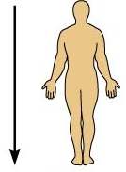
The navel is inferior to ___

The mental region is inferior to ____

Create your own:

Anterior: Towards the front of the body, in front of
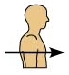
The heart is anterior to _____

The esophagus is anterior to ____

Create your own:

Posterior: Towards the back of the body, behind.

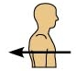
The vertebral column is posterior to ___

The heart is posterior to ___

Create your own:

Lateral: Away from the midline, towards the sides
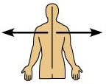
The ears are lateral to _____

The antecubital region is lateral to ____

Create your own:

Medial: Towards the midline, on the inner side of
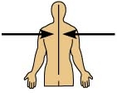
The navel is medial to ___

The mental region is medial to ____

Create your own:

Proximal: closer to the origin of the body part or closer to the trunk.
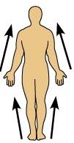
The wrist is proximal to ____

The knee is proximal to ____

Create your own:

Distal: farther from the origin of the body part, farther from the trunk.
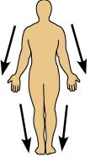
The sural region is distal to ___

The carpal region is distal to ___

Create your own:

Proximal and distal can often times cause confusion. If it helps, think of it in this way:
The elbow is proximal to the wrist: The elbow is closer to the trunk than the wrist is to the trunk.
The ankles are distal to the knees: The ankles are farther from the trunk than the knees are from the trunk.
**The terms proximal and distal are specific to the extremities. We do not use the terms “superior” or “inferior” when dealing with the relationships between structures on the extremities. So, the wrist will always be distal to the elbow, not inferior to it.

Superficial: closer towards the surface, external
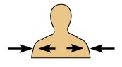
The dermis is superficial to ___

Deep: Away from the surface, more internal
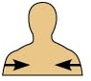
The lungs are deep to ___

The femur is deep to ___

Mitosis and Meiosis

Part One: Intro
Part Two: Onion Root tip slides
Part Three: mitosis kit

Please Note: Today’s lab deals with viewing several slides. Be sure to use appropriate microscope technique. Drop the stage to the lowest position before adding or removing a slide. Use the scanning power to locate and center an image before moving to a higher magnification. Use the course adjust knob ONLY with the scanning power, never with the low or high power lenses. Once you’ve upgraded to the low power (100X) or the high power (400X) be sure to use the fine adjust knob. If you have any questions regarding microscope usage, ask your TA.

Mitosis:
Mitosis is part of the cell cycle in which the contents of the nucleus are redistributed into two new nuclei. In a human body cell, there are 46 chromosomes. Following a mitotic division, there will be two cells, each having 46 chromosomes. In order to have a successful mitosis, there needs to be a successful interphase. During interphase, the cell prepares for the upcoming division process by doubling the amount of the DNA within the nucleus.

Part Two:
Using the onion root tip slides, you’ll be able to see and identify all of the stages below. Use the high power lens to best see the features (400X). The first cell stage (and most abundant) is interphase. Interphase is NOT part of mitosis, but includes a necessary preparation stage in which DNA duplication (replication) takes place.
Below is an illustration of interphase. Notice that the nucleus is intact and the nuclear contents are in the chromatin shape. Find a cell in interphase and draw it in the space provided. Label as many features as you can identify.

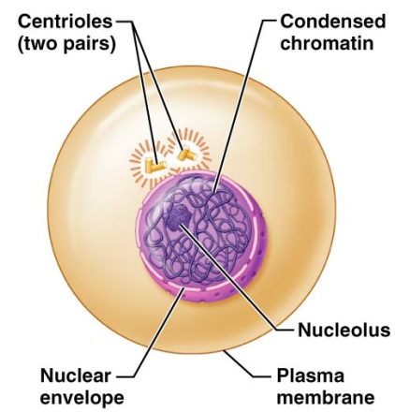

Mitotic stages: Prophase
The illustration below represents a cell in prophase (late prophase.) The nucleus has already broken down and the chromatin has all condensed into chromosomes. The spindle fibers are formed, and the centrioles have moved to the poles of the cell.
Identify a cell in prophase and draw it in the space provided. Label as many features as you can identify.

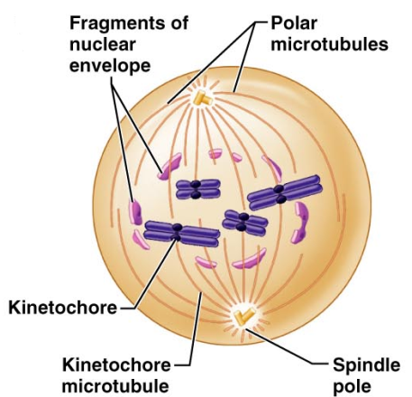

Mitosis: Metaphase:
During metaphase, the chromosome will line up with the centromeres (kinetochore) on the metaphase plate. The spindle fibers (microtubules) are attached to both the chromosomes and to the centriole (spindle pole) This stage is very brief, but visually distinct. Find a cell in metaphase and draw it in the space provided. Label as many features as you can identify.

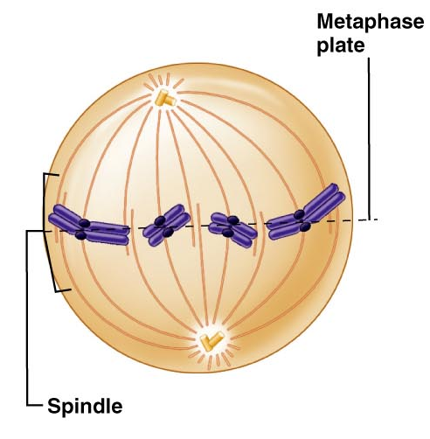

Mitosis: Anaphase
During Anaphase, the chromosomes start to split apart. The centromere (kinetochore) rips in two, allowing the now daughter chromosomes to move towards the poles. Also during anaphase, many animal cells start to demonstrate the “cleavage furrow” which is the beginning of cytokinesis. Since the slides you have are plant cells, you’ll not see this process. You may notice the beginnings of a new cell plate/cell wall used to separate the one cell into two. Find a cell in anaphase and draw it in the space provided. Label as many features as you can identify.

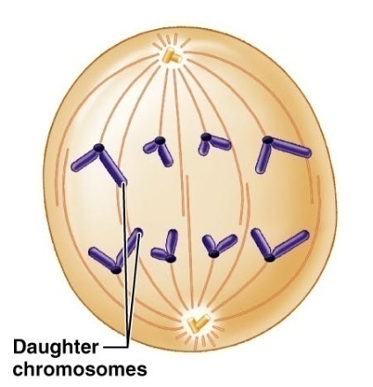

Mitosis: Telophase
In Telophase of mitosis, the daughter chromosomes have reached their destination. The nuclear membrane begins to reform and the spindle fibers start to break down. The chromosomes begin to relax back into chromatin. The nucleolus is replaced. Again, the illustration at the left is an animal cell in which the cleavage furrow can be seen. The plant cells (onion root tip) will not have a cleavage furrow. Find a cell in telophase and draw it in the space provided. Look for two smaller cells side by side, and you’ll likely have telophase. Label as many features as you can identify.

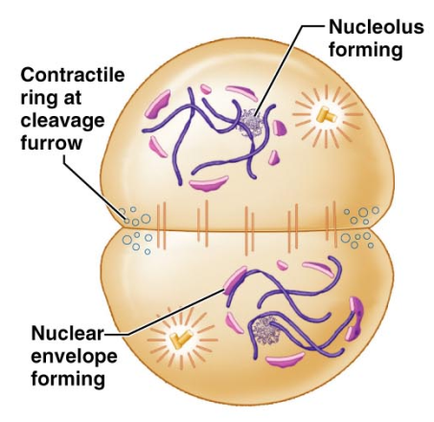

Part Three: Mitosis Kit

Points to consider as you consider mitosis
- The DNA is located in the nucleus of a cell
- Chromosomes are made up of DNA
- In order to reorganize the chromosomes during mitosis, the nucleus must be dismantled.
- Centrioles and spindle fibers will help to move the chromosomes around
- The cell has to double the DNA before it divides it in two.

Materials you will need:
40 red beads
40 yellow beads
2 red centromeres
2 yellow centromeres
4 plastic (clear) tubular centrioles
Paper towel(s)

Interphase
During interphase the cells must duplicate the DNA in the nucleus. If it did not, a cell going through mitosis would end up with only half of the DNA that it needs.

- Create two strands of seven red beads. Use the red centromere to complete the chromosome.
- Create two strands of yellow beads. Use the yellow centromere to complete the chromosome.
- Open/unfold a paper towel and place it on your desk. The paper towel will represent the nucleus of the cell. During interphase, your chromosomes will be located on the paper towel.

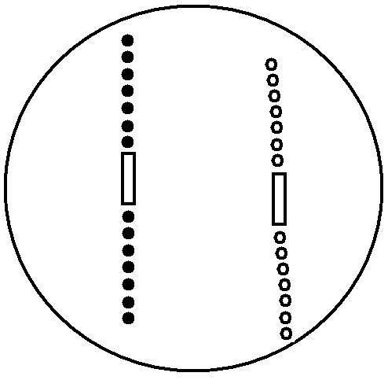

The chromosomes you’ve just created can be considered homologous chromosomes. They will be housed within the nucleus. At this point, your nucleus contains two chromosomes total (1 pairs). If this were a human cell, instead of two chromosomes, we’d have 46 (23 pair) chromosomes.

Interphase: Replication
- DNA replication occurs during interphase. The nucleus remains intact and unchanged.
- Construct another red chromosome identical to the first.
- Construct another yellow chromosome identical to the first.
- Link your two red chromosomes together to create a sister chromatid
- Link your two yellow chromosomes together to create a sister chromatid

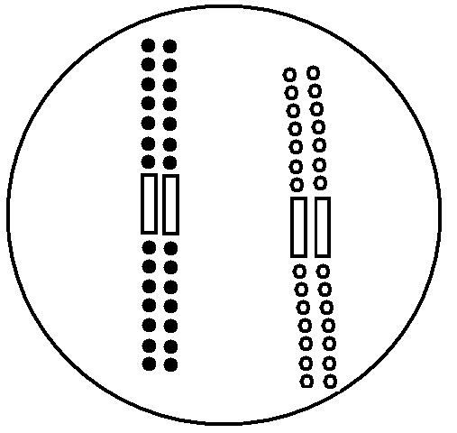

- Find a pair of plastic centrioles. Place them outside of the napkin (nucleus). Recall that the centrioles exist in the cytoplasm, not the nucleus. They also will replicate to prepare for the upcoming mitotic division.

Entering Mitosis
During mitosis the nucleus disappears, the chromosomes divide and relocate, and then the nucleus is restored. Mitosis is divided into four stages: Prophase, Metaphase, Anaphase, and Telophase

Prophase
During prophase the centrioles take up “polar” positions. Spindle fibers begin to appear. Chromatin condenses to chromosomes. The nucleus starts to disappear.

- Move your centrioles into their polar positions (North Pole/South Pole or you can do East/West poles). Keep the centrioles off the napkin/nucleus since they are in the cytoplasm.
- Remove your napkin. Recall that during prophase the nuclear envelope breaks down. The chromosomes are now free to move about the cell.

Draw what your materials look like at this stage:

Metaphase
During metaphase the duplicated chromosomes (sister chromatids) will line up along the metaphase plate.
- Imagine a line that runs between the two poles of your cell, much like the equator separates northern/southern hemispheres. This line is the metaphase plate.
- Assemble your sister chromatids along the metaphase plate. Place the centromeres of the sister chromatids directly on the metaphase plate.

Draw what your materials look like at this stage

Anaphase
During anaphase, the sister chromatids will be split into two daughter chromosomes. The spindle fibers draw the chromatids away from the metaphase plate and towards the centrioles.
- Pull apart your sister chromatids. Push the separated chromosomes toward their respective poles. Their final destination is the centrioles.

Draw what your materials look like at this stage

Telophase
During telophase, much of what was done in prophase is reversed: the spindle fibers disappear, the nuclear membrane is reformed, and the chromosomes relax into chromatin
- Both red and yellow daughter chromosomes should be at a centriole.
- Take two napkins (or split the one you used earlier in half). Place one napkin under each centriole, red, and yellow chromosome. This represents your nuclear membrane reforming.
- Start pulling the pop-beads off your chromosomes and place them on the napkin. This represents your chromosome returning to chromatin.

Draw what your materials look like at this stage

Keep in mind that at this point, we have successfully divided the chromosomes (mitosis) but have not yet divided the cell. The process of cytokinesis will split the one cell that we started with into two new cells. Each new cell will be called a daughter cell.

Questions

Define homologous chromosome

What parts make up a chromosome? Draw a single chromosome and label the chromatid and the centromere.

Which three events make up the cell cycle?

Which four events make up mitosis?

Meiosis

Meiosis is a special version of cell division. Instead of creating two cells that have identical DNA, meiosis creates four cells with half the chromosomal number of the original. In our human cells, we start with 46 chromosomes, but as we go through meiosis, we’ll create four cells with 23 chromosomes. We use this specialized division to create gametes: egg cells and sperm cells. Because there is twice that the division takes place, the first time through is Meiosis I (called a reduction division) and the second time is Meiosis II (called an equational division).

Interphase I
Just like interphase for mitosis, interphase I of meiosis results in the DNA duplicating (replicating).
- Place a napkin down to represent your cell’s nucleus
- Create two strands of five red beads. Use the red centromere to complete the chromosome.
- Create two strands of five yellow beads. Use the yellow centromere to complete the chromosome.
- Construct another red chromosome identical to the first.
- Construct another yellow chromosome identical to the first.
- Link your two red chromosomes together to create a sister chromatid
- Link your two yellow chromosomes together to create a sister chromatid
- Place the plastic centrioles off the napkin to represent their location in the cell’s cytoplasm.

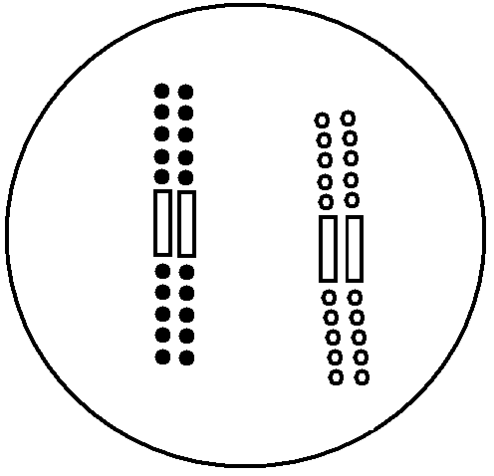

Prophase I
Much of Prophase I will be similar to Prophase of Mitosis. There will be a few differences.
During prophase the centrioles take up “polar” positions. Spindle fibers begin to appear. Chromatin condenses to chromosomes. The nucleus starts to disappear.

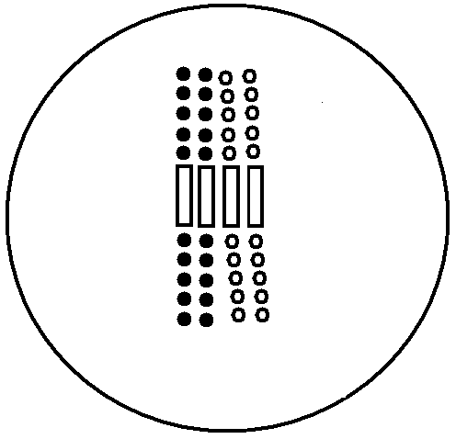
- Move your centrioles into their polar positions (North Pole/South Pole or you can do East/West poles). Keep the centrioles off the napkin/nucleus since they are in the cytoplasm.
- Remove your napkin. Recall that during prophase the nuclear envelope breaks down. The chromosomes are now free to move about the cell.
- Make your chromosomes synapse. At this stage, each member of a homologous pair finds its partner and lies next to it. The structure is called a “tetrad.” Push your red sister chromatid and yellow sister chromatid next to one another to demonstrate this. This synapsing can take place anywhere in the “nucleus”; you do not line them up on the metaphase plate.

To encourage genetic diversity, we will see crossing over at this point.
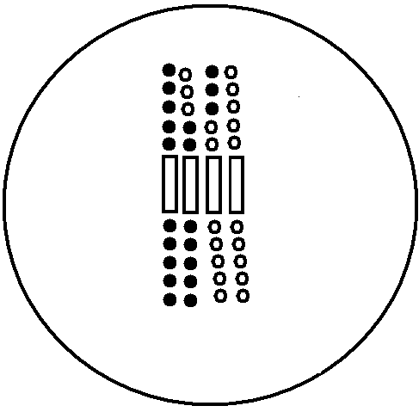
- Pull three of the red beads off of the red sister chromatid. Locate the yellow beads that are closest to where you pulled the red beads from. Pull three yellow beads off the sister chromatid.
- Add your three yellow beads to the red strand. Add your three red beads to the yellow strand.
- Notice at this point the chromosomes are no longer identical.

Metaphase I

During metaphase the duplicated chromosomes (sister chromatids) will line up along the metaphase plate in the tetrad form. The pair of chromosomes will span the metaphase plate, with one member of the homologous pair on one side and the other member of the pair on the opposite side. This is also where we’ll see independent assortment: for each tetrad, which sister chromatid ends up on which side of the metaphase plate is random.
- Imagine a line that runs between the two poles of your cell, much like the equator separates northern/southern hemispheres. This line is the metaphase plate.
- Assemble your tetrads along the metaphase plate. The red homologous pair should be on one side of the metaphase plate and the yellow pair should be on the other.
  - This varies from metaphase of mitosis because the centromeres are not along the metaphase plate.
Draw what your materials look like at this stage: Metaphase I

Anaphase I
During Anaphase I, the spindle fibers will pull half of the tetrad towards one centriole and the other half of the tetrad towards the opposite centriole
- Move the red sister chromatid towards one pole.
- Move the yellow sister chromatid towards the opposite pole. Their final destination is the centrioles.

Draw what your materials look like at this stage: Anaphase I

Telophase I
During telophase I, much of what was done in prophase I is reversed: the spindle fibers disappear, the nuclear membrane is reformed, and the chromosomes relax into chromatin
- The red sister chromatid should be at one centriole; the yellow should be at the other.
- Take two napkins (or split the one you used earlier in half). Place one napkin under each centriole, red, and yellow chromosome. This represents your nuclear membrane reforming.
- Start pulling the pop-beads off your chromosomes and place them on the napkin. This represents your chromosome returning to chromatin.

Draw what your materials look like at this stage: Telophase I

Cytokinesis
At this stage, the first meiotic division is complete, but the cell still needs to split into two. Cytokinesis will divide the original cell into two new cells.

NOTE: Normally in mitosis, the cell would go into interphase. However, because we’ve completed only the first meiotic division, there is no interphase before starting the second division.

Prophase II
The main events are the same as prior: the centrioles take up “polar” positions. Spindle fibers begin to appear. Chromatin condenses to chromosomes. The nucleus starts to disappear.
- Reassemble your sister chromatids as you saw them in Telophase I
- Move your centrioles into their polar positions. Keep the centrioles off the napkin/nucleus since they are in the cytoplasm.
- Remove your napkin. Recall that during prophase the nuclear envelope breaks down. The chromosomes are now free to move about the cell.
- You will have two cells to deal with at this point. One cell will contain the red sister chromatid. The other cell will contain the yellow sister chromatid.

Draw what your materials look like at this stage: Prophase II

Metaphase II
During metaphase the sister chromatids will line up along the metaphase plate.
- Imagine a line that runs between the two poles of your cell, much like the equator separates northern/southern hemispheres. This line is the metaphase plate.
- Assemble your sister chromatid along the metaphase plate. Place the centromere of the sister chromatid directly on the metaphase plate.
Draw what your materials look like at this stage: Metaphase II

Anaphase II
During anaphase, the sister chromatid will be split into two daughter chromosomes. The spindle fibers draw the chromatids away from the metaphase plate and towards the centrioles.
- Pull apart your sister chromatids. Push the separated chromosomes toward their respective poles. Their final destination is the centrioles.

Draw what your materials look like at this stage: Anaphase II

Telophase II
During Telophase II, much of what was done in prophase is reversed: the spindle fibers disappear, the nuclear membrane is reformed, and the chromosomes relax into chromatin
- All daughter chromosomes should be at a centriole.
- Take two napkins (or split the one you used earlier in half). Place one napkin under each centriole and chromosome. This represents your nuclear membrane reforming.
- Start pulling the pop-beads off your chromosomes and place them on the napkin. This represents your chromosome returning to chromatin.
Draw what your materials look like at this stage: Telophase II

Following Telophase II, meiosis is done. However, the cell has not split. Cytokinesis must take place to divide the contents of the cytoplasm and create the two new cells. We had one cell as our starting point. After meiosis I we had two cells. Following meiosis II we have four cells. Within the nucleus we will find half of the amount of genetic material as before. Our starting cell had 46 chromosomes (23 pair) while each of our four final cells will have 23 chromosomes (no pairs).

Epithelium

Epithelia are tissues that create linings or coverings. When looking at epithelia, you may see several cell types arranged to create a tissue.

Find a slide labeled Simple Squamous: Lung Tissue
In simple squamous tissue, there is one layer (simple) of flattened tile-like cells. Simple squamous tissues can be found in the alveoli of lungs and in the capillaries. In the image to the left, the alveoli demonstrate this very thin layer of cells. Locate the alveolar tissue on your microscope and compare it to the photomicrograph. Keep in mind that much of what you’ll be seeing is the air within the alveoli. The cellular structures are the thin borders of the alveolar sacs
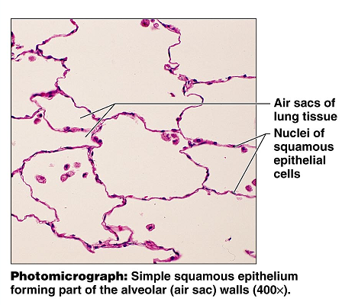

Find a slide labeled Simple Cuboidal: Kidney Tissue
The cuboid (square-ish) cells have the nuclei located in the center of the cell. In the photomicrograph below, the round glands are made up of a single layer of these square shaped cells. Even though there are several cuboid cells in each gland, there is only one layer of cells, making it simple cuboidal. Draw the simple cuboidal cells as you see them under the microscope (400X)

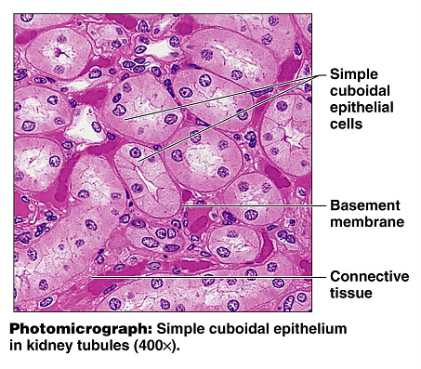

Find a slide labeled Simple columnar: Duodenum

Look for cells at the edge of the tissue selection that are longer than they are wide. They should have a round or oval nuclei located near their attachment to the basement membrane. The image below is of the stomach, and is at a greater magnification than what you’ll use for the duodenum. The duodenal tissue will also contain smooth muscle and other tissue types, so be aware that the simple columnar cells will be at the edge of the tissue selection. Draw and label the simple columnar cells that you see in the field of view. You may also see goblet cells. They are responsible for the production of mucus, and they have a flask-like shape.
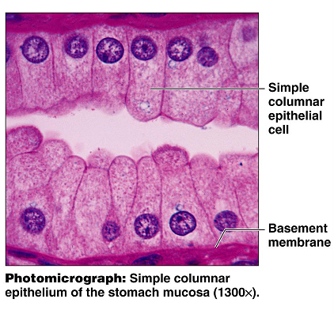

Find a slide labeled pseudostratified epithelium: Trachea
The pseudostratified epithelium is a single layer of cells that appears to have several layer based on the location of the nuclei. This tissue may be ciliated and have goblet cells, as seen in the image below. Locate the pseudostratified tissue in your field of view, and label the features.

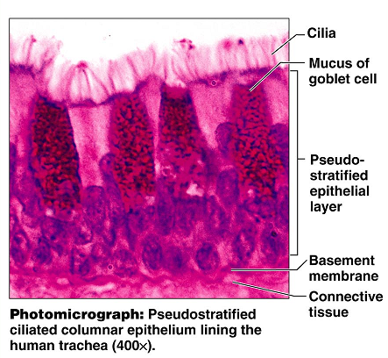

Locate the slide: Stratified squamous epithelium
This tissue is stratified (has multiple layers) of the squamous type cell. The basal cells (cells near the attachment site at the basement membrane) tend to have more of a cuboid appearance than the typical flattened appearance associated with the squamous cells. On the skin, the stratified squamous epithelium is keratinized. The protein keratin provides a toughness and water-proofing to protect the underlying layers. Stratified squamous is prevalent in areas that are likely to experience wear and abrasions. Draw the stratified squamous as you see it in the field of view (400X)
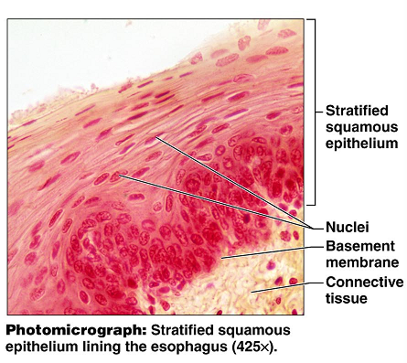

Locate the transitional epithelium: urinary bladder
Transitional epithelium is designed to stretch as the bladder and other urinary organs fill and empty. The basal cells (near the basement membrane) tend to have a cuboid appearance, while the surface cells can have a domed appearance or a squamous appearance, depending on the amount of stretch the tissue is under. Draw the transitional epithelium as viewed in the field of view under high power (400X).

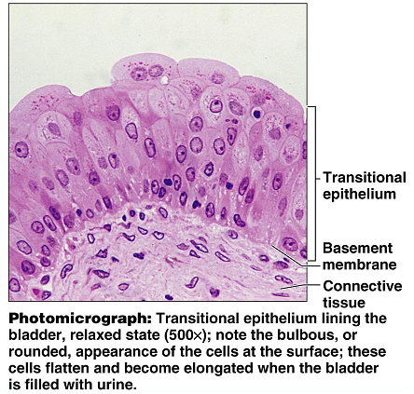

- When you are done with the microscope for the day, complete the following checklist:
  - _____ turn off the light
  - _____ remove the slide (return all slides)
  - _____ drop the stage to the lowest position
  - _____ put the scanning objective lens in place
  - _____ secure the cord
  - _____ stow the microscope carefully
  - _____Check and clean your work space

Connective Tissues

Please Note: Today’s lab deals with viewing several slides. Be sure to use appropriate microscope technique. Drop the stage to the lowest position before adding or removing a slide. Use the scanning power to locate and center an image before moving to a higher magnification. Use the course adjust knob ONLY with the scanning power, never with the low or high power lenses. Once you’ve upgraded to the low power (100X) or the high power (400X) be sure to use the fine adjust knob. If you have any questions regarding microscope usage, ask your TA.

Part 1: Connective Tissues
After viewing the slides, use your text book or lab manual to answer the questions

Slide: Areolar Connective Tissue
In your field of view, try to identify fibroblasts, macrophages, and mast cells. You may be able to identify some white blood cells as well.

Question: What is the function of areolar connective tissue?

Question: Where can areolar connective tissue be found?

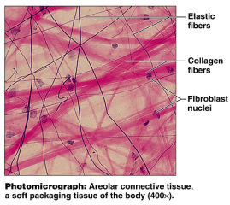

Slide: Adipose Tissue
In your field of view, you will find what appears to be empty cells. These spaces once housed the fat stores in the adipocytes. Try to identify the nuclei which are pushed off to the side.
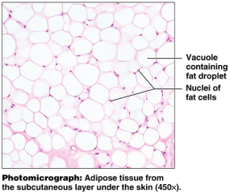

Question: What is the function of the adipose tissue?

Question: Where are some locations in which adipose tissue is found.

Question: within the adipocyte, what is the vacuole?

Reticular Connective Tissue (no slide available)
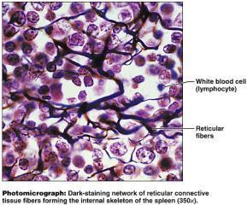
Reticular connective tissue contains a great deal of the reticular fibers. Observe the branched/networked nature of the fibers.

Question: Where is reticular connective tissue found?

Question: What is the function of reticular connective tissue?

Dense Regular Connective Tissue
This type of connective tissue can be seen in tendons. Notice how this tissue type is mostly fibers with few cells. The fibers are arranged in a regular pattern, giving a wavy appearance to the tissue. Also note that the image on the right is magnified 1000X. Your microscope will get you to 400X without oil immersion.
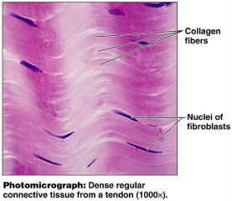

Question: Which fiber type is most prominent in this tissue type?

Question: Although cells are not abundant in this tissue, which cell is the most frequently found in this type?

Question: What is an aponeurosis?

Cartilage:
Slides: Hyaline Cartilage, elastic cartilage, fibrocartilage

Hyaline Cartilage: Slide: Monkey Trachea or trachea

In this tissue type, the collagen fibers form a network that is not easily seen; it appears as an evenly colored background. What is noticeable is the lacunae which house the chondrocytes. When looking at the trachea slides, keep in mind that hyaline tissue may not be the only tissue type appearing on this slide. You’ll have to search for the hyaline characteristics.

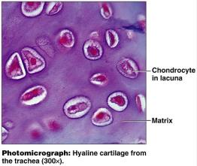

Question: Where is hyaline cartilage found?

Question: Which type of bone formation begins with a hyaline “bone” that gets ossified?

Question: In the term “chondrocyte”, what does “chondro” refer to?

Cartilage: Elastic Cartilage
Slide: Elastic cartilage or Epiglottis

Make a comparison of the hyaline cartilage to the elastic cartilage. Both have lacunae, but the lacunae in the elastic cartilage are more pronounced. Also, elastic cartilage has visible elastic fibers whereas the fibers in hyaline cartilage were much more subtle.

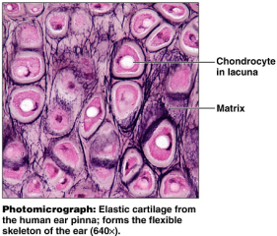

Question: In which locations can elastic cartilage be found?

Question: What is the advantage of having elastic fibers in the matrix? Which quality does this give the elastic cartilage?

Cartilage: Fibrocartilage
Fibrocartilage contains a large amount of the thick collagen fibers. Still present are the lacunae and the chondrocytes. Compare this cartilage to the hyaline and the elastic cartilages.

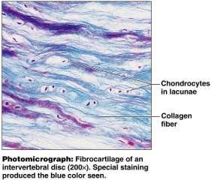

Question: Where is fibrocartilage found?

Question: what is the function of fibrocartilage?

Connective Tissue: Bone
Note that this connective tissue has a calcified matrix unlike the previously viewed tissues. Locate the central canal and lamella while viewing the osteon. Again, this tissue type contains lacunae, but rather than containing chondrocytes like the cartilage did, these contain osteocytes.
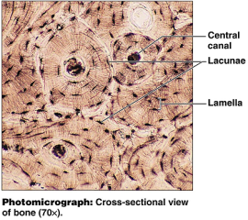

Question: What is the function of the central canal?

Question: What is the function of the canaliculi?

Question: What is an osteon?

Connective Tissue: Blood
Slide: Blood or Wright’s stain
Blood is a connective tissue used for transportation. The matrix is a fluid matrix (plasma) and the cells are the red and white blood cells.
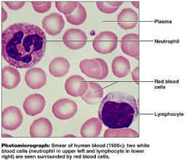

Question: According to your lecture notes (or text book) What are the functions of connective tissues in general?

Given the four tissue types (Epithelia, Connective Tissue, Muscle, and Nervous), try to arrange them into their groups. (List the slides and tissues you’ve viewed this lab and last into their appropriate categories below.)

Epithelia:
Simple Stratified Other

Connective Tissue:
Connective Tissue Proper “Special” Connective Tissue

- When you are done with the microscope for the day, complete the following checklist:
  - _____ turn off the light
  - _____ remove the slide (return all slides)
  - _____ drop the stage to the lowest position
  - _____ put the scanning objective lens in place
  - _____ secure the cord
  - _____ stow the microscope carefully
  - _____Check and clean your work space

Quiz One

Quiz one will cover all labs up to this point.

Recall that the quiz will be a practical, so you’ll be responsible identifying images from a microscope, identifying structures you’ve labeled in lab, and you’ll also be responsible for answering questions that come from the content of the lab manual. All material from pages 7 – 41 is fair game for the quiz.

Things to consider as you review: (This is by no means an all-inclusive list)

What are the parts to the microscope and their functions?
Am I familiar with all of the anatomical regions?
Can I correctly use the terminology (anterior, distal, deep, etc)?
What are the functions and distinguishing characteristics of epithelial tissues?
How can I identify and recall the slides for the epithelial tissues?
What are the functions and distinguishing characteristics of the connective tissue?
How can I identify and recall the slides for the connective tissues?
Can I identify and draw the stages of mitosis?
Do I know the difference between mitosis and meiosis?

Axial Skeleton
The human skeleton is divided into two main regions: axial and appendicular. The axial skeleton contains the skull, vertebrae, ribs, and sternum. The appendicular skeleton contains the bones of the upper and lower extremities, and the girdles that attach them to the axial skeleton.

For the purposes of this lab, we will not be spending a great deal of time on the skull. Be aware, though, that the skull has two divisions to it. It contains the facial bones as well as the cranial bones.

Skull: Observe the bones of the skull.

Vertebral column

Be able to locate and identify the features listed below on both the images and the actual bones.

- Vertebrae (all levels: cervical, thoracic, and lumbar)
  - Body
  - Spinous process
  - Vertebral foramen
  - Vertebral arch
  - Transverse process
  - Pedicle
  - Lamina
- Vertebrae: Cervical
  - Atlas
  - Axis
  - Dens/odontoid process
  - Transverse foramina

- Vertebrae: Thoracic
  - Articular facets
- Sacrum
  - Median sacral crest
  - Anterior/Posterior sacral foramina
  - Sacral promontory
  - Sacral hiatus
  - Sacral ala
  - Transverse ridges
  - Sacral canal
- Coccyx
- Ribs (note true versus false ribs)
  - Head
  - Neck
  - Tubercle
- Sternum
  - Xiphoid process
  - Manubrium
    - Jugular notch
  - Body

From your text book, label the following images:

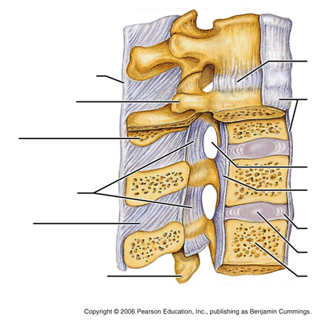

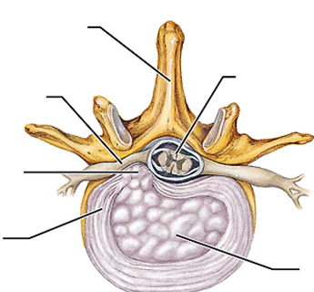

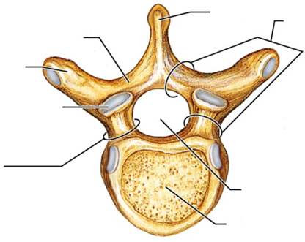

Observe the first cervical vertebra: C1
This structure varies from the other vertebra in that it has a modified body. The shape of C1 allows rotation to take place with the skull, as well flexion and extension. Look at the smooth articular surfaces that form the joints with the occipital regions of the skull.
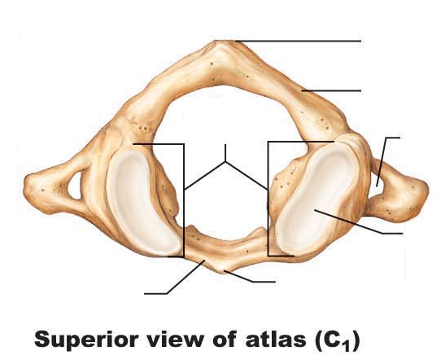

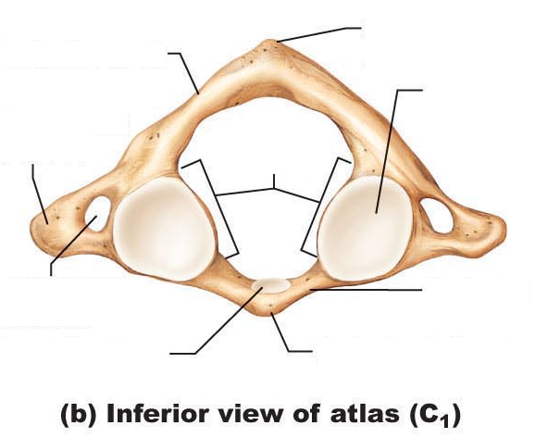

Observe the second cervical vertebra: C2
Notice on the superior aspect is a bony protrusion called the dens or odontoid process. This process articulates with C1 and allow us to have a great deal of rotation at this level. Find a C1 and a C2 vertebra and fit them together properly to observe how their articulation allows for this pivoting to take place.

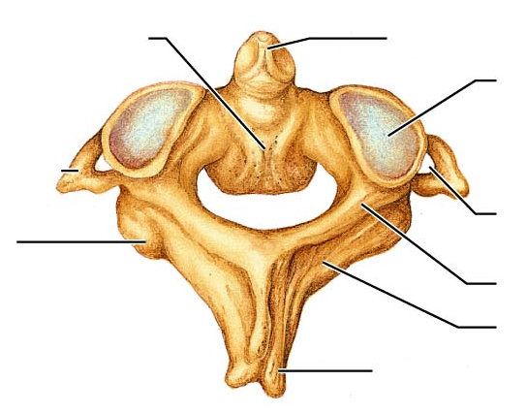

Observe the remaining cervical vertebrae. Notice the presence of the transverse foramina, which allow the arteries to run through a protected environment on their way to the brain.

Compare the bodies of the cervical vertebra to those of the thoracic vertebrae and those of the lumbar vertebra.

What do you notice in terms of shape?

What do you notice in terms of size?

Compare the cervical, thoracic, and lumbar vertebrae.
What do you notice about the spinous processes for each region? (indicate distinctions about shape, size, and orientation of the SP)

Compare the cervical, thoracic and lumbar vertebrae.
What do you notice with regards to the transverse processes for each region?

What feature do the thoracic vertebrae have to accommodate the ribs?

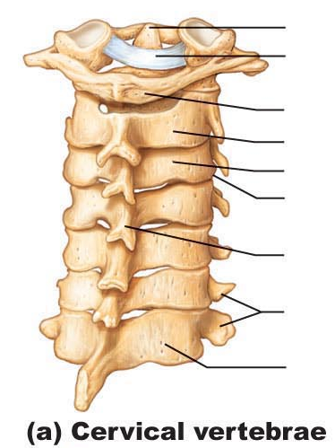

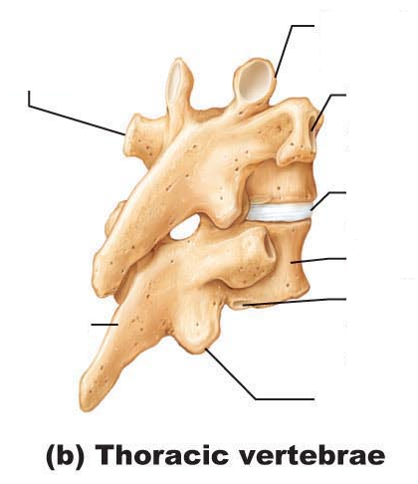

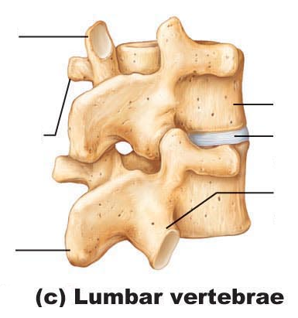

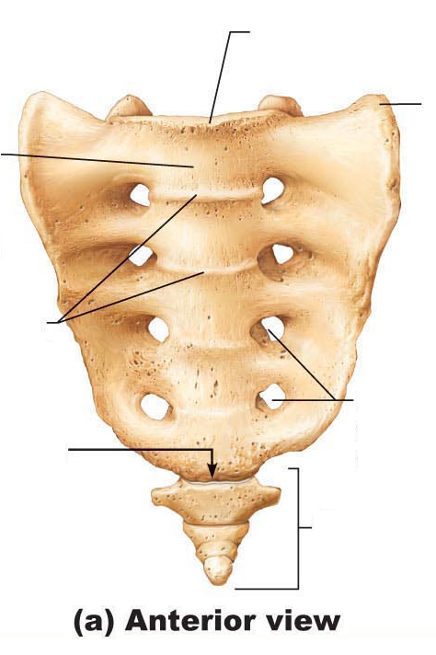

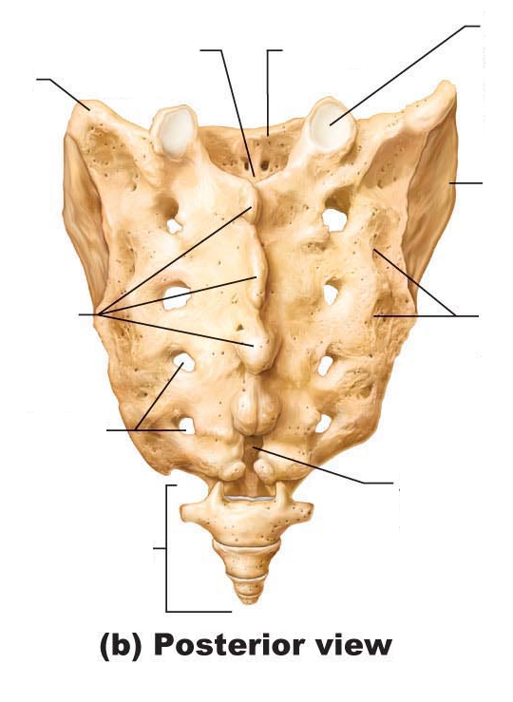

Thoracic Cage:
The thoracic cage is the protective environment that houses the delicate organs of the chest. It is composed of the sternum, the ribs, and the thoracic vertebrae, as well as the costal cartilage. As we breathe, our chest needs to be able to expand and contract. The articulations of the ribs at the vertebrae allow this to happen, as does the costal cartilage attachments to the sternum.

Observe the features of the thoracic cage and complete the labeling on the diagrams below.

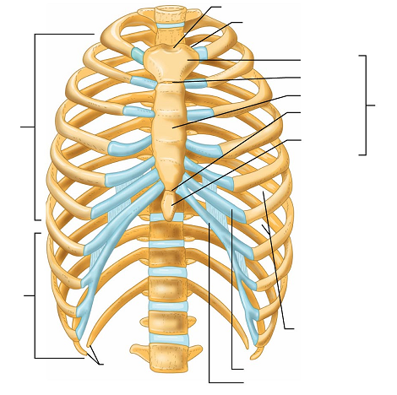

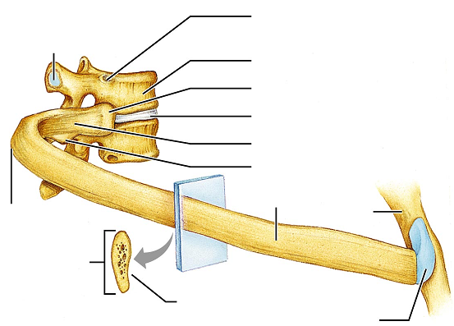

Define and be familiar with the terms below:

Condyle
Epicondyle
Facet
Fissure
Foramen
Fossa
Fovea
head
Meatus
Process
Spine
Sulcus
trochanter
tuberosity
tuburcle

Before leaving lab, be sure that you can find and identify each of the features on the axial skeleton bones that you were asked to label in the above images.
Appendicular Skeleton

Obtain the bones of the upper extremity and
locate the following features and landmarks:

- Clavicle
  - Sternal end
  - Acromial end
- Scapula
  - Acromion process
  - Glenoid fossa
  - Coracoid process
  - Posterior features:
    - Scapular spine
    - Supraspinous fossa
    - Infraspinous fossa
  - Anterior features:
    - Subscapular fossa
- Humerus
  - Head
  - Greater tubercle
  - Lesser tubercle
  - Intertubercular groove
  - Deltoid tuberosity
  - Trochlea
  - Capitulum
  - Coronoid fossa
  - Olecranon fossa
- Ulna
  - Olecranon process
  - Coronoid process
  - Styloid process
  - Head
- Radius
  - Head
  - neck
  - Styloid process
- Wrist and hands
  - Carpal bones
  - Metacarpals
  - Proximal phalanges
  - Middle phalanges
  - Distal phalanges

Obtain bones of the lower extremity and located the features and landmarks

- Pelvis
  - Ilium
    - Iliac crest
    - Anterior superior iliac spine
    - Anterior inferior iliac spine
    - Posterior superior iliac spine
    - Posterior inferior iliac spine
    - ala
  - Ishium
    - Ramus
    - Ischial tuberuosity
  - Pubis
    - Superor and inferior ramus
    - Symphysis pubis
    - Obdurator foramen
    - Pubic arch
  - Acetabulum

- Femur
  - Fovea capitis
  - Head
  - Neck
  - Greater trochanter
  - Lesser trochanter
  - Lateral condyle
  - Medial condyle
  - Lateral epicondyle
  - Medial epicondyle
  - Patellar surface
- Patella
  - Apex
  - Factes
- Tibia
  - Intercondylar eminence
  - Lateral condyle
  - Medial condyle
  - Tibial tuberosity
  - Medial malleolus
- Fibula
  - Head
  - Lateral malleolus
- Ankle and Foot
  - Tarsal bones
    - Calcaneus
    - Talus
  - Metatarsals
  - phalanges

Use the lab manual, your notes, or your textbook to answer the following questions. These questions are to be answered before leaving lab.

- Which bones make up the pectoral girdle?

- Which feature of the scapula divides the posterior aspect into superior and inferior portions?

- Identify the glenoid fossa of the scapula. With which bone will it articulate to form the shoulder joint? What type joint arrangement is this?

- Which features of which bones form the hinge joint at the elbow?

- Which feature of the ulna prevents hyperextension of the elbow?

- Which features of which bones form the pivot joint at the elbow?

- Which bones make up the pelvic girdle?

- What type of cartilage forms the pubic symphysis joint?

- What are three differences that can be seen in a male pelvis versus a female pelvis?

- What are the functions of the greater and lesser trochanters in the femur.

- Which bone contains the medial malleolus?

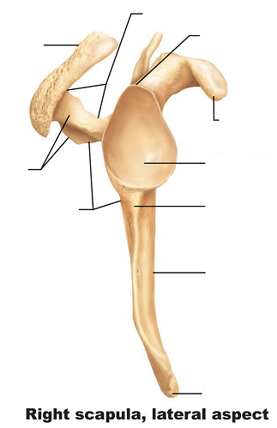

- Which bone contains the lateral malleolus?

- How many metatarsals are in the foot?

- How many phalanges are in the foot?

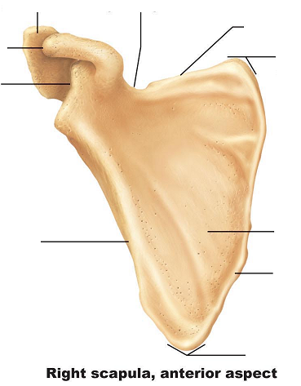

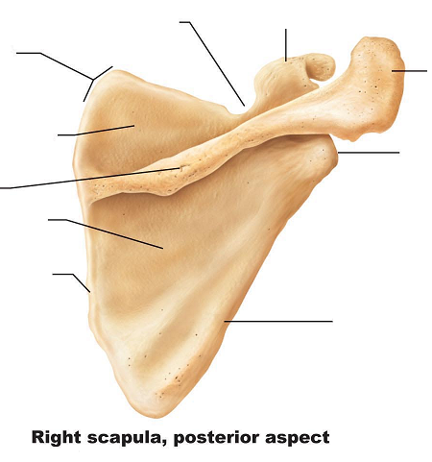

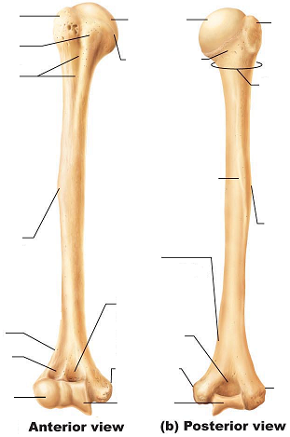

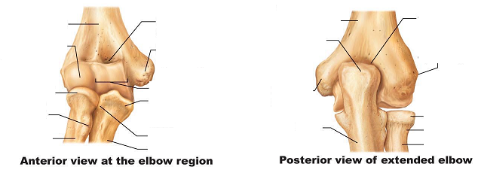

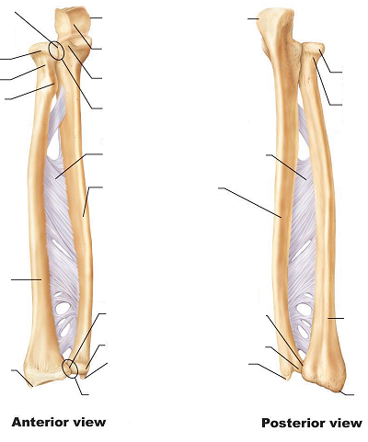

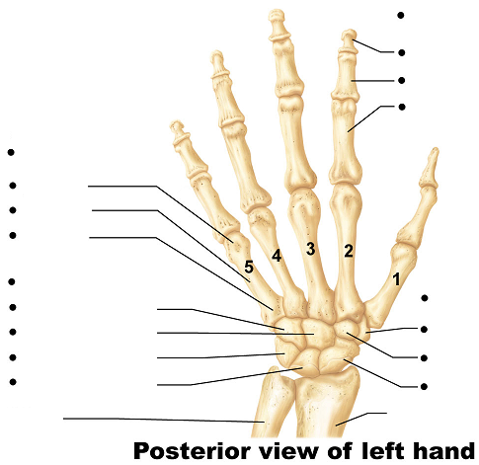

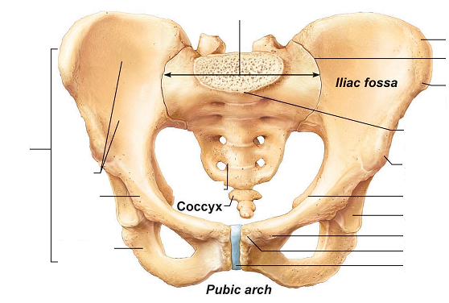

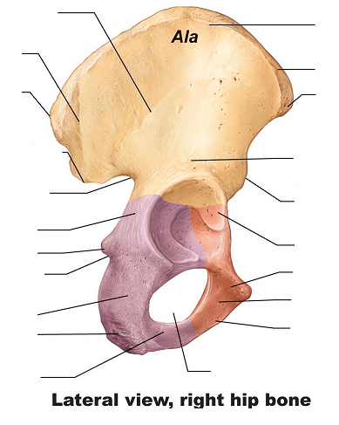

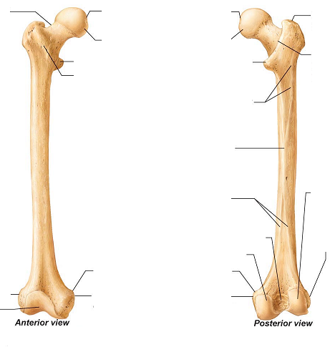

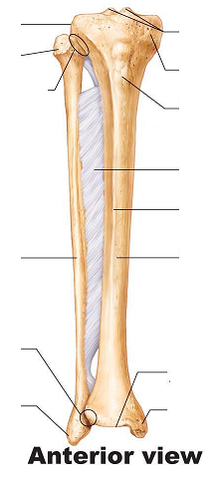

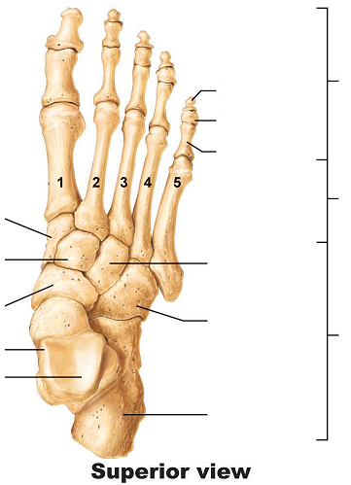

Muscles
Recall that there muscle tissue is divided into three categories: skeletal, smooth, and cardiac. Review each of the three types of tissues under a microscope.

Cardiac Muscle
Cardiac muscle is found only in the heart. It is involuntary. The control for the cardiac muscles comes from within the heart: the SA node. The cardiac tissue is also striated. When viewed under a microscope, you should be able to observe the bands or striations. Notice the branching shape of the cells. They have a “Y” appearance to them. Also note the intercalated discs. These discs help form the gap junctions that allow for rapid communication within the heart tissue. View and draw cardiac muscle.
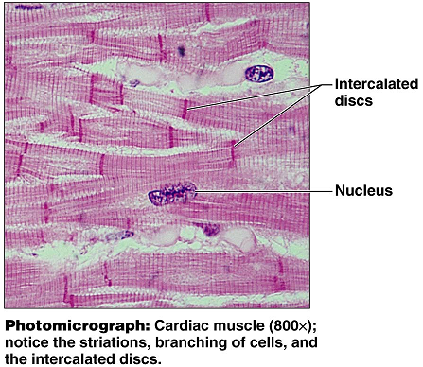

Smooth muscle:
Smooth muscle is located in organs and vessels. It is responsible for propelling food through the digestive tract as well as constricting blood vessels to raise blood pressure. The smooth muscle cell does not have striations, giving it a smooth appearance under the microscope. Smooth muscles have a tapered appearance, are shorter than skeletal muscle fibers, and have only one nucleus for each cell. View and draw smooth muscle.

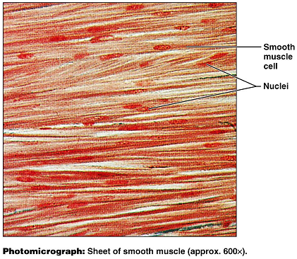

Skeletal Muscle:
Skeletal muscle is voluntary and striated. Skeletal muscle cells (muscle fibers) are multinucleate. In addition to being able to see the banded appearance under high power, we can also observe the areas where it receives signals from nerves. View and draw skeletal muscle.
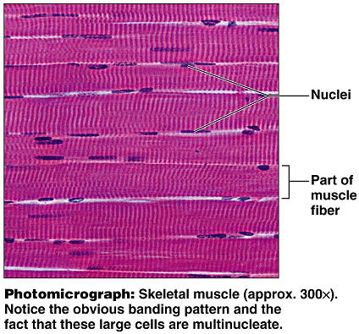

Motor Units:
A motor unit contains the nerve that runs to the muscle, and all of the muscle fibers that are innervated. Some motor units have one nerve fiber that runs to hundreds of muscle fibers. This type of arrangement gives us gross or bulky control. We see this type of arrangement in the low back muscles. Other motor units have one nerve fiber that innervates just a few muscle fibers. This is how we get our fine motor control. We see this in the eye muscles and in the fingers. View and draw a motor unit.

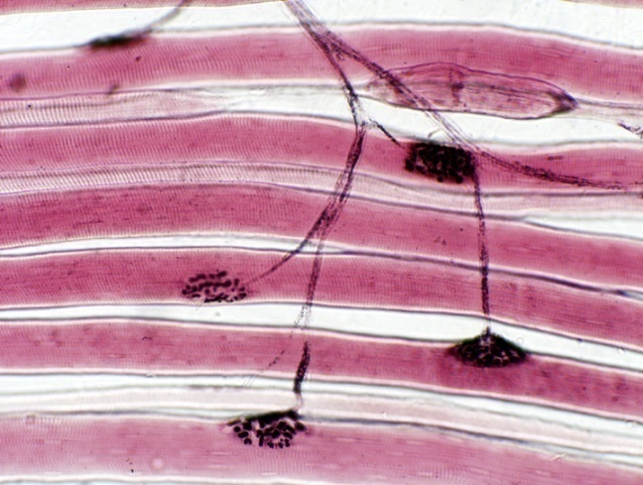

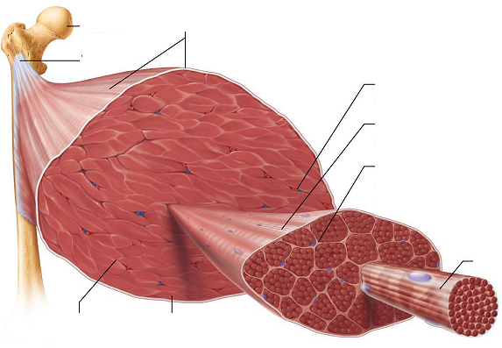

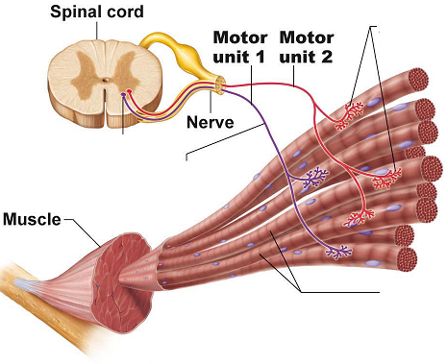

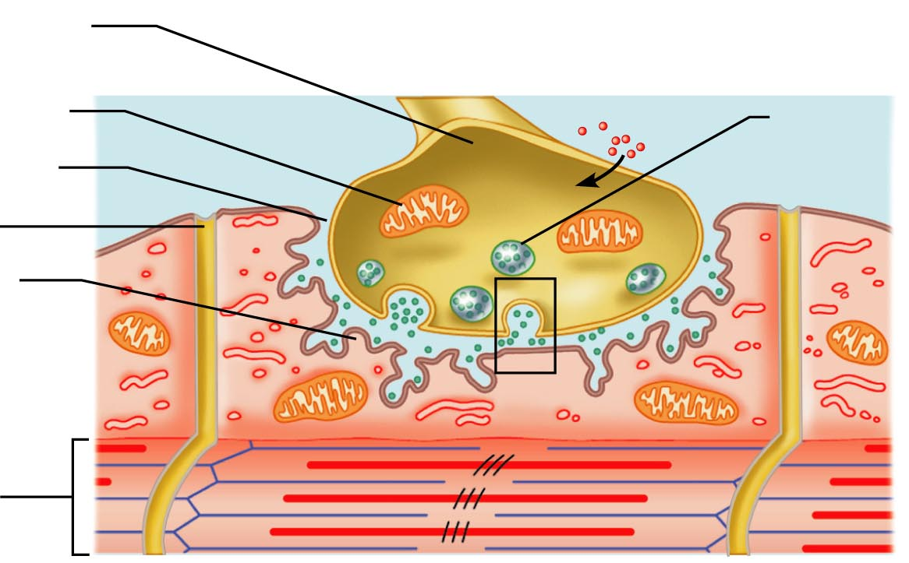

Questions:
- In which type of tissue (cardiac, smooth, or skeletal) would neuromuscular junction be located?

- What is the function of the gap junctions (intercalated disks) present in cardiac muscle tissue?

- Which protein fibers in skeletal muscle act together to cause contractions?

- Describe the process that takes place at a neuromuscular junction. Try to put it into your own words.
Include the following terms: vesicle, neurotransmitter, synaptic cleft

- How does the shape and appearance of smooth muscle differ from skeletal muscle?

Skeleton muscle contracts rapidly. However, it also fatigues quickly as well. Compare this to smooth muscle and cardiac muscles that have a slower response, and little to no fatigue. To demonstrate rapid muscle contractions and fatigue, we’ll perform the following exercise.

- Work in pairs. One person from your group will perform the exercise and the other person can record data and keep an eye on the time.
- Get a clothes pin
- To isolate the muscle activity, hold the clothespin with the thumb and index finger, but keep your remaining fingers straight (extended).
- The timekeeper will announce the beginning of a 20 second interval.
- The person with the clothespin with try to rapidly and repeatedly squeeze the clothespin open. Count the number of times you were able to open the clothespin within 20 seconds.
- The timekeeper will note the end of the 20 seconds and IMMEDIATELY announce the beginning of another 20 second interval.
- Do not rest or relax between intervals
- Keep track of the number of pinches in each 20 second interval and record them below.
- Record your results for a 3 minute span of time (complete nine 20-second rounds)

Time (20 seconds each) | Pinches per round
1
2
3
4
5
6
7
8
9

Answer the following questions:

Did the skeletal muscles used show signs of fatigue?

What physical symptoms, other than your results, did you notice?

What type of movement was being performed by the index finger?

Which muscles were causing that movement to take place?

Locating Muscles
To “palpate” means to feel. Place your hand lightly over the muscle in question to feel the location and the contraction. Obtain your lab partner’s consent before palpating them. Be respectful of his or her space.

- On your lab partner, palpate the Deltoid muscle. Activate it to view arm abduction.
- On your partner, palpate the biceps brachii muscle. Activate it to view forearm flexion.
- On your partner, palpate the triceps brachii muscle. Activate it to view forearm extension
- On your partner, palpate pectoralis major muscle. Activate it to view arm flexion
- On your partner, palpate latissimus dorsi muscle. Activate it to view arm extension
- On your partner, identify the location of the iliopsoas muscle. Activate it to view hip flexion.
- On your partner, palpate the quadriceps muscles. Activate them to view knee extension
- On your partner, palpate the hamstring muscles. Activate them to view knee flexion.
- On your partner, palpate tibialis anterior muscle. Activate it to view dorsiflexion.
- On your partner, palpate the gastrocnemius and soleus muscles. Active them to view plantar flexion.

Isotonic muscle contractions:
As the tension on a muscle increases, the muscle will respond by changing length.
If you do a biceps curl holding a weight, you are performing an isotonic contraction. The biceps muscle changes length, and the forearm flexes at the elbow. Because the weight of your object remains the same, your muscle remains isotonic (same tone) even though the length of the muscle is changing.

Concentric contractions: A concentric contraction is a type of isotonic contraction. If you lift a 10 lb weight to do a biceps curl, you are performing a concentric contraction as you flex the forearm. The muscle is able to overcome the weight or resistance and shorten the muscle fibers.

Eccentric contractions: An eccentric contraction is also a type of isotonic contraction. Eccentric contractions are often times described as “braking” contractions. With an eccentric contraction, the strength of the contraction is weaker than the amount of force being applied to it. Imagine that same bicep curl from above. As the forearm flexes, the biceps undergoes a concentric contraction, shortens, and brings the weight up. However, as the forearm extends, the triceps are activated. The triceps, plus the weight act to pull and lengthen the biceps muscle. The bicep is still contracting (braking) to slow or smooth the movement during the act of extension. If the eccentric contraction were absent, the forearm would flop into extension with no resistance and no control. An eccentric contraction is still an isotonic contraction because the length of the muscle is changing as the forces remain constant. The key thing to keep in mind here is that “contraction” doesn’t always mean “shortening.” In cases of eccentric contractions, the muscle can both contract and lengthen (qualifying it for the change-in-length needed for an isotonic designation.)

Isometric contractions:
With isometric contractions, the length of the muscle remains the same, but the forces exerted (tone) may change. As we attempt to move or lift object that exceed our muscles’ abilities, we utilize isometric contractions: trying to lift a car or pushing against a locked door. Our body uses isometric contractions in many of our postural muscles to allow us to maintain our balance.

In the following questions, identify the muscle primarily responsible for the motion, the antagonist, and identify the type of contractions being used.

- In order to walk, we plantar-flex at the ankle.
  - Primary muscle used:
  - Antagonist:
  - Contraction used in agonist (primary muscle):
  - Contraction used in the antagonist (opposing muscle):
- Extension at the knee
  - Primary muscle (group) used:
  - Antagonists:
  - Contraction used in agonists:
  - Contraction used in antagonists:
- Flexion at the hip:
  - Primary muscles used
  - Antagonists:
  - Contraction used in agonists:
  - Contraction used in antagonists:
- Extension at the elbow (assume you are pushing against something that won’t budge)
  - Primary muscle used:
  - Antagonist
  - Contraction used in agonist:
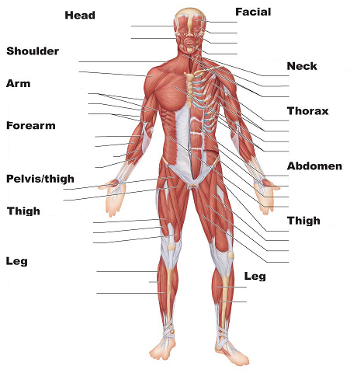
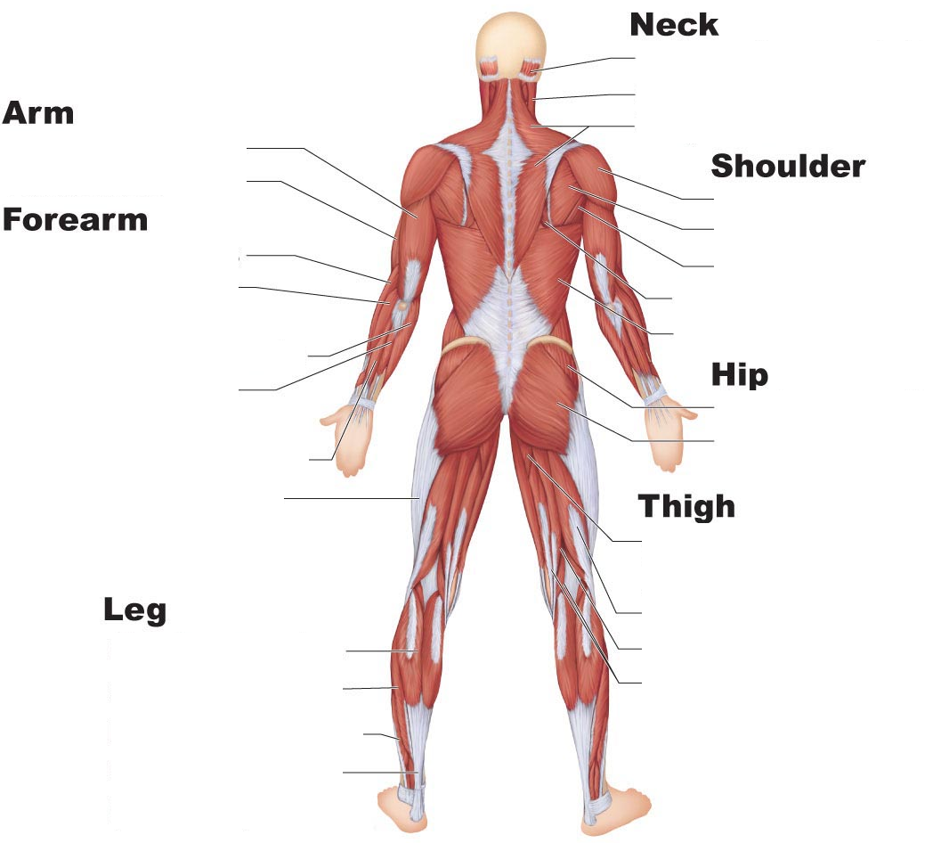

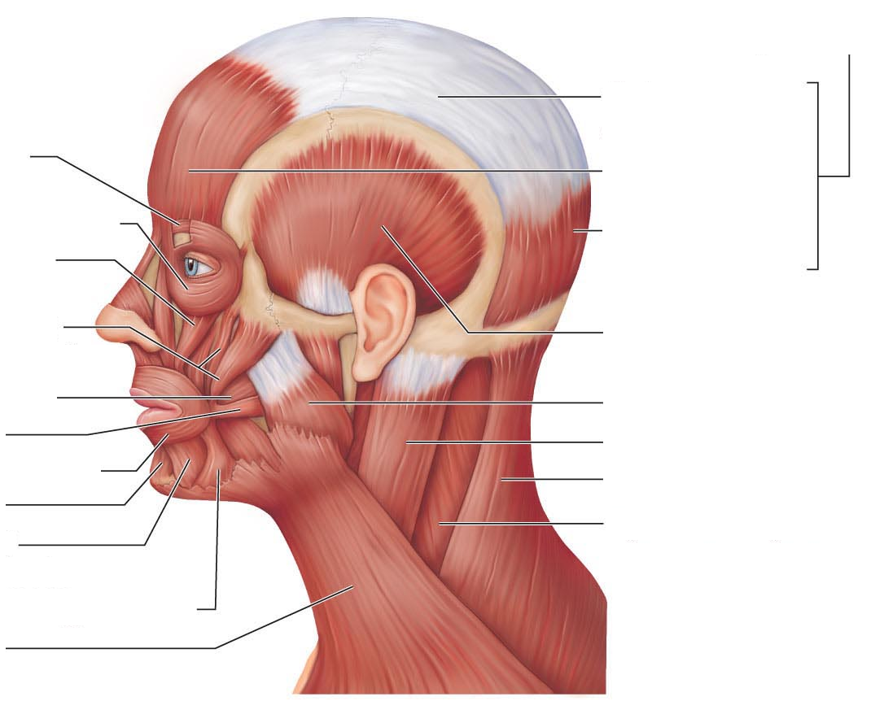

Quiz Two: Lab Practical

Covers axial skeleton, appendicular skeleton, and muscles

All information and images are potential quiz questions.

Ask yourself…

Do I know where each of the bones are?
Do I know the major features of each bone?
Can I identify an individual bone away from the skeleton?
Can I distinguish between the vertebrae (cervical/thoracic/lumbar) based on their shape?
Can I answer the bone questions from the lab manual?
Can I identify the structures on the images from the lab manual?
Do I know where the muscles are?
Can I distinguish between skeletal/smooth/cardiac on a microscope slide? Based on their descriptions?
Can I describe isotonic versus isometric contractions? Concentric versus eccentric?

Brain and Spinal Cord

When observing the sheep brain, locate the following structures:

Before making any cuts, view the brain and locate
Longitudinal fissure
Transverse cerebral fissure
Frontal lobe
Parietal lobe
Temporal lobe
Occipital lobe
Cerebellum
Pituitary gland
Olfactory bulbs
Optic chiasma
Pons
Medulla oblongata

After making your sagittal section, locate
Arbor vitae
Medulla oblongata
Thalamus
Mammillary body
Pineal body
Ventricles
Corpus callosum

After making your coronal section locate
Longitudinal fissure
Gray/white matter
Fornix
Lateral and third ventricles
Thalamus
Hypothalamus

After sectioning the spinal cord locate
Pia mater
Posterior median sulcus
Anterior median sulcus
Gray and white matter

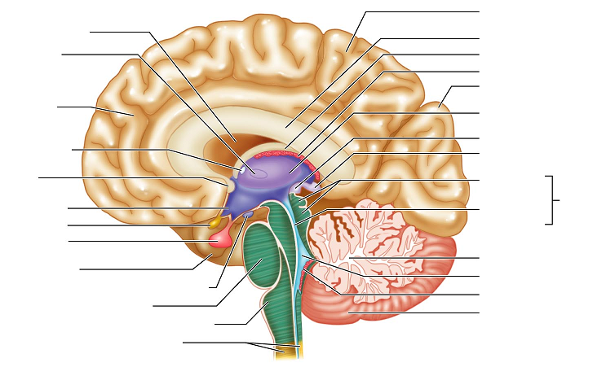

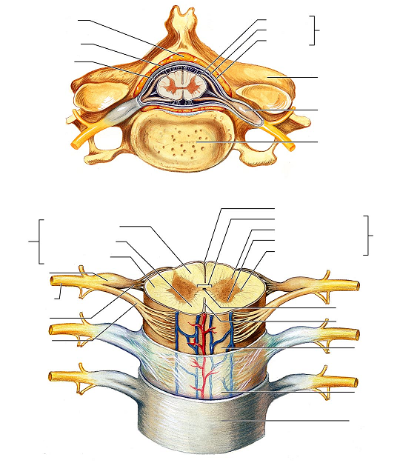

Peripheral Nerve
Examine the peripheral nerve cross section at 40X (scanning power). Try to discern the axon bundles/fascicles. Bringing the magnification up to high power (400X) will help you see the individual axons.
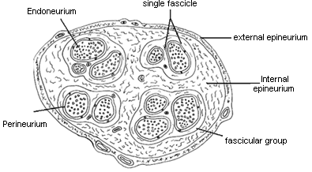

Draw the peripheral nerve at 40X
Label as many features as you can identify

Draw the peripheral nerve at 400X
Label as many features as you can identify

Answer the questions using your lab manual, your text book, and your lecture notes. Answer the questions before leaving lab.

What is the function of the myelin sheath?

What cell type is responsible for the myelin sheath in a peripheral nerve? In a CNS nerve?

Where do we commonly find multipolar neurons?

Where do we commonly find bipolar neurons?

Where do we commonly find unipolar neurons?

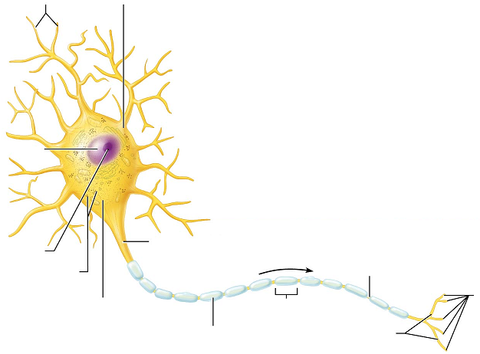

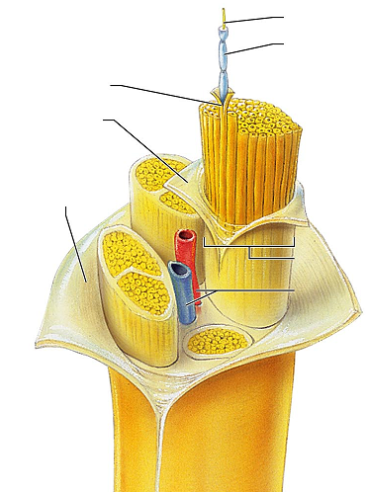

Spinal Cord
Microscope: View the prepared slide of the spinal cord and draw it. Identify white and gray matter, anterior and posterior horns, gray commisure, central canal

40X

400X

View the Giant Multipolar Neuron slide. View and identify as many structures as possible

What type of material composes the gray matter of the spinal cord?

What type of material composes the white matter of the spinal cord?

What is the location and function of the dorsal root ganglion?

What are the three meningeal layers that cover the brain and spinal cord?

What is a sulcus?

What is a gyri?

Which three regions make up the diencephalon?

What function does the thalamus have?

Where is the choroid plexus found and what does it do?

In the medulla, what are the pyramids?

What is the optic chiasma?

What are the ventricles? How many are there?

What is the function of the corpus callosum?

Neurological Exams (Spinal)

Sensory pathways

In the CNS there are two main ascending pathways that deal with incoming sensory input.

One is the spinothalamic tract, which conveys touch, pressure, temperature, and pain pathways. The first order neurons in the ST (spinothalamic tract) start off in the body and run into the spinal cord; their cell bodies are located in the dorsal root ganglion. The second order neurons immediately cross over to the opposite side of the cord ascend until they reach the thalamus. The third order neurons run from the thalamus to the somatosensory cortex of the brain: the post-central gyrus.

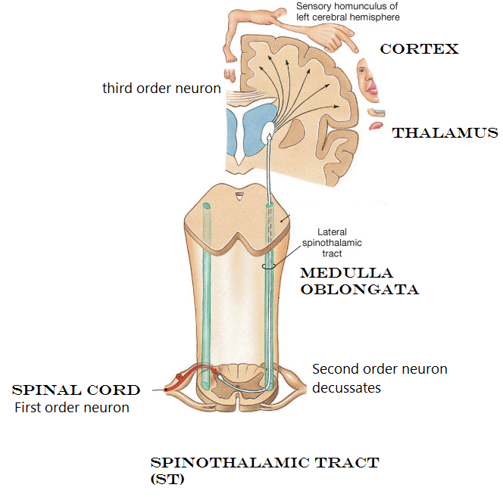

The other is the DCML (Dorsal Column Medial Lemniscus) which carries impulses related to vibration, joint position, and integration of information. At the level of the spinal cord, the DCML is also known as the Posterior Column and can be further divided into Fasciculus gracilis and Fasciculus cuneatus. The first order neurons of the DCML start off as afferent neurons with the cell bodies located in the dorsal ganglia. They synapse at the spinal cord. The second order neurons ascend, decussating at the pyramids in the medulla. The second order fibers ascend to the level of the thalamus, where again they will synapse. The third order neurons go from the thalamus to the cortex.

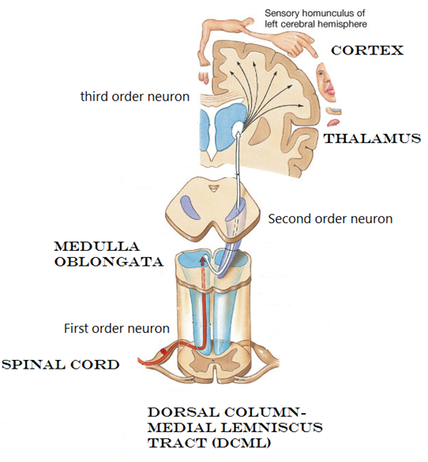

We can challenge both the ST and the DCML pathways to see if they are functional.

To evaluate the DCML, we will test vibration sense, positional sense, and discrimination.

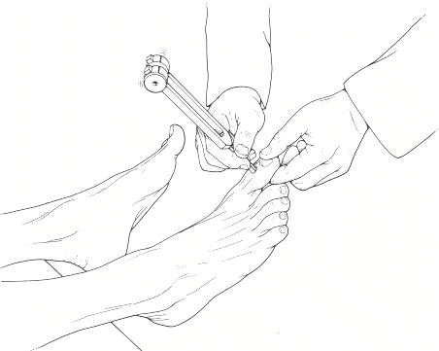
Vibration:
Find a tuning fork. Have your lab partner sit comfortably with eyes closed. Ask them to hold out their hand, palm down. Strike the tuning fork. We are interested in the vibration. Hold the tuning fork by the stem (do not contact the vibrating tines) and place the tip of the stem on one of your lab partner’s distal interphalangeal joint. The toes are ideal. If your lab partner is willing to remove a sock/shoe, use a toe. If not, use a finger. Be sure to test both right and left sides.

Ask your partner if he/she feels the vibration from the tuning fork.

If your lab partner is unable to feel the vibration, what might this indicate?

Positional sense:
Your lab partner should be sitting comfortably with eyes closed. With one hand, secure the distal interphalangeal joint of the middle finger. With the other hand, gently push the tip of the finger either up or push the tip of the finger down. Ask your lab partner which direction the fingertip was moved. Test both right and left hands for positional sense.

Discriminative sensations

Tactile direction
While your lab partner sits comfortably with eyes closed, place your fingertip on the dorsum of his/her hand. Hold your position there briefly, and then choose a direction to move. Move only about an inch. Let your partner tell you if you moved towards the fingers (distally), towards the wrist (proximally) or if your movement was to the right or left. Test both right and left hands. Repeat the test placing your finger at the knee. Again make a discrete one-inch movement: right, left, proximal or distal. Test both right and left lower extremities. Ask your lab partner which direction the movement was.

Graphesthesia
Graphesthesia is the ability to recognize letters or writing on the skin just by feeling it, without visual input. Typically, the writing is done on the palm of the hand, but it can be done almost anywhere.
While your lab partner sits comfortably with eyes closed, palm up, draw a letter on the palm of his/her hand. Use a fingertip, pen cap, stylus, cotton-tipped swab, or similar item. Please do not put ink on your lab partner for this project.

Draw a letter. Ask your lab partner to identify it. Test the opposite hand.
This time, use your lab partner’s back. Choose a short word and “write” it on their back. Ask them to tell you what the word was.

Stereognosis
Stereognosis is the ability to identify and object by touching it. While your lab partner sits comfortably with eyes closed, choose a small object and place it into his or her hand. Allow them to manipulate it, and then ask them what it is. Choose a common object like a coin, a key, a paper clip, etc. Use your creativity in choosing a material, but try to find something that is well recognized.

Pacinian Corpuscles
Pacinian corpuscles are exteroreceptors scattered deep in the dermis and subcutaneous tissues. They consist of a sensory dendrite surrounded by layers of flattened cells and layers of collagen fibers that form an egg-shaped capsule. They are receptors for vibration and touch. To locate the Pacinian Corpuscle on the slide, find the yellow curved structure (fingernail on the slide) and look deep to it. The corpuscles are encapsulated by the Schwann cells which creates the layers of the capsule.

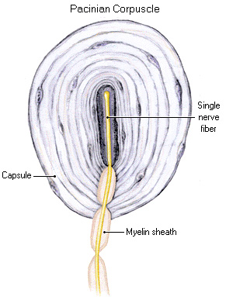

Try to identify and label the
following structures in your drawing:

Fingernail
Keratinized epithelium
Schwann cells
Adipose tissue
Sweat glands

Would the fiber that runs from a Pacinian corpuscle be afferent or efferent?

To evaluate the spinothalamic tract, we can test for touch, temperature, and pain perception.

Pain
Find a cotton-tipped swab with a wooden stick and break it in half. If that is not available, you can use a tooth-pick. We will test for both “sharp” sensation and “dull” sensation.

While your lab partner sits comfortably with eyes closed, take the tooth-pick or sharp end of the cotton-tipped swab and lightly touch it his/her hand. Ask your lab partner to tell you if they feel “sharp” or “dull”. Touch the same spot with the cotton-tipped end. If you are using a toothpick, you may need to wrap the toothpick in a bit of cotton so the end is dull. Choose several locations to test: back of the hand, forearm, legs, dorsum of foot, each time using both sharp and dull. Test both right and left sides.

Temperature:
Find a tuning fork. Run the stem of the tuning fork under cold or warm water. While your lab partner sits comfortably with eyes closed, place the stem of the tuning fork against their skin. Ask if the temperature is warm or cold. Test both warm and cold on right and left sides.
When you are done with the test, be sure the tuning forks are completely dried before returning them.

Light touch thigmesthesia: sensitivity to touch
Take a cotton ball. While your lab partner sits comfortably with eyes closed, touch the cotton ball to the skin. Do not drag or move the cotton, just a light touch. Ask your lab partner if they can feel it.

Questions:

Do the ST and DCML tracts decussate in the same location? Which one decussates where?

Motor Pathways

Monosynaptic reflexes
In monosynaptic reflex like the patellar reflex, the impulse has only to cross one synapse (mono = one). We can see this type of reflex arc in the stretch reflexes of our muscles.
The stretch will be caused by the reflex hammer or the hand striking the tendon. This stimulation will cause the afferent fiber to send an impulse towards the CNS. Once at the CNS (note that here the CNS is the lumbar spinal cord… NOT the brain) the afferent fiber will synapse with the efferent fiber. Recall that the efferent fiber is the motor fiber. The motor fiber will run to the effector (the quadriceps) to create the leg extension. There will also be motors running to the antagonists (hamstrings) to keep them relaxed so the quadriceps can extend the leg.

Exercise: tap the patellar reflex
- Have your lab partner sit in a location where they can sit comfortably upright while the lower legs can freely swing.
- Locate the patella. Find the tendinous depression immediately inferior to the patella
- Stand off to the side of your lab partner. Recall that the goal here is leg extension, and you don’t want to be standing in the way.
- With a reflex hammer or with the side of your hand, quickly strike the tendons.
- Note: The strike must be rapid and with a moderate force. Your goal is to see the reflex, not harm your lab partner. Keep in mind that your lab partner will be testing the same reflex on you in a bit.
- Repeat the process on the opposite leg, and then switch so your lab partner can try it on you.
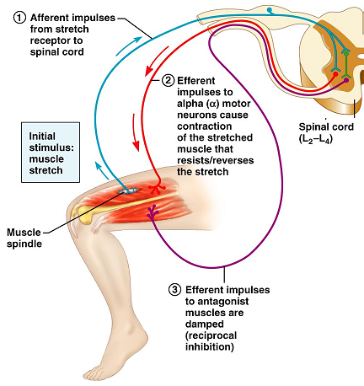
Exercise: tap the Calcaneal (Achilles or Ankle jerk) reflex
Spinal cord levels S1 and S2
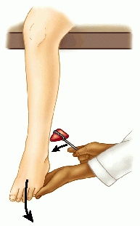
- Have your lab partner sit in a location where they can sit
comfortably upright while the lower legs can freely swing.

- Ask your lab partner to relax their leg and ankle as much as
possible. With one hand, lift the toes into dorsiflexion. (Put a slight
pressure on the bottom of the foot, lifting the toes.)

- Swing the reflex hammer and strike the Calcaneal (Achilles)
Tendon. Feel and look for a rapid plantar flexion.

- Repeat the process on the opposite ankle.

- Are the intensity of the responses even from left to right?

- Switch and allow your lab partner to tap your calcaneal reflex

Exercise: Elicit the Plantar response
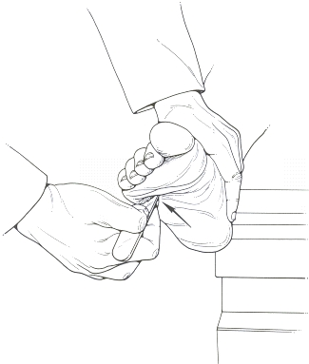
The Plantar response is not a deep tendon reflex like the patellar and calcaneal responses were. The Plantar response is a withdrawal response.
Question: Since this is a response to pain, in which ascending column would this pathway run?

- Ask your lab partner to sit comfortably after removing a shoe (and sock).
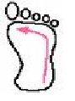
- With the back of a reflex hammer (the pointed metal end) quickly stroke along the plantar surface of the foot. Start at the heel, moving along the lateral edge of the sole, and then crossing from 5th digit to 1st digit at the ball of the foot.

- Observe the response. A normal response includes flexion of the toes, and can include flexion at the knee and hip. An abnormal response includes extension at the toes.

“Babinski response” Newborns are born with an immature nervous system. When the bottom of their foot is stimulated, the toes will extend and fan out. This is normal for newborns, but not for adults. In adults, this positive plantar response is indicative of an upper motor neuron lesion of the corticospinal tract.

Exercise: tap the biceps reflex
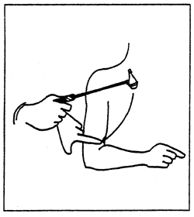
Spinal cord levels C5 and C6
- As your partner to sit comfortably and relax the arm in their lab or on a desk-top.
- Place your index finger along the antecubital fossa and ask your lab partner to “make a muscle”. You should feel the biceps tendon strike your finger.
- Ask your partner to relax again. Keep a light pressure on the biceps tendon.
- Quickly and firmly strike your finger with the reflex hammer. Stretching the biceps tendon will cause the same monosynaptic type response as seen with the patellar reflex. The biceps will contract and you’ll see forearm flexion.
- Repeat the process on the opposite arm.
- Allow your lab partner to perform the reflex on you.

Exercise: tap the triceps reflex
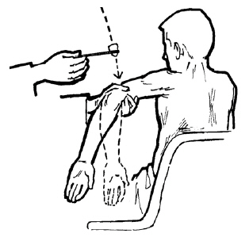
Spinal cord levels: C6 and C7

- While your lab partner is seated and relaxed, support his/her arm away from the body with one hand, as shown in the image to the right.
- Place a thumb or finger proximal to the olecranon over the triceps tendon
- Strike your finger with the reflex hammer.
- Look for extension at the elbow.
- ** This reflex can be challenging. In addition to looking for movement, you can try to feel for the muscle contraction under your fingers.
- Repeat the process on the opposite side.

Exercise: tap the finger flexion reflex
Spinal cord levels: C6, C7, and T1

- Ask your lab partner to sit, relaxed, with palm up.
- Place your index finger along the proximal interphalangeal joints. Ask your partner to curl their fingers around yours for a second, and then to relax them.
- Strike your finger with the reflex hammer
- Look for the fingers to reflexively flex and curl.
- Check the opposite side
- Allow your lab partner to perform the reflexes on you

NOTE: the importance of reflexes is not so much that they are present or absent, but that they are equal from left to right. This is why we check reflexes on both sides of the body to compare. An inequality can indicate a lesion at that particular level of the spinal cord.

Quiz Three:
Covers Brain and Spinal cord labs and neuro exams labs.

Ask yourself…
Am I familiar with the brain and spinal cord anatomy from the dissection? From the models? From the images labeled in the lab manual?
Which microscope slides were used? Can I identify them?
Have I answered, reviewed, and understand the questions from the lab manual?
Can I describe the components and sequence of a monosynaptic reflex arc?
How does a monosynaptic reflex differ from a withdrawal reflex?
What spinal cord levels are tested for with the reflexes?

Eye and Vision
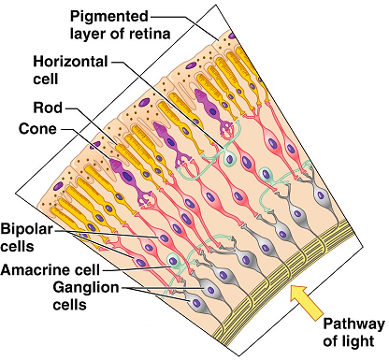
Before starting the dissection, take a look at the slide of the retina.

View “monkey retina” slide at 400X
Using the image to the right to get your bearings, try to find the following features on the slide:

Ganglion cells layer
Bipolar cell layer
Cones/rod layer

Eye Dissection:

View the external structures of the eye.

You’ll find that most eyes have a thick layer of fatty tissue (adipose tissue). Before making your incisions later on, you may wish to remove this layer.
If you look at the posterior aspect of the eye, you’ll see the optic nerve. You’ll also see the extrinsic eye muscles. The extrinsic eye muscles are responsible for moving the eyeball.

From your text book or from your lecture notes, list the six extrinsic muscles and indicate the function of each. Indicate the cranial nerve that controls it.
Eye muscle | Function | Cranial nerve

Observe the sclera and the cornea.

The cornea is the clear portion at the front of the eye. Often times with the preservation, they cornea takes on a cloudy appearance. Look through the cornea to see the iris, which is the colored portion of the eye. Observe the pupil.

The sclera (sclera means “tough”) is the white of the eye. It is very durable, so as you begin your dissection, use care; the eye can be slippery and tough. This makes for a potentially dangerous combination.

Recommendation: Use the scalpel to make an incision in the eye. Start your incision at about the half-way point between the front and the back of the eye. After creating a space, use the scissors to cut the sclera and separate the eye into anterior and posterior portions.

Anterior half:
This section of the eye will contain the lens and iris and cornea. Use the scissors to remove the cornea. You’ll notice a thin watery fluid that leaks out. This is the aqueous humor. Look through the cornea and set it aside. Observe the iris and lens from both the front and the back. Locate the ciliary body

What is the function of the ciliary body?

Remove the lens. Place it on a paper with writing and try to look through it.

Set the anterior half aside and turn your attention to the posterior half of the eye. The thick, jelly-like fluid that was inside the posterior compartment is called the vitreous humor.

What is the function of the vitreous humor?

Identify the retina. It is the thin tissue along the posterior aspect of the eye that falls easily away from the walls of the eye. The location where the retina remains anchored to the eye is the optic disc. This is the location where all of the nerves accumulate to leave the eye as the optic nerve.

Why would the optic disc create a blind spot in our eyes?

Observe the iridescent coloration of the wall of the eye behind the retina. This layer is the tapetum lucidum. This layer is found in many mammals, but not in humans. This is the layer of the eye that gives it a reflective quality. This is what makes your cat’s eyes appear to glow in the flash of a camera. It allows these animals to see in low light, but the clarity of their vision is compromised. Our eyes contain the choroid layer located between the sclera and the retina. Instead of the glowing eyes seen in animals with a tapetum lucidum, we get the red-eye effect when pictures are taken.

What is the function of the choroid layer?

Follow the optic disc through to the outside of the eye where it becomes the optic nerve. Try to squeeze the optic nerve. You may notice some whitish material that oozes out. This is the myelin that covers the axons running in that nerve.

What is the pathway the optic nerve impulses will follow to get to the visual cortex of the brain?

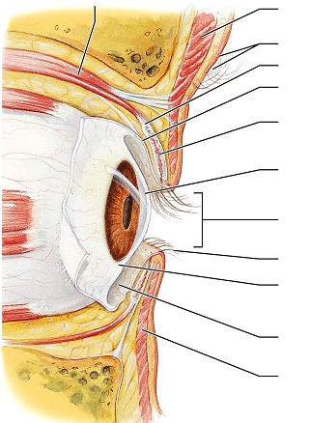

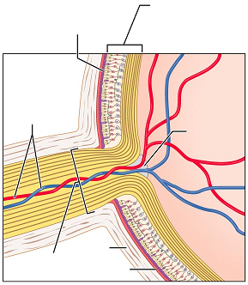

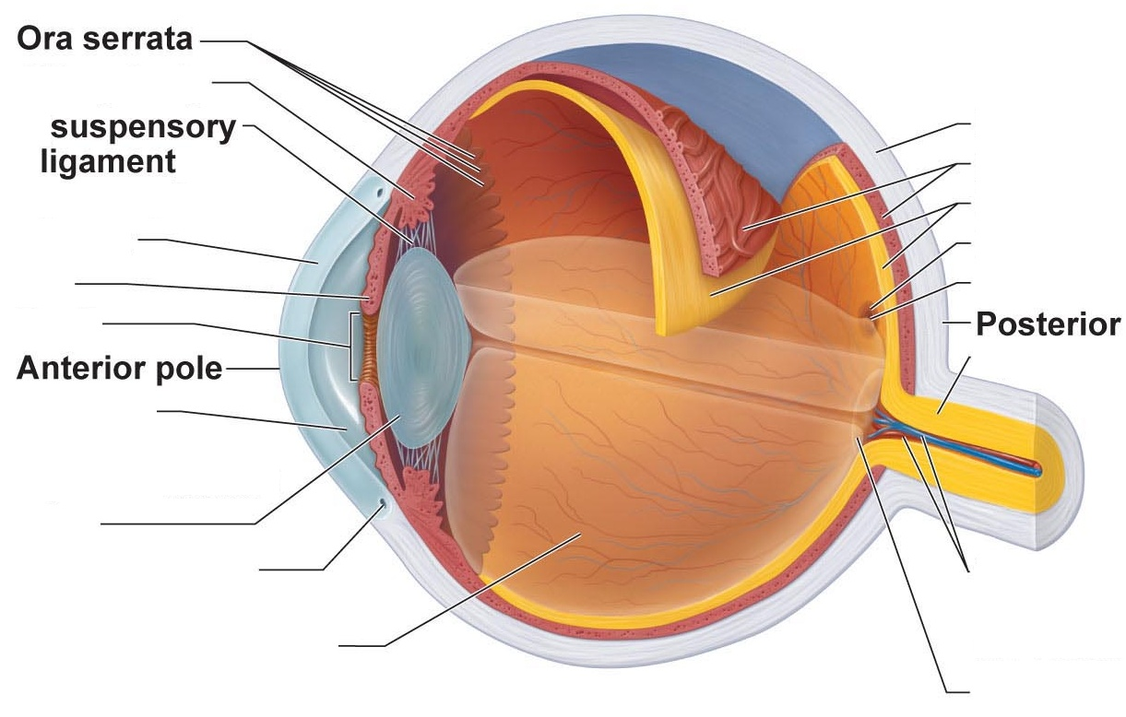

Visual Acuity
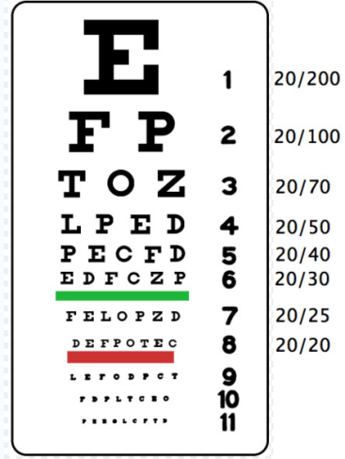

- Stand 20 feet from the Snellen chart (visual acuity chart) on the wall. Have your lab partner stand next to the chart. Remove your glasses if you wear them.
- Cover one eye with your hand, but keep it open.
- Use your uncovered eye to read the smallest line possible on the chart. Your lab partner will check for accuracy.
- Record the numbers on the line that was read correctly.
- Repeat the process using using the opposite eye

An average reading for visual acuity is 20/20. This means that at 20 feet, you can see what other people can see at 20 feet. A reading of 20/10 reflects an increased acuity. It means that from 20 feet, you can see what others have to be at 10 feet to see. A reading of 20/30 reflects a decreased acuity. From 20 feet you can see what other can see from 30 feet.

Acuity: left eye |  | Acuity: right eye
Acuity: left eye with glasses (contacts) |  | Acuity: right eye with glasses (contacts)

Astigmatism
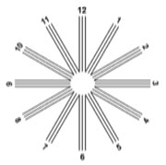
- Stand 20 feet from the Astigmatism chart.
- Indicate to your lab partner if any of the lines look darker or thicker than others.
- Remove your glasses if you wear them.
- Cover one eye with your hand, but keep it open.
- Use your uncovered eye to look at the chart
- Repeat the procedure with your opposite eye.
- Repeat the procedure with your glasses on

Result: + or -
Right eye, no glasses
Right eye, glasses
Left eye, no glasses
Left eye, glasses

A negative result for astigmatism means that you do not have astigmatism. Seeing lines that are darker or thicker is a positive result; you may have astigmatism.

Astigmatism is caused by a defect in the cornea or lens. It results in the light coming into the eye being redirected and scattered. Some of the light entering the eye hits the retina and is sharply focused, and other light does not focus on the retina, resulting in the altered vision.

Color Vision Tests

The rods are responsible for our vision in dim light; the cones for full light. If we have deficits in our cones, we may havea red-green colorblindness. This trait is genetic. It is sex-linked, meaning that if the mother is a carrier, the son may have the trait.

View the images

Blind spot Testing

Our retinas contain rods and cones that allow us to see. However, where the nerves enter and leave the eye at the optic disc, there are no receptors. Therefore, at that location, there is no vision. Each eye has a blind spot, but our brain fills in the gaps when we have both eyes open.

- Close one eye
- Look at one of the spots on the page. You’ll be able to see the other spot with your peripheral vision.
- Move your head away from the page (or move your lab manual farther away from your eye). Do this slowly.
- At some point, you’ll notice that the second dot disappears
  - The light coming from the area of the dot is hitting your optic disc, and there are no receptors there.
  - The spot will be gone, but the paper will still appear white. Your brain is filling in the gaps based on the surrounding visual field.

Photopupillary reflex
Materials: pen light
Your size of your pupil is dependent on the smooth muscles in your iris. When we are exposed to bright light, the iris will cause the pupil to constrict; this prevents too much light from entering the eye. When we are in dim light, the iris will cause the pupil to dilate, allowing more light to enter to optimize our vision.

- Have your lab partner sit comfortably while covering up both eyes with his or her hands.
- Get a penlight, turn it on, and move it close to one of your lab partner’s hands.
- Ask your lab partner to move his/her hand.
- Shine the penlight in the uncovered eye and watch the pupil for any changes.

What roles to cranial nerves II and III play in the photopupilary reflex?

Cranial Nerves

For this lab you’ll be working with a lab partner to test some of the cranial nerves. Please be respectful of your partner when physical contact is called for.

Cranial Nerves

Pair up and test your lab partner on the following motions. Use your text book and your lecture notes to determine which muscles and which cranial nerves were used.

Action | Present | Absent | Muscle activated | Cranial nerve used
Smile
Close eyes tightly
Raise eyebrows
Puff cheeks
Open mouth
Clench teeth
Raise shoulders

Hold your finger about a foot in front of your partner’s nose. Draw an “H” pattern in the air and ask your partner to follow the tip of your finger without moving his/her head.

Indicate below if the activity was observed and which eye muscles were used

Action | Present | Absent | Eye muscle used | Cranial nerve
Both eyes look up

Both eyes look down
Right eye looks right
Left eye looks right
Right eye looks left
Left eye looks left

Pupillary response
Hold your hand vertically at the bridge of your lab partner’s nose. Your goal is to shield one eye from the light shining in the other.
- Shine a pen-light into the left eye. Observe the pupil of the left eye.
- Shine a pen-light into the left eye. Observe the pupil of the right eye.
- Shine a pen-light into the right eye. Observe the pupil of the right eye
- Shine a pen-light into the right eye. Observe the pupil of the left eye.

Action | Response of left pupil | Response of right pupil
Light in left eye
Light removed from left eye
Light in right eye
Light removed from right eye

Which cranial nerve is conveying the light information to the brain?

Which cranial nerve is responsible for the pupillary response?

Based on what you know of the pathway of the optic tract, why would light shining in one eye result in a change in both pupils?

Accommodation
Have your partner focus on a distant object within the room for one minute. Observe the pupil. While your partner is focusing on the distant object, prepare an object to be nearby. Hold a pen about six inches away from his/her face. At the end of the minute ask your partner to switch the focus from a distant object to the near one. Observe the pupil and the movement of the eyes.

Describe the changes you are seeing.

Why would these changes be taking place?

What could you do to test Cranial Nerve I?

Place your hand lightly on your lab partner’s throat. You want to gently contact the throat at about the level of the larynx. Ask your lab partner to swallow.
Did the left and right sides of the throat feel as if they were moving symmetrically?

Which cranial nerve are you testing?

Have your lab partner face you. Lightly and evenly stroke the following regions on the face. Be sure to test the right and left sides at the same time: use both of your hands to perform the test. Ask your lab partner if the sensations can be felt evenly on both sides.

Region | Present | Absent | Cranial Nerve responsible
Forehead
cheeks
jawline

Pain
Find a cotton-tipped swab with a wooden stick and break it in half. If that is not available, you can use a tooth-pick. We will test for both “sharp” sensation and “dull” sensation.

While your lab partner sits comfortably with eyes closed, take the tooth-pick or sharp end of the cotton-tipped swab and lightly touch it to his/her forehead, cheek, and jaw. . Ask your lab partner to tell you if they feel “sharp” or “dull”. Touch the same spot with the cotton-tipped end. If you are using a toothpick, you may need to wrap the toothpick in a bit of cotton so the end is dull. Choose several locations to test, each time using both sharp and dull. Test both right and left sides.

Temperature:
Find a tuning fork. .While your lab partner sits comfortably with eyes closed, place the tuning fork against their skin. Ask if the temperature is warm or cold. Test both warm and cold on right and left sides of the face. Check at forehead, cheek, and jaw..

Which cranial nerve is responsible for pain and temperature to from the face?

Have your lab partner open his or her mouth and say “Aahhh”. Observe the uvula and the soft palate.

Which cranial are you testing?

Have your partner stick out his or her tongue. Observe the tongue. Does it protrude along the midline, or does it move to one side?

Which cranial nerve are you testing?

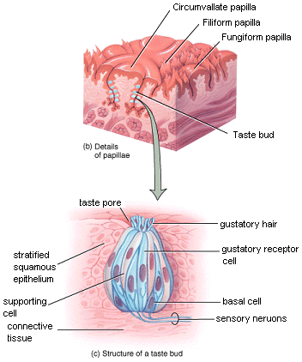
Taste buds
Recall that the term “papillae” means projection. In the tongue’s papillae we will find the gustatory cells or taste cells. When these cells are exposed to food the stimulation results in a signal being sent to the brain.

View the slide of the rabbit tongue.
Try to locate the stratified squamous epithelium, the papillae, and the taste buds.

Cranial Nerve VIII: Vestibulocochlear

Sound localization:

- Have your lab partner sit comfortably with eyes closed.
- Click your fingernails, or snap your fingers to create a sound within the audible range of your lab partner’s ears.
- Ask your lab partner to point to where the sound from.
- Move the noise to a new location and repeat the process.
- Record your results

 | Actual Location | Reported location
First noise
Second noise
Third noise

Rinne’s Test:
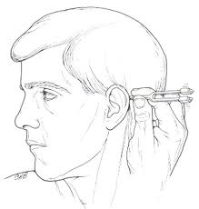
Rinne’s tests bone conduction (vibrations passing through bone) versus air conduction (vibrations passing through air).
- Lab partner sits comfortably
- Palpate behind the ear to locate the mastoid process
- Strike a tuning fork. Hold it by the stem, never the tines.
- Place the stem of the tuning fork on the mastoid process
- Ask your lab partner if they hear it.
- Ask your lab partner to tell you when the noise stops.
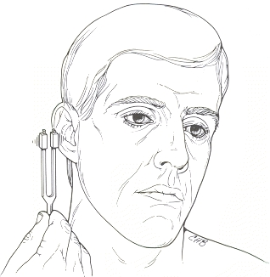
- Immediately remove the stem of the tuning fork from the mastoid process and bring the tines of the tuning fork directly in front of the ear canal.
- Ask your partner if they can hear the tone
- Repeat the process for the opposite ear.
- Record your results on the table below

Normally, the air conduction should be louder than the bone conduction (it takes a lot more energy for the vibrations to push through bone rather than air.)
If bone conduction is greater that air conduction, or in other works, if the sound is heard longer on the mastoid process than in front of the ear, then it indicates a conductive hearing deficit. Conductive deficits involve the outer and the middle ear.

Test | Left Ear: Normal or Impaired? | Right ear: Normal or Impaired?
Rinne’s Test
Weber’s Test
Repeated Weber’s With Cotton

Weber’s test
Weber’s test tries to distinguish between conduction deafness versus sensory deafness.

- Lab partner sits comfortably
- Strike the tuning fork
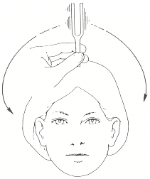
- Place the tuning fork on a midline feature: middle of the forehead or along the middle of the top of the head.
- Ask your lab partner if they can hear/feel the vibrations
- Ask your lab partner if the sound/vibrations can be felt/heard equally between the left and right sides, or if one side is louder than the other.

In a normal test, the sound should be heard evenly between left and right ears. In an abnormal test, the sound will be louder in one ear than the other.
Conductive impairment: sound is louder in affected ear
Sensory deafness: sound is louder in unaffected (normal) ear
This test is not diagnostic, but it’s a good starting point to further evaluate hearing abnormalities.

To reproduce the conductive impairment, do the following:
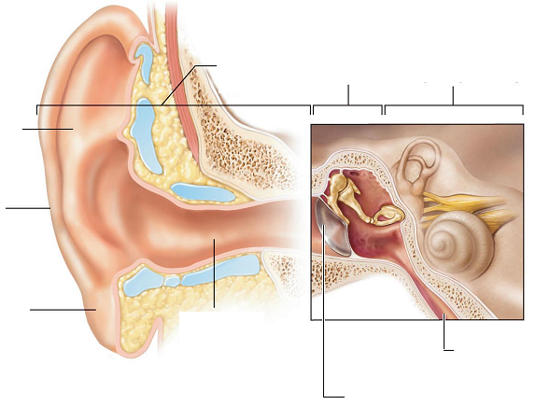
- Lab partner sits comfortably
- Pack one ear with a cotton ball
- Strike the tuning fork
- Place the tuning fork on a midline feature: middle of the forehead or along the middle of the top of the head.
- Ask your lab partner if they can hear/feel the vibrations
- Ask your lab partner if the sound/vibrations can be felt/heard equally between the left and right sides, or if one side is louder than the other.

For this next test, be sure to be in a cleared area. Stay near your partner and be prepared to support them if necessary. Ask your lab partner to stand. Observe their equilibrium. Do they sway or are they stable? Now ask them to close their eyes. Be in a position to support or stabilize your partner if needed. Can your partner stay balanced? Do they sway to one side?

Which cranial nerve are you testing?

Answer the following questions about the ear

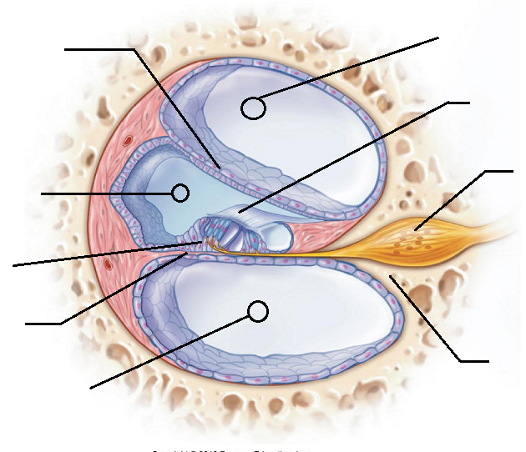

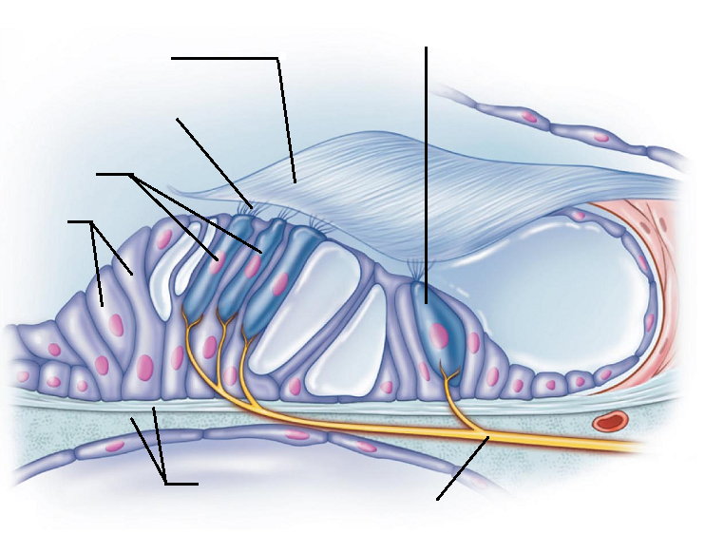

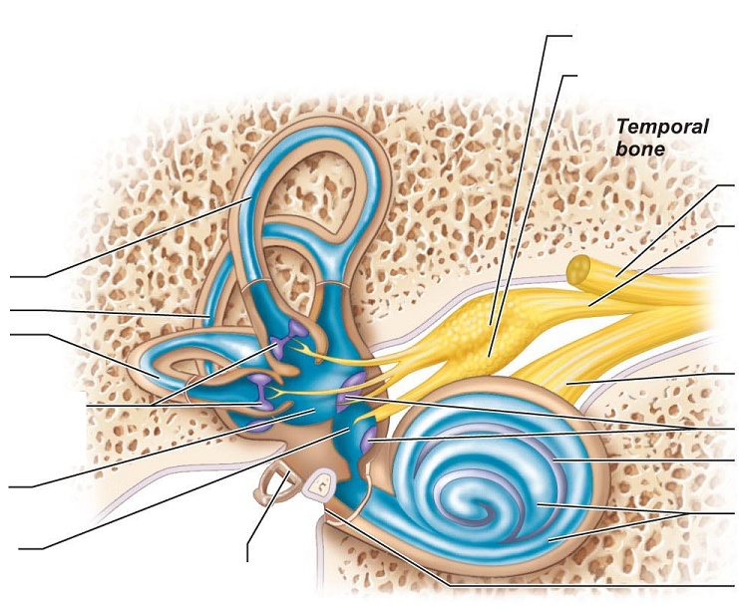

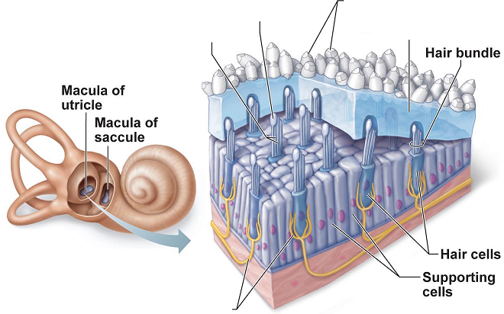

What is the cochlea?

What is the auditory pathway to the brain?

What is the function of the semicircular canals?

What are the ossicles?

Define the following terms: saccule, utricle, otoliths (Where are they and what do they do?)

Your last lab quiz will cover eye anatomy, ear anatomy, and the cranial nerves.

Ask yourself…
Can I label the anatomy from the images, from the models, and from the dissection?
Have I answered and understood all of the questions from the lab manual?
Can I identify all of the cranial nerves and their related functions?
Do I know what the cranial nerve tests are testing for?
Have I reviewed the pathways to the brain for the various senses mentioned in the lab manual?
Am I familiar with the inner ear structures and functions?

