Blood

Blood is a type of connective tissue. It has both solid and fluid components. The solid components include red blood cells (erythrocytes), white blood cells (leukocytes) and platelets (thrombocytes). There are five different types of leukocytes, all with unique physical and functional characteristics. Leukocytes can be divided into two categories based on how their cytoplasm appears: granulocytes (neutrophils, eosinophils, and basophils) and agranulocytes (monocytes and lymphocytes).
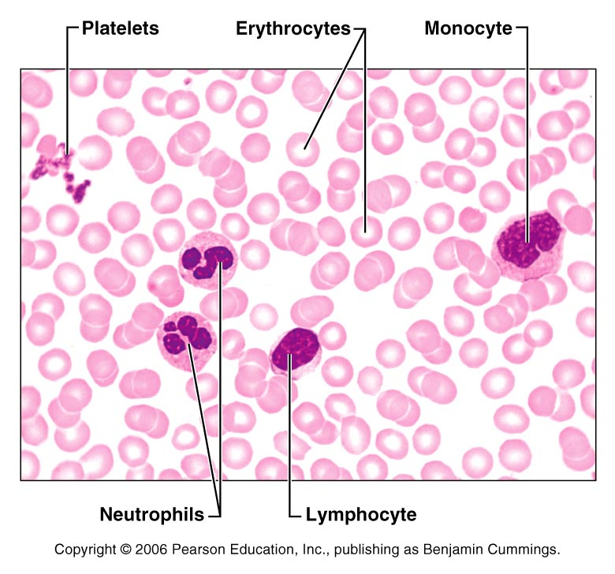

Differential White Blood Cell Count

A differential count of the white blood cells shows the percentage of each of the various types of white blood cells. The relationship will shift with various disorders or diseases, so a differential can be a helpful tool. For example, in a bacterial infection, we would expect to see the number of neutrophils elevated. If there were a parasitic worm infection, the percentage of eosinophils would be elevated.

View, draw, and label a blood slide. On one slide, you should be able to see red cells, white cells, and platelets. You will have to scan the slide to find the different types of white cells. One easy way to distinguish white cells from red cells is the presence of a nucleus (dark blue/purple staining.) Pay attention to size. Often times the leukocytes are identified by their size as compared to the red cells. Also note the shape of the nucleus. Indicate the color of the cells and note the appearance of the cytoplasm.

Red cells
Neutrophil
Lymphocyte
Monocyte
(Basophils and eosinophils are rare)
Platelets

Differential White Blood Cell Count
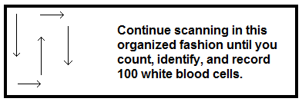
To perform the differential, obtain a blood slide. View under high power. Start at one edge of the slide, and begin counting and recording the types of white blood cells you come across. Ignore the red cells for this procedure. Work in an organized fashion so that the same cells do not get counted and recorded more than once. Move to the top of the slide, shift the slide to the right, move to the bottom, shift the slide to the right, move to the top, etc. Each time you identify a white blood cell, record it. Find one hundred white cells total; this will give you the percentage of white cell types… or the differential.

Normal values for leukocytes: | Tally | Percentage
Neutrophil: 54 – 62%
Eosinophil: 1 – 3 %
Basophil: less than 1%
Lymphocyte: 25 – 33%
Monocyte: 3 – 9%

Answer the following questions: The answers may be found in lab material, lecture material, or your text book. Please have the questions answered before leaving lab.

- What is an antigen? An antigen is a marker on the cell’s surface that identifies it as foreign.
Location: Chapter 17, text glossary, lecture notes

- What is an antibody? An antibody is a circulating plasma protein, designed to seek out and destroy foreign materials. Antibodies are designed to fit onto specific antigens.
Location: Chapter 17, text glossary, lecture notes

- What are the main antigens found on the surface of a blood cell?
A and B antigens are found on the blood cell surface. They can be arranged as A, B, AB or O
Location: Chapter 17, lecture notes

- If a blood cell has Antigen A, which antibody will be found in the plasma?
Antibody B

- If a blood cell has Antigen B, which antibody will be found in the plasma?
Antibody A

- If the blood contains no antibodies in the plasma, which blood type is it?
AB

- If the blood contains Antibody A and Antibody B in the plasma, which blood type is it?
Type O

- What type of reaction would you expect to see if Antigen A comes in contact with Antibody A.
When antigen and antibody fit together as Antigen A and Antibody A do, they create an agglutination reaction, or clump.
Chapter 17, lecture notes

- Which substance within a red blood cell is responsible for carrying oxygen?
Hemoglobin
Chapter 17, Lecture notes

- What is a reticulocyte?
An immature erythrocyte. It has lost its nucleus, but still has some of the membranous structures on the inside. A reticulocyte will mature into an erythrocyte in the blood stream.
Chapter 17, lecture notes

- Which is the largest of the white blood cells? Monocyte
Lecture notes, Chapter 17

Label the following images. Your text book should have the completed diagrams.

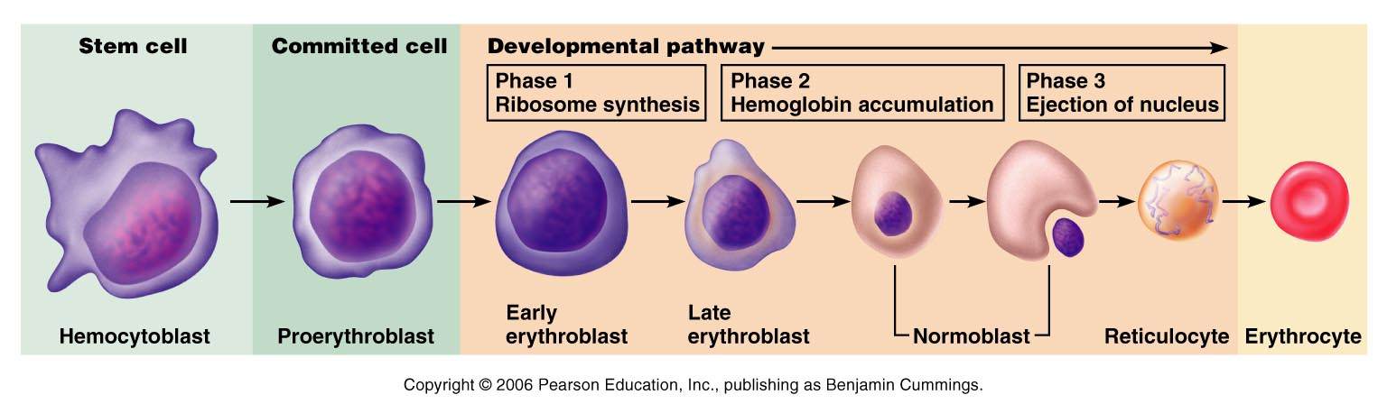
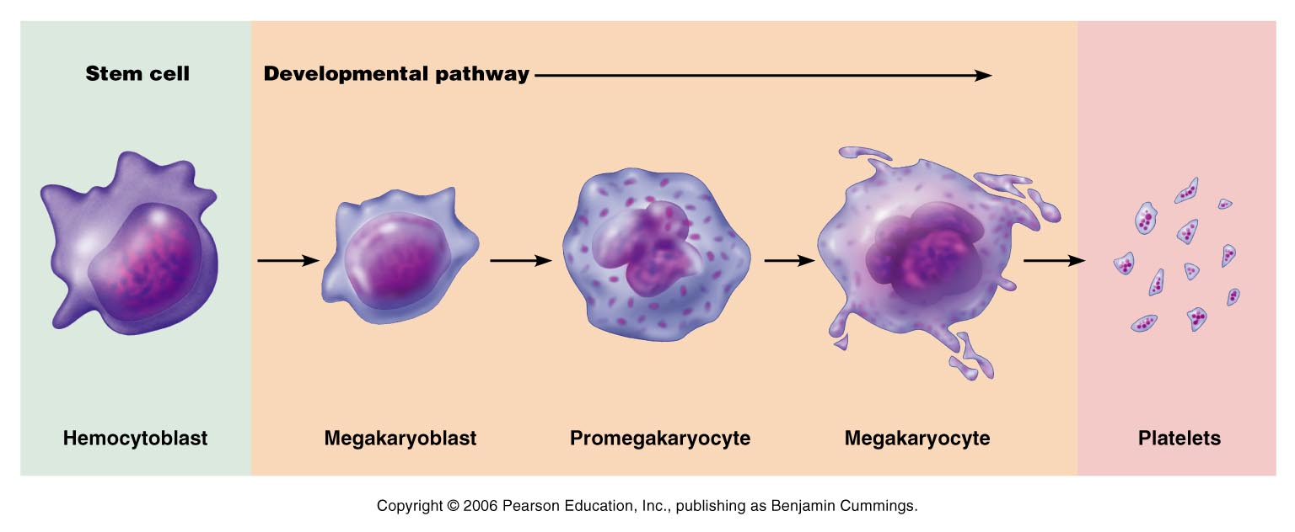
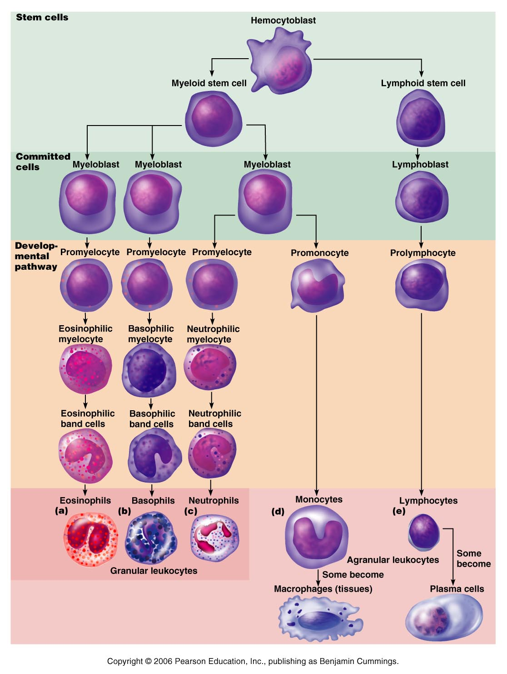
ABO-Rh blood typing

Part One: Introduction
Part Two: Blood kit

Each red blood cell has antigens on its surface that serve a variety of functions. The ABO antigens are markers on the plasma membrane that tells the body that this cell is one of its own. In the plasma there are antibodies. In a healthy system, your antibodies will NOT react with your antigens. However, should an antigen that is not your type be present, your circulating antibodies will be able to link to it, causing agglutination.
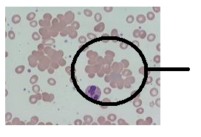

Note in the image to the left, the normally individual red cells have become clumped together. In this state, they are unable to circulate or function as designed. The antibodies have multiple attachment sites that link and hold the red blood cells together.
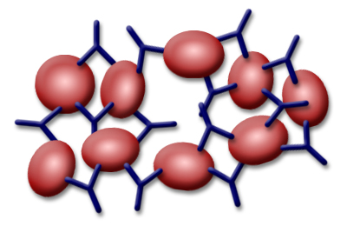

In the chart below, add the appropriate antigens to the RBCs represented. In the space below, indicate which, if any antibodies would be located in the plasma.
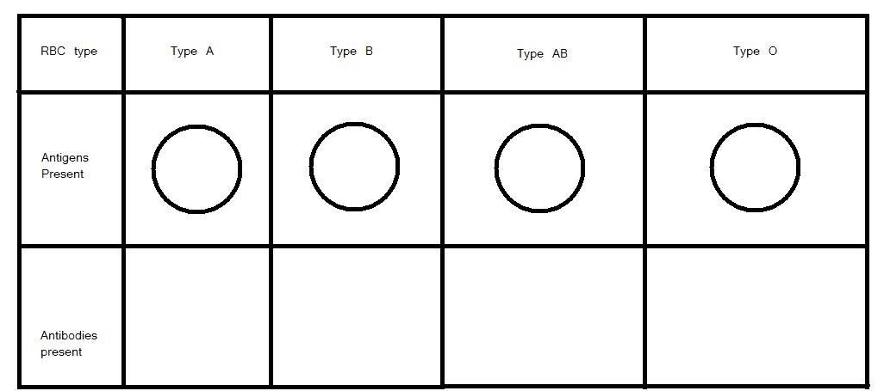

When blood is donated, the red blood cells of a donor are introduced into the system of a host. The donor antigens must be free of interactions with the host antibodies, or agglutination will take place. If the antigen type matches the antibody type, then the agglutination reaction can happen. The dangers of agglutination are multiple. First of all, it prevents the RBCs from circulating and performing their duties of distributing gasses. Secondly, the clumped RBCs can block arteries and prevent blood flow to the tissues. Lastly, the clumping causes the plasma membranes to burst open, releasing large and potentially dangerous amounts of hemoglobin into the plasma. Hemoglobin can be toxic when outside of the cell.

Rh groups
The Rh group serves as an identifier, in addition to the ABO blood types. Rh was discovered about 40 years after the ABO types were determined. Rh seems to follow dominant-recessive genetic patterns.

If a cell displays the Rh antigen (called Antigen D) then the person is Rh+.

If the antigens are absent, they are Rh-.

When an Rh- person is exposed to an Rh antigen, they can create Antibody D.

Rh interactions:
One of the greatest threats with Rh incompatibility comes with mother/fetus interactions. If the mother is Rh- and the fetus is Rh+, the potential exists for a dangerous interaction.

Questions: Use your lab notes, your lecture notes, and your text book to find the answers to the following questions. Please make sure your questions are complete before leaving lab.

- If the mother is exposed to an Rh antigen, she will create Antibody D. With her first exposure, what type of immunoglobulin is formed? (IgA, IgG, IgE, IgM, or IgD)
IgM created after first exposure
Lecture notes, Chapter 21

- Is that antibody type able to cross the placenta?
No, too large to cross the placenta

- With a second exposure, what antibody type is formed? (Ig G, A, M, E, or D)
IgG formed

- Is this type able to cross the placenta?
Yes, IgG crosses the placenta

Blood Kits : Determining Blood Type

Use the same precautions in dealing with these simulated blood products as you would using real blood. Please use gloves, and follow the TAs instructions regarding clean-up.

You will need:
Anti-A serum (represents Antibody A)
Anti-B serum (represents Antibody B)
Anti-Rh serum (represents Antibody D)
A blood typing tray
Some paper towels
Blood samples
Stirring sticks
Gloves

Step One:
Place the blood typing tray on paper towels. (This will make it easier to see the reactions once they take place.) Into each of the three wells, place five (5) drops of blood from “patient 1”.

Step Two:
In the well labeled “A”, place 3 drops of Anti-A serum

Step Three:
In the well labeled “B” place 3 drops of Anti-B serum

Step Four:
In the well labeled “Rh” place 3 drops of Anti-Rh serum

Step Five:
Mix each well with a separate mixing stick: avoid cross contamination by using a dedicated stir stick for each of the wells.

Step Six:
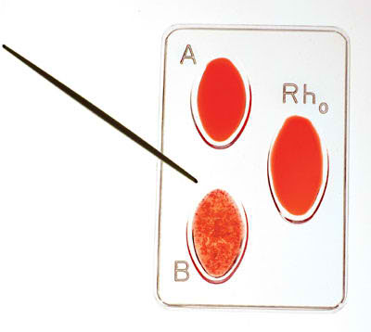
Check the wells after about 10 – 15 seconds. Gently tip the tray back and forth to determine if agglutination has taken place.

In the sample tray to the right, wells “A” and “Rh” retain their even coloration. Well “B” starts to show signs of agglutination. Look for a separation of the fluid and a speckled or grainy residue at the bottom of the well.

What type of blood does this tray demonstrate?
Ans: This would be Type B- blood.
(Antibody B in the well has reacted with Antigen B on the cell surface.) Since there are no reactions in Wells A or Rh, we know that those antigens are not present on the cell’s surface.

Step Seven:
Record your results in the chart below. Rinse the tray, and reuse it to find the remaining unknown blood types.
Repeat steps 1 – 6 using the remaining unknown samples.

