Cardiovascular system: Structure and function of the heart

Part 1: Information
Part 2: Histology
Part 3: Images
Part 4: Cat
Part 5: Questions

Part One: Information

The heart is located near the midline of the thoracic cavity in the mediastinum. The base of the heart is the superior aspect of it. This is where the large arteries and veins enter and exit. The apex of the heart is the inferior aspect, where the cone-shaped heart comes to a point. The heart is bordered inferiorly by the diaphragm. The right border is the right lung and the left border is the left lung. The heart is housed by a tough fibrous bag called the pericardium. The inner pericardial layers produce fluid to help maintain a low-friction environment for the movement of the heart. The heart is composed of four chambers, two atria (left and right) and two ventricles (left and right). The heart is also divided into right and left sides for function. The right side of the heart contributes to the pulmonary circuit. This blood entering the heart is deoxygenated and will be pumped to the lungs (pulmonary). The left side of the heart is the systemic circuit. The blood has come from the lungs, so it contains oxygen. The left ventricle will circulate the oxygenated blood to the body (system). The ventricles are the more muscular chambers responsible for pushing the blood into the arteries.

Part Two: Histology

The heart muscle is different from skeletal muscles (which is striated and voluntary) and smooth muscle (which is smooth and involuntary) in that it is involuntary and striated. Under magnification, the bands (stria) can be seen, similar to skeletal muscle. Cardiac muscle contains intercalated discs that adheres the branching cardiac muscle to one another and allow for rapid communication to take place between cells.

Cardiac Muscle: look for branched cells and intercalated disks. Note that there is only one nucleus per cell.

Part Three: Images
Label the following images

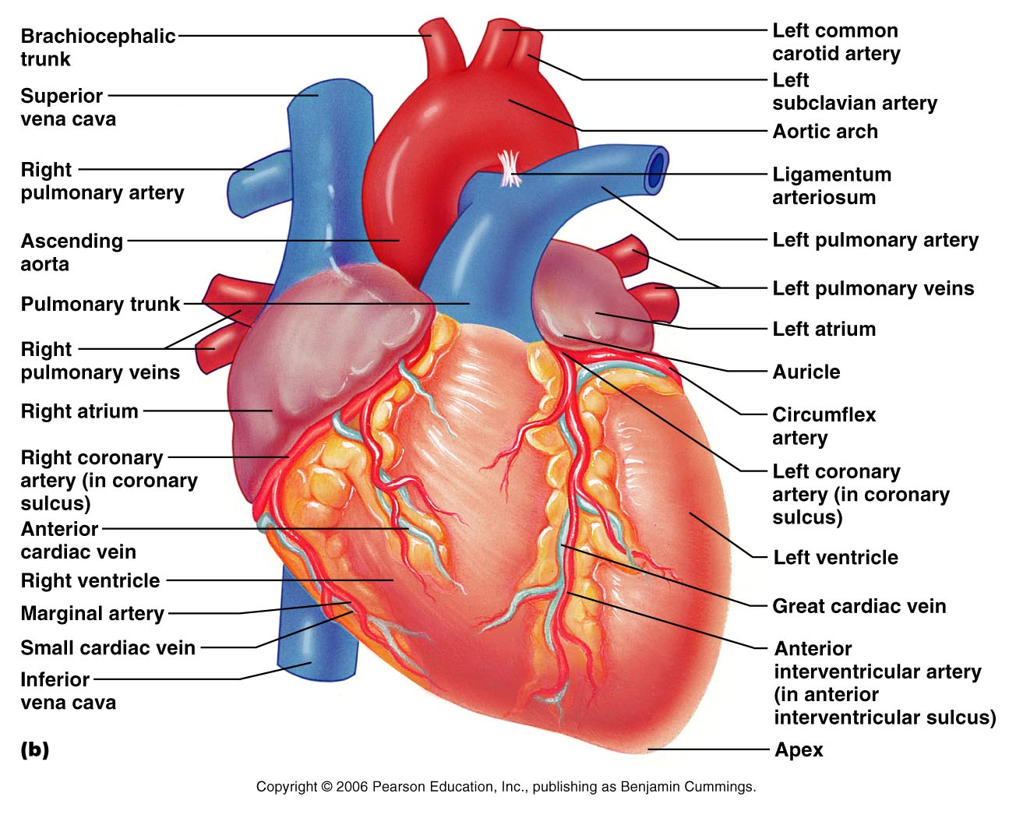

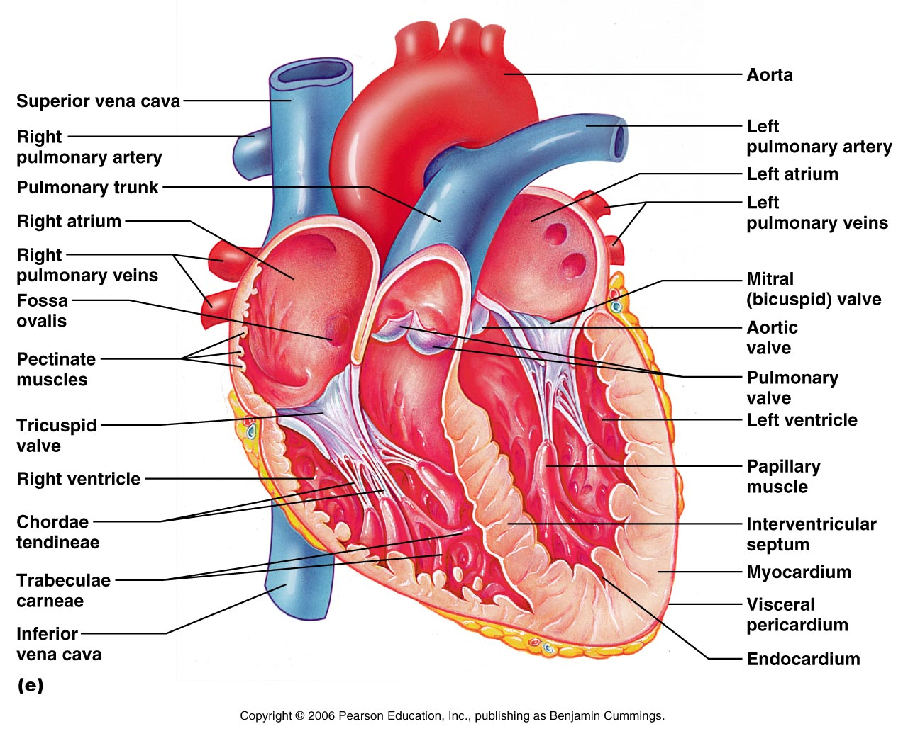

Heart Sounds:
The heart sounds are well known as “lubb dubb”. The sounds are the result of the opening and closing of the heart valves.

The lubb sound is the mitral and tricuspid valves slamming shut with ventricular contraction.

The dub sound is the semilunar valves (aortic and pulmonary) closing with ventricular relaxation.

Because of the location of the valves and the orientation of the heart in the chest, the different heart sounds can be heard best in different regions. Consult the image below. Find a stethoscope and auscultate (listen to) the heart sounds in each of the four locations.

Ladies, you may wish to put the stethoscope into position (especially since 5th ICS-MCL tends to be just inferior to the left breast), and then allow your lab partner to listen.

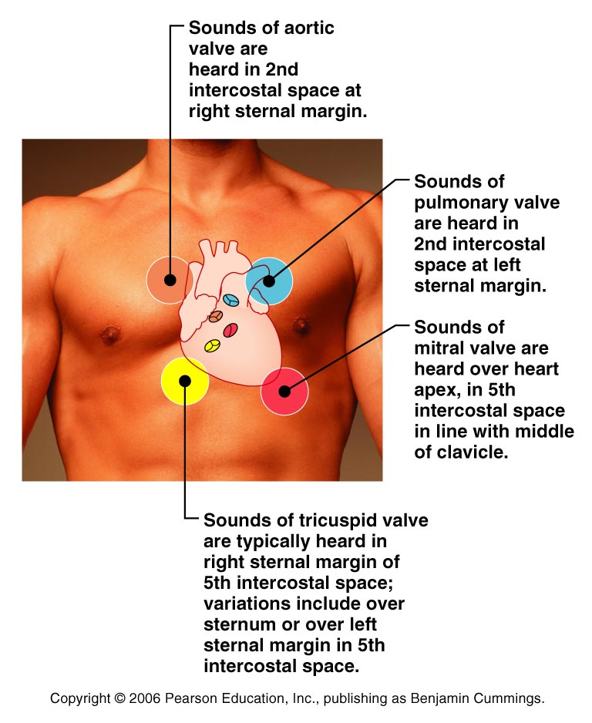

What was the quality of sound auscultated at the 2nd ICS, right sternal margin?

What was the quality of sound auscultated at 5th ICS, right sternal margin?

What was the quality of the sound auscultated at 2nd ICS, left sternal margin?

What was the quality of the sound auscultated at 5th ICS, mid-clavicular line?

Part Four: Cat

Structures to identify on the cat
- Diaphragm
- Lungs
- Trachea
- Pericardium
- Right auricle
- Right atrium
- Left auricle
- Left atrium
- Right ventricle
- Left ventricle
- Apex
- Thymus gland
- Thyroid gland

Arteries:
- Pulmonary trunk
- Ascending aorta
- Aortic arch

Veins:
- Superior vena cava
- Inferior vena cava

Observe the human models and identify the following:
- Superior Vena Cava
- Inferior Vena Cava
- Right and left atria
- Right and left ventricles
- Tricuspid valve
- Mitral valve
- Chordae tendinae
- Papillary muscles
- Trabeculae carneae
- Pulmonary and aortic semilunar valves
- Pulmonary trunk
- R/L pulmonary arteries
- R/L pulmonary veins
- Apex of heart
- Base of heart
- Aorta
- Myocardium
- Interatrial septum
- Interventricular septum
- Ligamentum arteriosum
- Fossa ovalis

Note: Many of the arteries and veins associated with the heart will be identified soon in the upcoming Blood Vessels lab.

Part Five: Questions Use your lab notes, your lecture notes, and your text book to find the answers to the following questions. Please make sure your questions are complete before leaving lab.

- How many main branches off of the aorta are there in humans? In cats? Which ones are they?
Human aorta:
Brachiocephalic a.
Left common carotid a
Left subclavian a
Cat:
Brachiocephalic a
Left subclavian a

- Where are the AV (atrioventricular) valves located
AV valves are located between the atrium and the ventricle. On the right side, the AV valve is the tricuspid; on the left it is the mitral (bicuspid).

- How do the AV valves differ from the semilunar valves:
  - Location: AV valves are between atria/ventricles. Semilunar are guarding the entrances to the pulmonary and aortic arteries.
  - Shape: AV valves have flaps or cusps. Semilunar are more balloon-shaped in appearance
  - Function: AV valves keep blood from entering the atria. Semilunar keeps blood from entering the ventricles.

- What physical differences do you note when comparing the left ventricle to the right ventricle?
Left Ventricle should have a larger muscle mass.

- Describe the appearance of the chordae tendinae. What is their function? The chordae tendinae have a string-like or ropy appearance. They function to anchor the AV valves into the ventricle so the valves do not open into the atria.

- Which valves are on the right side of the heart?
AV valve: Tricuspid
Semilunar: Pulmonary

- Which valves are on the left side of the heart?
AV: Bicuspid/Mitral
Semilunar: Aortic

- The Superior Vena Cava drains blood from which regions?
from all systemic areas above the diaphragm
Location: Chapter 19

- Describe both the base and the apex of the heart in terms of anatomy and location
The base of the heart is the superior portion of the heart, located at about the 2nd ICS
The apex of the heart is the inferior portion of the heart, located at about the 5th ICS (intercostals space)

- Which artery carries deoxygenated blood? Arteries carry blood away from the heart. Deoxygenated blood leaving the heart is in the right and left pulmonary arteries.

- Which vein carries oxygenated blood? Veins carry blood toward the heart. Oxygenated blood comes to the left side of the heart through the right and left pulmonary veins.

Cardiovascular System: Cardiac Cycle and EKG

Part One: Information
Part Two: Images
Part Three: EKG
Part Four: Questions

Part One:
The cardiac cycle is the sequence in which the atria and ventricle contract, as well as the conductive events that allow for the contraction. The atria contract while the ventricles are relaxed; as the ventricles contract, the atria are relaxed. This cycle of contraction and relaxation also causes variations in pressure in the chambers. As the ventricle contract and squeeze blood into the arteries, the arterial pressure rises (systolic pressure). As the ventricles relax, the arterial blood is under a less pressure, and the arterial pressure drops (diastolic pressure). This variation in arterial pressure is recorded as arterial blood pressure. The brachial artery in the arm is often the artery used to determine blood pressure.

Part Two: label the following images
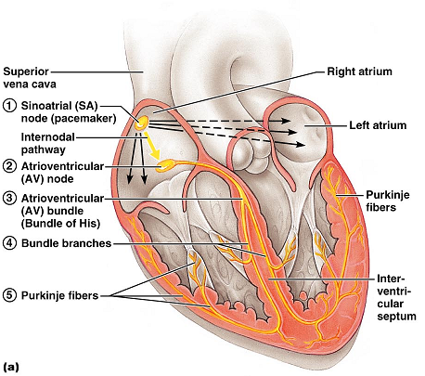

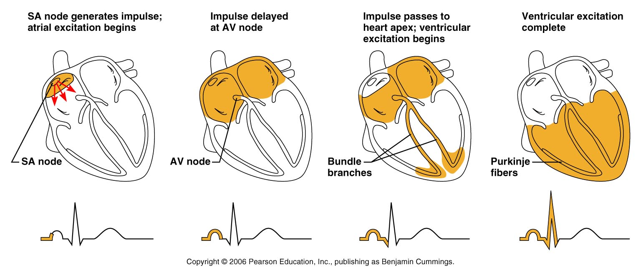

Part Three: EKG
In an EKG, the conduction system of the heart is being evaluated. The conduction system is the part of the heart that transmits the electrical signals to and through the heart muscle so that contraction can take place.
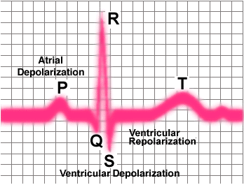

Part Four: Questions Use your lab notes, your lecture notes, and your text book to find the answers to the following questions. Please make sure your questions are complete before leaving lab.

- What is systole? Ventricular contraction

- What is diastole? Ventricular relaxation

- Where is the SA node? Located in the right atrium, inferior to the entrance of the superior vena cava

- Where is the AV node? Location in the inferior portion of the Interatrial septum, above the tricuspid valve

- What is the function of the AV node? Causes a brief delay in the conduction impulses in the heart. This delay allows for the atria to respond and contract before the ventricles do.

- What does an EKG test? EKG records the electrical currents generated in the heart.

- What are the EKG waves and to what do they correspond?
P: atrial depolarization
QRS: atrial repolarization and ventricular depolarization
T: ventricular repolarization

- What’s considered a normal blood pressure? 120/80

EKG:

If the EKG machine is working, record an EKG and print it out. Pick out one cardiac cycle and label the waves on the printout. Know what is occurring in each wave. Be able to identify EKG waves and events for a lab exam.

