Connective Tissues

Please Note: Today’s lab deals with viewing several slides. Be sure to use appropriate microscope technique. Drop the stage to the lowest position before adding or removing a slide. Use the scanning power to locate and center an image before moving to a higher magnification. Use the course adjust knob ONLY with the scanning power, never with the low or high power lenses. Once you’ve upgraded to the low power (100X) or the high power (400X) be sure to use the fine adjust knob. If you have any questions regarding microscope usage, ask your TA.

Part 1: Connective Tissues
After viewing the slides, use your text book or lab manual to answer the questions

Slide: Areolar Connective Tissue
In your field of view, try to identify fibroblasts, macrophages, and mast cells. You may be able to identify some white blood cells as well.

Question: What is the function of areolar connective tissue? Wraps and cushions organs, contains macrophages which can “eat” bacteria, plays role in inflammation.

Question: Where can areolar connective tissue be found? Can be located underneath the skin, around capillaries, mucus membranes, and surrounding organs as a “packaging”
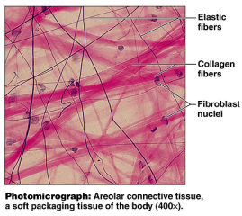

Slide: Adipose Tissue
In your field of view, you will find what appears to be empty cells. These spaces once housed the fat stores in the adipocytes. Try to identify the nuclei which are pushed off to the side.

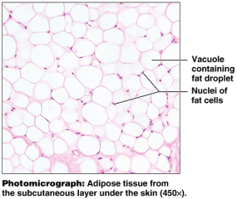
Question: What is the function of the adipose tissue? Provides fuel reserves, insulation, supports and protects organs

Question: Where are some locations in which adipose tissue is found. Found within the hypodermis, around kidneys and eyeballs, within abdomen, breasts.

Question: within the adipocyte, what is the vacuole? Inside the vacuole is fat

Reticular Connective Tissue (no slide available)
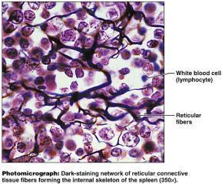
Reticular connective tissue contains a great deal of the reticular fibers. Observe the branched/networked nature of the fibers.

Question: Where is reticular connective tissue found?
lymph nodes, bone marrow, spleen

Question: What is the function of reticular connective tissue?
Function: forms an internal skeleton for the above structures.

Dense Regular Connective Tissue
This type of connective tissue can be seen in tendons. Notice how this tissue type is mostly fibers with few cells. The fibers are arranged in a regular pattern, giving a wavy appearance to the tissue. Also note that the image on the right is magnified 1000X. Your microscope will get you to 400X without oil immersion.

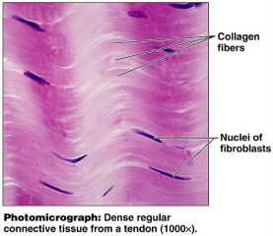

Question: Which fiber type is most prominent in this tissue type? Mostly collagen fibers

Question: Although cells are not abundant in this tissue, which cell is the most frequently found in this type?
Cell type: fibroblast

Question: What is an aponeurosis? (from the glossary, text, or lecture notes). The connective tissue that connects muscle to muscle.
Ex:
Tendon: muscle to bone
Ligaments: bone to bone
aponeurosis: muscle to muscle

Cartilage:
Slides: Hyaline Cartilage, elastic cartilage, fibrocartilage

Hyaline Cartilage: Slide: Monkey Trachea or trachea

In this tissue type, the collagen fibers form a network that is not easily seen; it appears as an evenly colored background. What is noticeable is the lacunae which house the chondrocytes. When looking at the trachea slides, keep in mind that hyaline tissue may not be the only tissue type appearing on this slide. You’ll have to search for the hyaline characteristics.

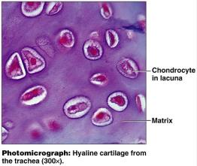

Question: Where is hyaline cartilage found? Embryonic skeleton, articular surfaces of long bones, costal cartilage, nose, trachea, and larynx.

Question: Which type of bone formation begins with a hyaline “bone” that gets ossified? Endochondral ossification

Question: In the term “chondrocyte”, what does “chondro” refer to?
chondro: cartilage
cyte: cell
Chondrocytes are the cell types that produce cartilage

Cartilage: Elastic Cartilage
Slide: Elastic cartilage or Epiglottis

Make a comparison of the hyaline cartilage to the elastic cartilage. Both have lacunae, but the lacunae in the elastic cartilage are more pronounced. Also, elastic cartilage has visible elastic fibers whereas the fibers in hyaline cartilage were much more subtle.

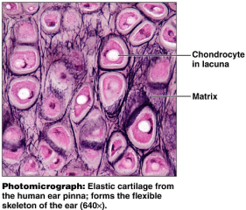

Question: In which locations can elastic cartilage be found? External ear, epiglottis

Question: What is the advantage of having elastic fibers in the matrix? Which quality does this give the elastic cartilage? Makes it much more flexible.

Cartilage: Fibrocartilage
Fibrocartilage contains a large amount of the thick collagen fibers. Still present are the lacunae and the chondrocytes. Compare this cartilage to the hyaline and the elastic cartilages.

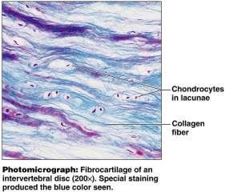

Question: Where is fibrocartilage found? Found in intervertebral discs, pubic symphysis, also in the knee

Question: what is the function of fibrocartilage? Functions as shock absorption
Connective Tissue: Bone
Note that this connective tissue has a calcified matrix unlike the previously viewed tissues. Locate the central canal and lamella while viewing the osteon. Again, this tissue type contains lacunae, but rather than containing chondrocytes like the cartilage did, these contain osteocytes.
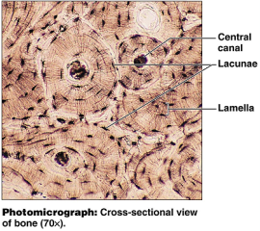

Question: What is the function of the central canal? Location for blood vessels (found in chapter 6)

Question: What is the function of the canaliculi? Connections that run between the lacunae and the central canal (found in chapter 6)

Question: What is an osteon? The structural unit of compact bone. Also called a Haversian system. They function as small, weight bearing pillars. (Chapter 6)

Connective Tissue: Blood
Slide: Blood or Wright’s stain
Blood is a connective tissue used for transportation. The matrix is a fluid matrix (plasma) and the cells are the red and white blood cells.
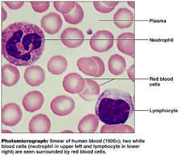

Question: According to your lecture notes (or text book) What are the functions of connective tissues in general?
Binding and support
protection
insulation
transportation

